**CI/CD pipelines using Git, Jenkins, Ansible, Docker**

**and Kubernetes on AWS**

open AWS click on EC2

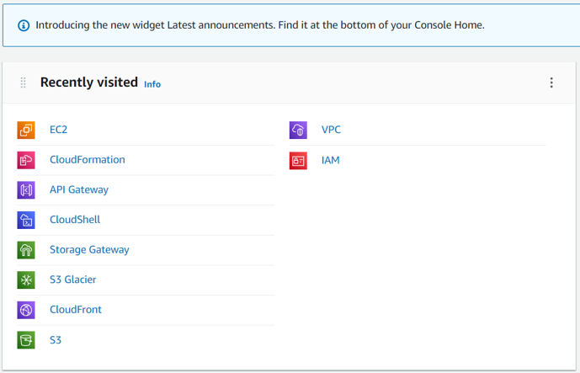

Click on Launch instance

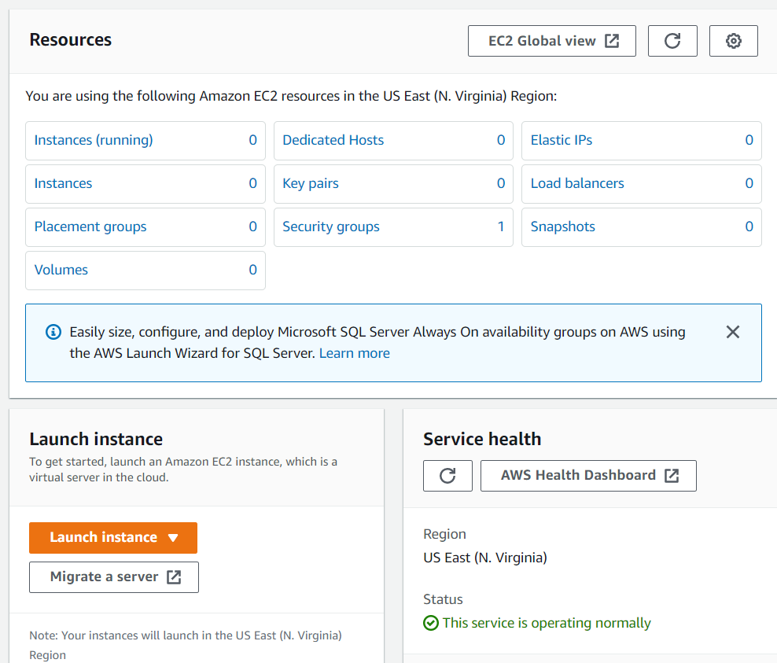

Click on select

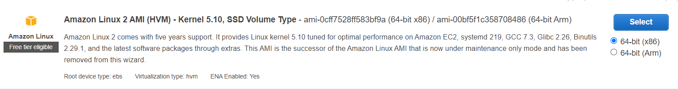

Click on Configure Instance Details

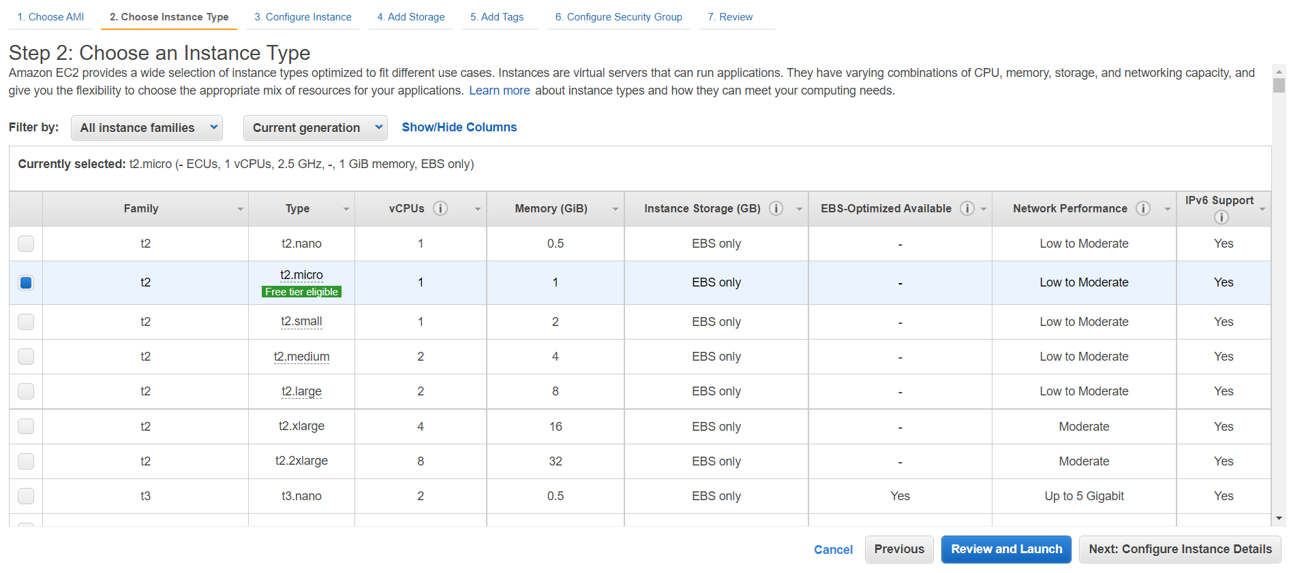

Click on Add Storage

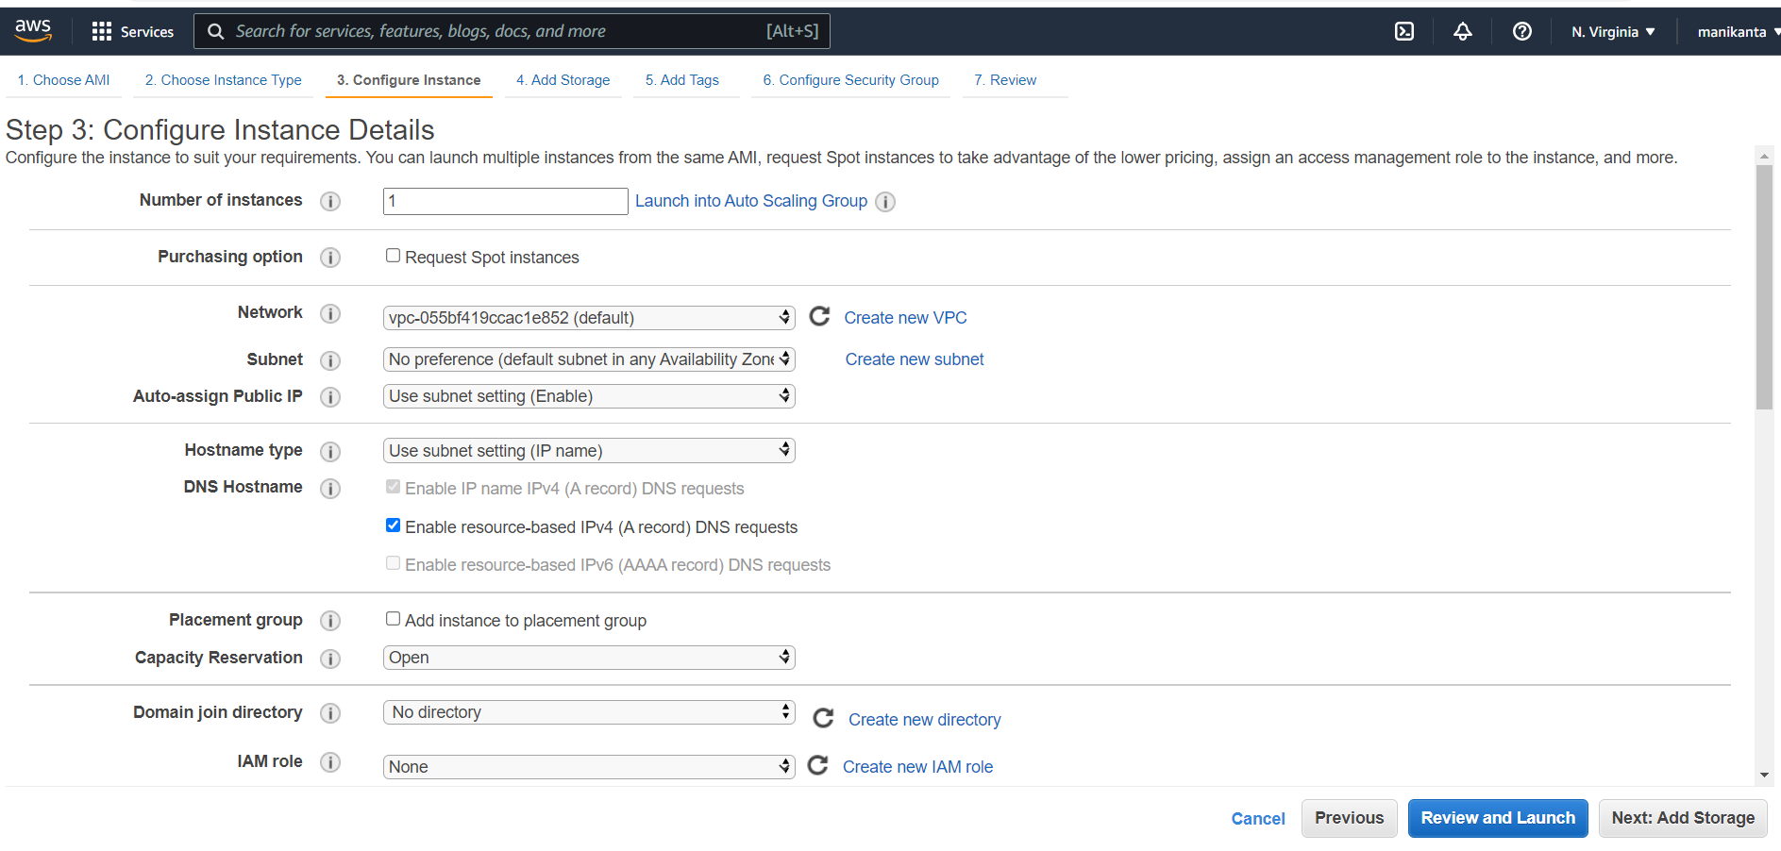

Click on Add Tags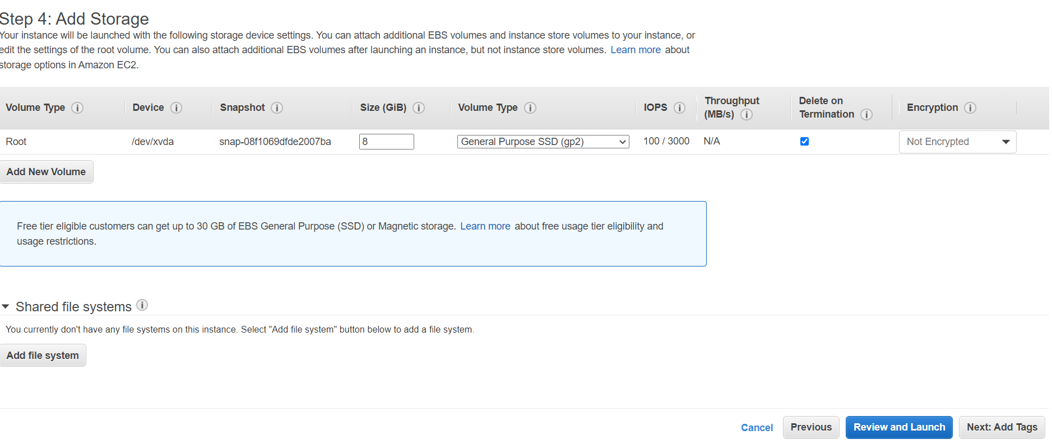

Click on Configure Security Group

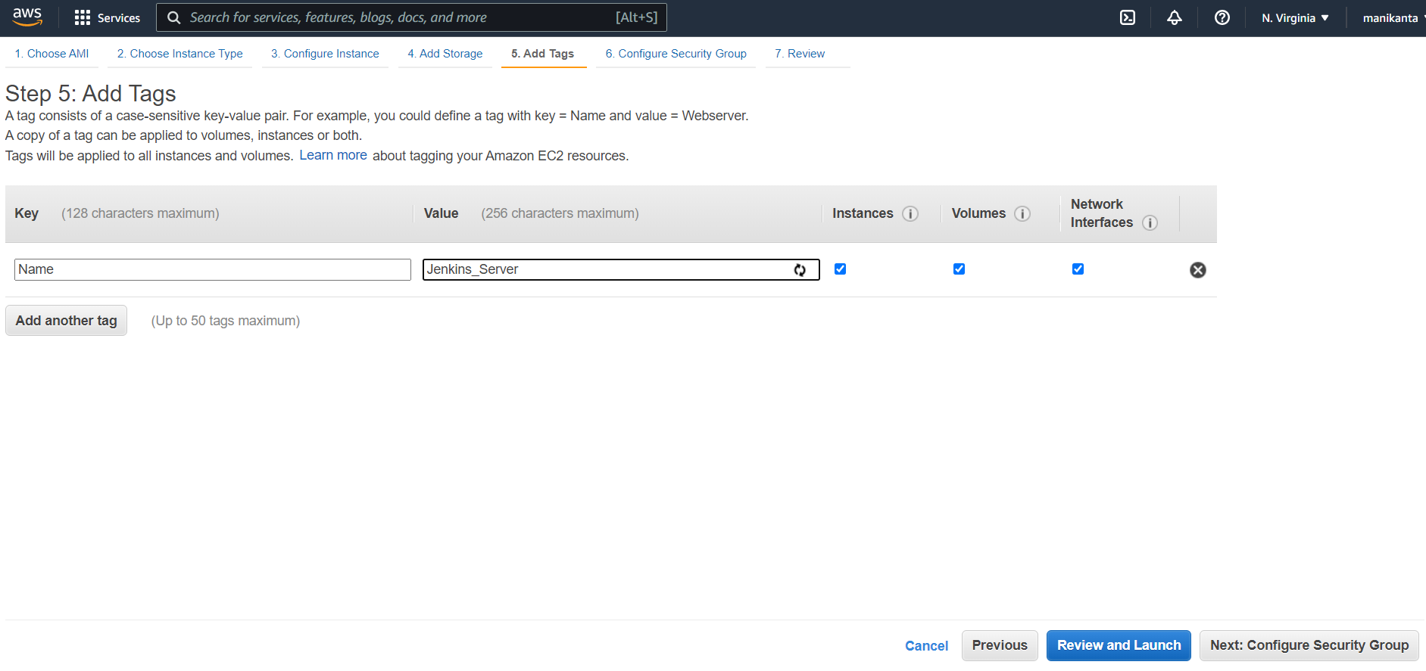

Click on Add Rule and add 8080 port

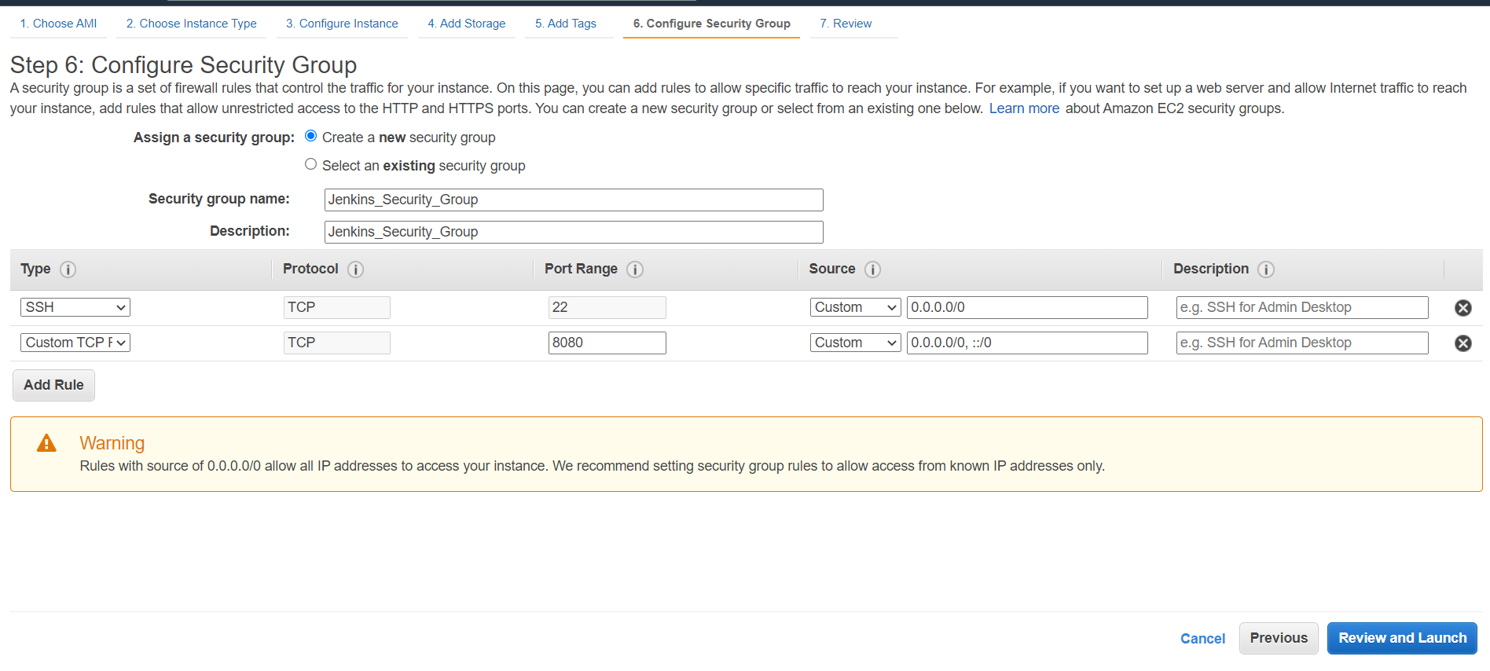

Click on launch

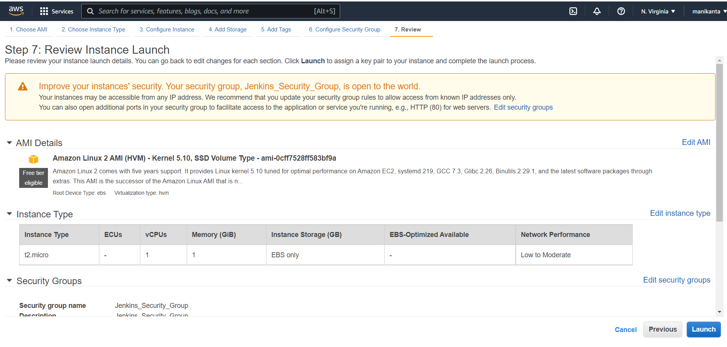

Copy the public ip

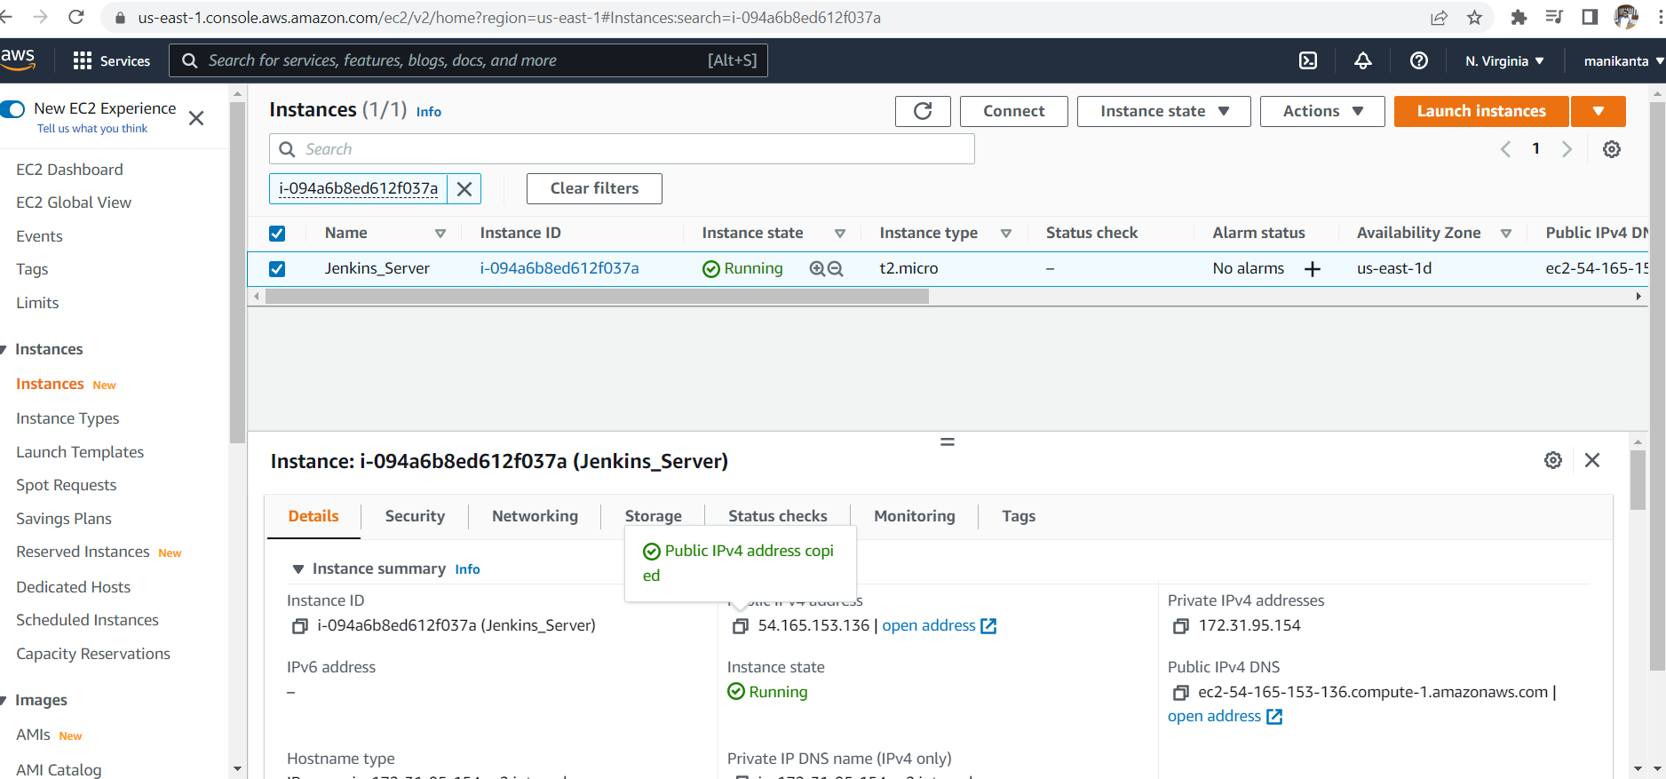

Open mobaxterm

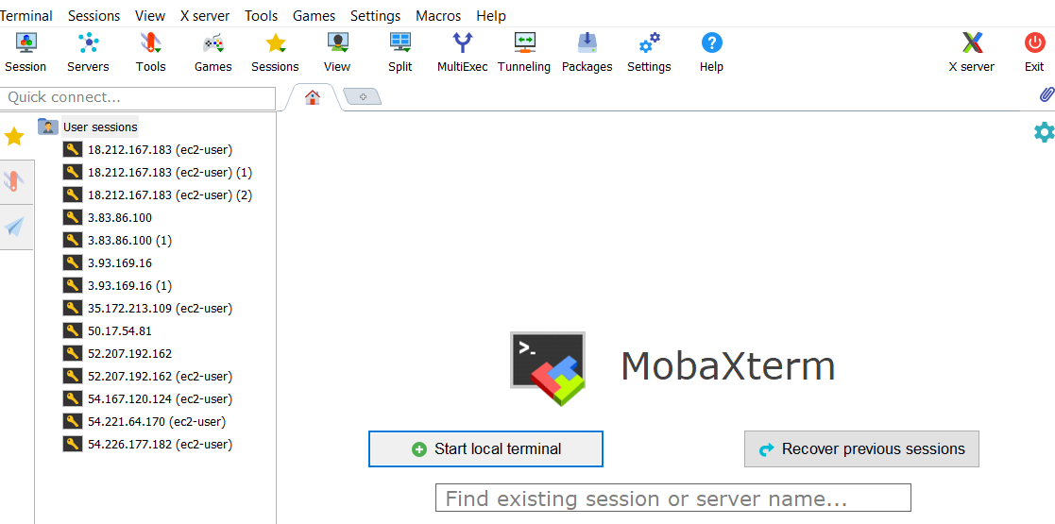

Choose sessions

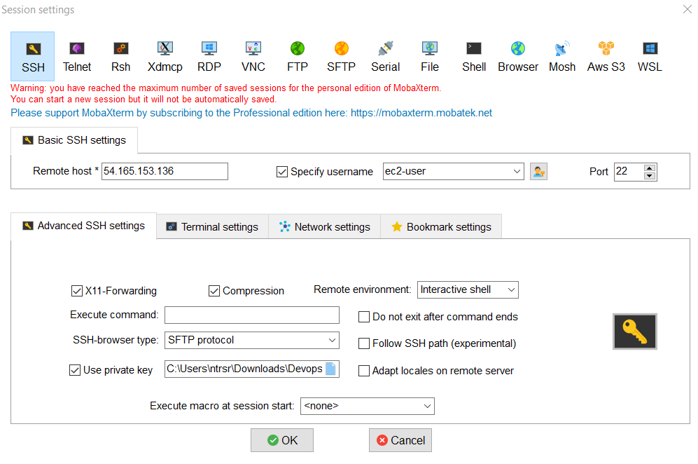

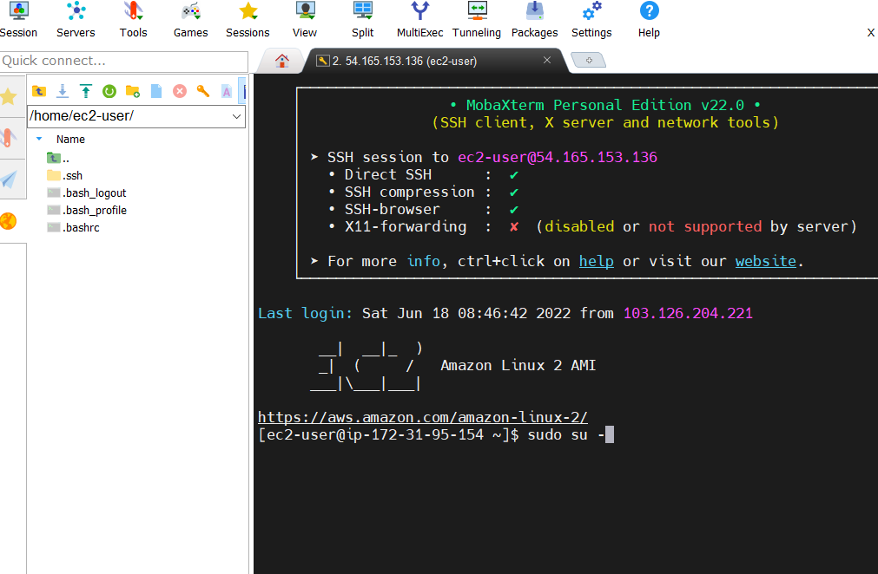

<https://pkg.jenkins.io/redhat-stable/>

Go through this site for Jenkins commands to install Jenkins

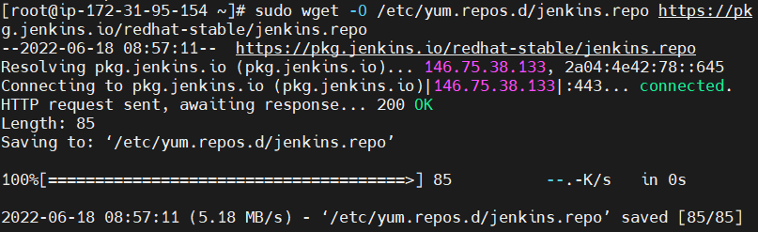



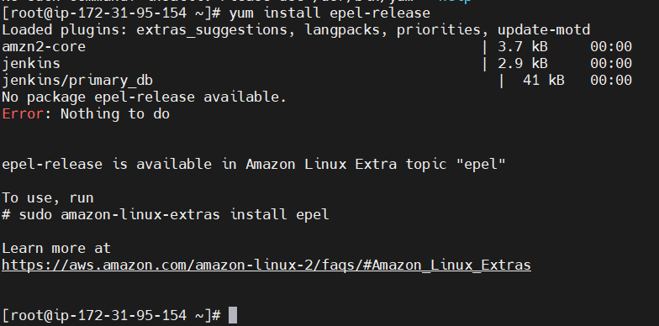

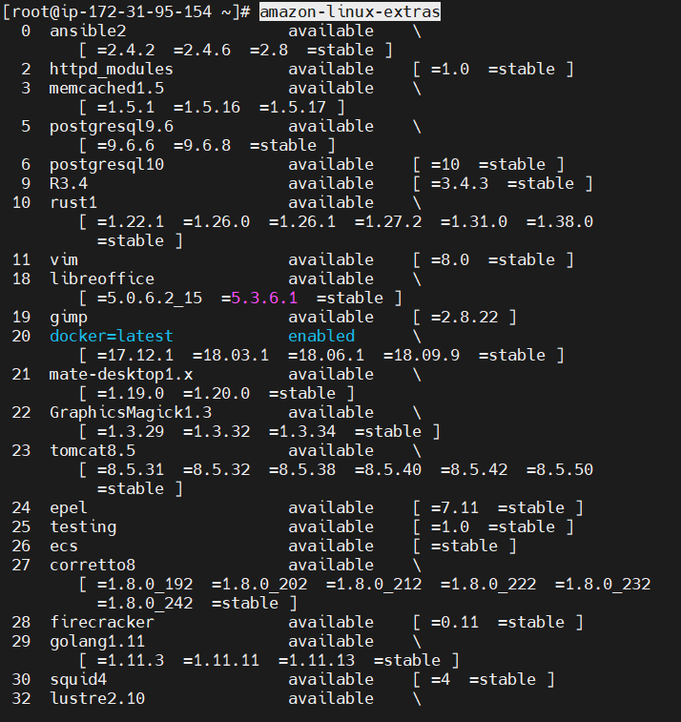

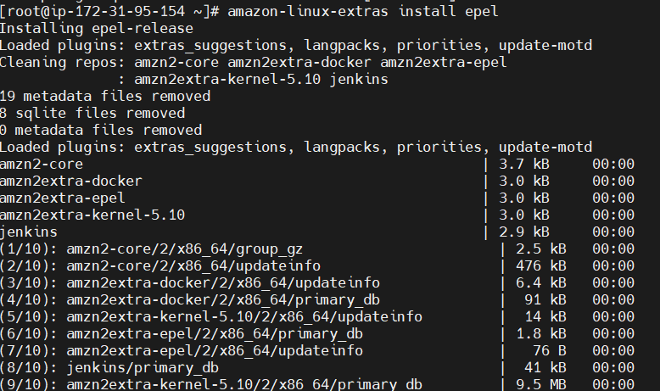

If we doesnot install epel packages we can not install jenkins

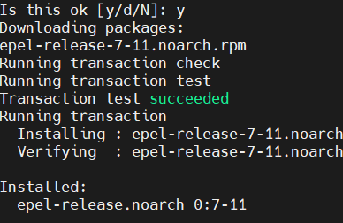

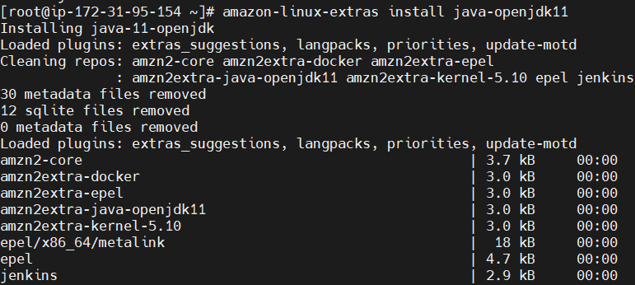

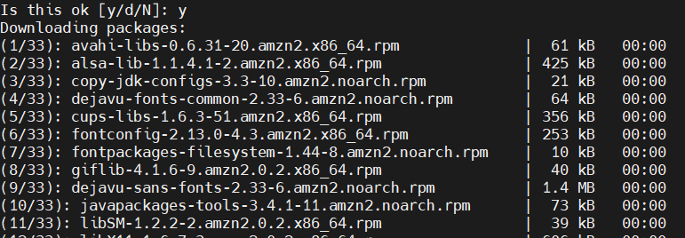

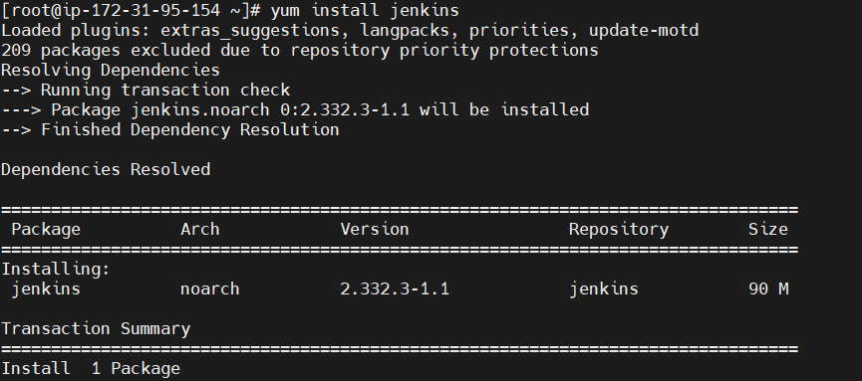

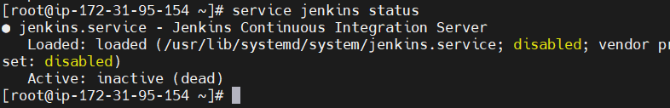



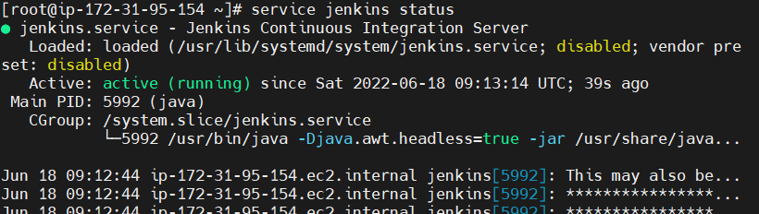

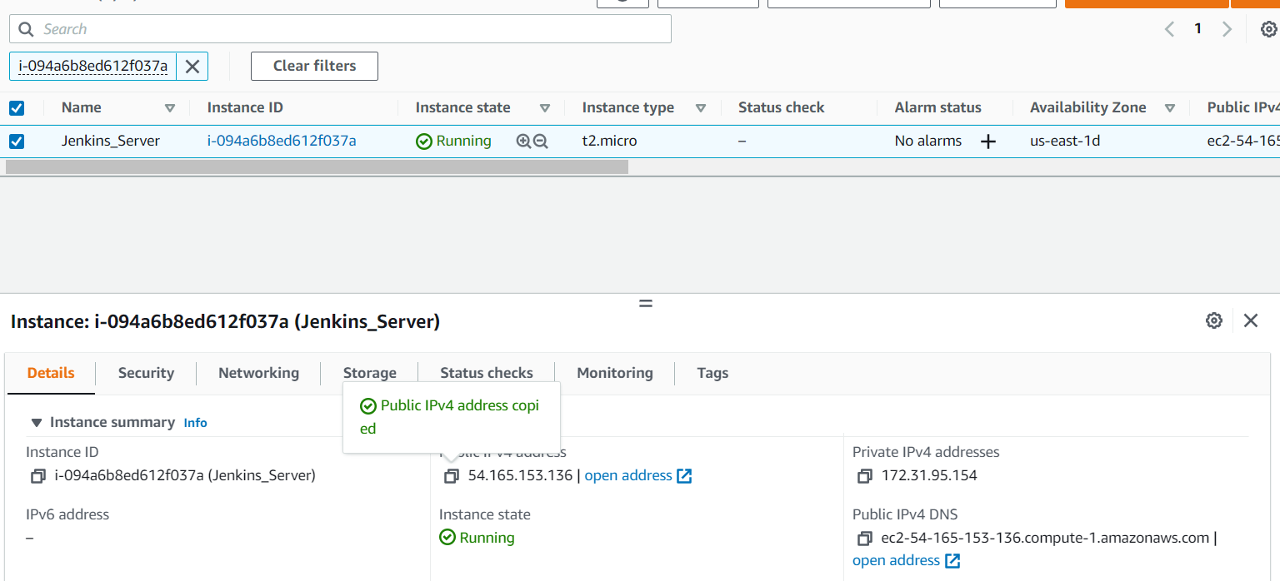

Take your public ip put it in the search bar with 8080 like below figure



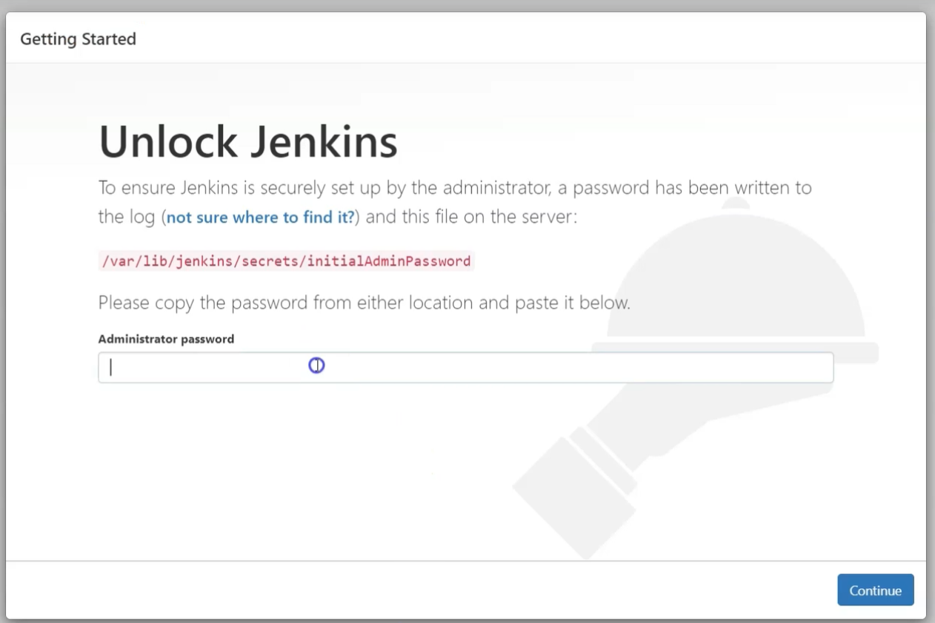

You will get this page

Take the path which shown in the figure



Copy the password and paste in the site

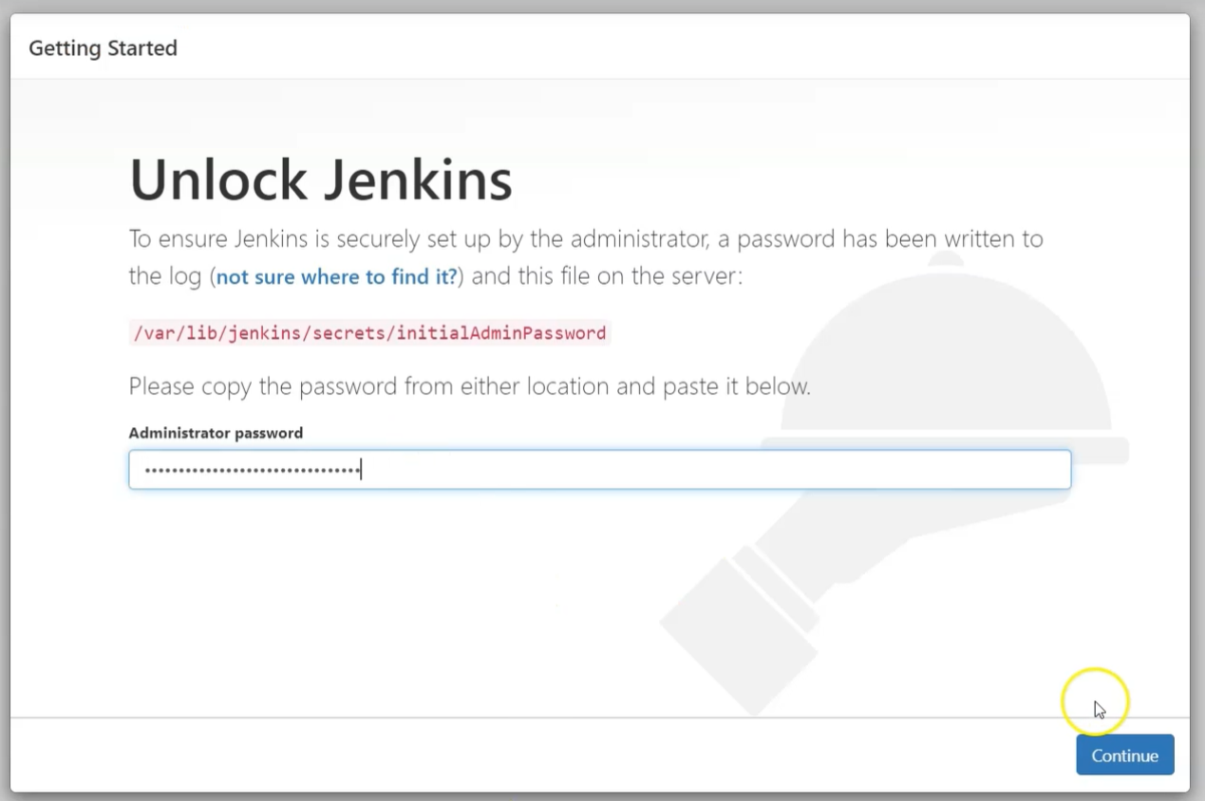

And continue

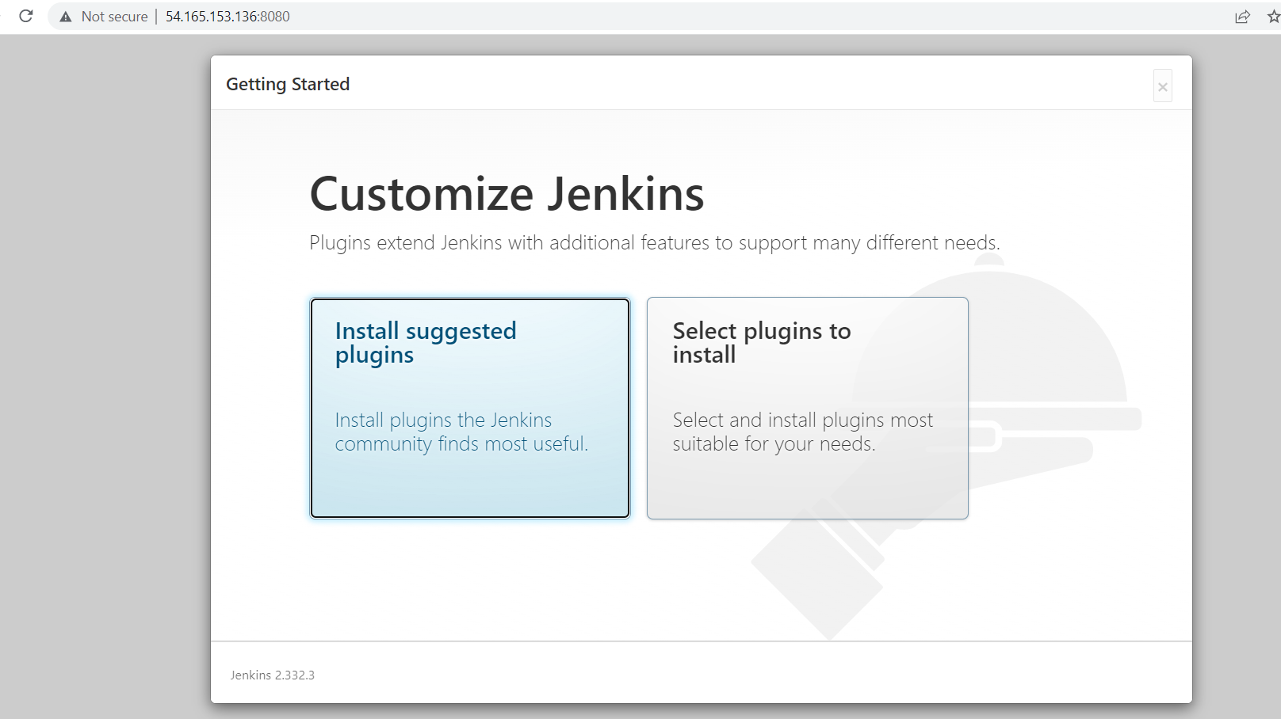

Cancel the installations

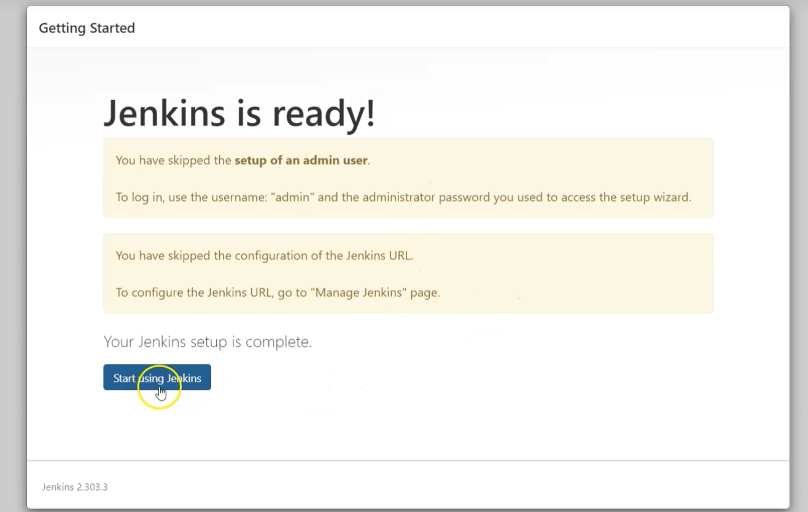

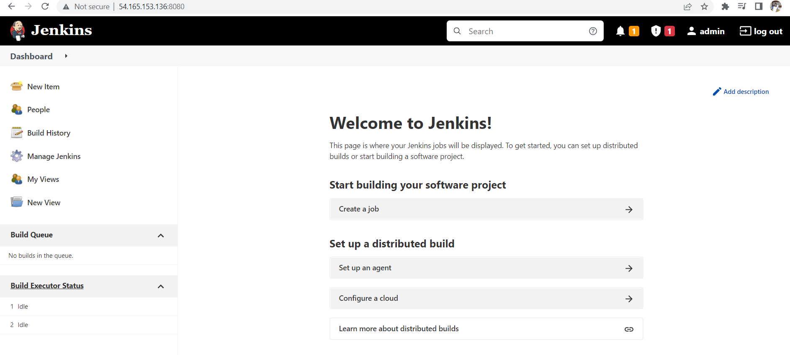

You will see this page

Later change your password go to manage jenkis

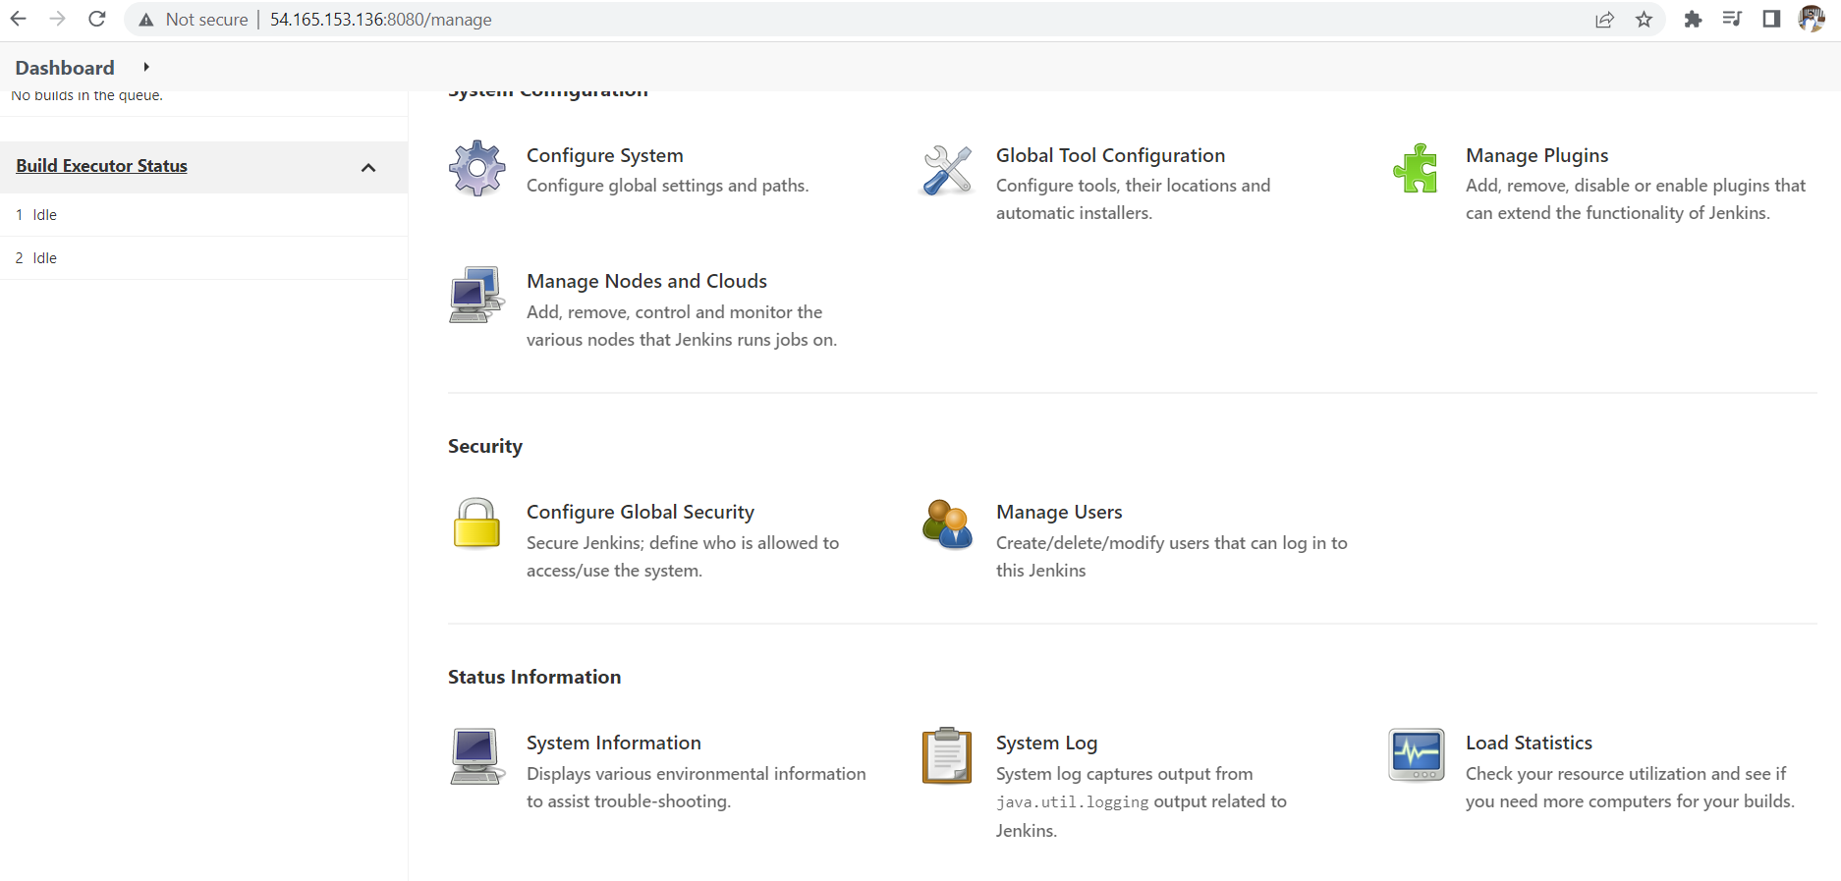

Later choose manage users

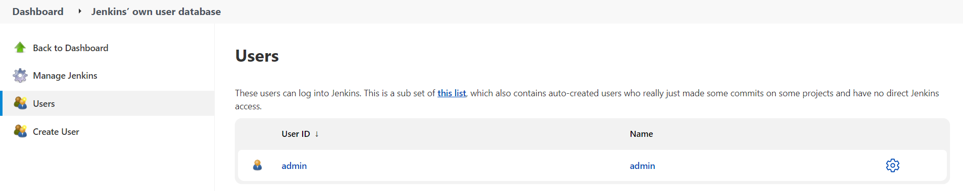

Click on admin

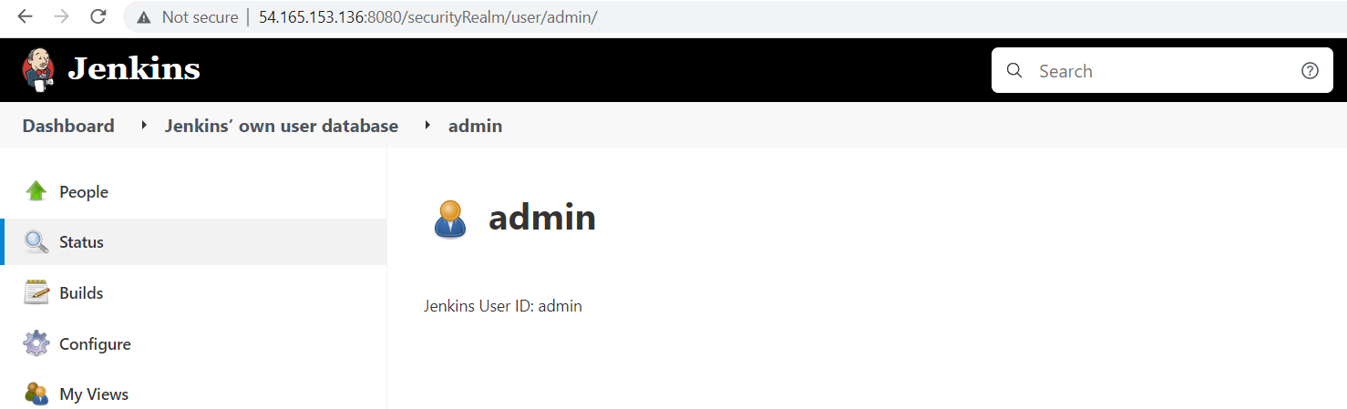

Click on configure

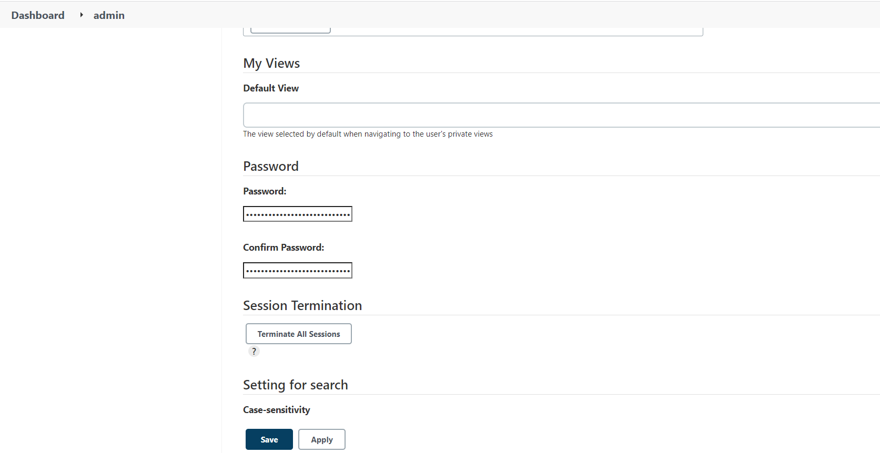

Change your password here

Later click on apply and save

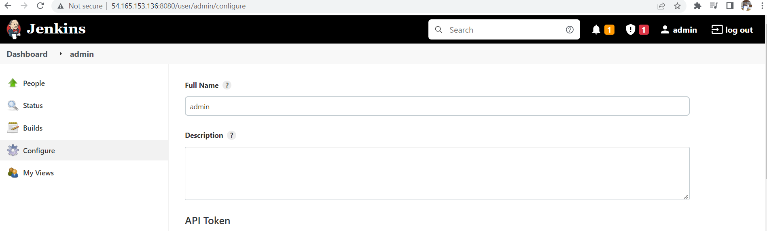

Then logout and try to login after login

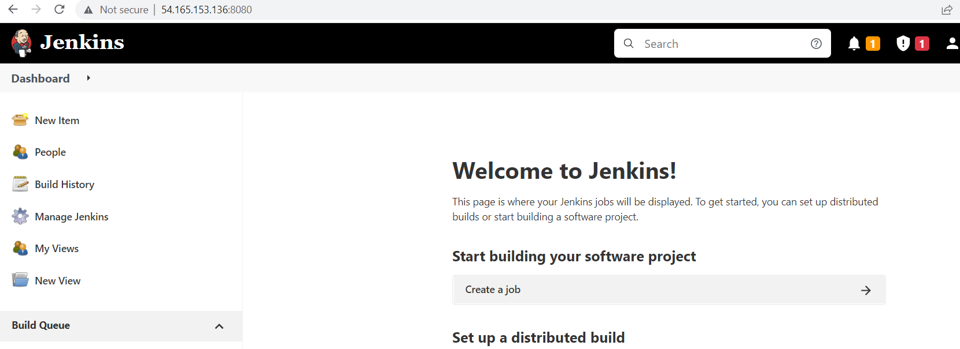

Click on new item

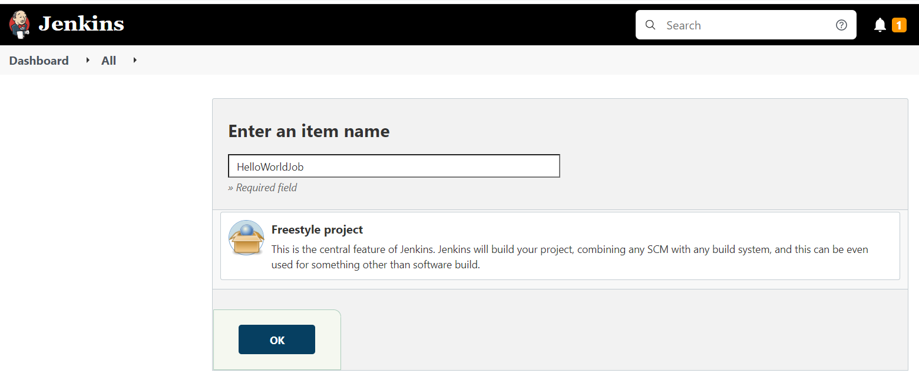

We name the project and click on the freestyle project and then click on ok

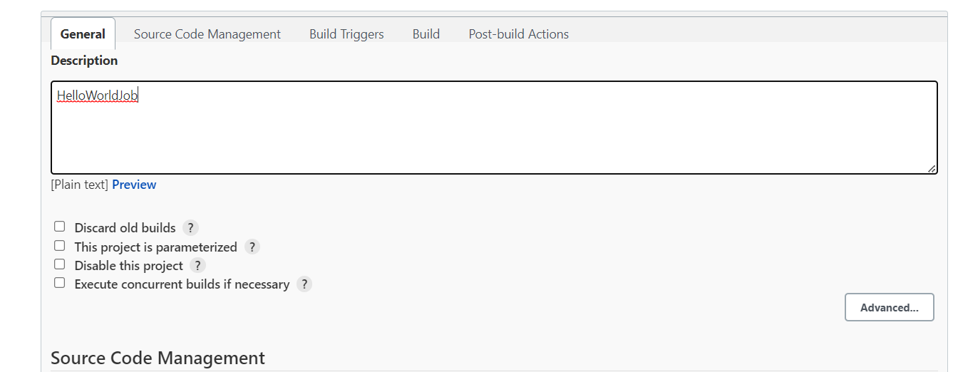

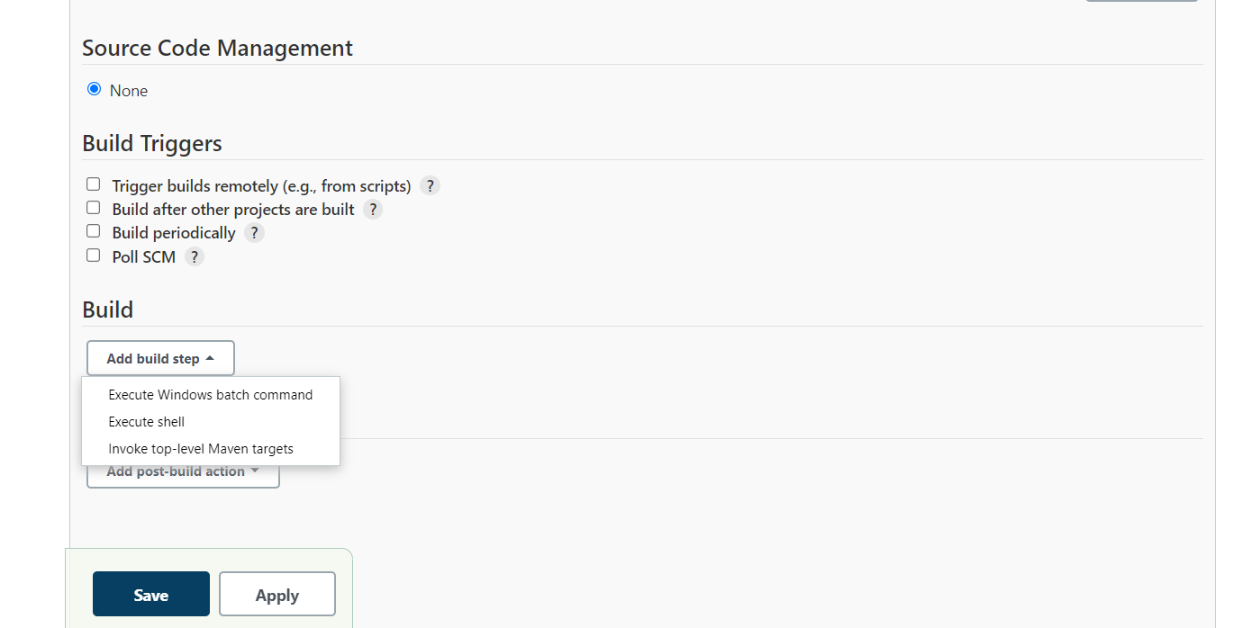

Choose execute shall

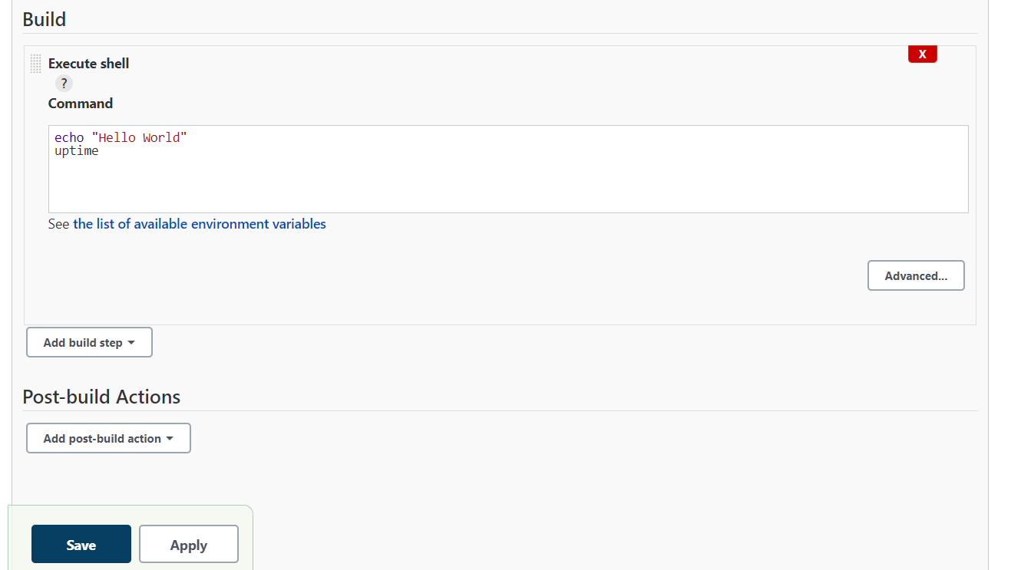

Apply and save

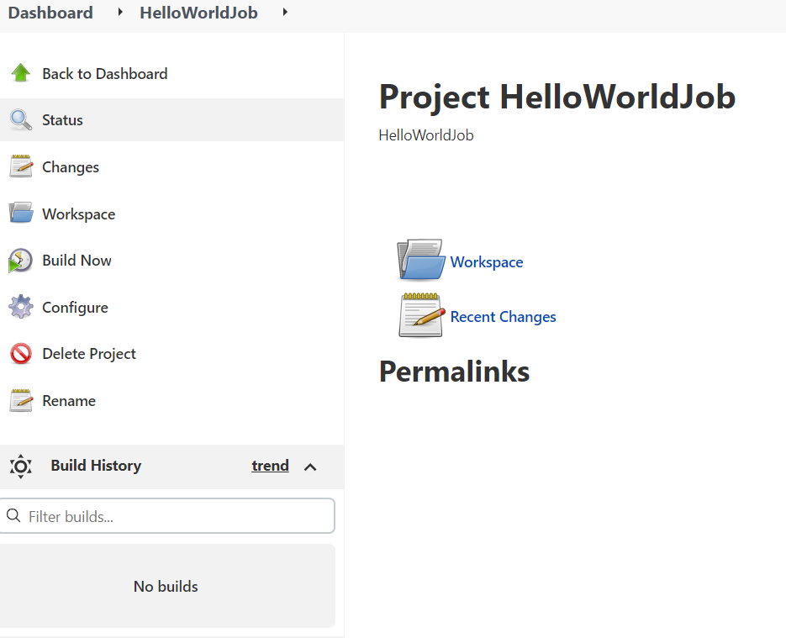

Click on Build now

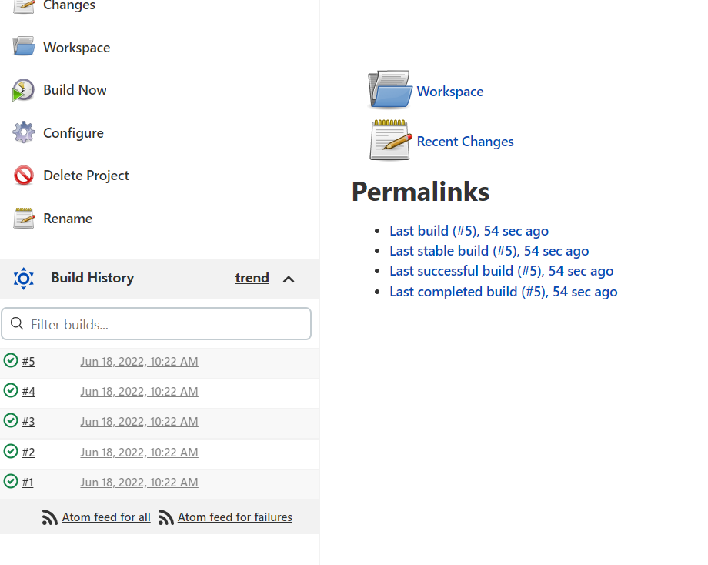

Click on the first build to see the output

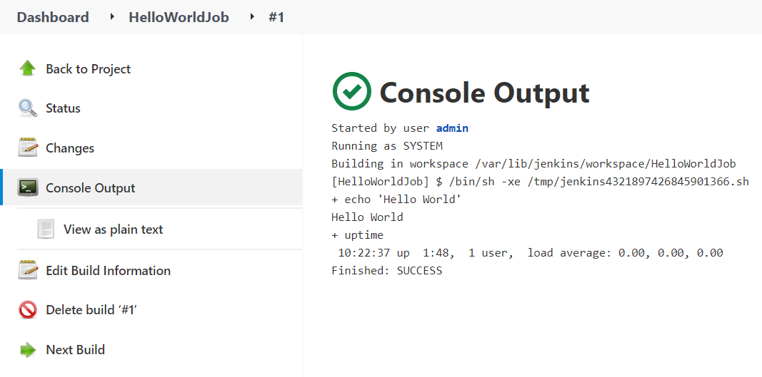

Now go server terminal and change the hostname



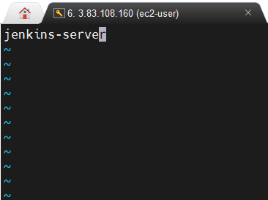

Change name as Jenkins-server

Now install git

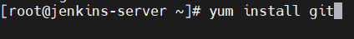

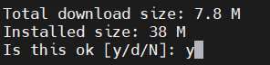

Check git version

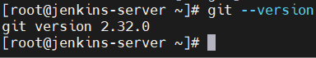

Now open Jenkins

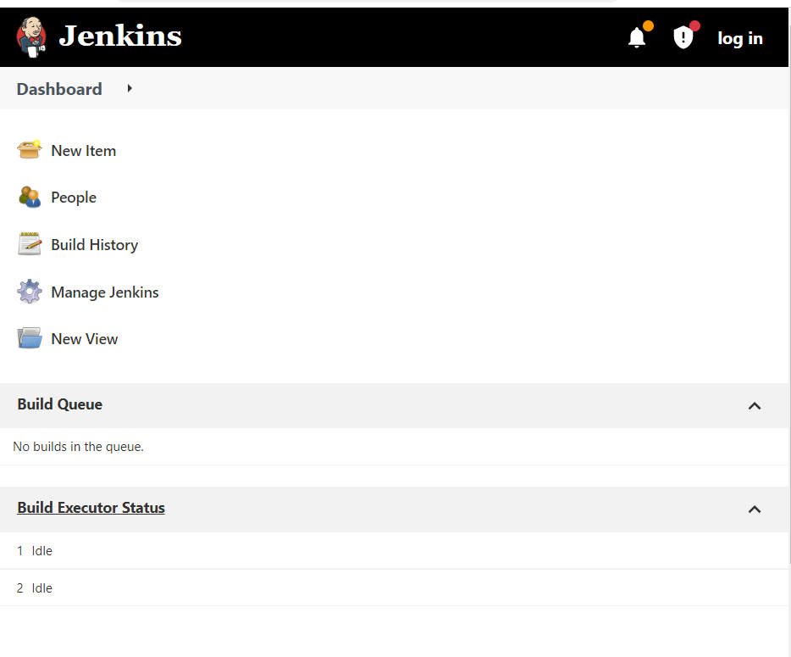

Click on manage Jenkins you will see this page now click on manage plugins

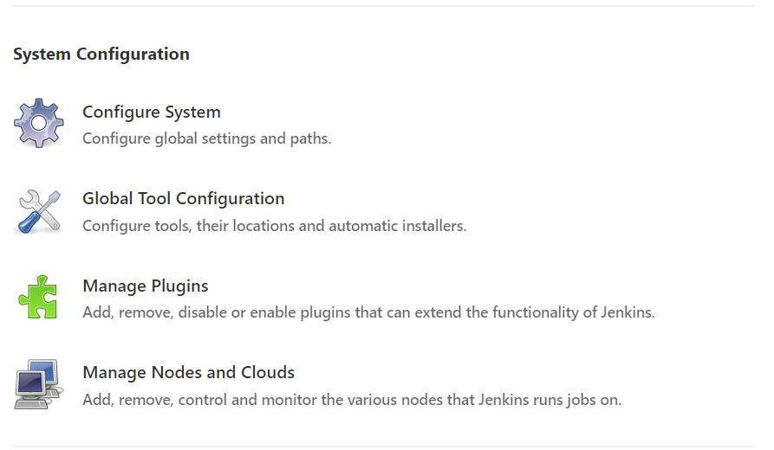

Click on available search as github put right mark in github and click on install eithout restart

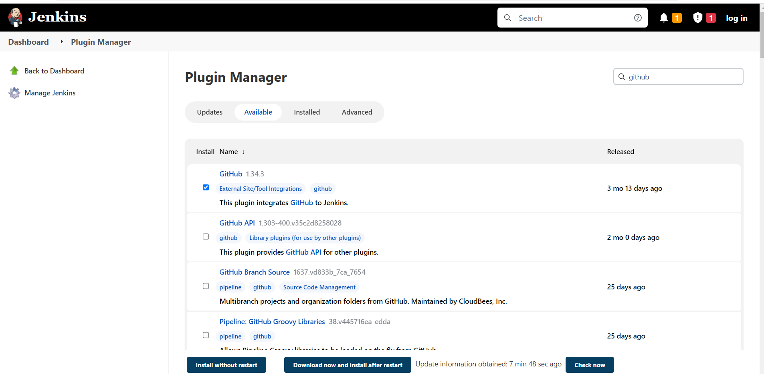

Click on go back to the top page

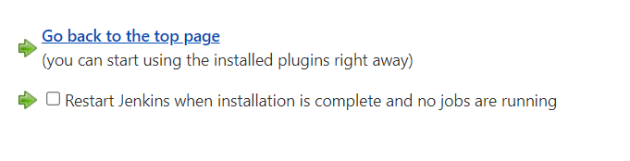

Click on manage jenkins

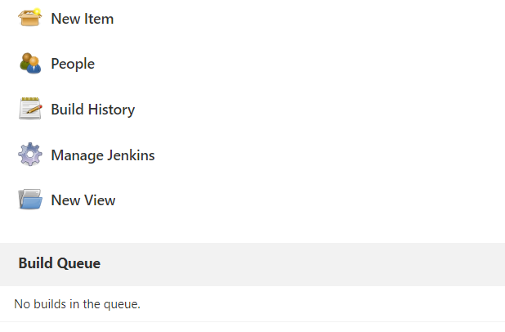

Click on global tool configuration

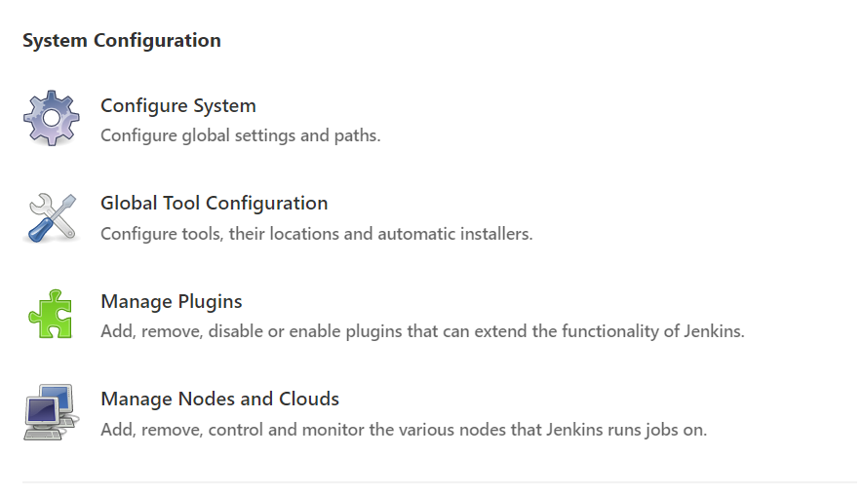

Change name to git as shown below figure apply and save

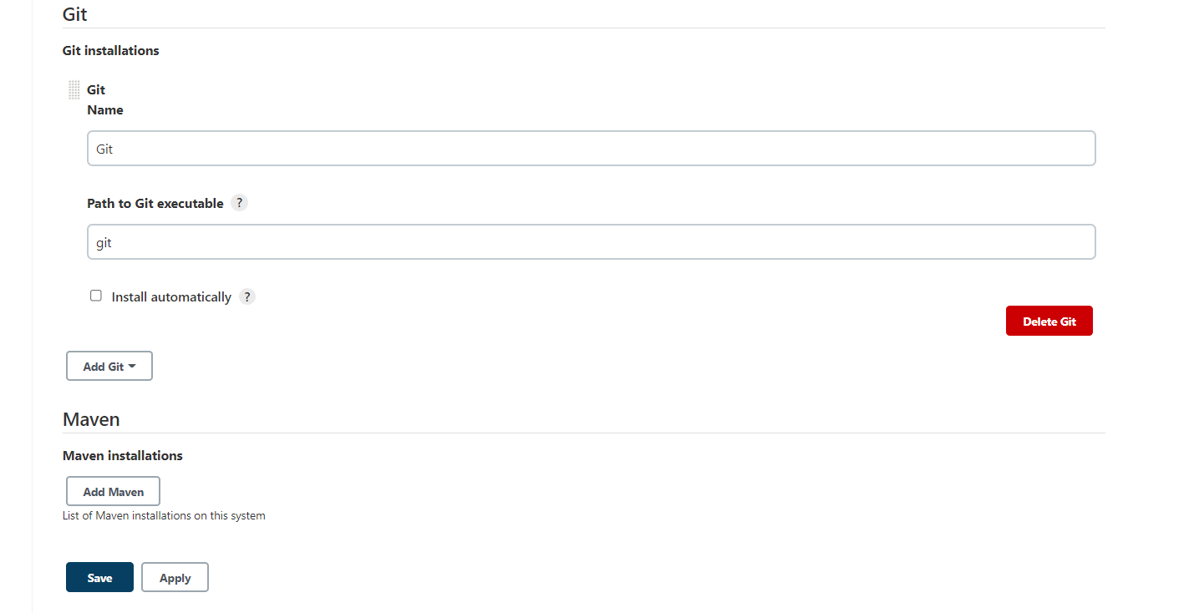

Now home page click on new item

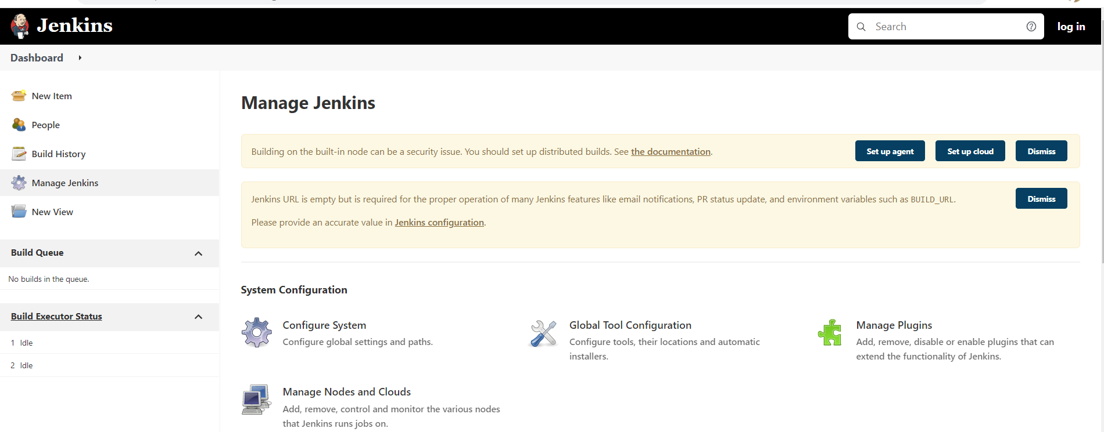

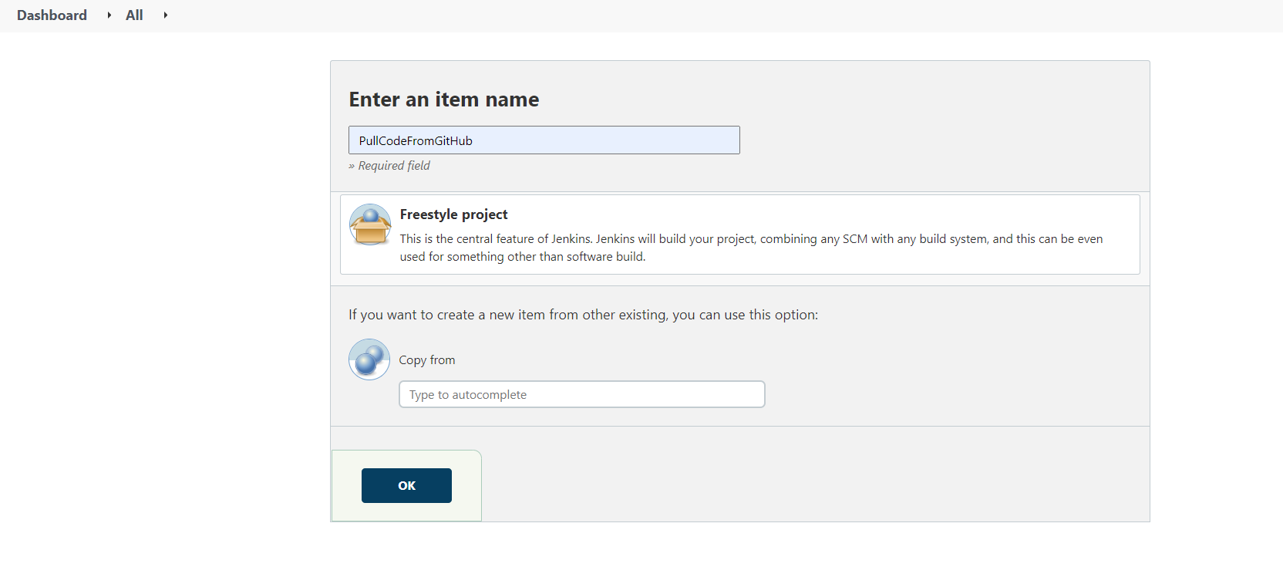

Click on freestyle project and click on ok

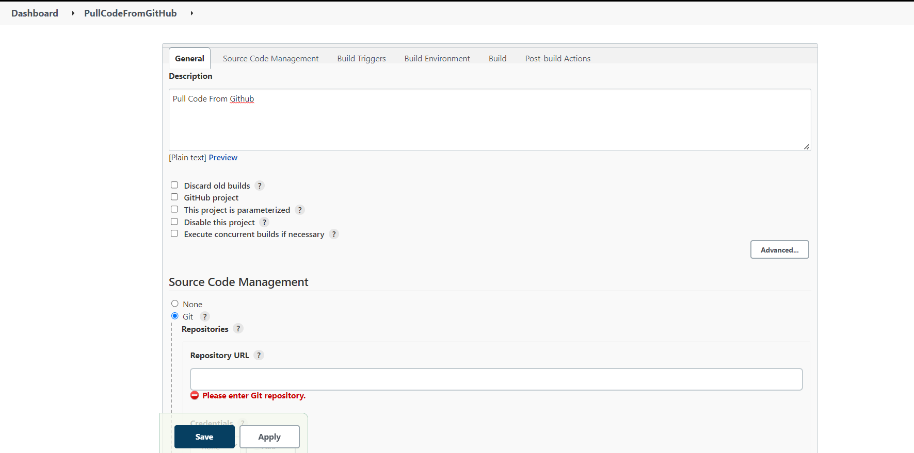

Take repository url from this site

<https://github.com/yankils/hello-world>

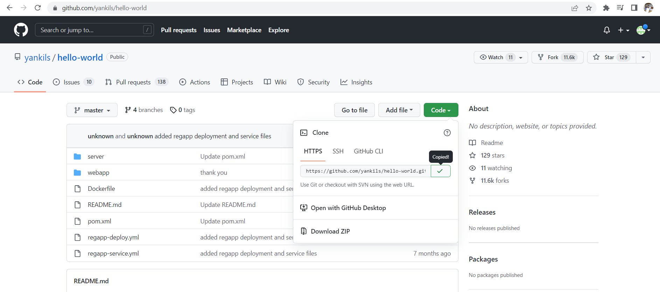

Copy Http url and paste in repository url

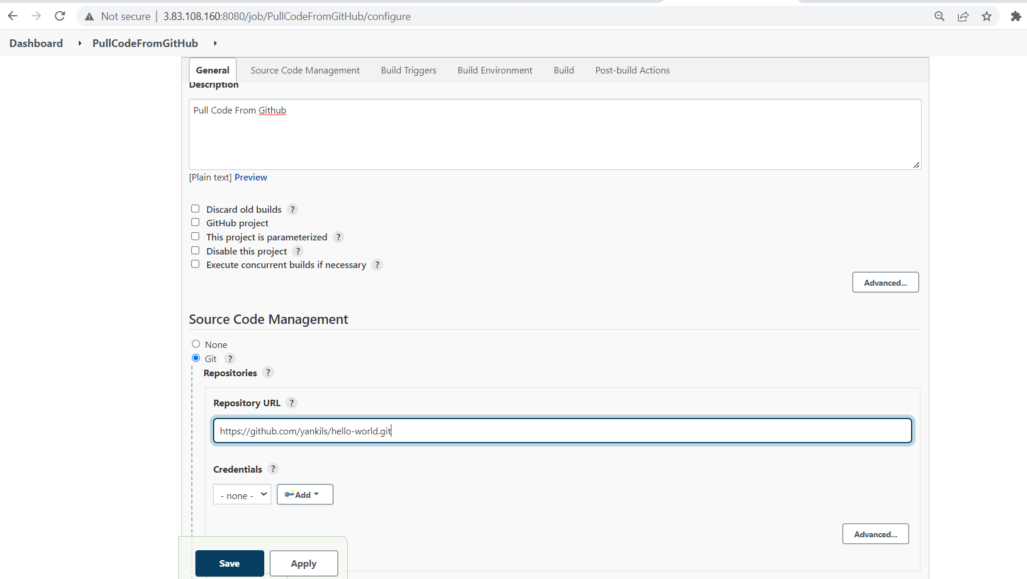

Apply and save

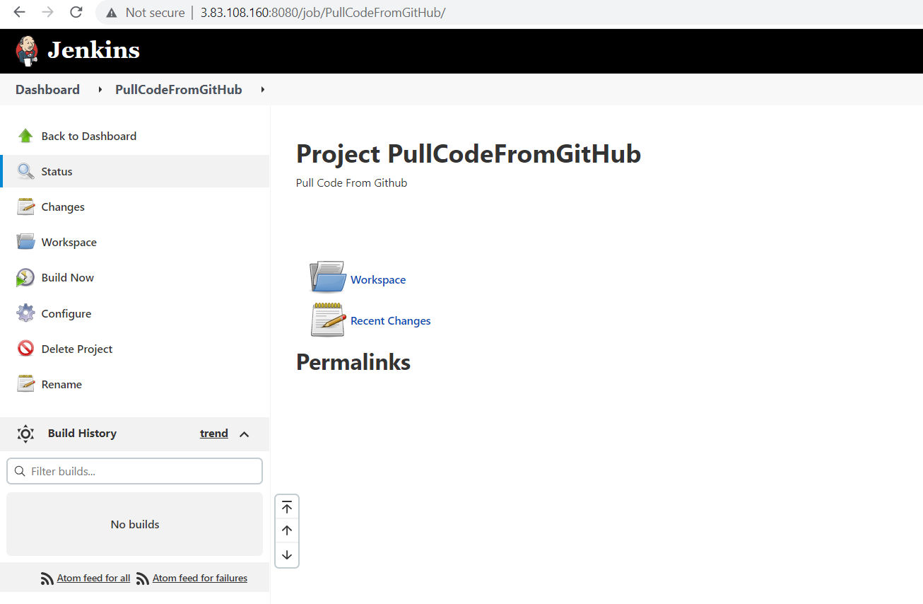

Click on build now

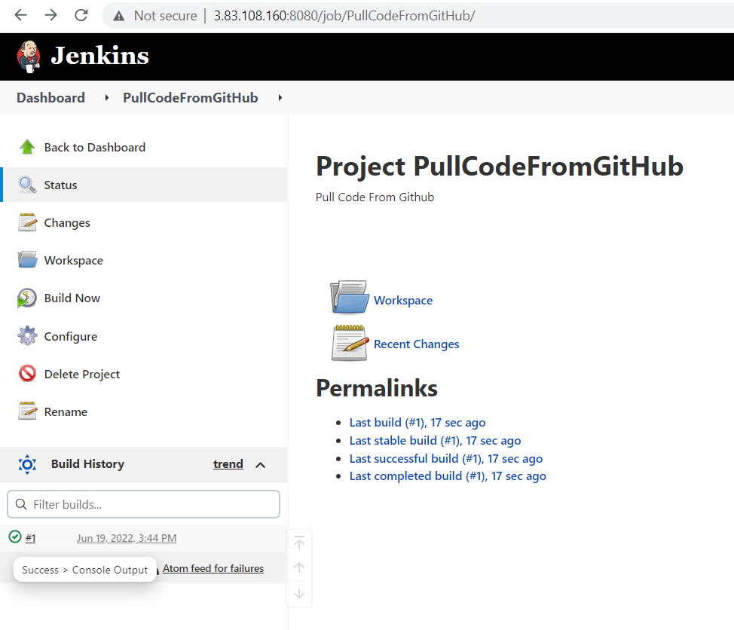

Click on console output right mark

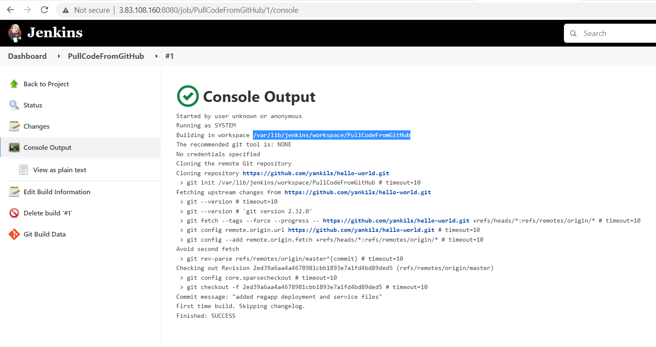

Copy the path paste in the terminal

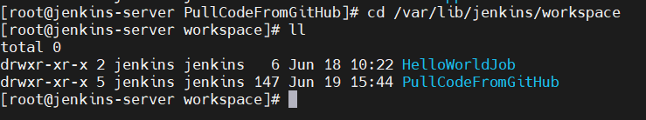

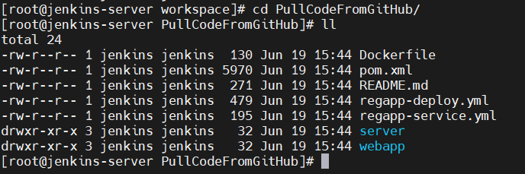

Integrate maven with Jenkins:

From here you can copy the url of maven

<https://maven.apache.org/download.cgi>

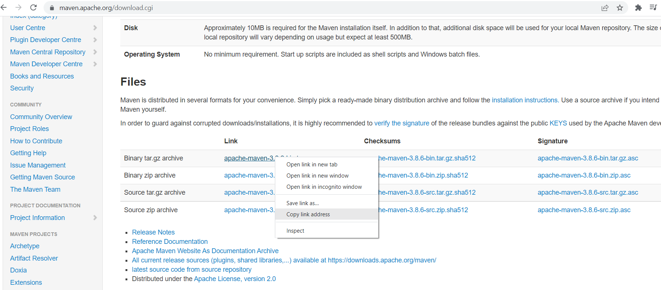

Copy the link address of [apache-maven-3.8.6-bin.tar.gz](https://dlcdn.apache.org/maven/maven-3/3.8.6/binaries/apache-maven-3.8.6-bin.tar.gz)

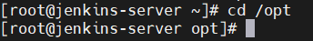

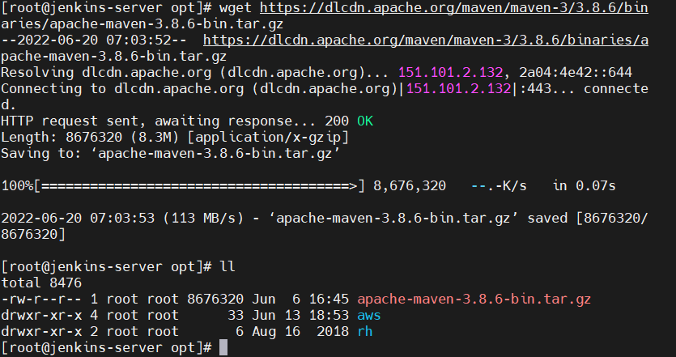

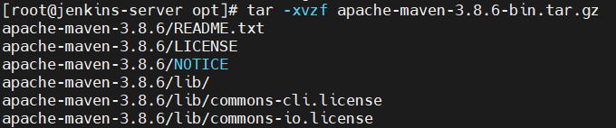

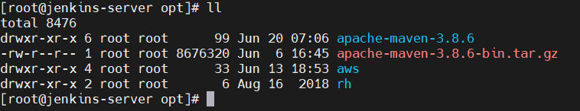

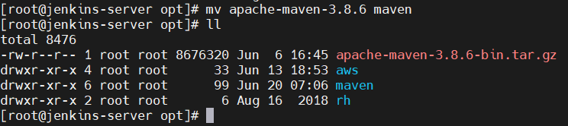

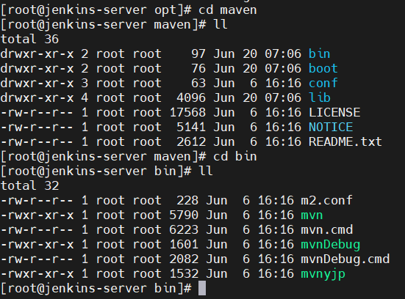

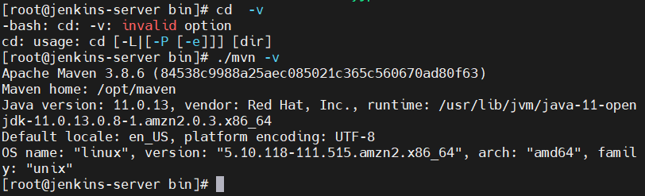

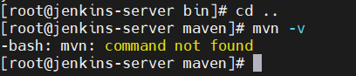

Now we need to setup environment variables

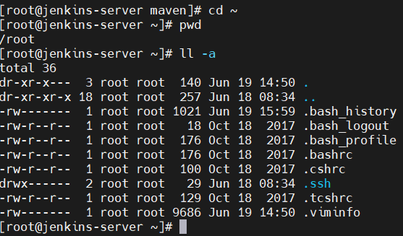



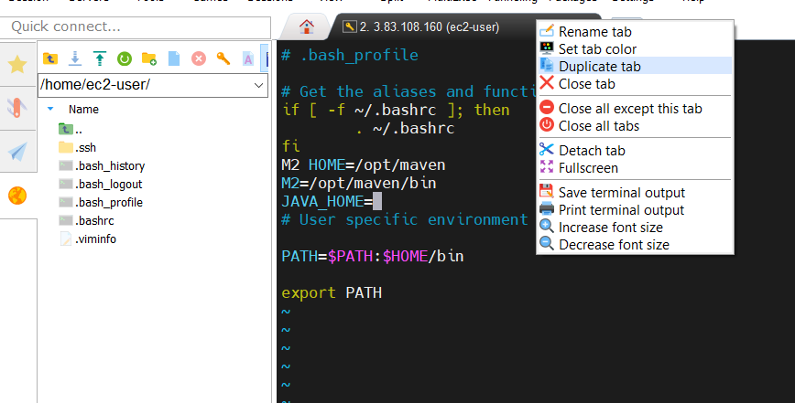

Click on duplicate tab

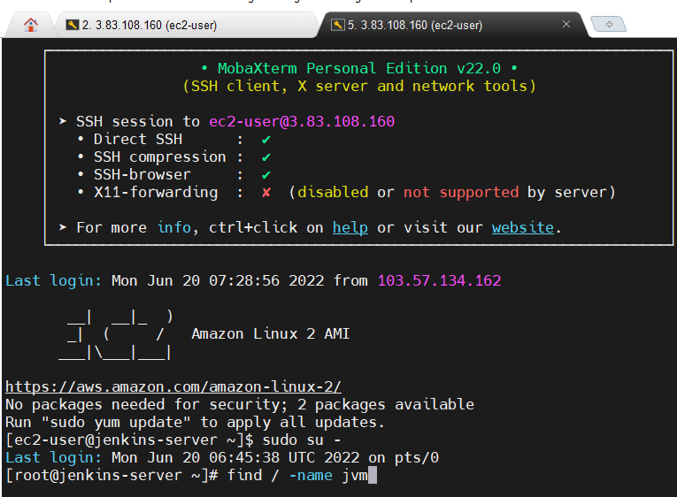

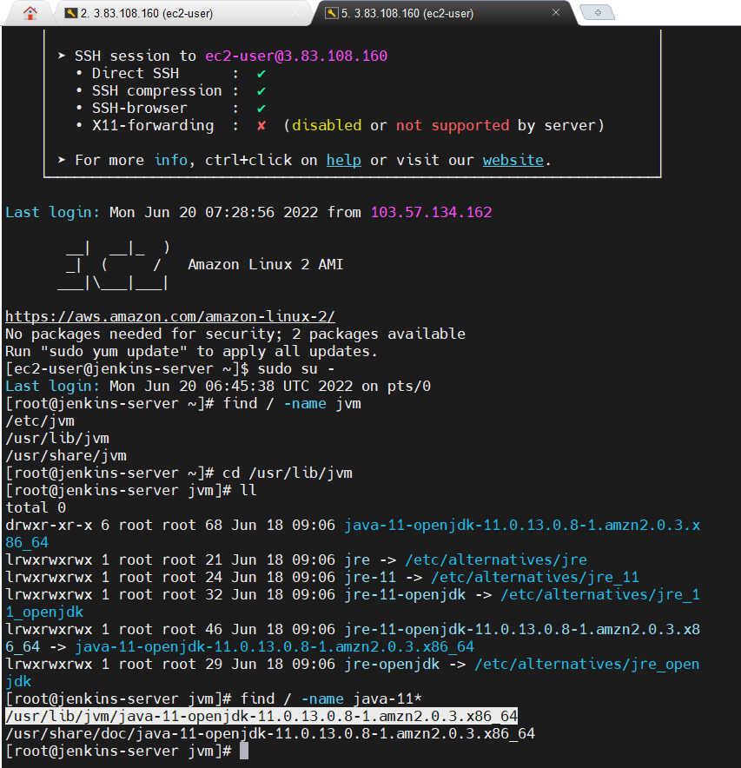

Copy this path and paste here as shown here

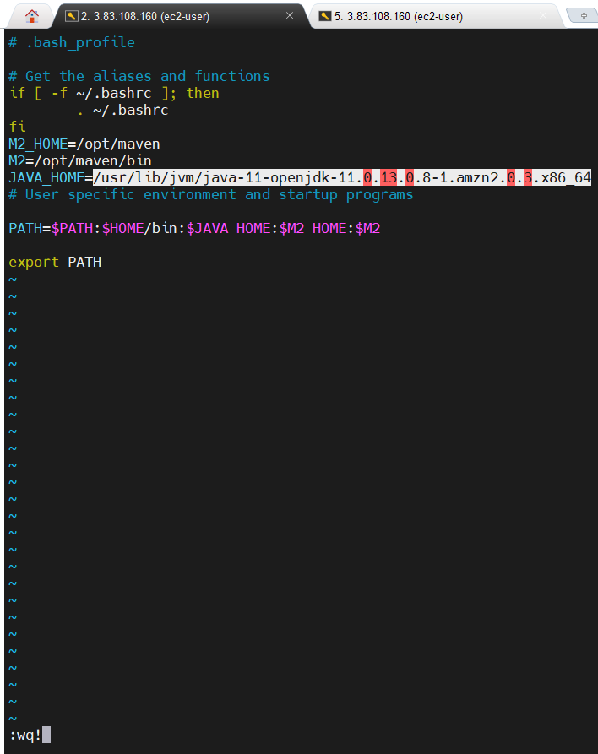

Here save file



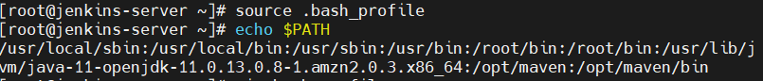

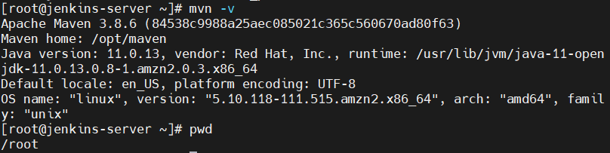

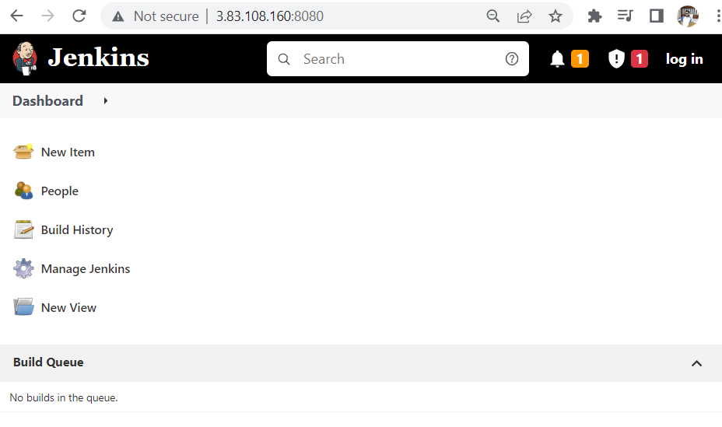

Click on manage Jenkins

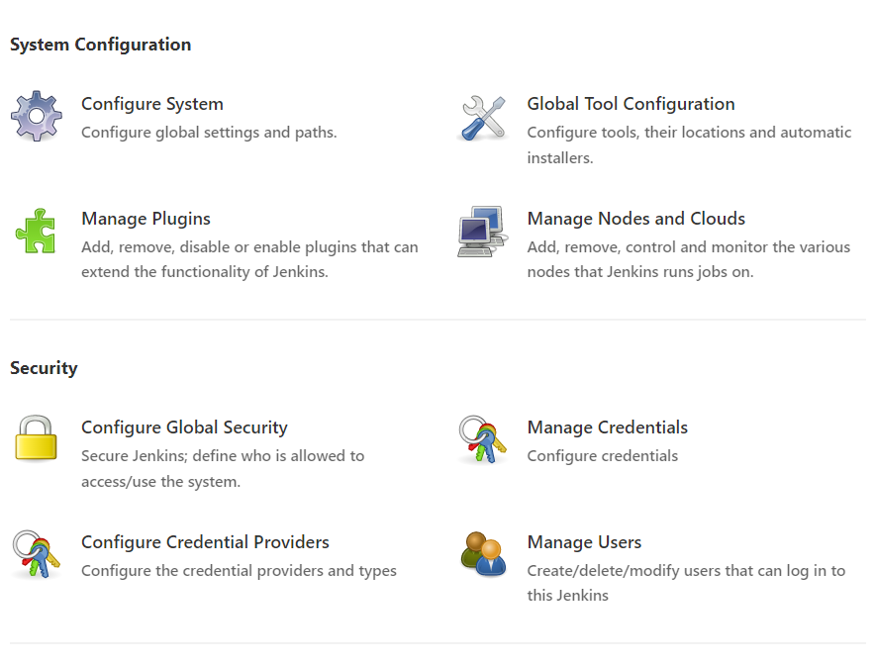

Click on manage plugins

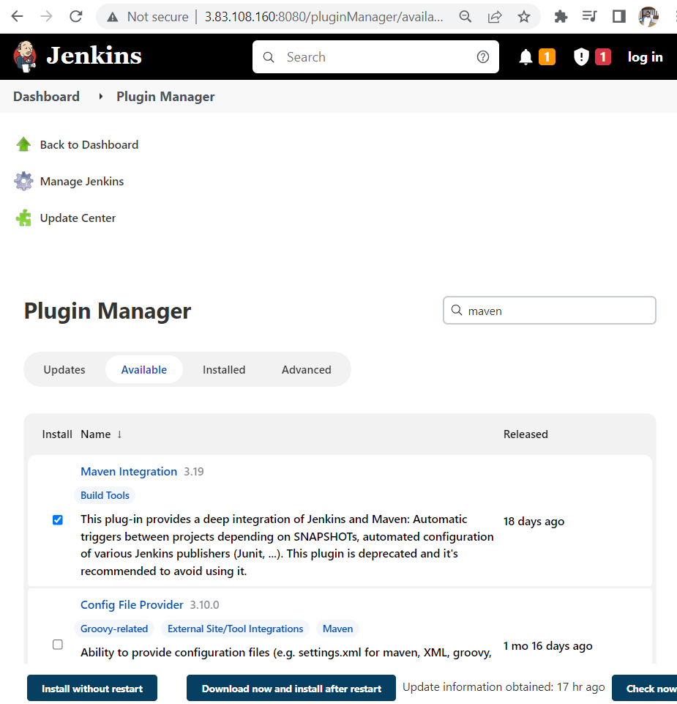

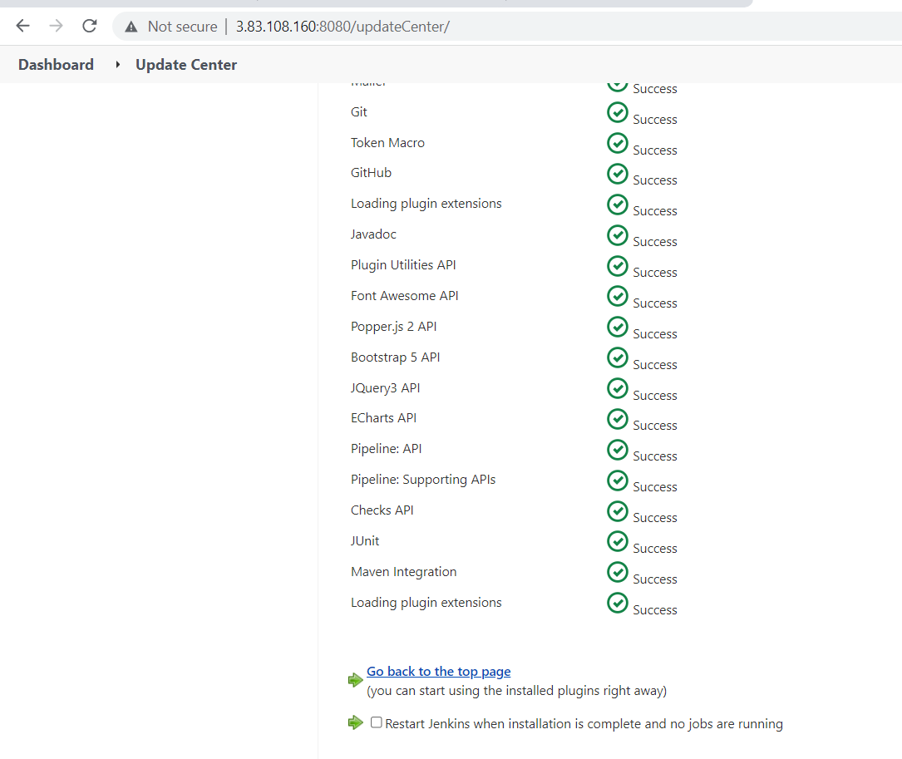

Go to Dashboard

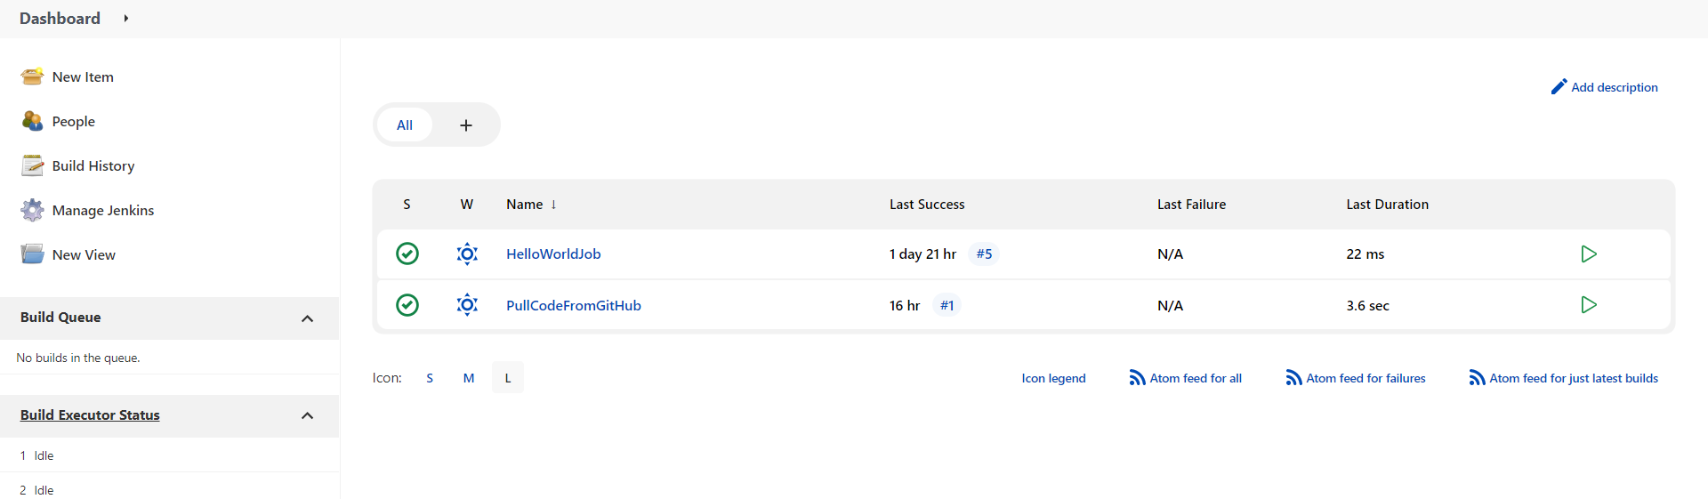

Manage Jenkins

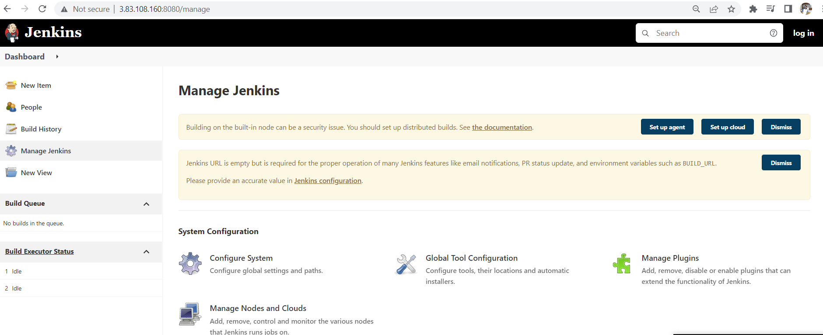

Click on global tool configuration

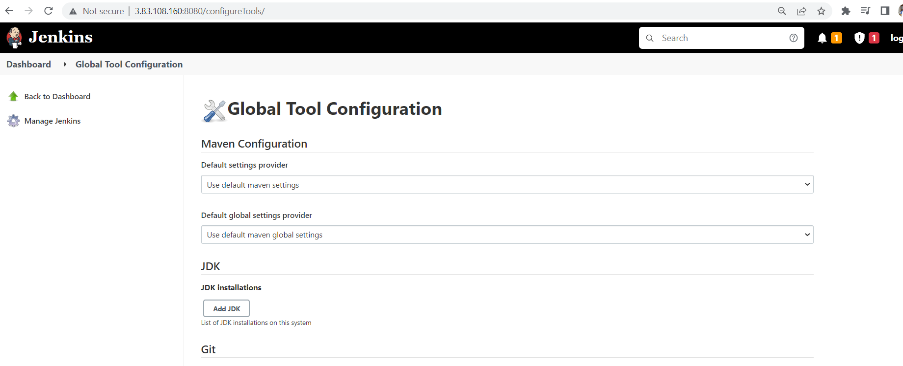

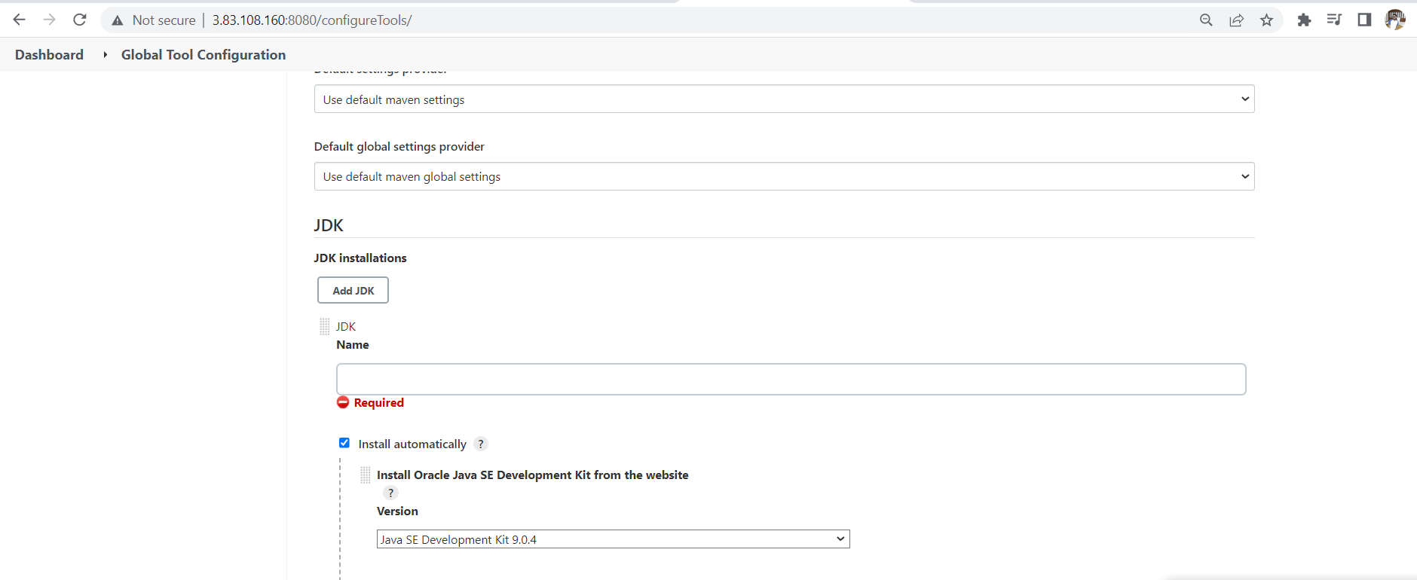

Remove install automatically

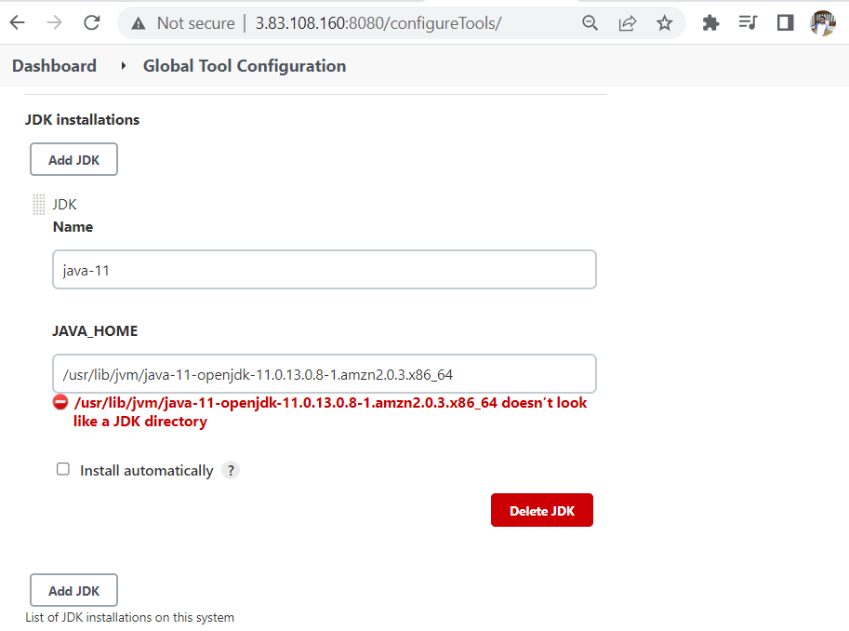

Click on add maven and remove tick mark on install automatically

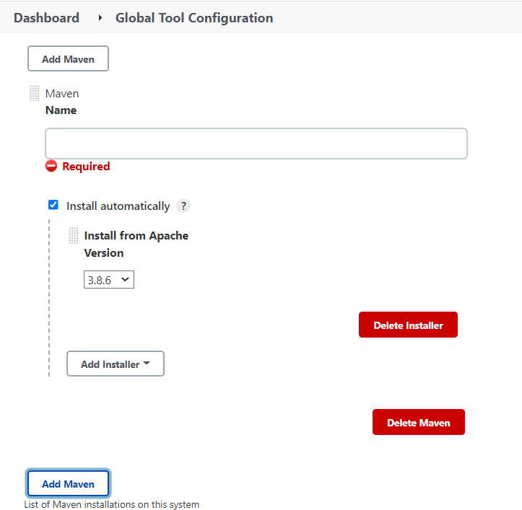

Make the changes as shown below

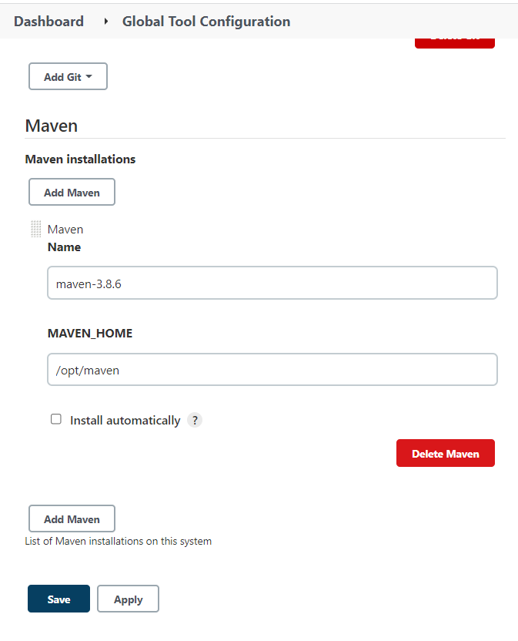

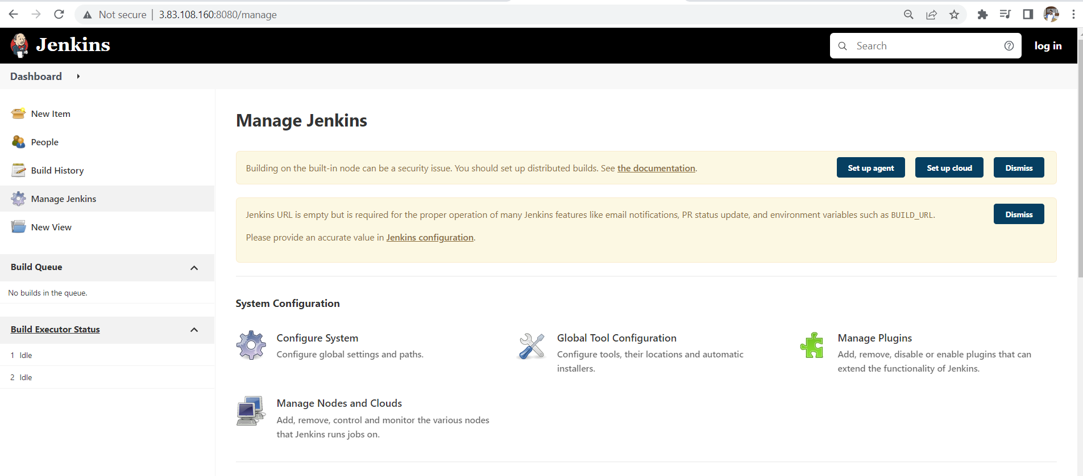

Click on the new item

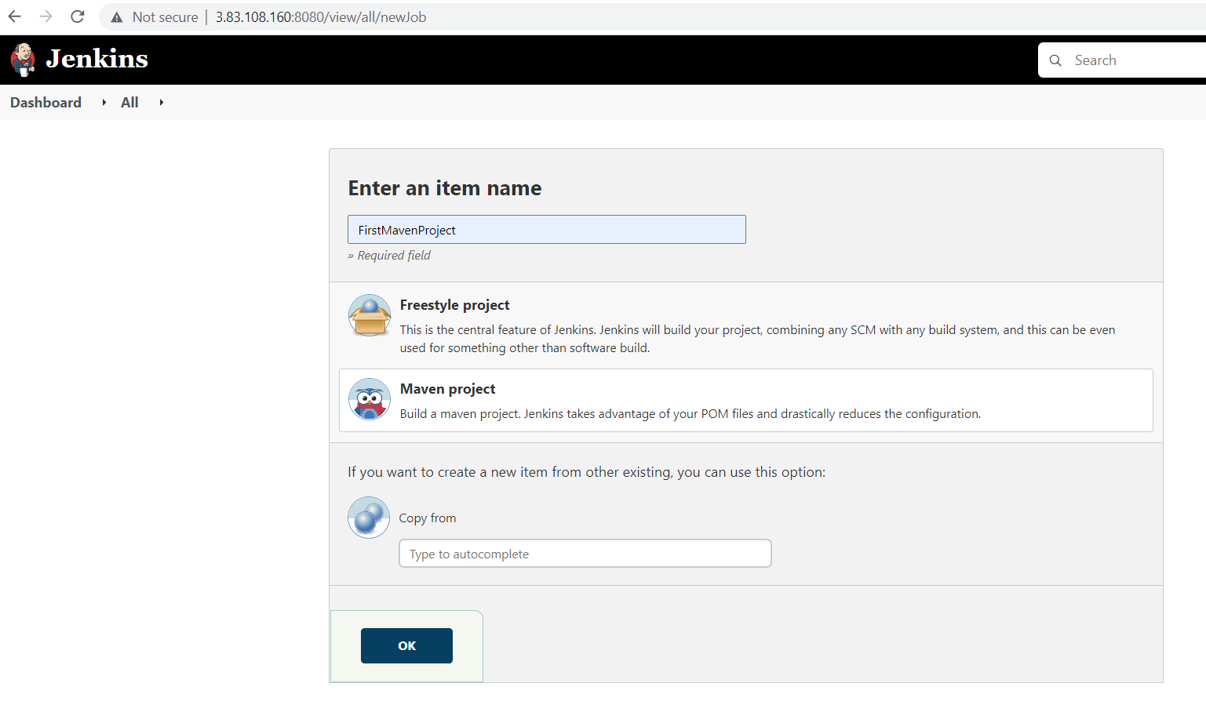

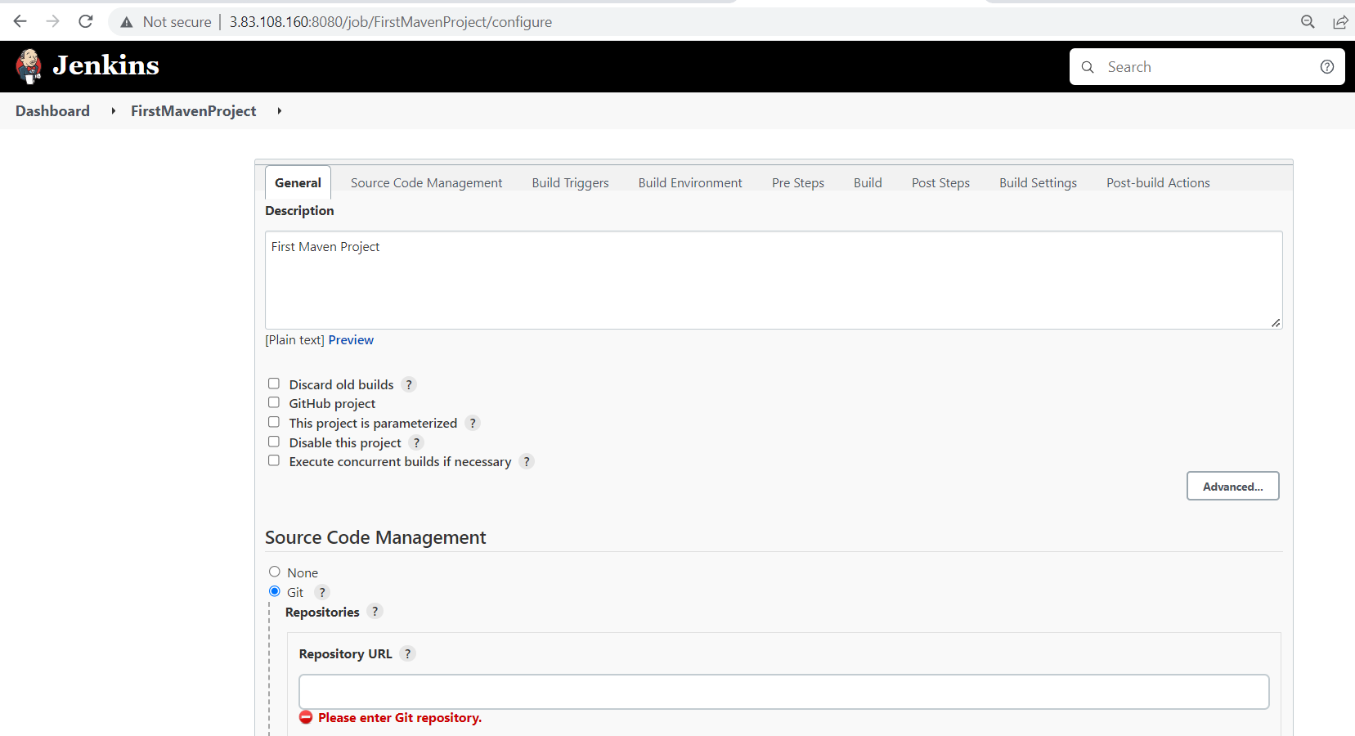

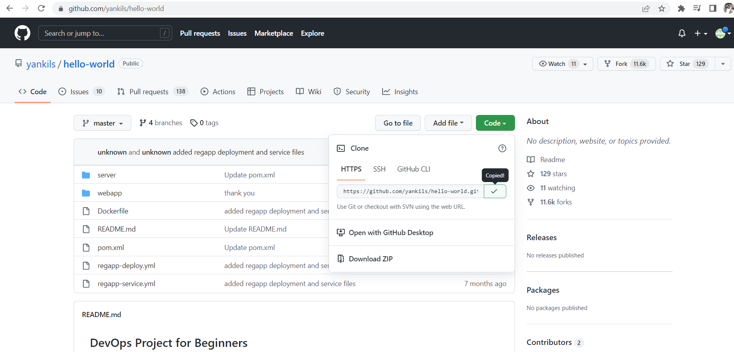

Copy the https git url and paste in the Jenkins job

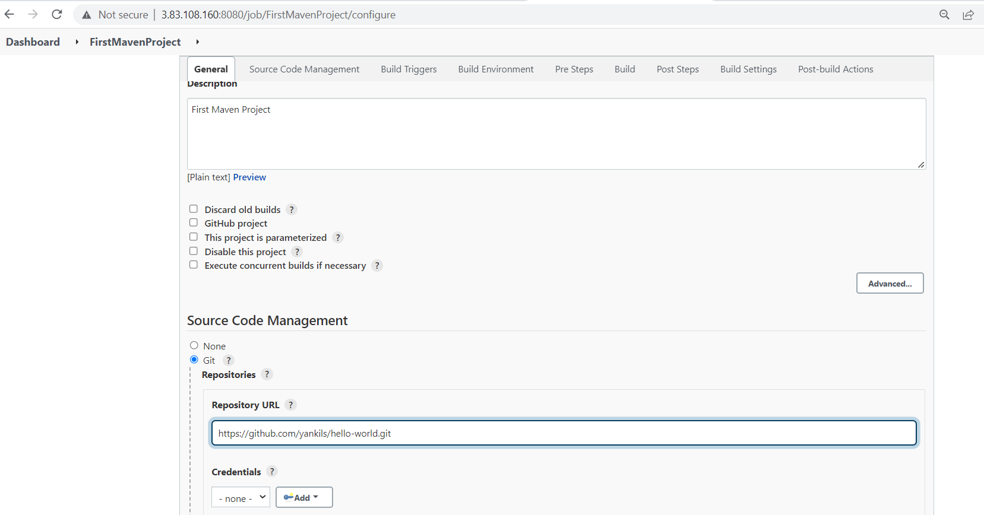

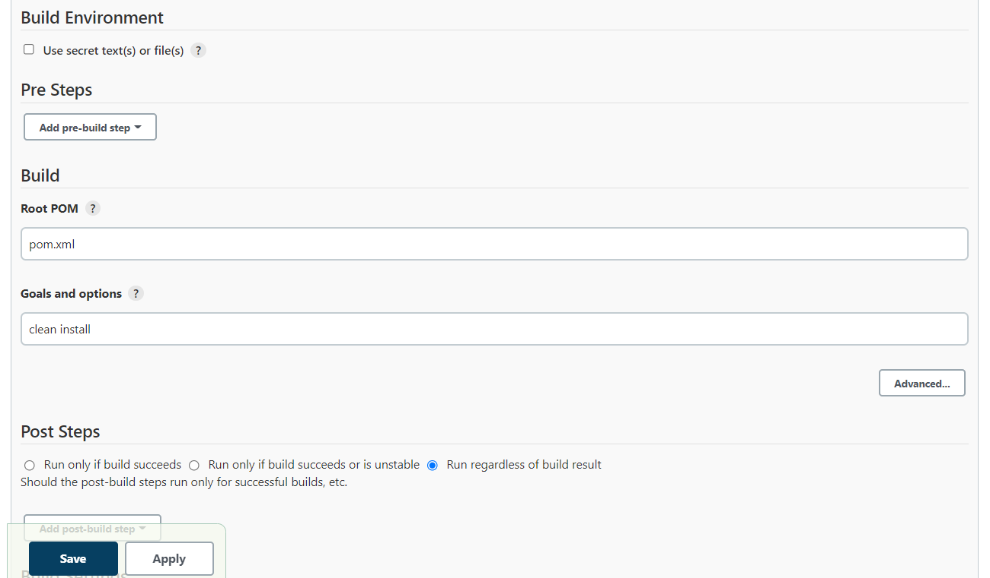

Save and apply

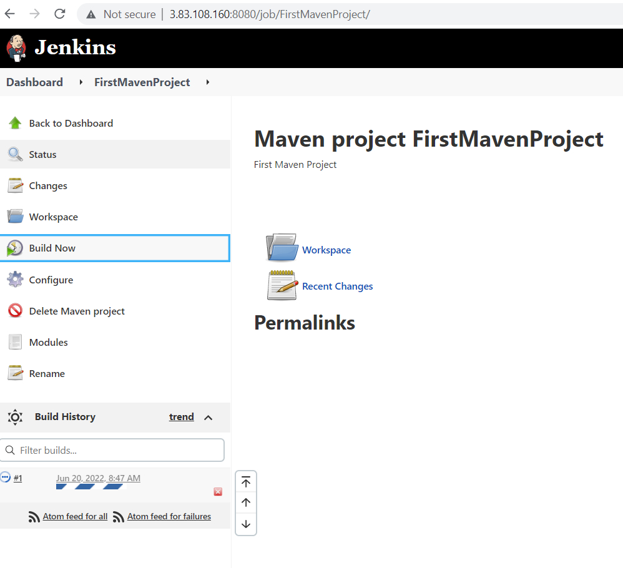

Click on build now

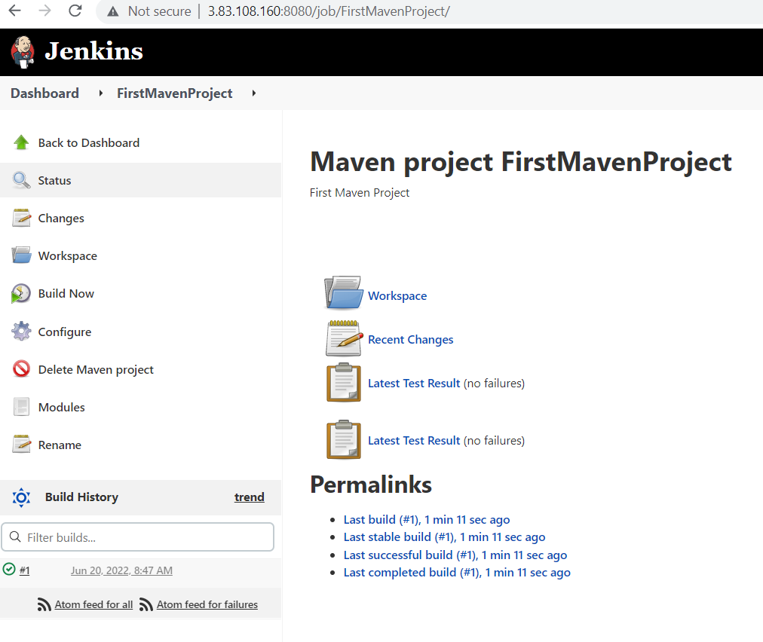

Click on right tick mark

You will get the output as shown below

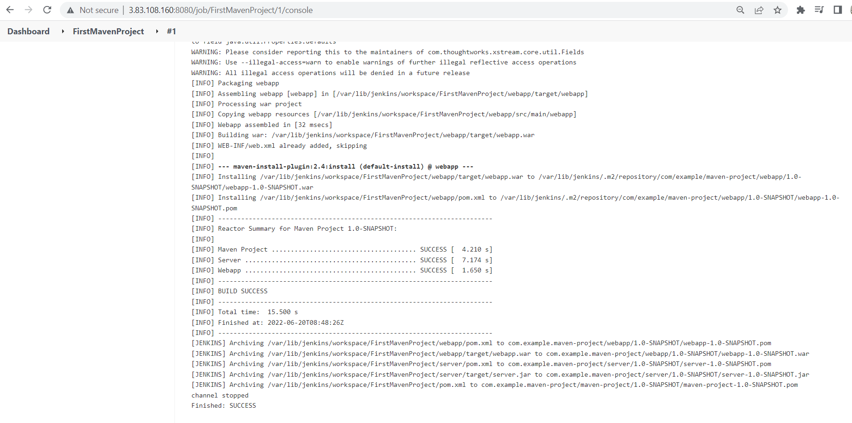

It will create a artifact that will store in certain path as shown below

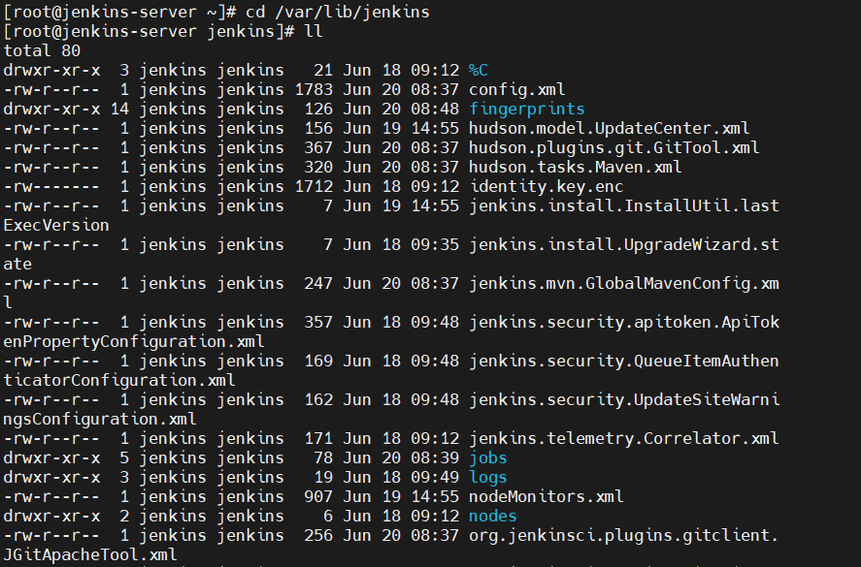

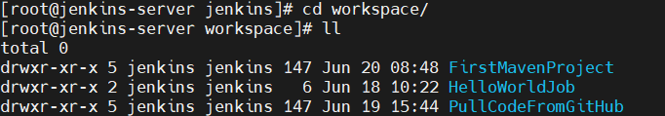

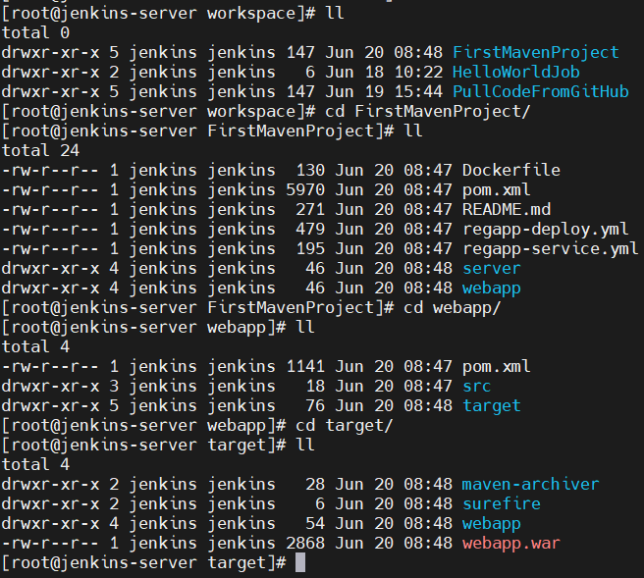

Deploy Artifacts On Tomcat Server

<https://github.com/yankils/Simple-DevOps-Project/blob/master/Tomcat/tomcat_installation.MD>

Now we have to create a instance by aws

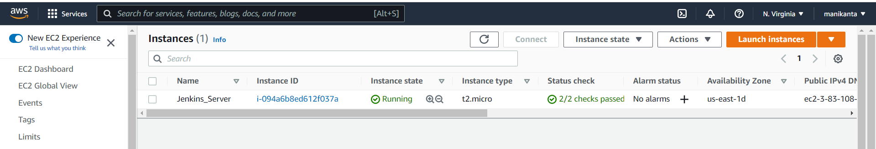click on launch instance

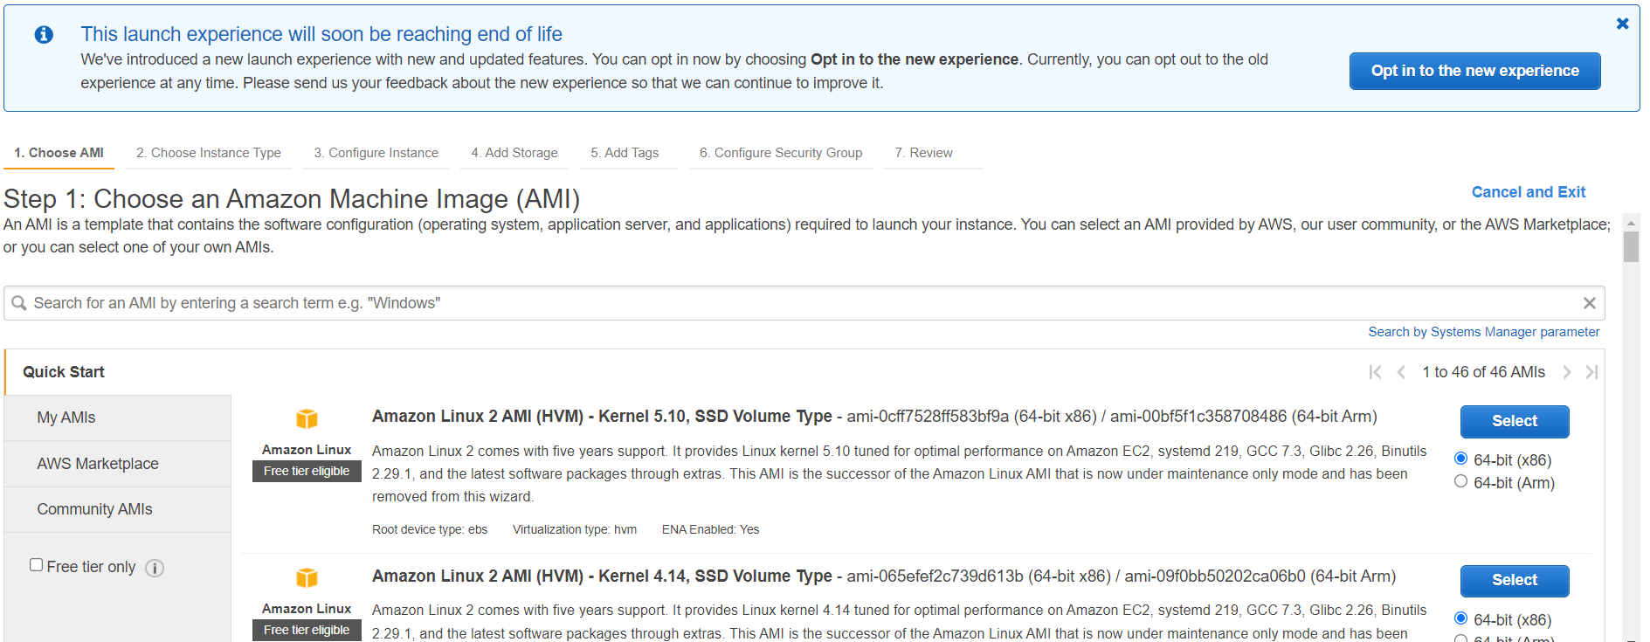

select first one

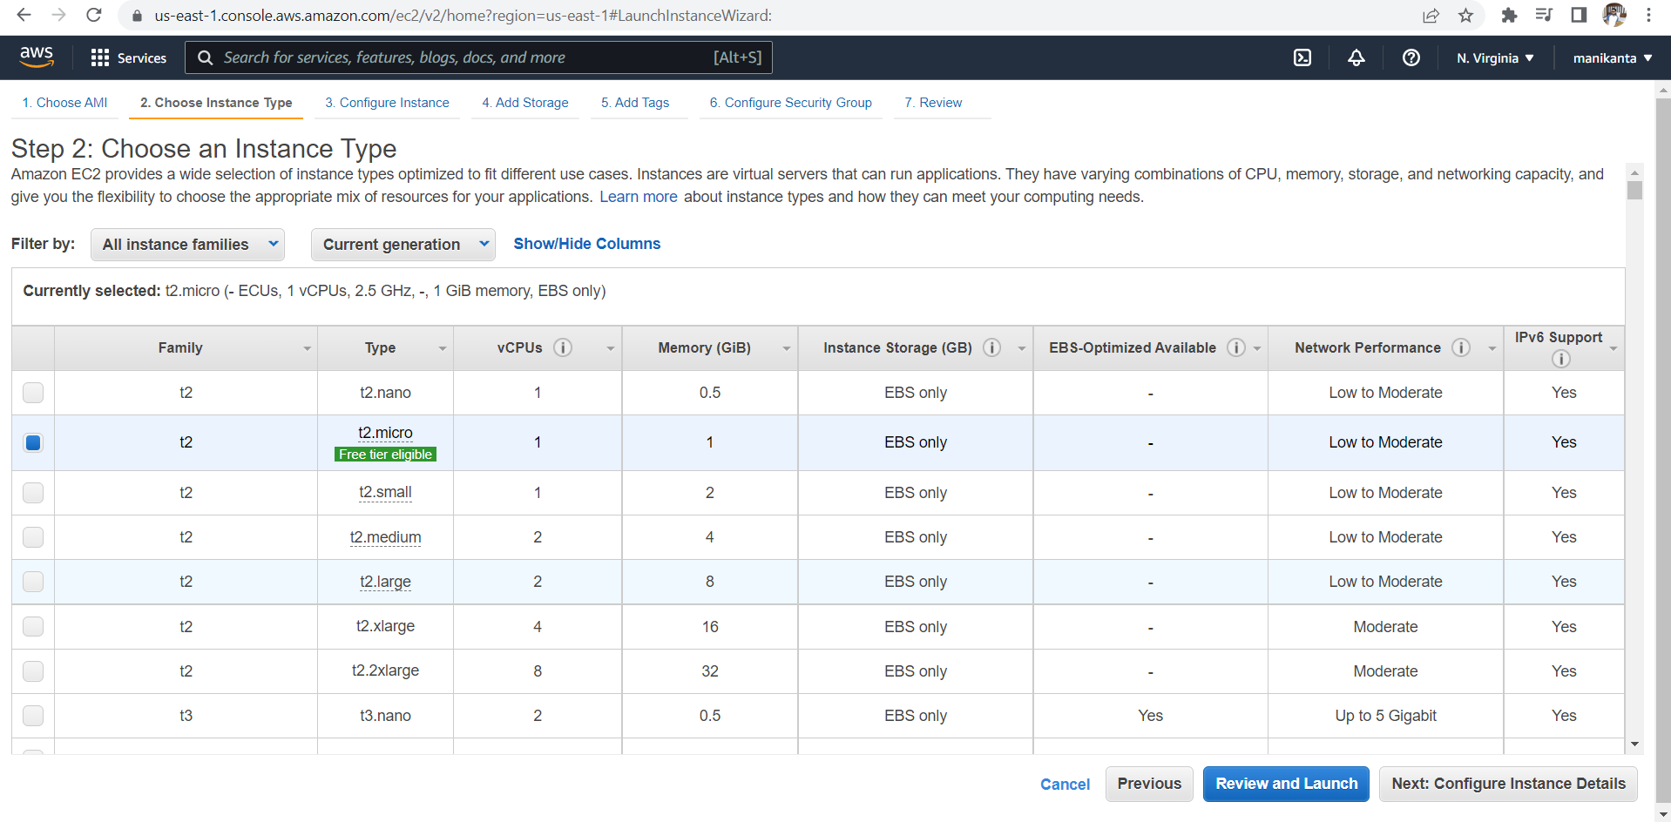

Click on configure instance details

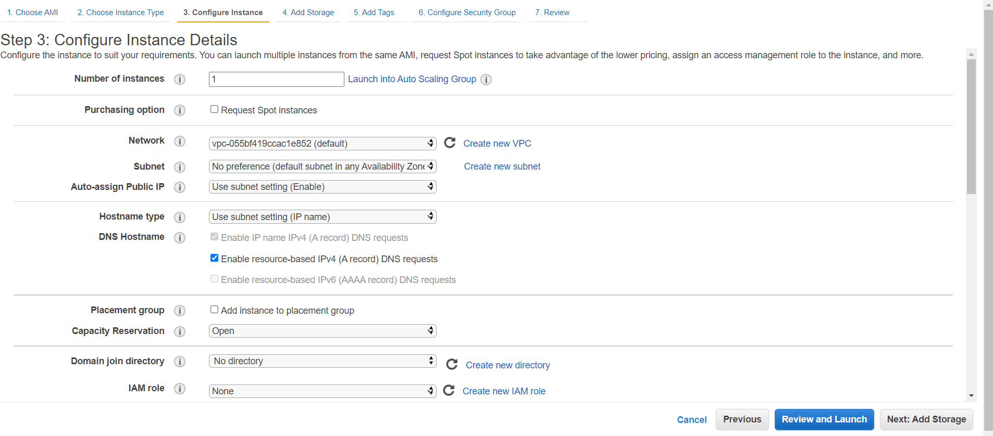

Click on add storage

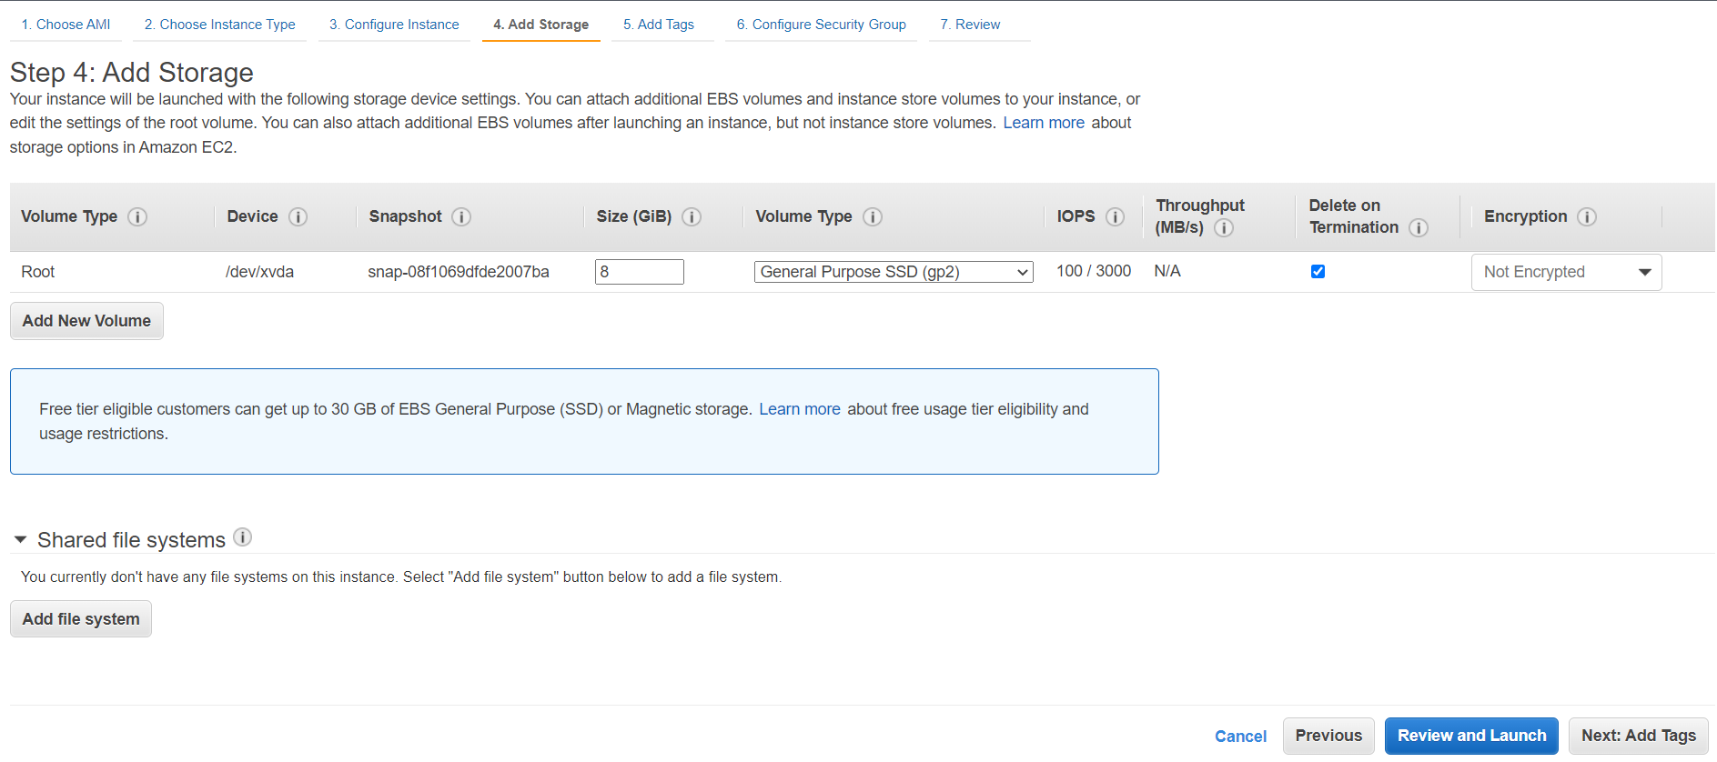

Click on Add Tags

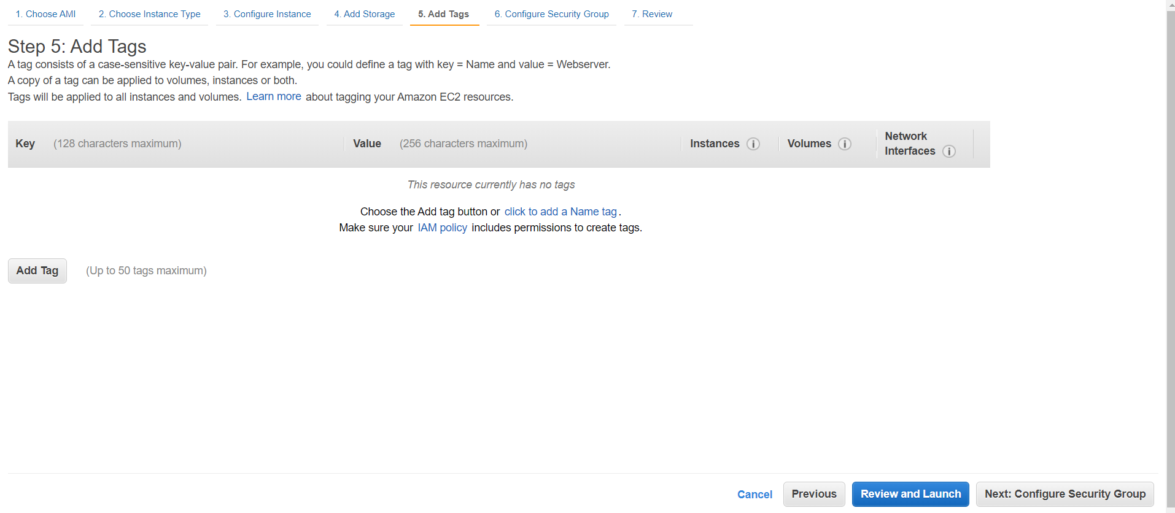

Click on add tag

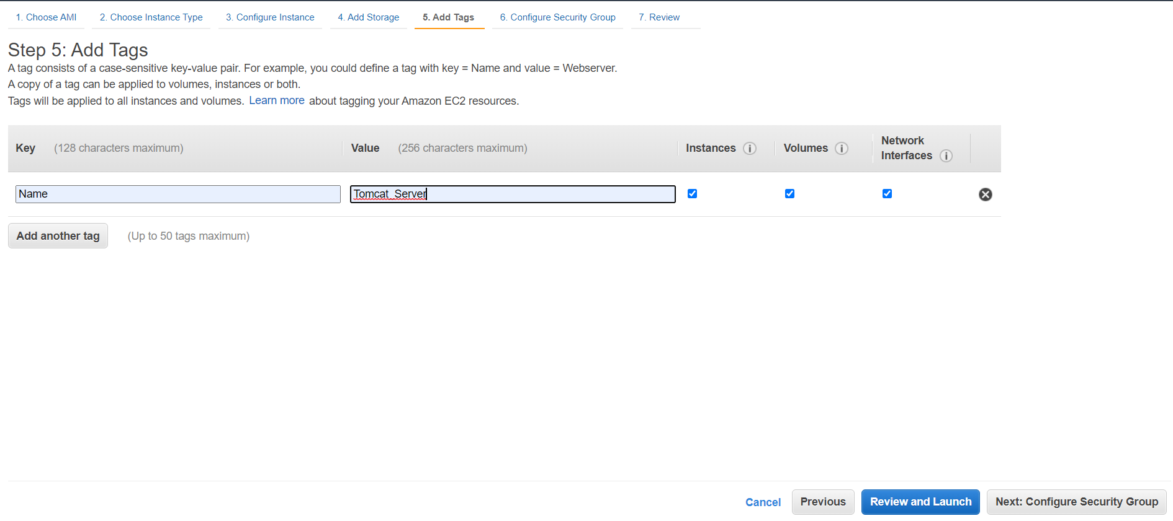

Click on configure security group

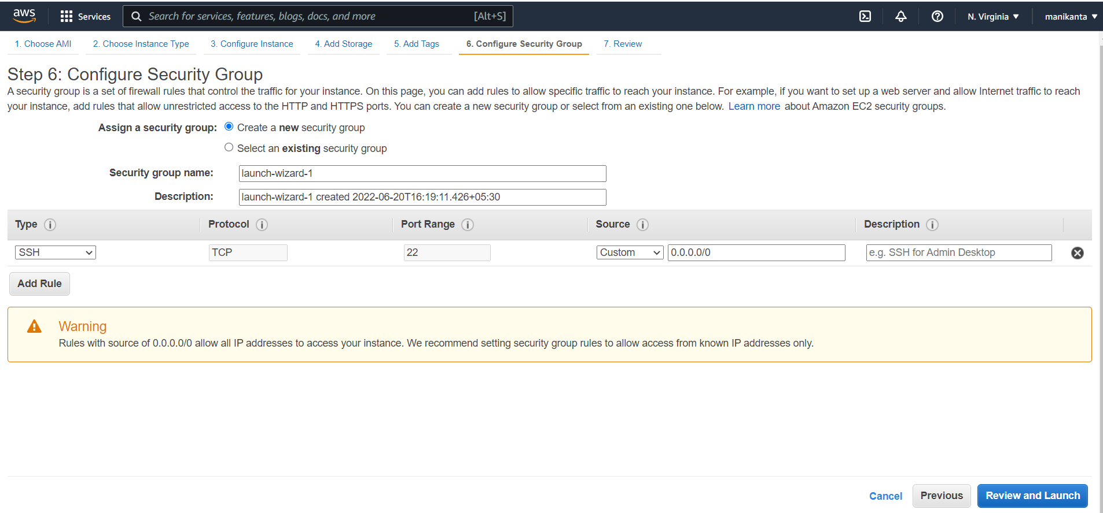

Click on add rule

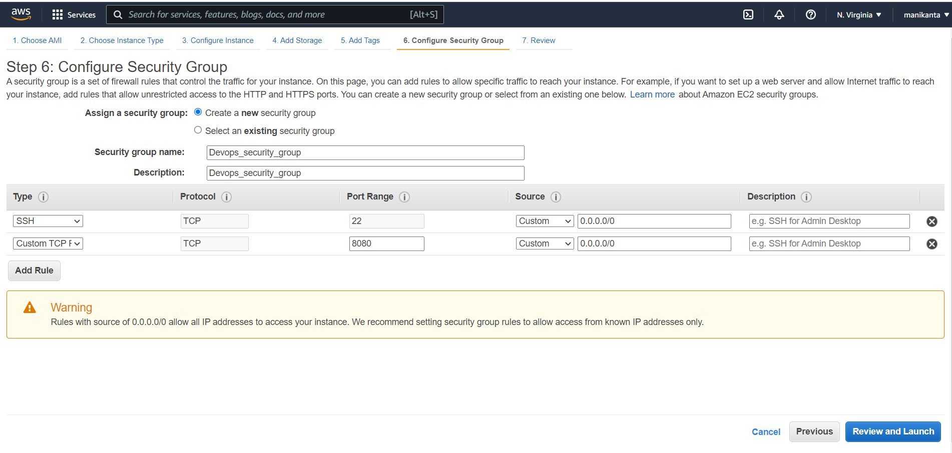

Click on review and launch

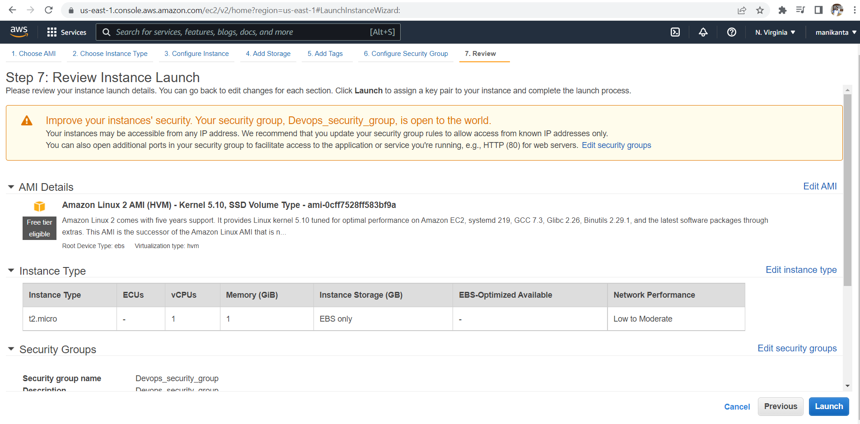

Click on launch

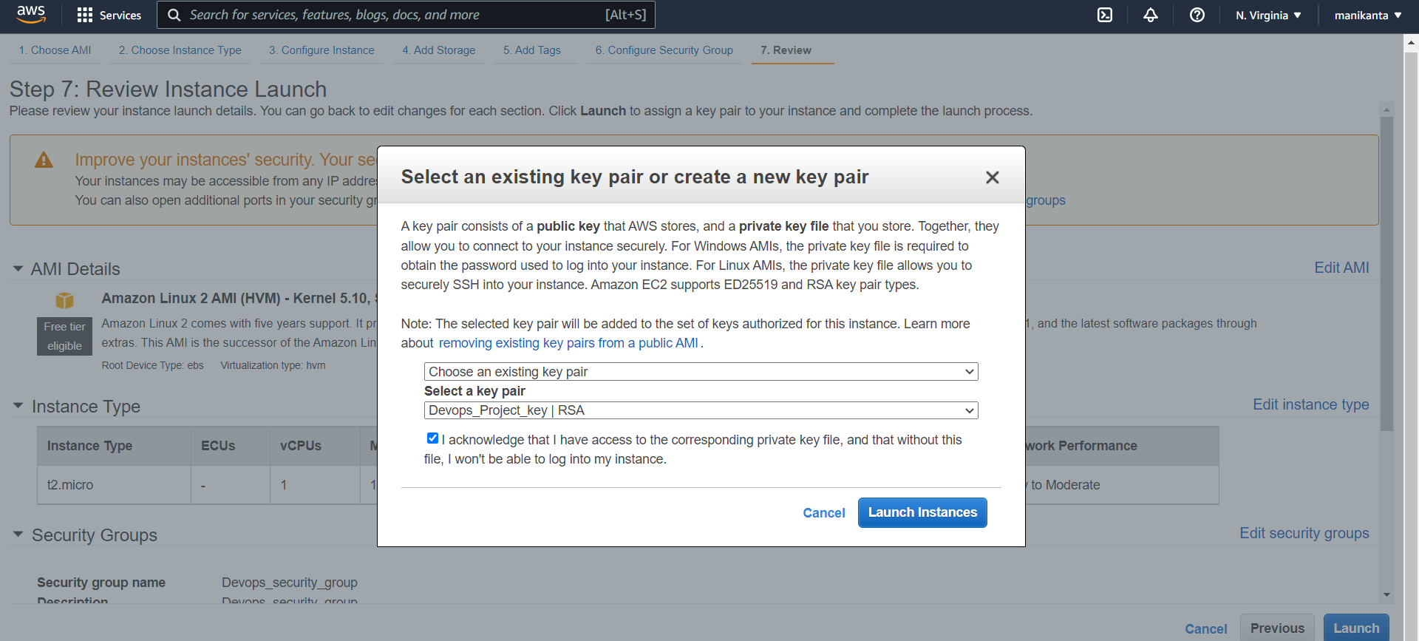

Choose existing key pair or you can create

Tick on I acknowledge and launch instance

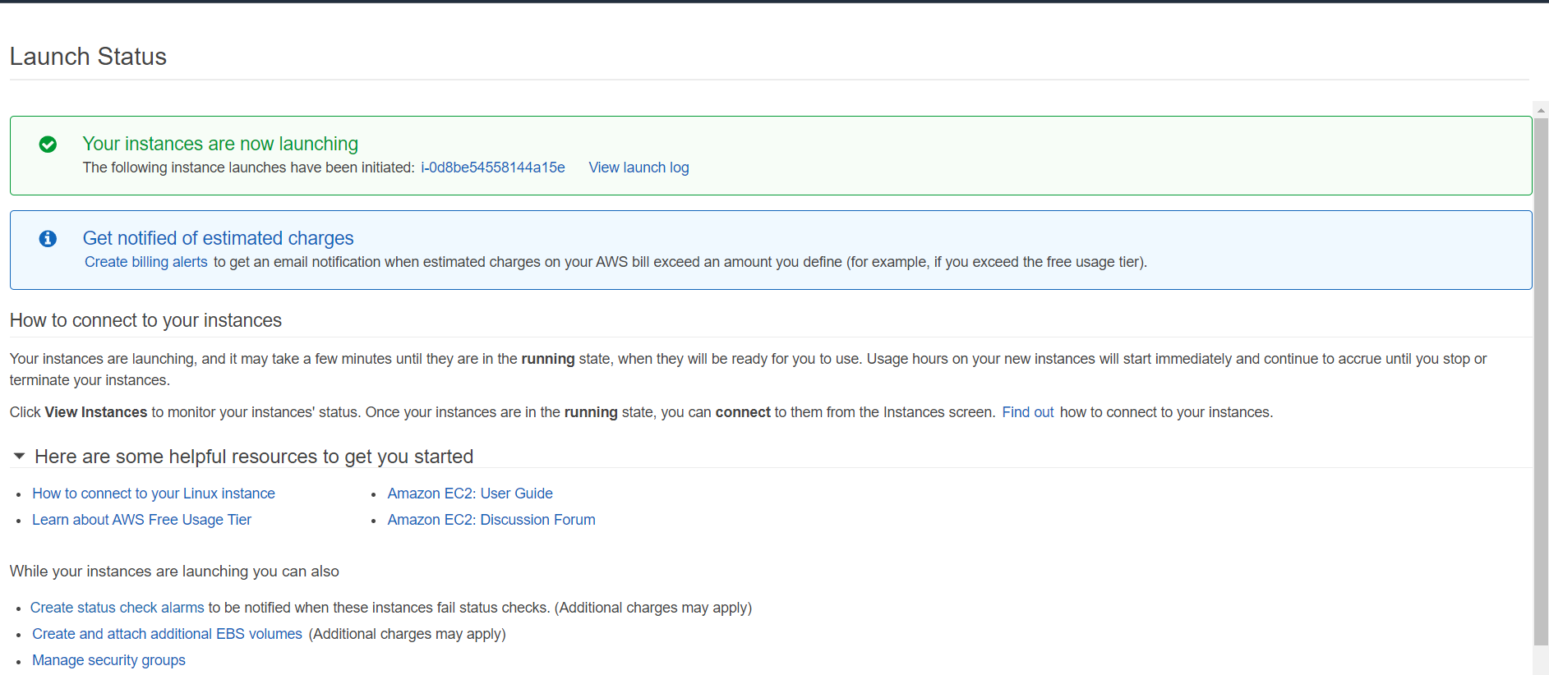

Click on this in the image [i-0d8be54558144a15e](https://us-east-1.console.aws.amazon.com/ec2/v2/home?region=us-east-1#Instances:search=i-0d8be54558144a15e;sort=instanceId)

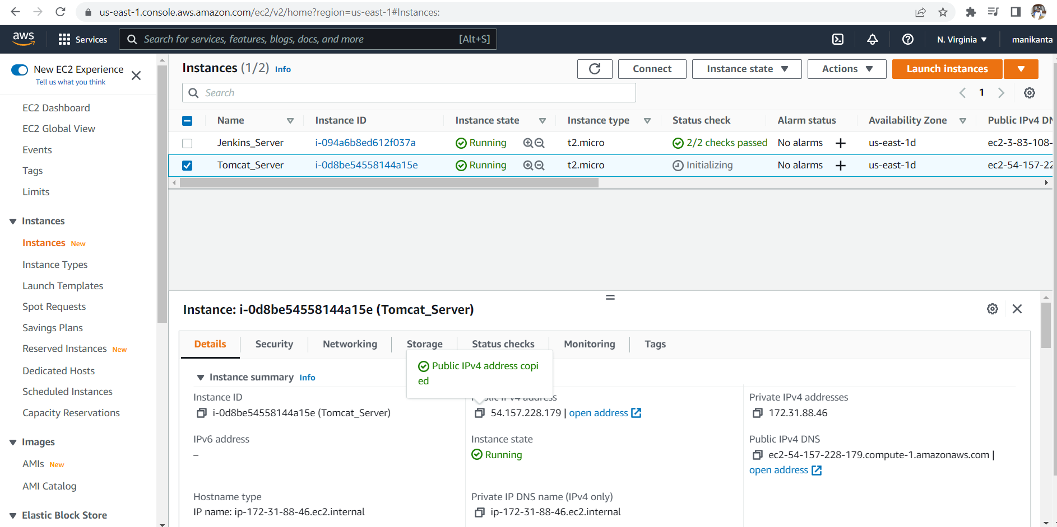

Copy the public ip and put it in the mobaxterm

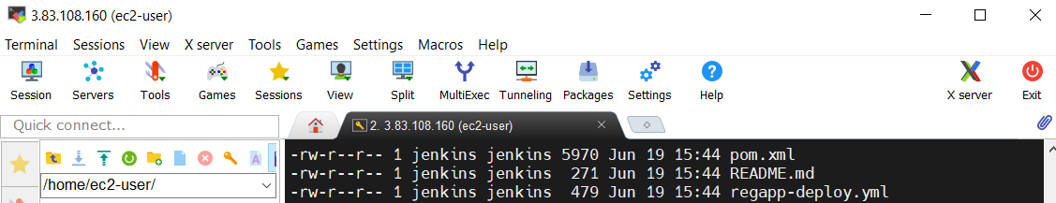

Click on the session

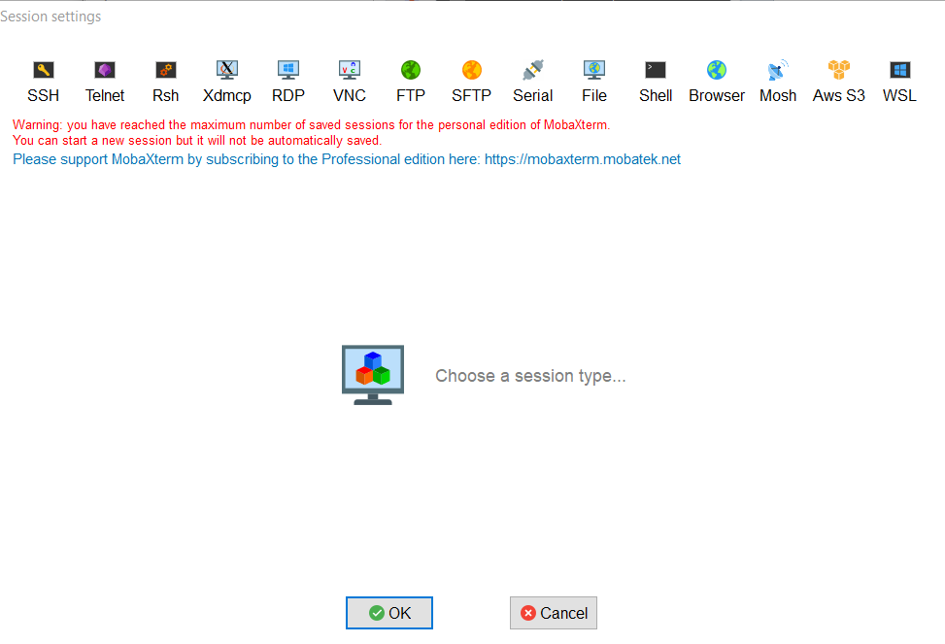

Click on SSH

And paste the public ip and specify the username as ec2-user

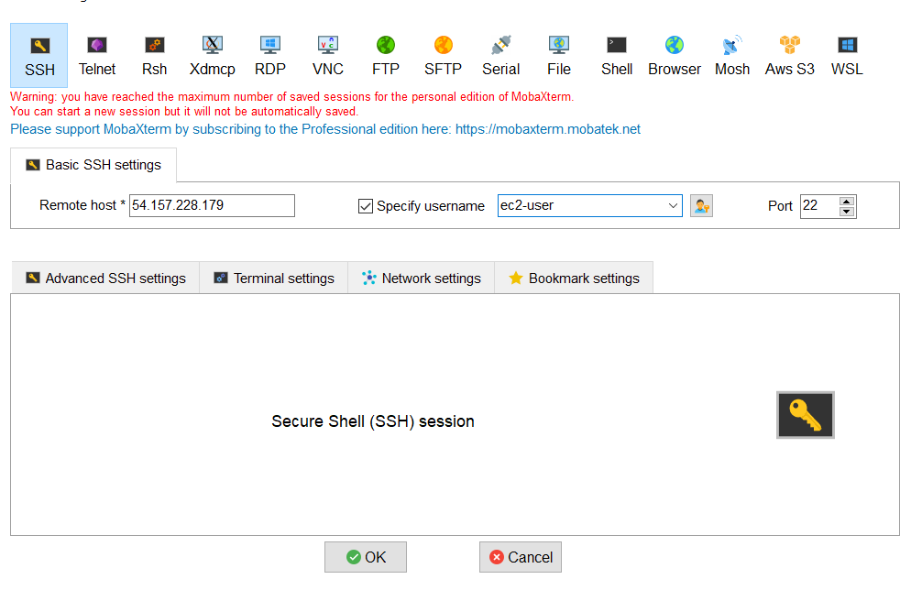

Again click on the advanced SSH settings

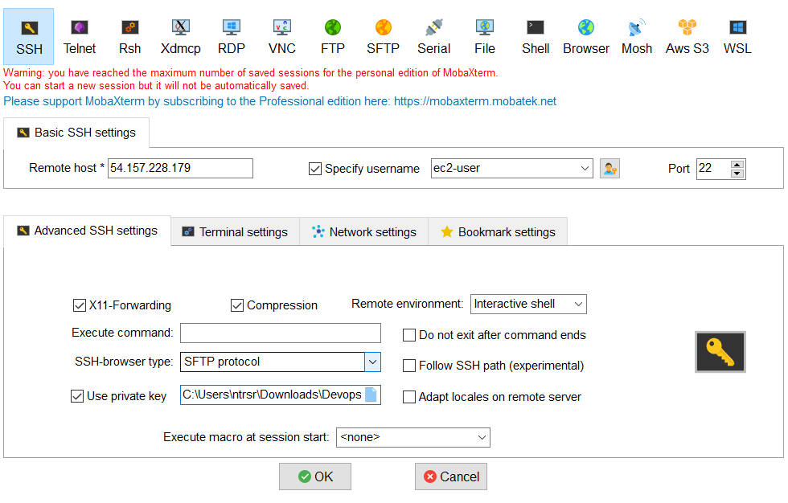

Choose private key and press ok

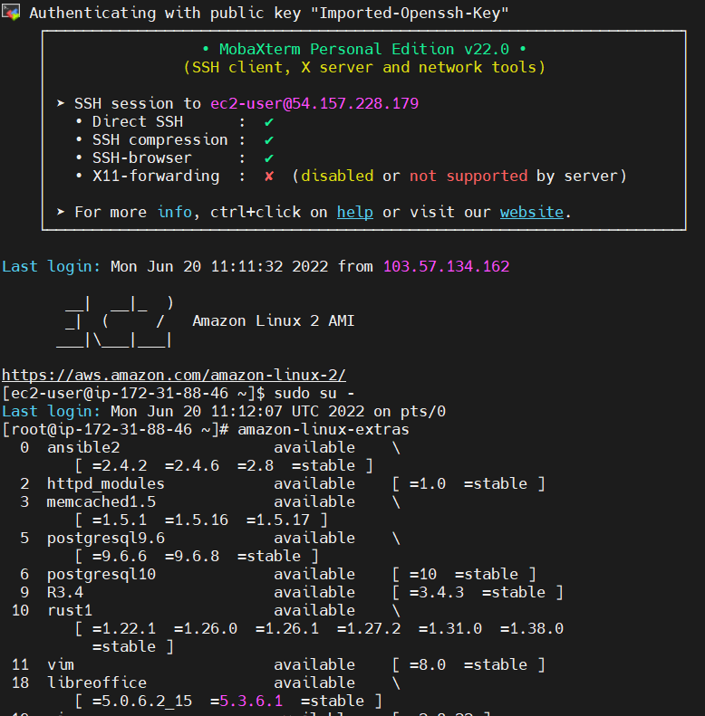

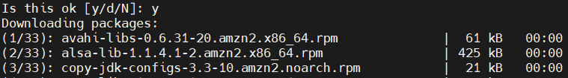

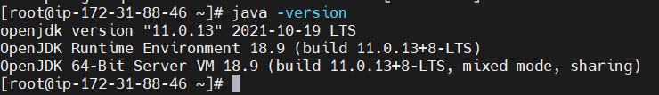

<https://tomcat.apache.org/download-90.cgi>

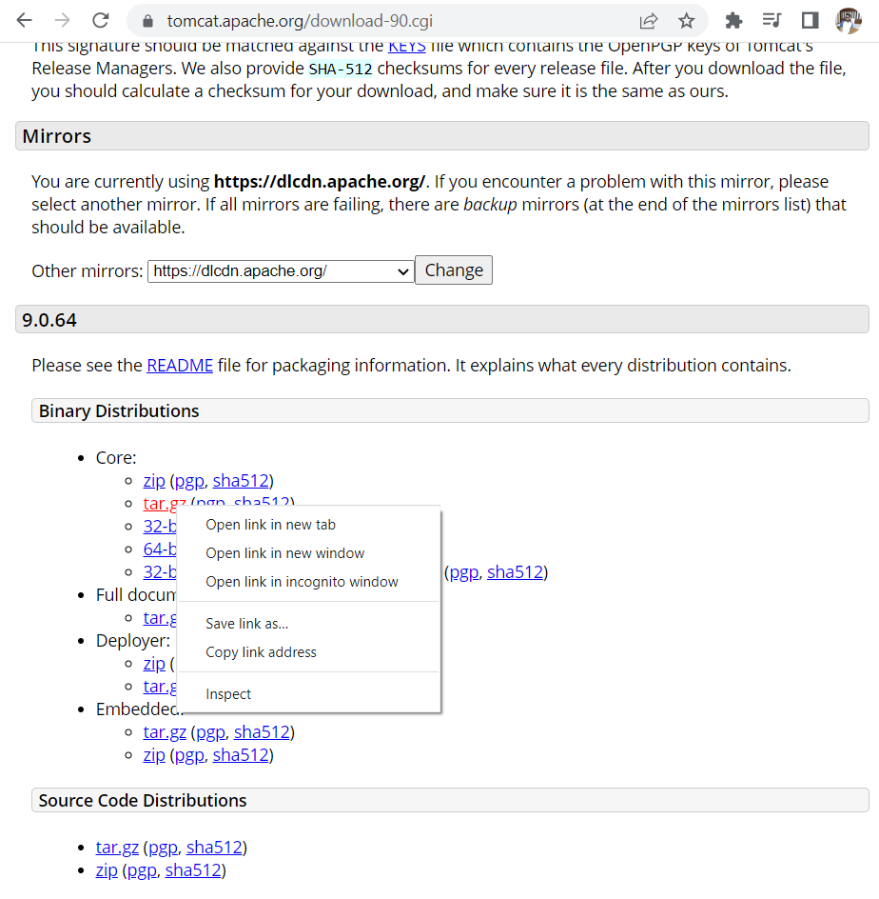

Copy link address

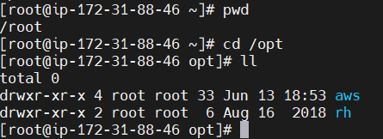

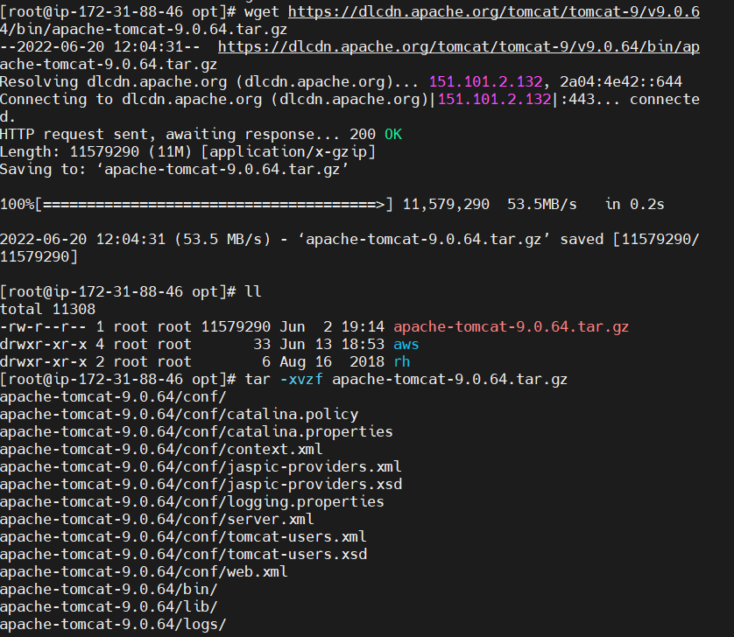

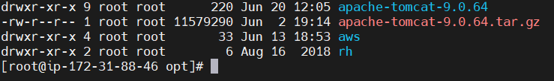

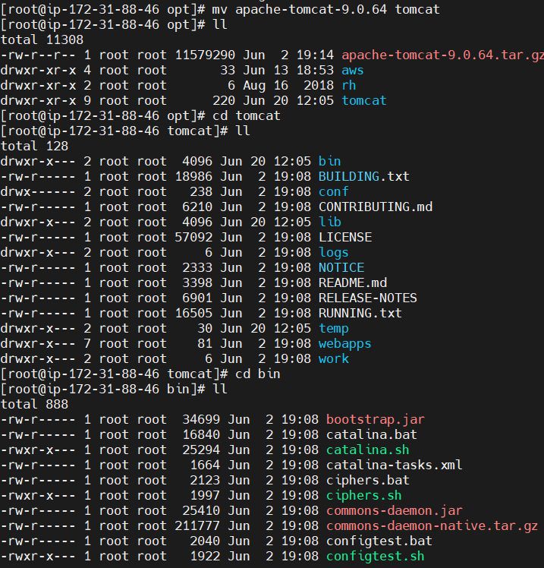

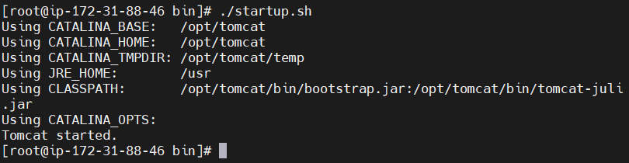

Now go to aws ec2 instance and copy the public ip of tomcat server

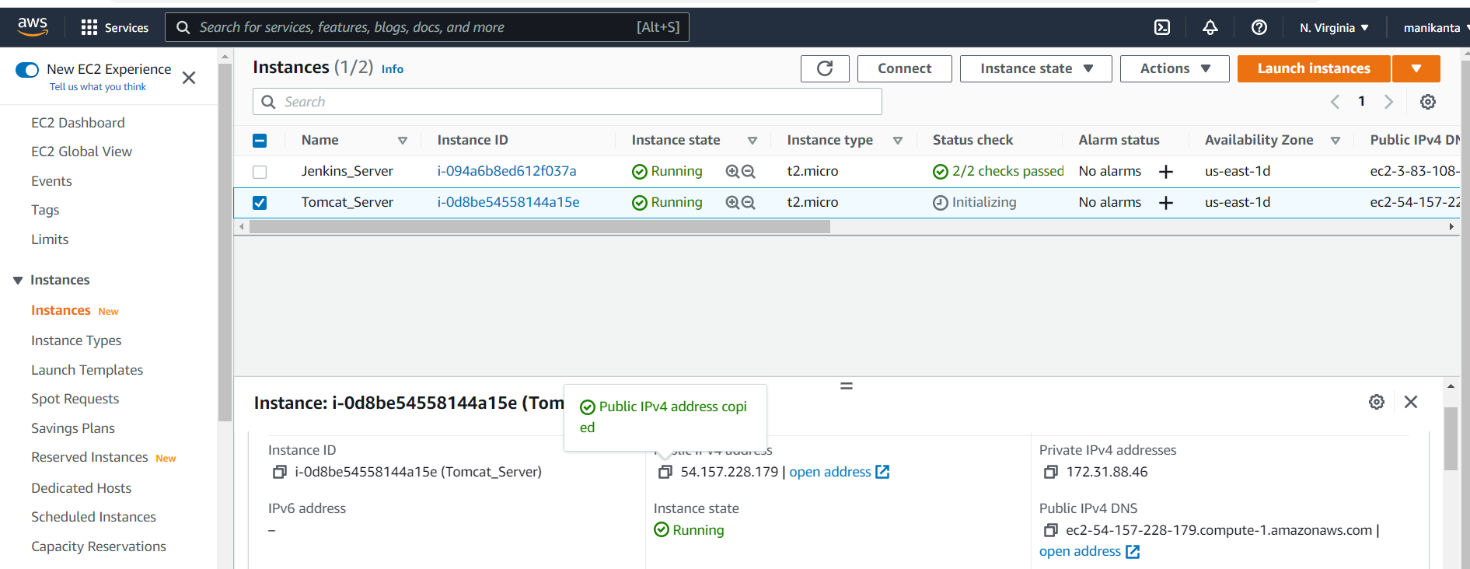

Put it in a search bar and press enter



You can see this inter face as shown below

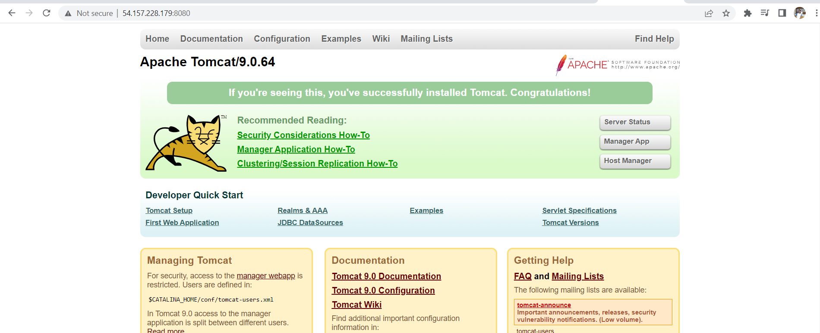

Click on Manager app you will see the below page

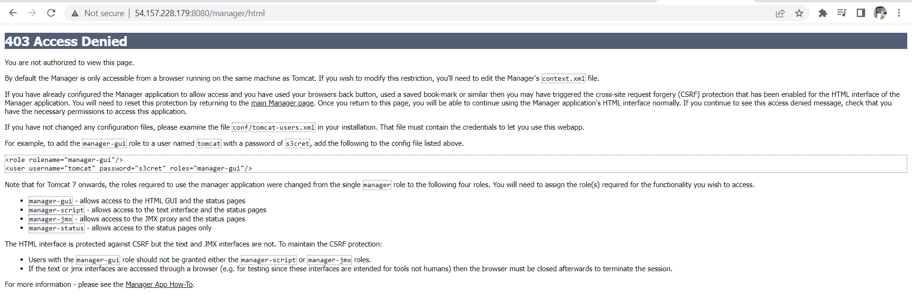

We need to update contex.xml file for that we need to follow the below steps

We need to goto the following path and find the file

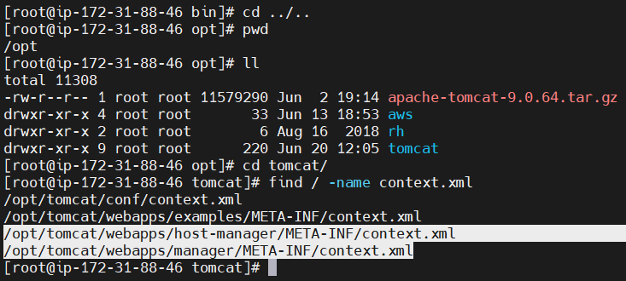

We need to edit the following highlighted xml files



Comment the value line

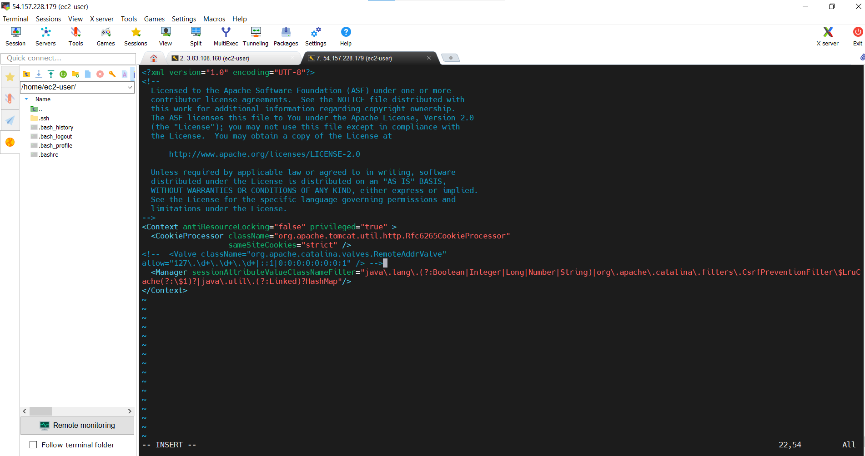

Again edit second file



Comment the value line

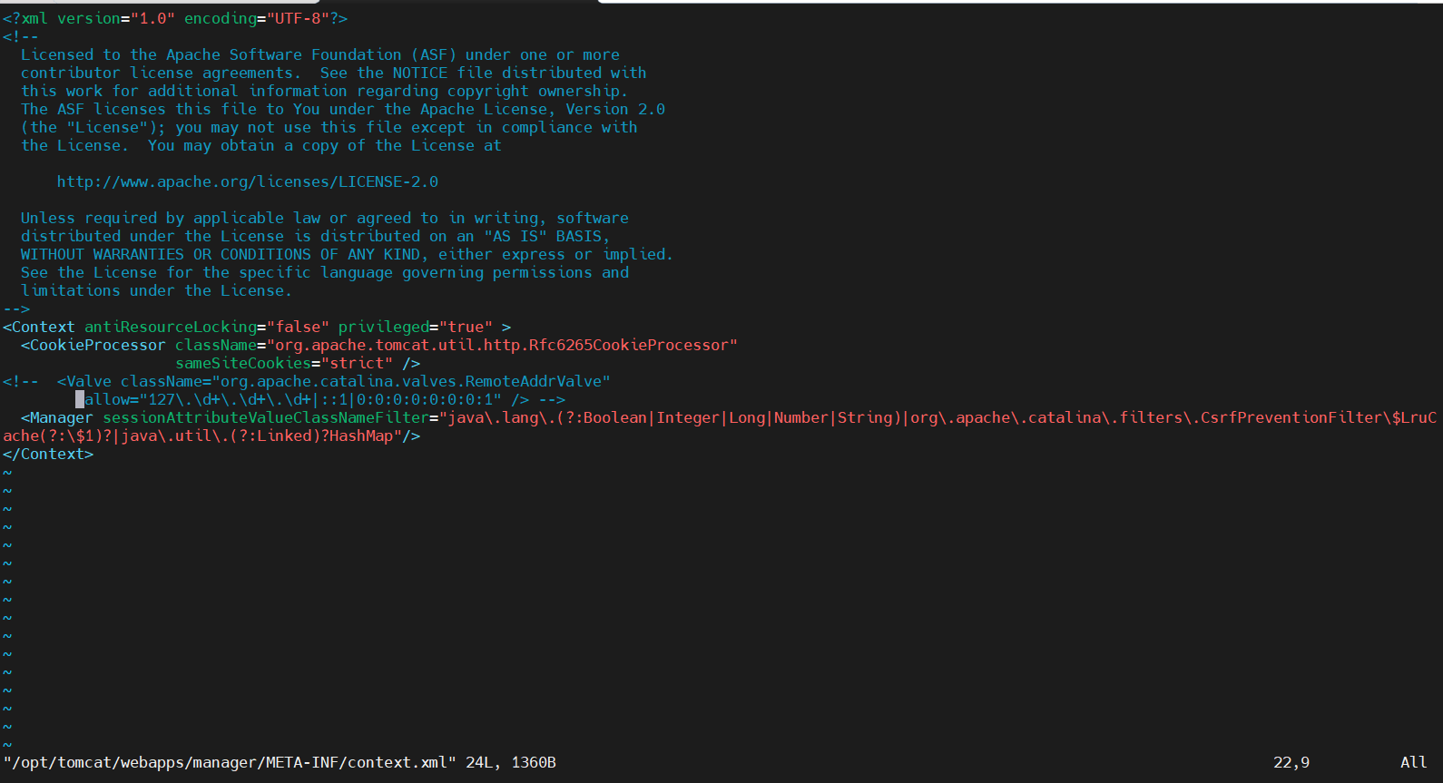

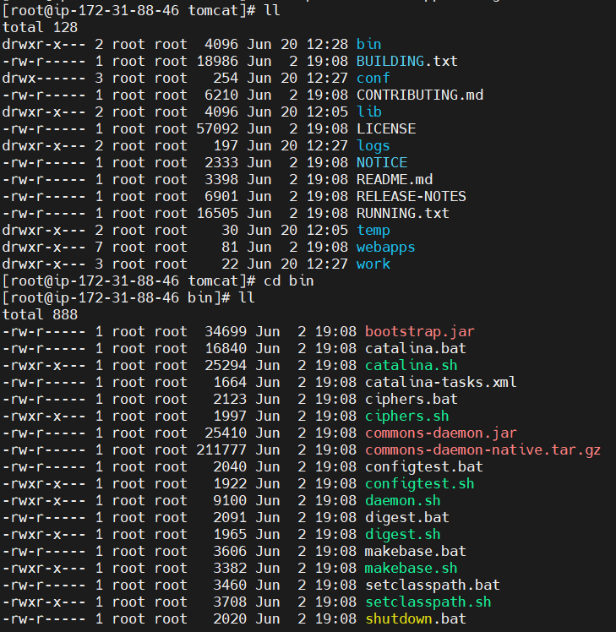

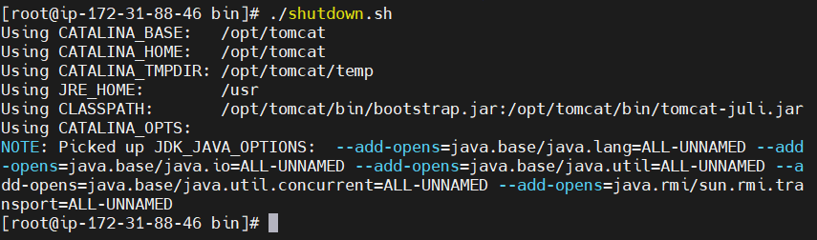

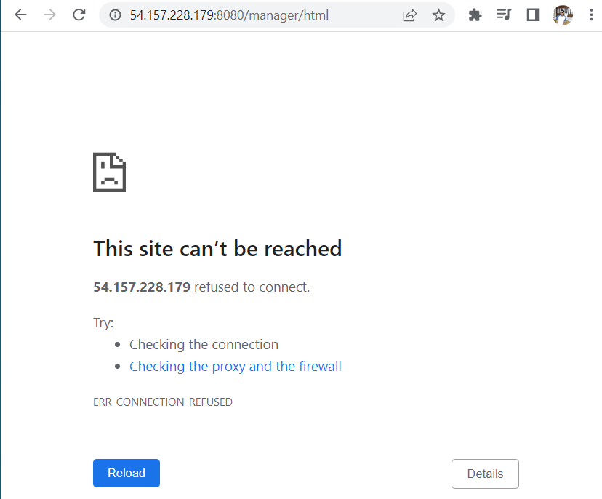

You will get tomcat site like this

Later run this command to start

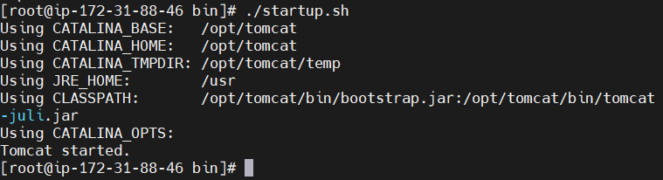

Reload the page

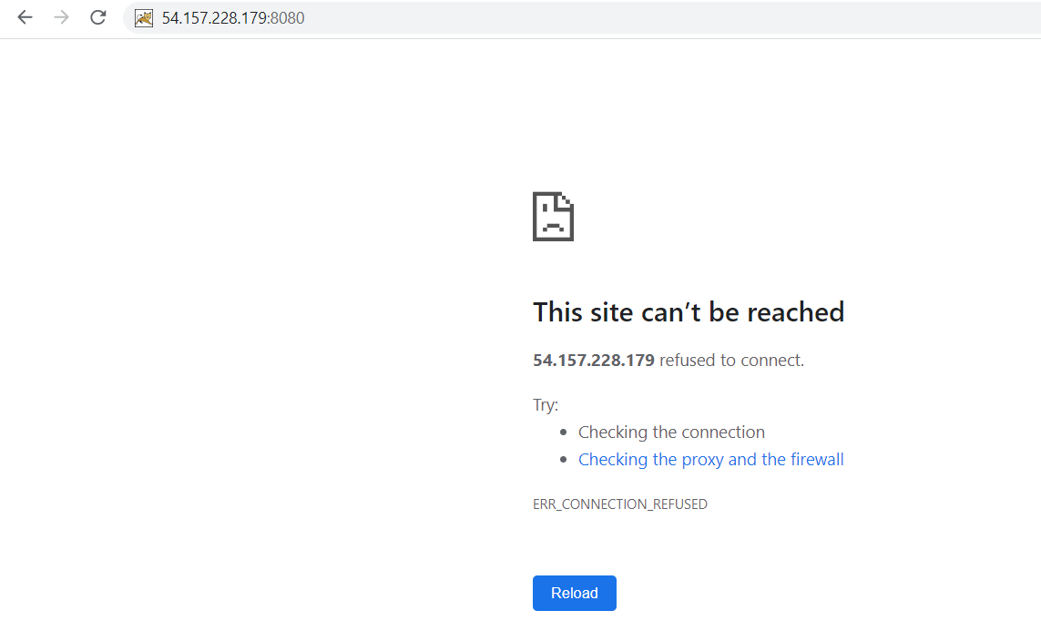

You will get the page like this

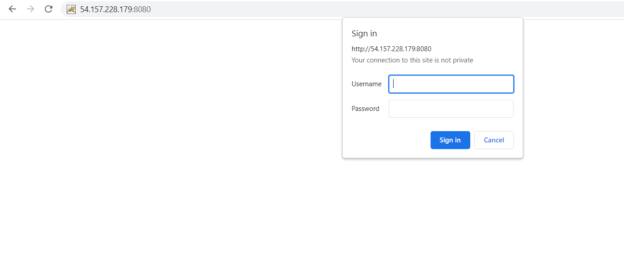

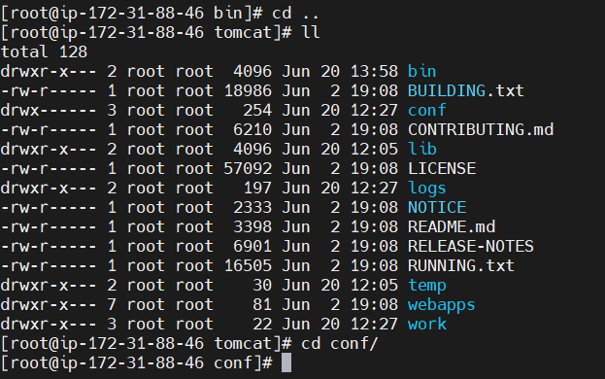

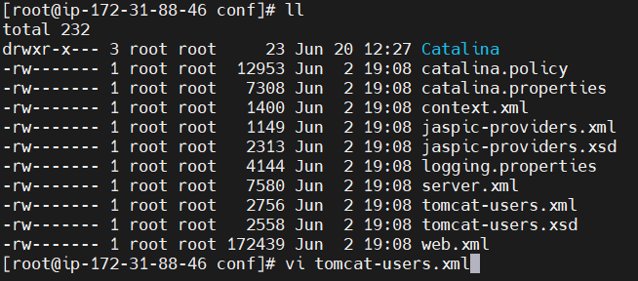

<https://github.com/yankils/Simple-DevOps-Project/blob/master/Tomcat/tomcat_installation.MD>

copy the code from here

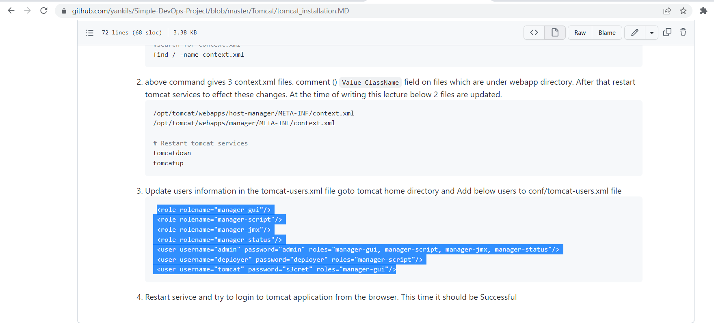

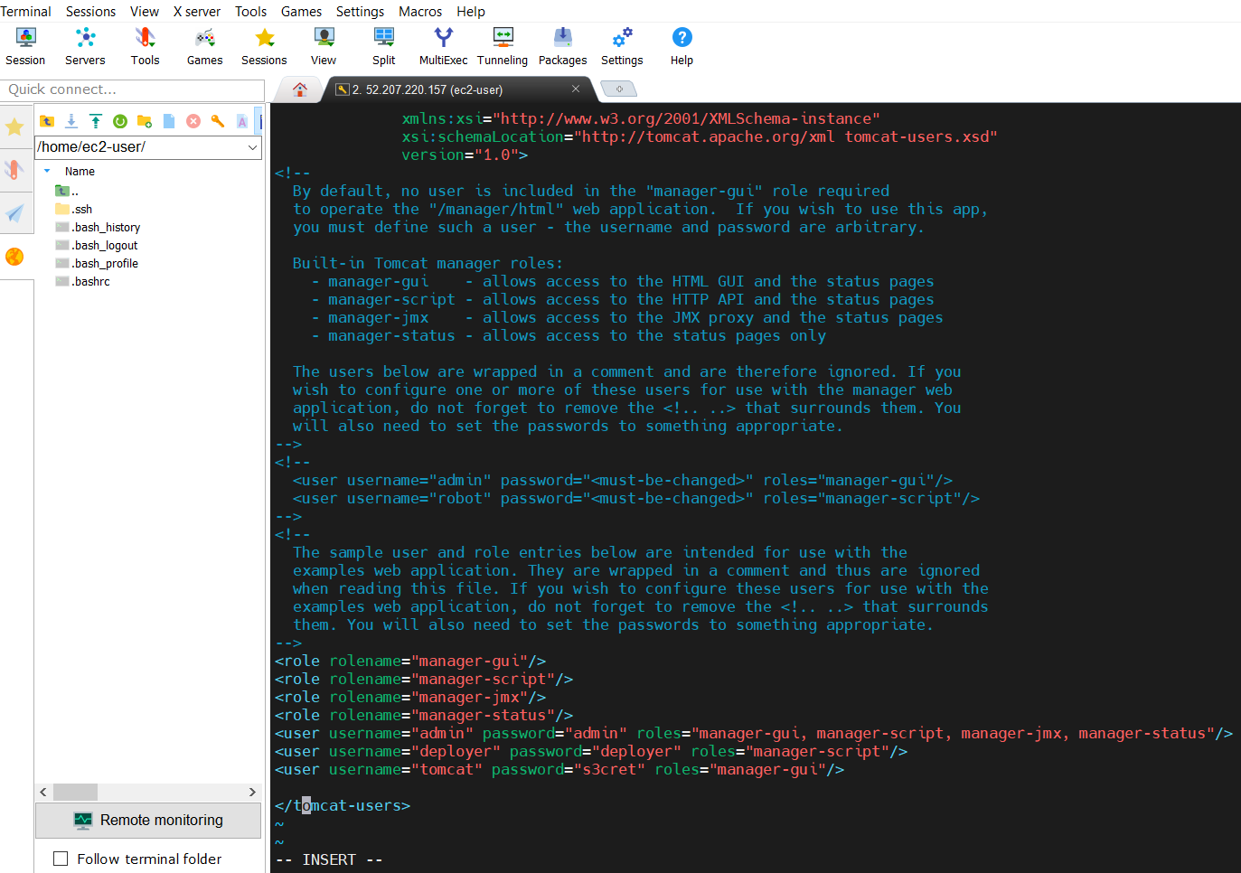

Follow this commands

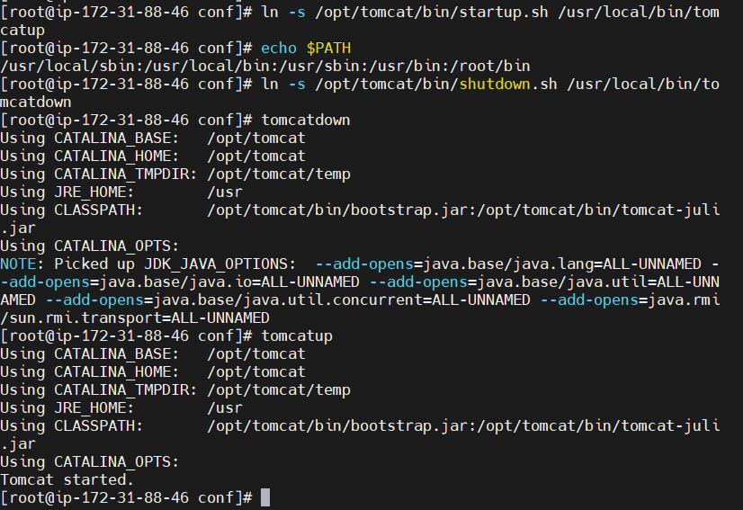

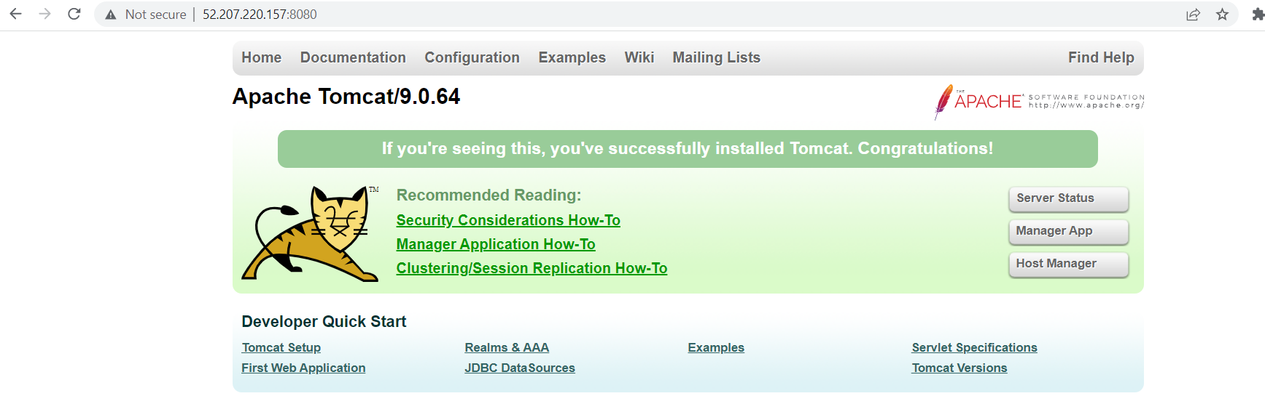

Enter your instance public ip with 8080 Reload the page and click on the manager app later you will get like this

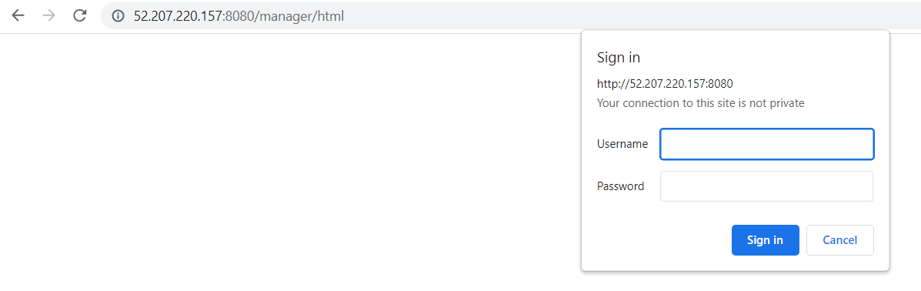

Now go through this url for username and password

<https://github.com/yankils/Simple-DevOps-Project/blob/master/Tomcat/tomcat_installation.MD>

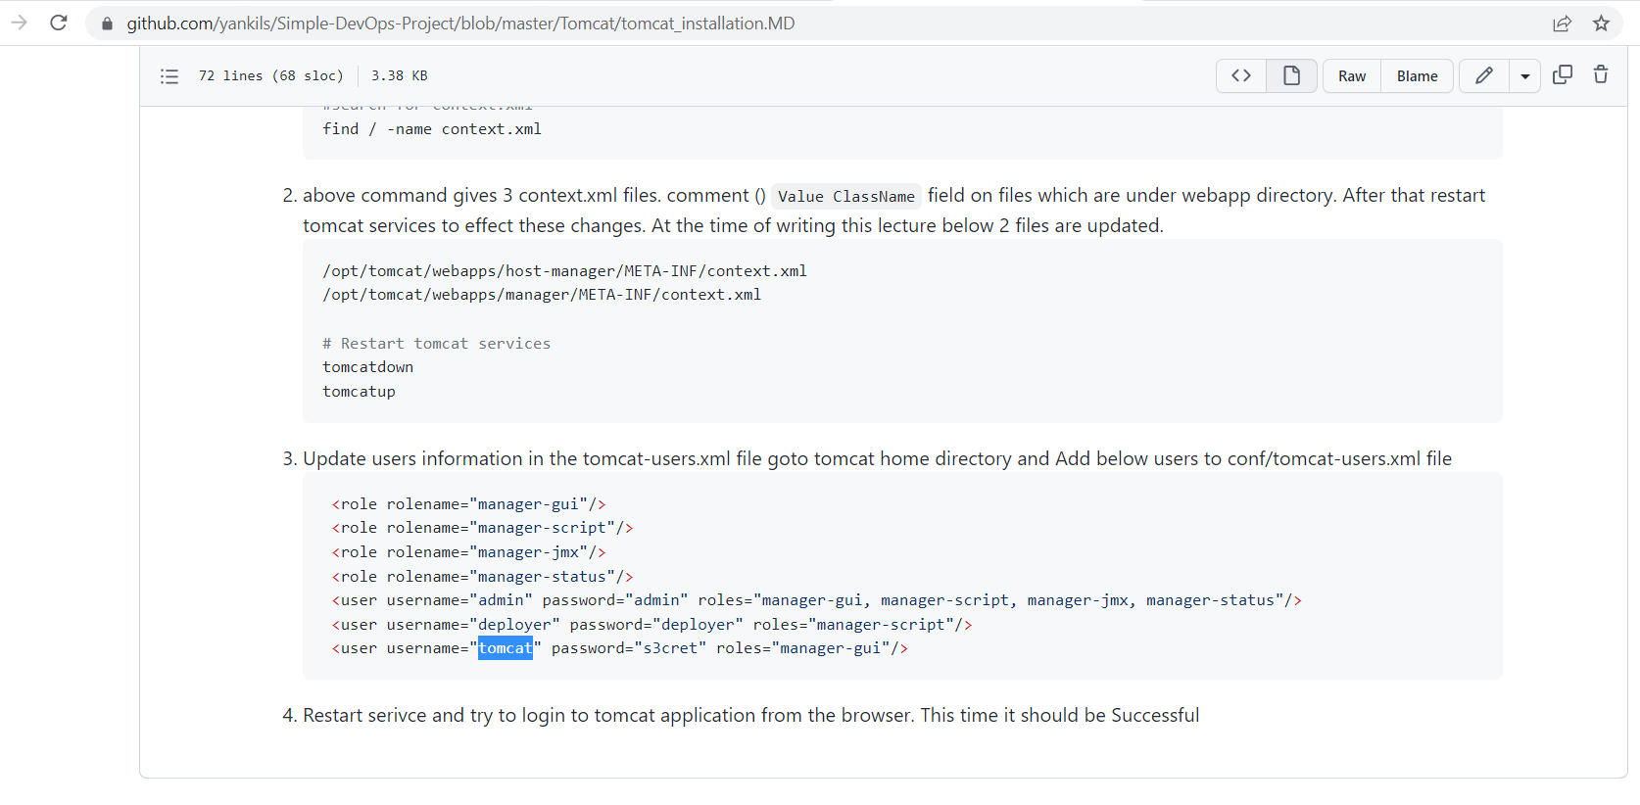

tomcat is username copy it and paste it in the folloing page

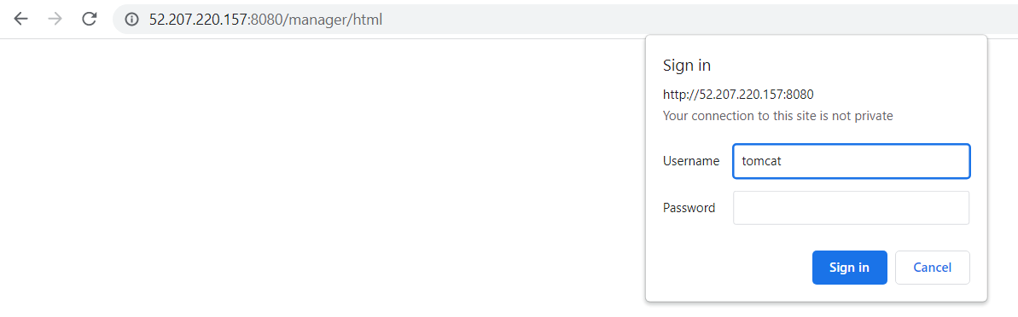

Again copy the password from the previous page that is

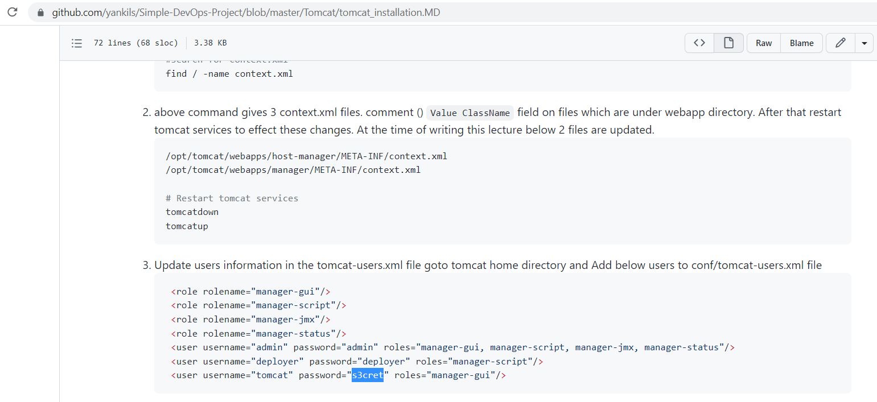

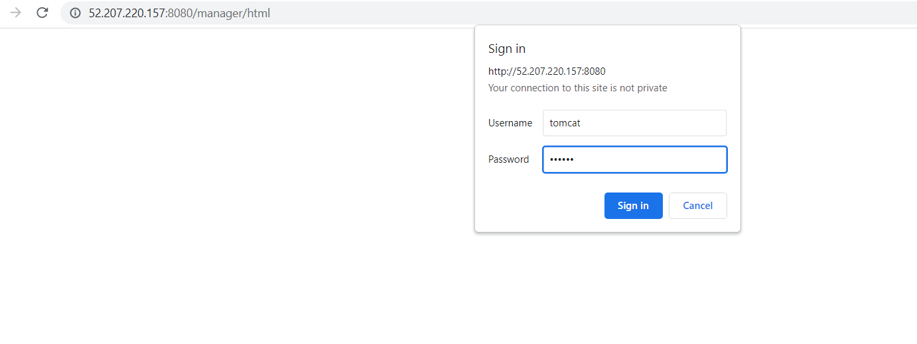

Press on sign in you will get this page this is the configuration of tomcat server

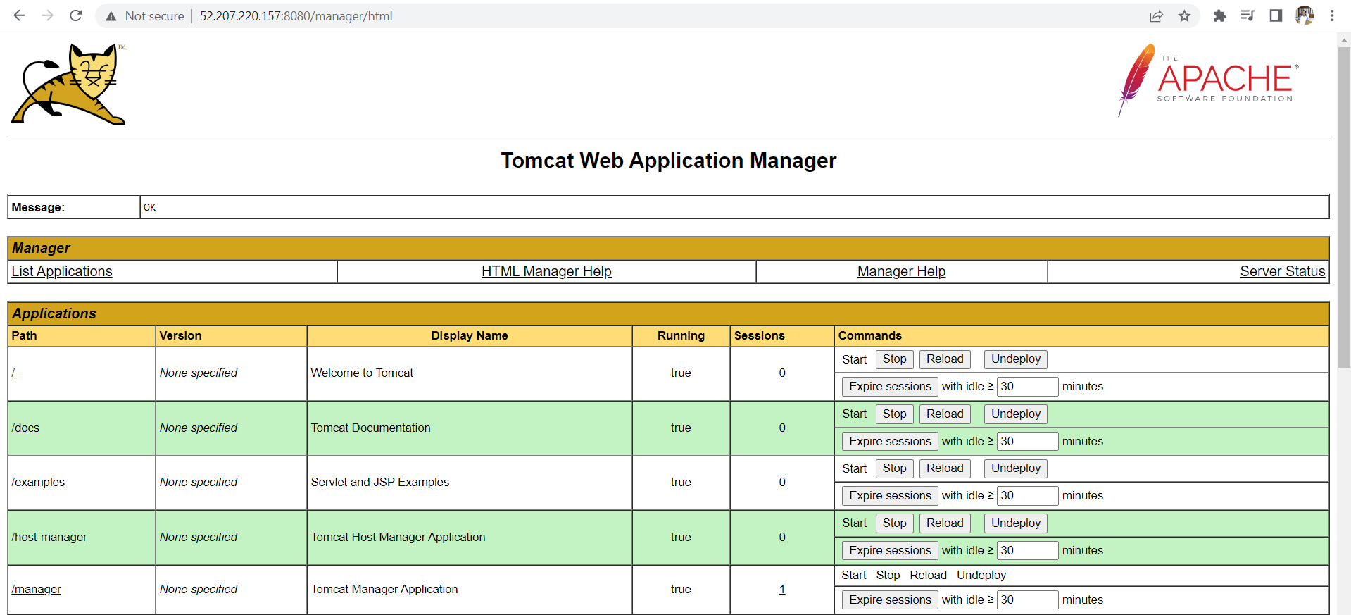

**Integrate tomcat with Jenkins:**

Now open your jenkins

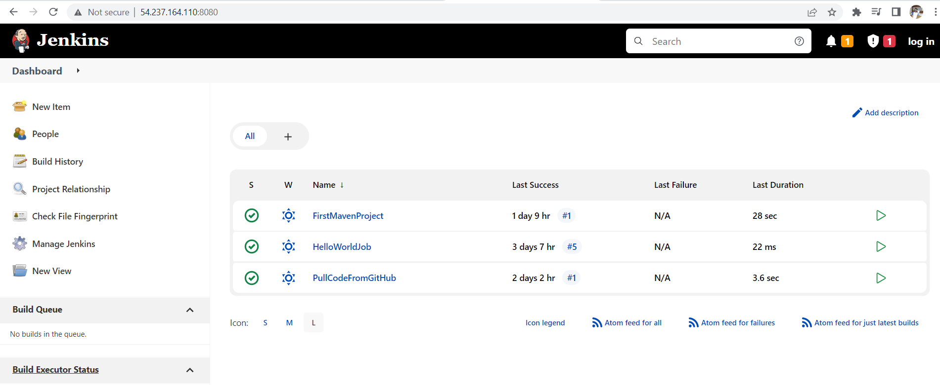

Click on manage jenkins

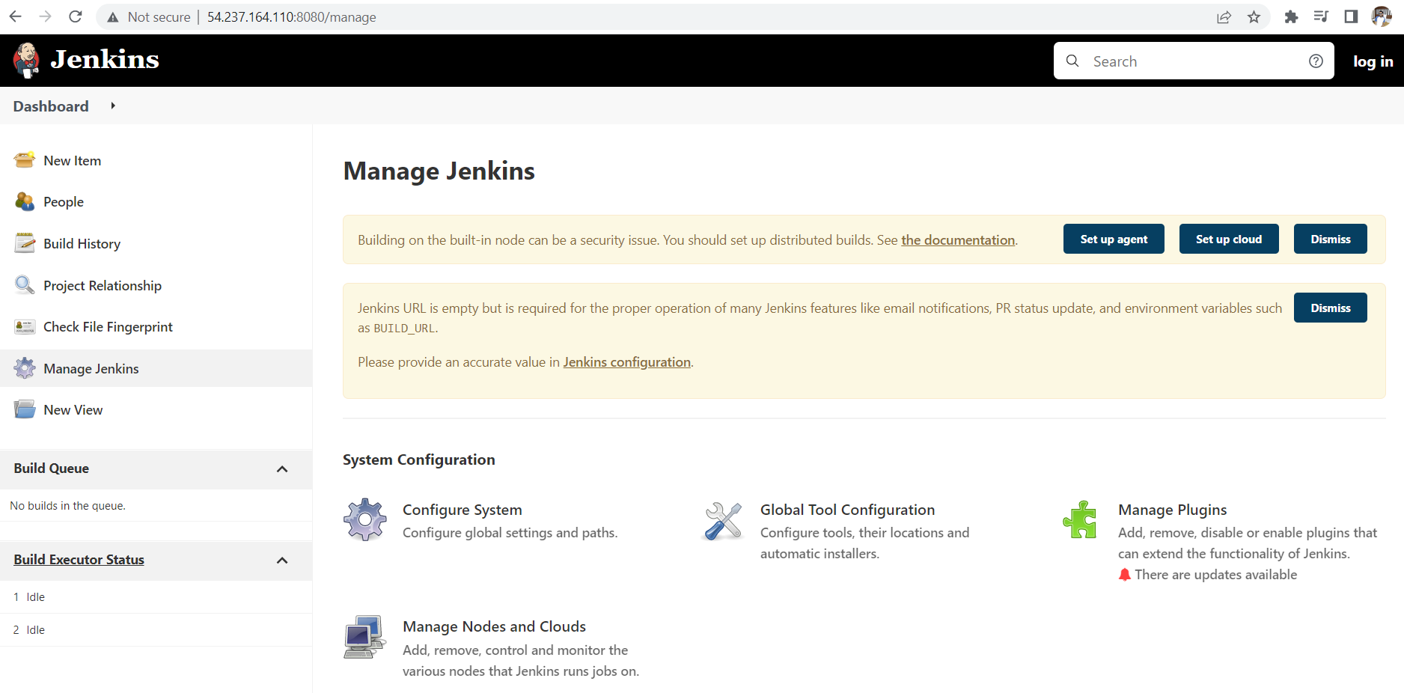

Click on manage plugins

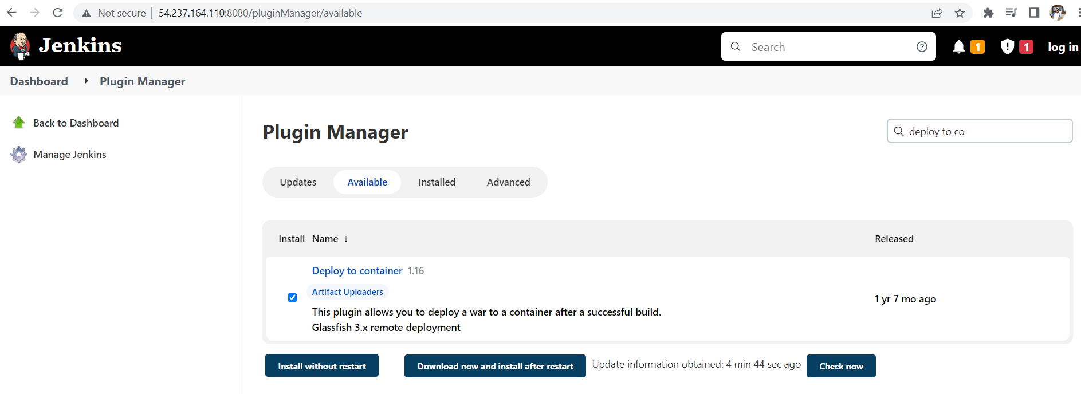

Click on available and search for deploy to container make tick on that and click on install without restart

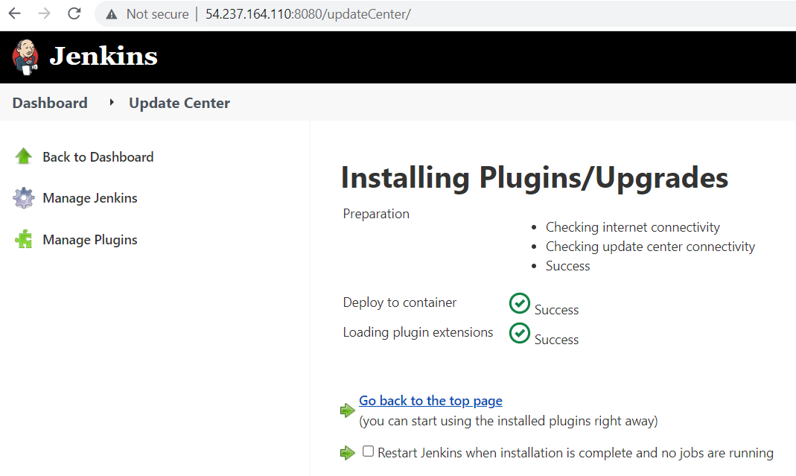click on go back to the page you will get this home page

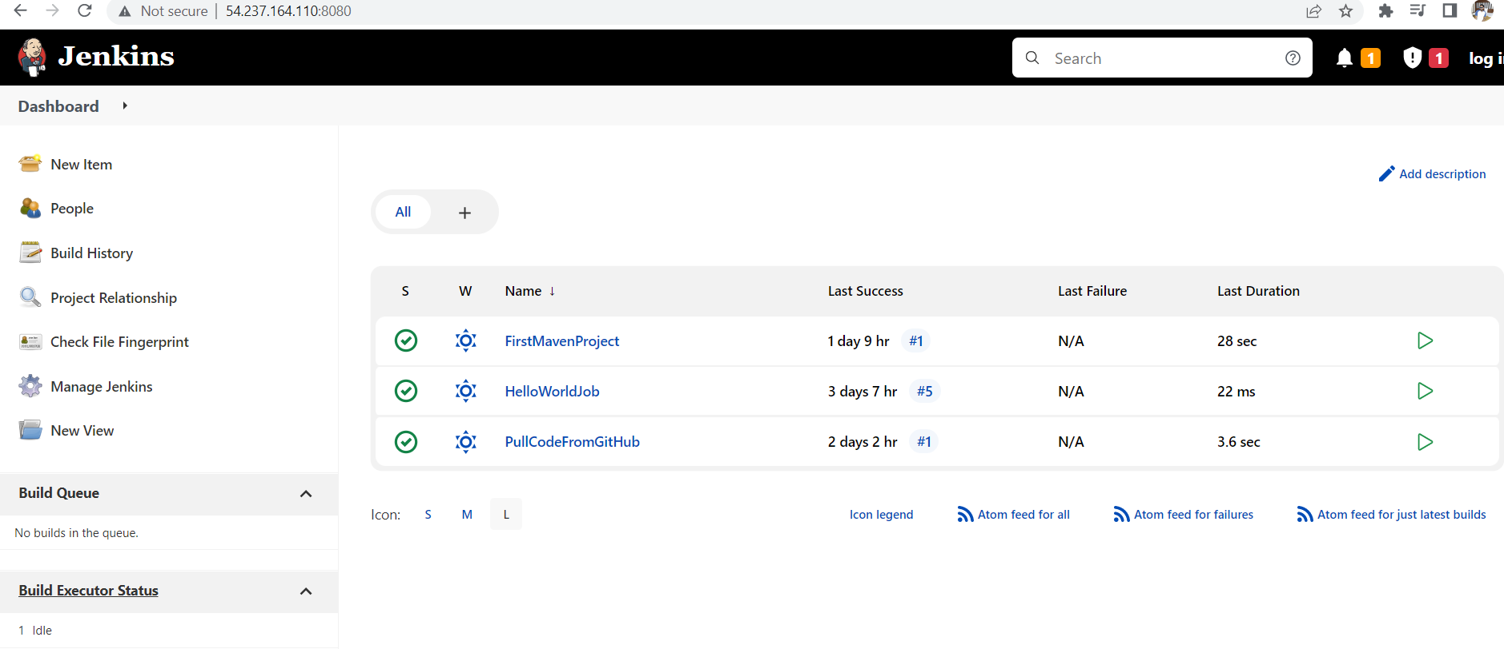

Now click on manage jenkins you will find below page

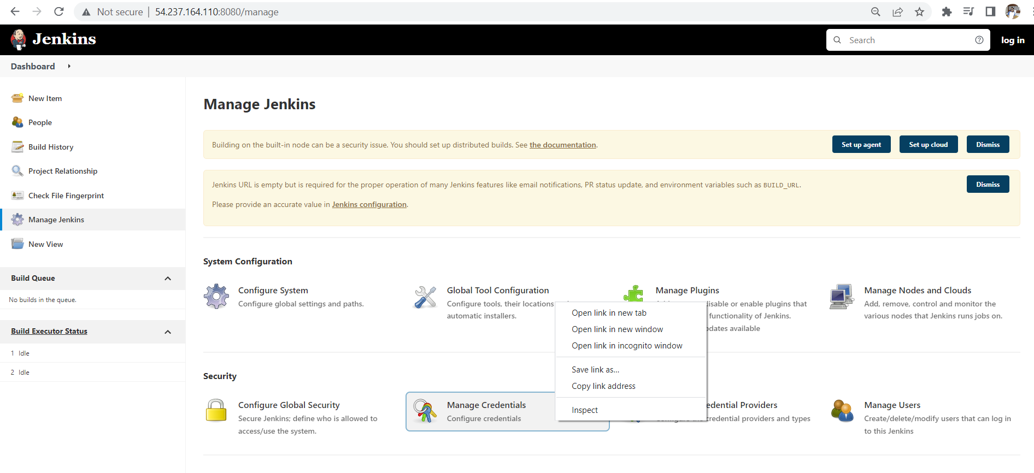

Click on manage credentials you will get the below page

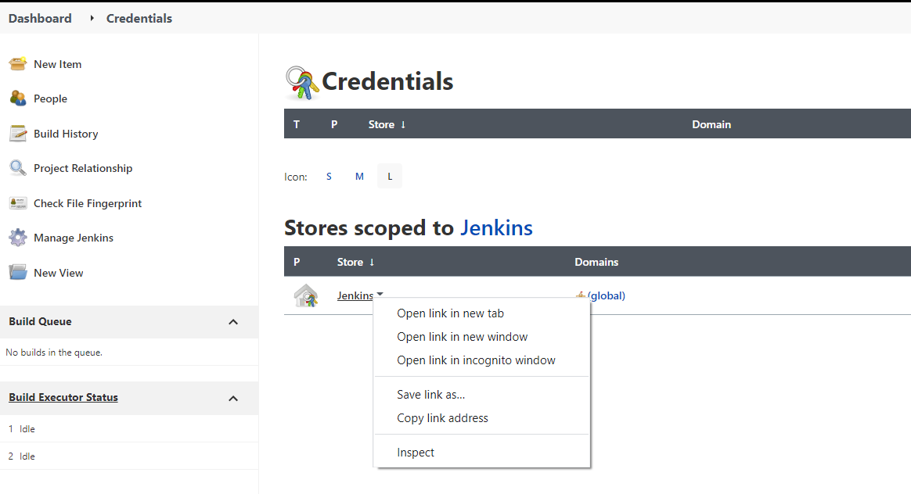

You should click on jenkins

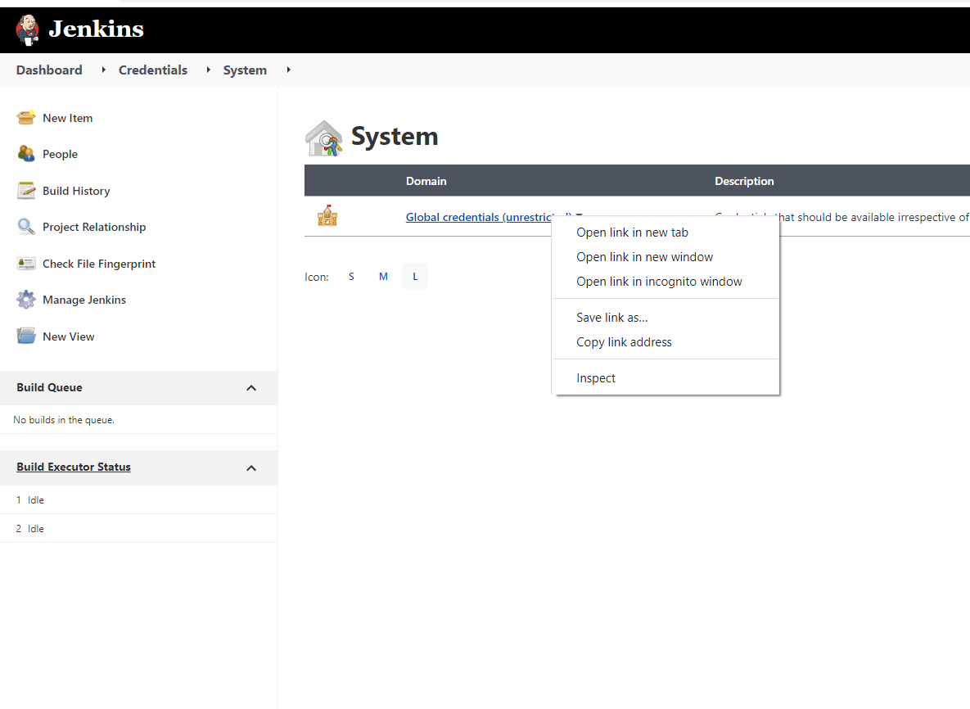click on global credentials

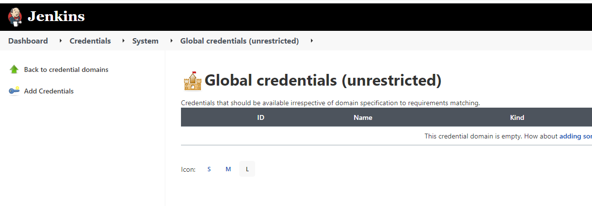click on add credentials

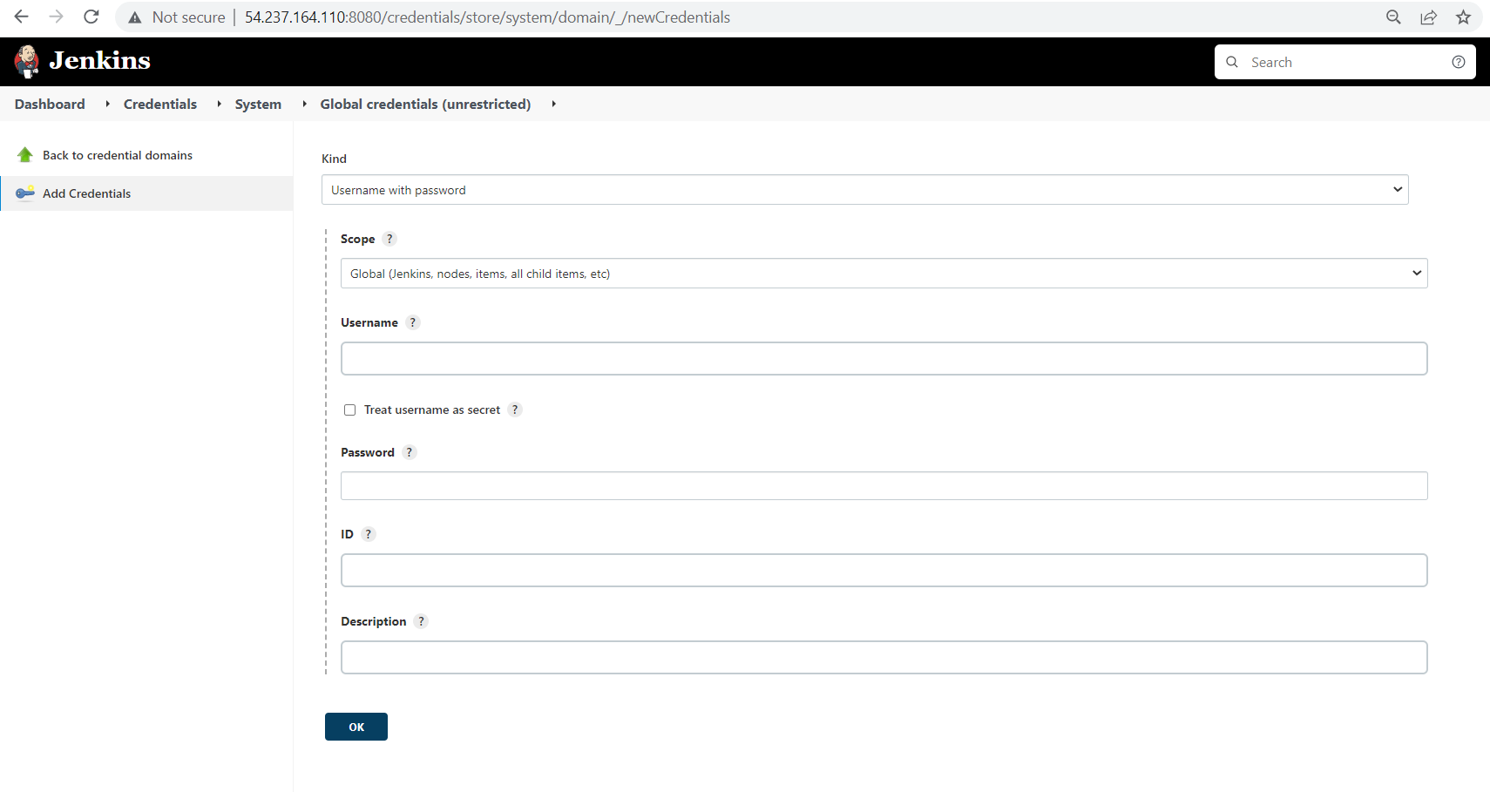you will get this page the user is copied from below page

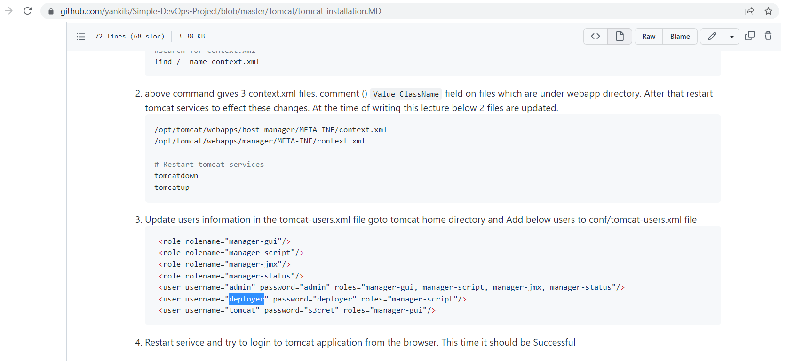

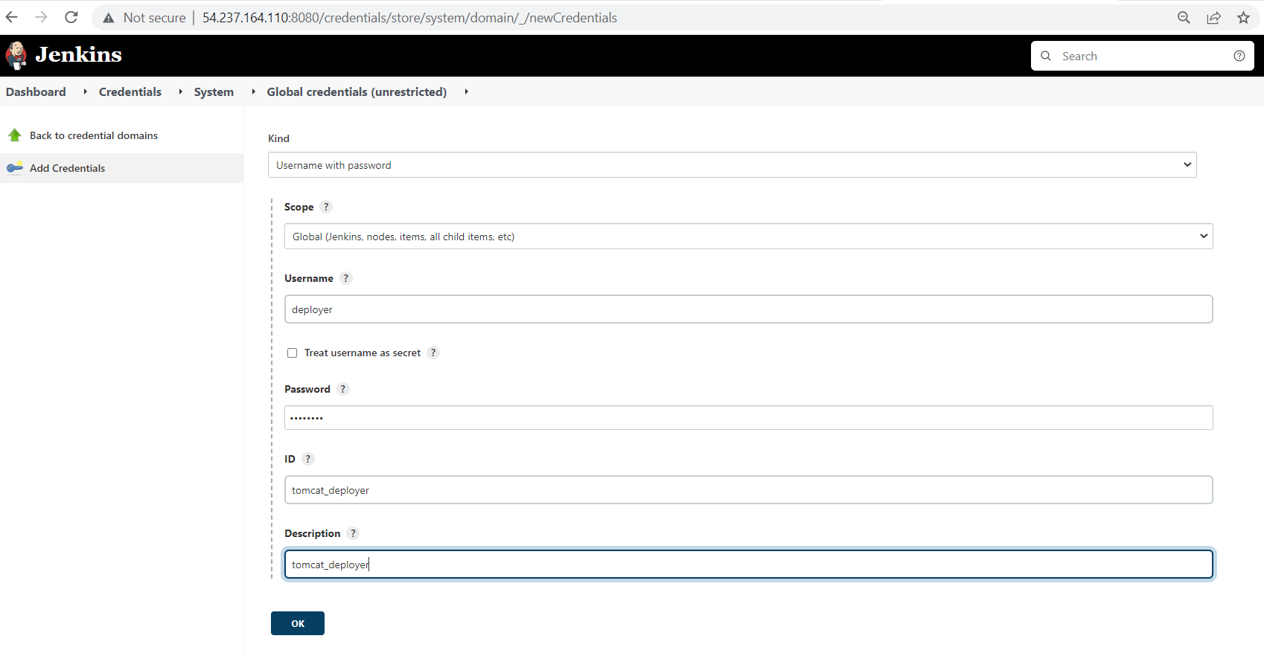

The username deployer and password is also same deployer we should name ID as tomcat_deployer description is also same tomcat_deployer

And then click on ok

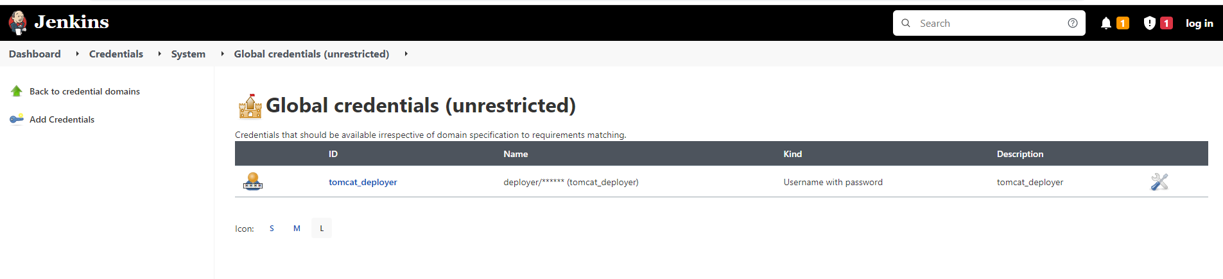

Click on Dashboard

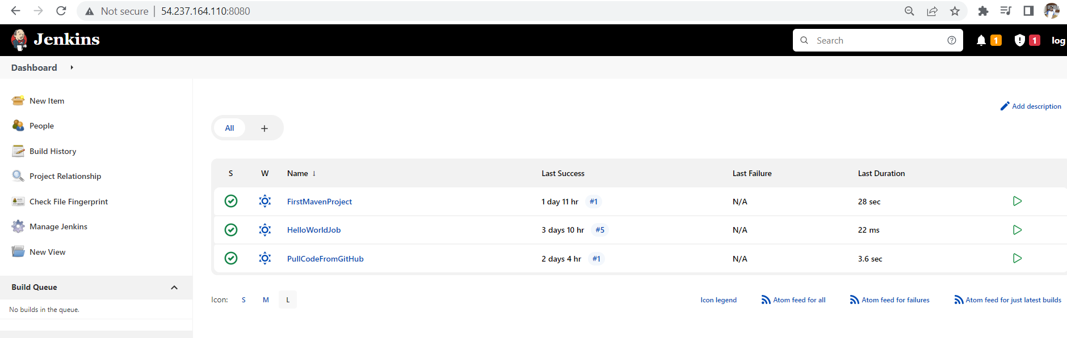

Click on new item

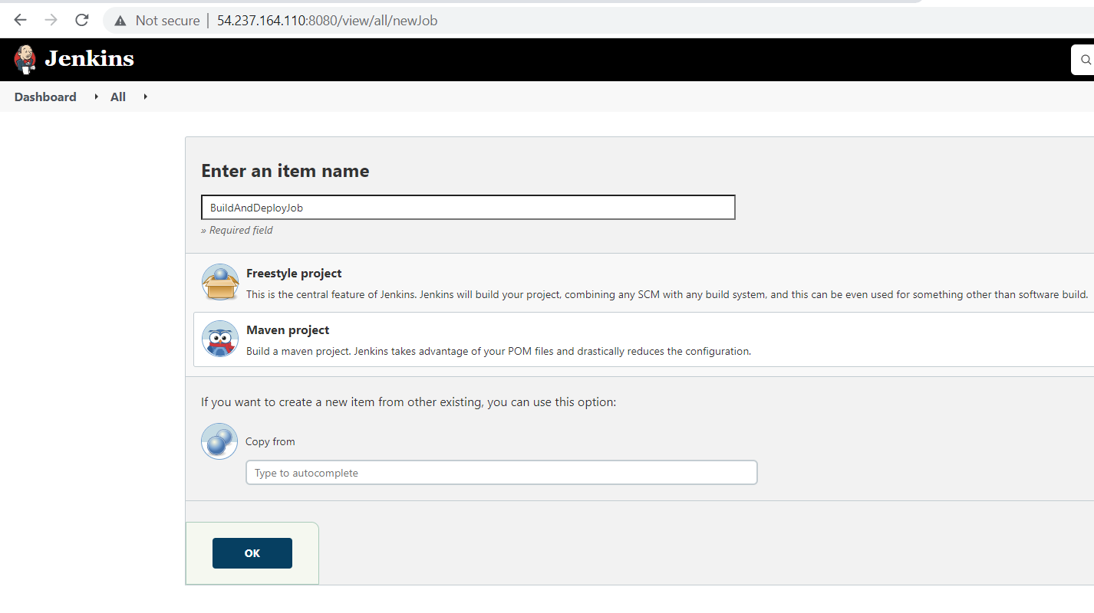

Click on ok

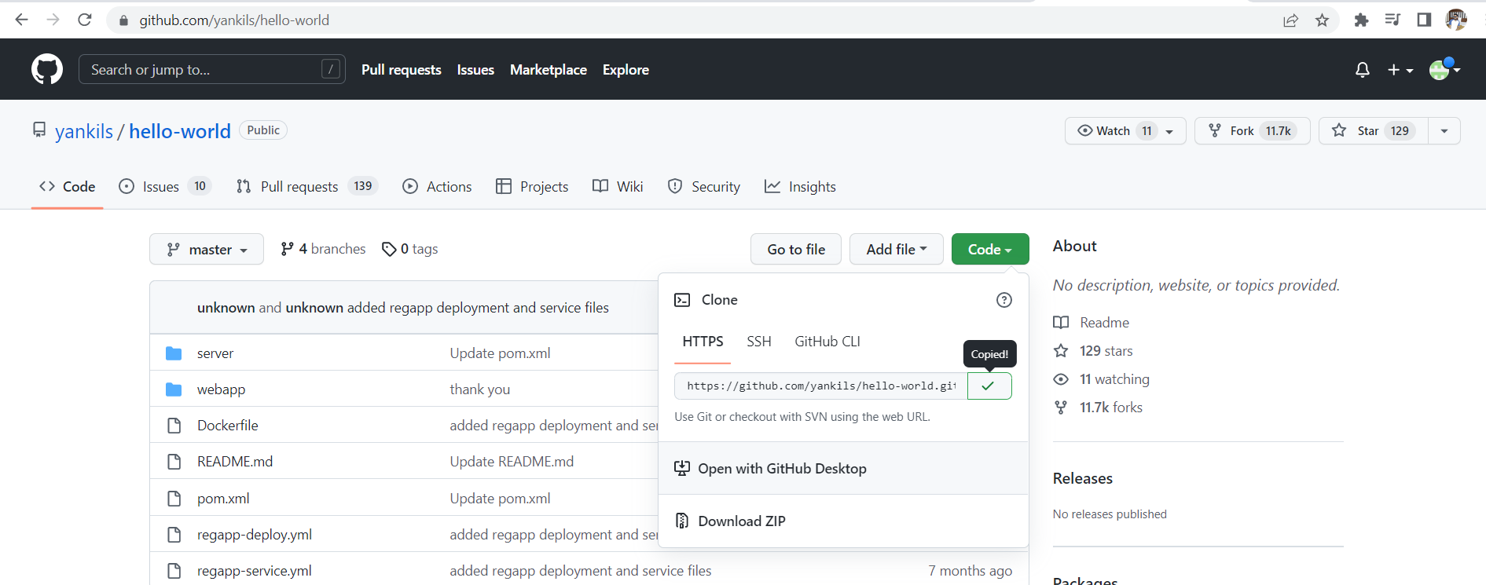

Copy the url and paste as shown below

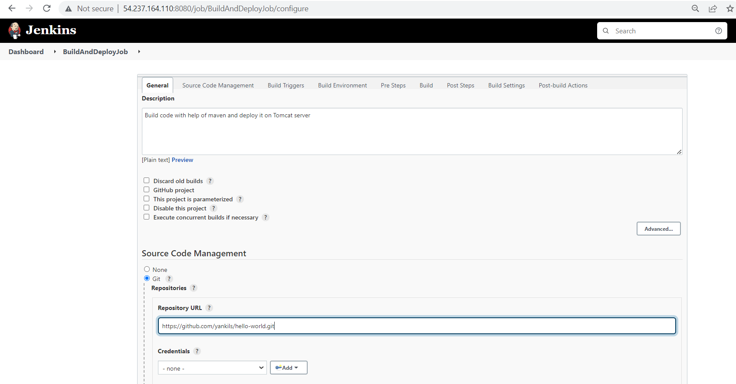

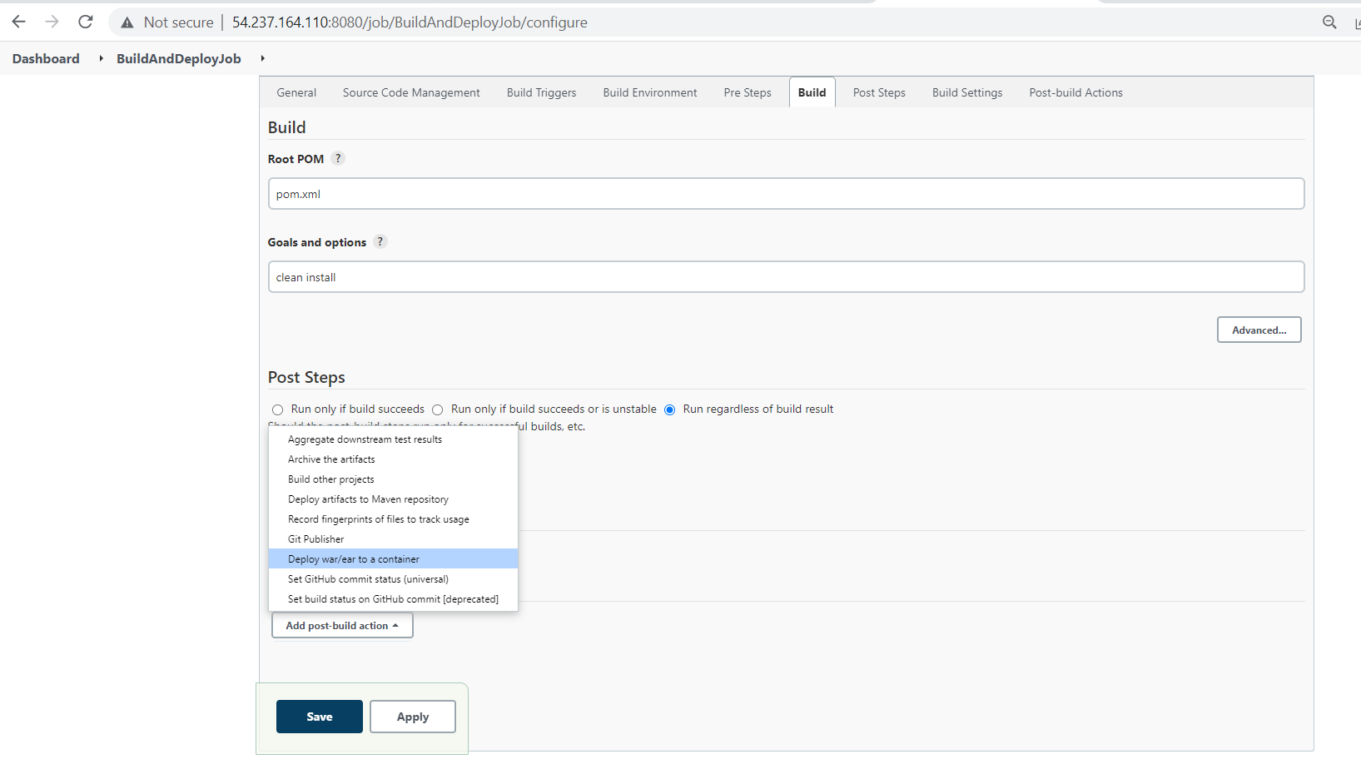

Select deploy war/ear to a container

Now you will get like this

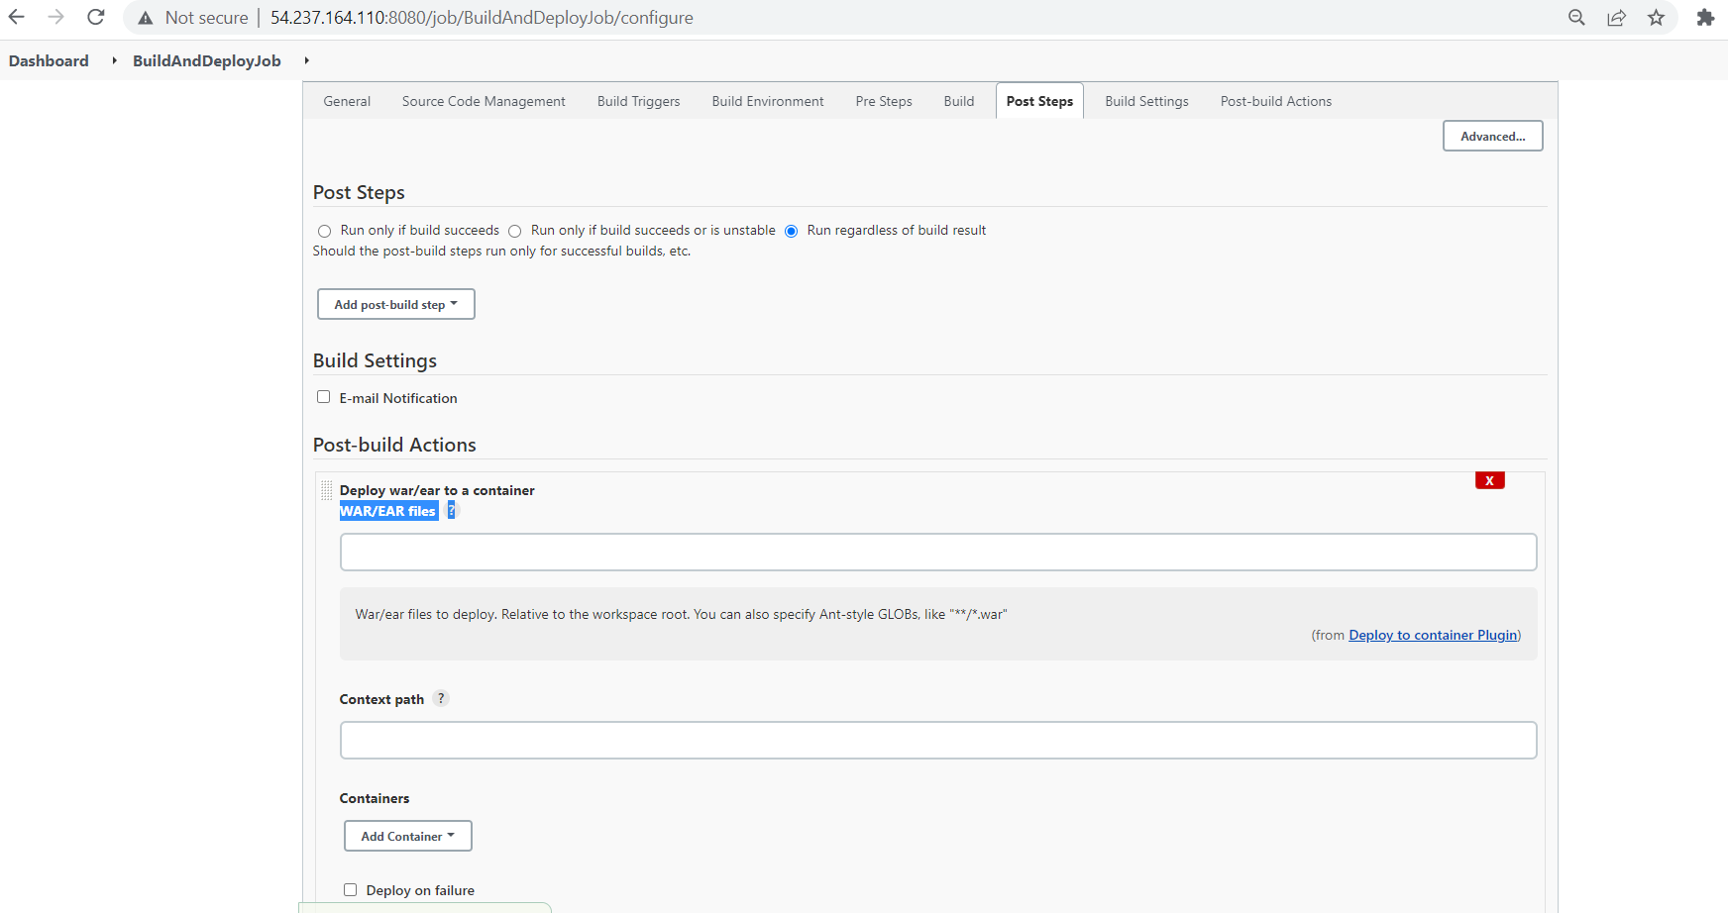

Click on the WAR/EAR files ? you find the line as

War/ear files to deploy. Relative to the workspace root. You can also specify Ant-style GLOBs, like "**/*.war"

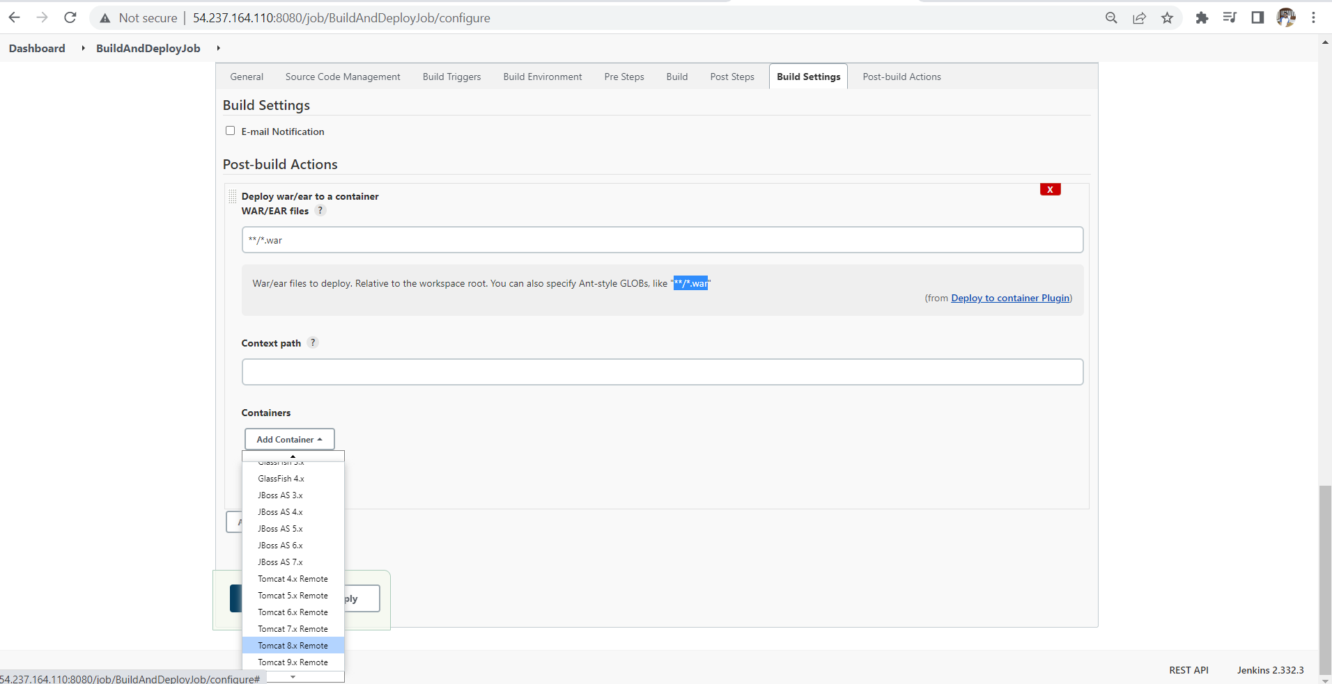 copy it and paste it in WAR/EAR file ? as shown above

And click on add container select Tomcat 8.x Remote

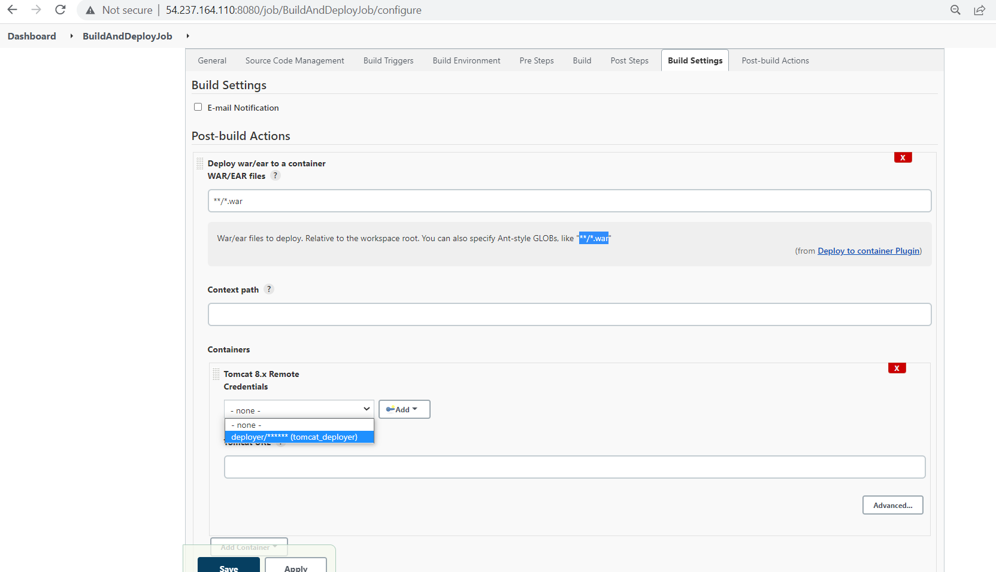

You can choose the credentials as shown above

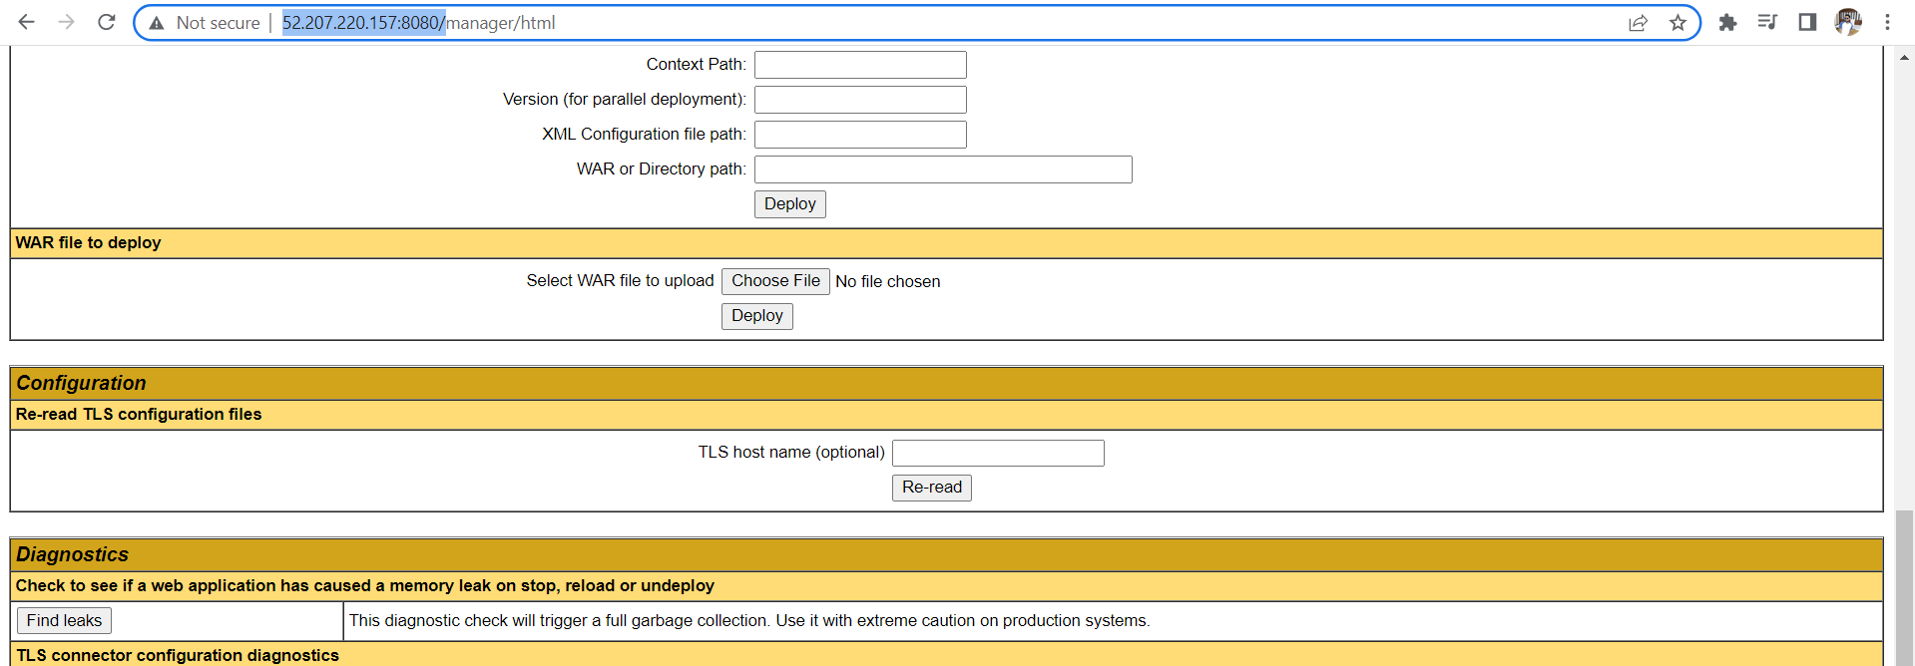

Copy the tomcat url and paste as shown below

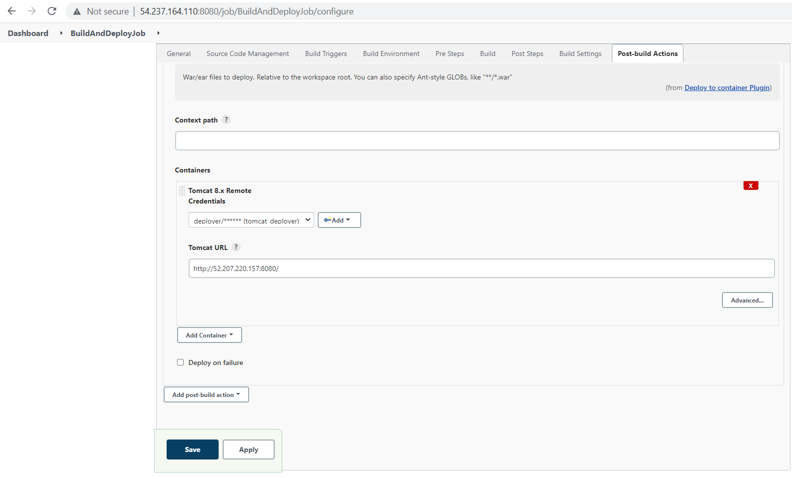now click on apply and save

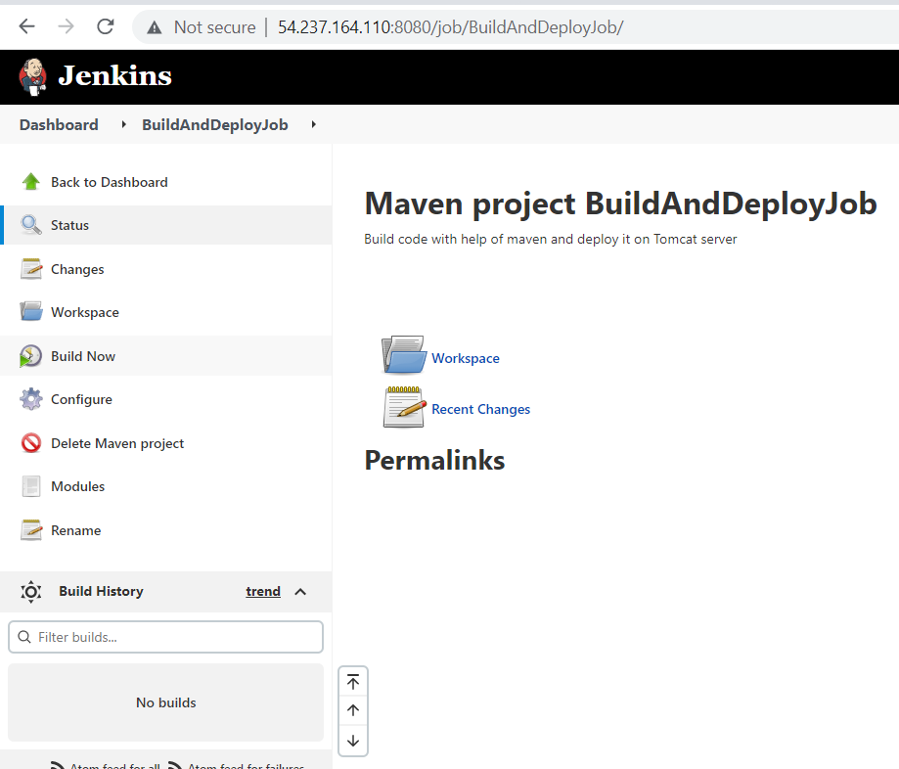

Later you will come to BuildAndDeployjob

Then you should click on Build Now

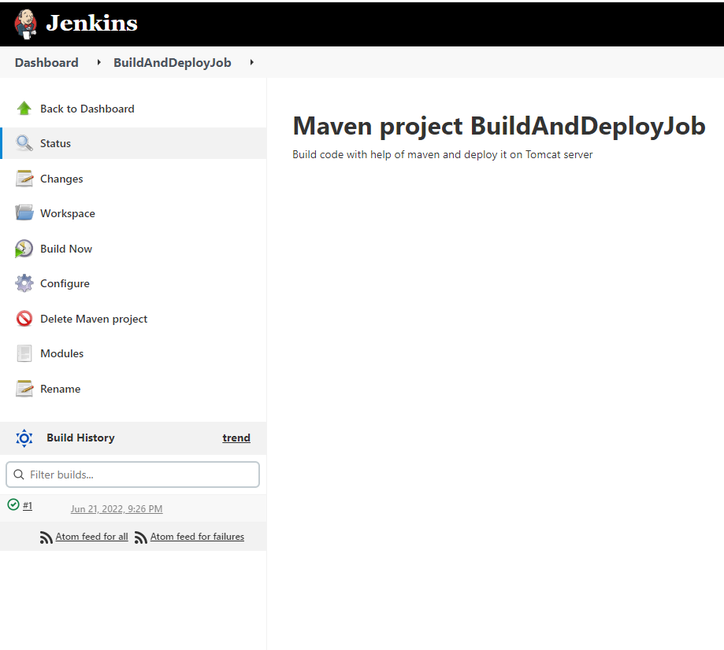

Click on tick mark you can see the output as shown below

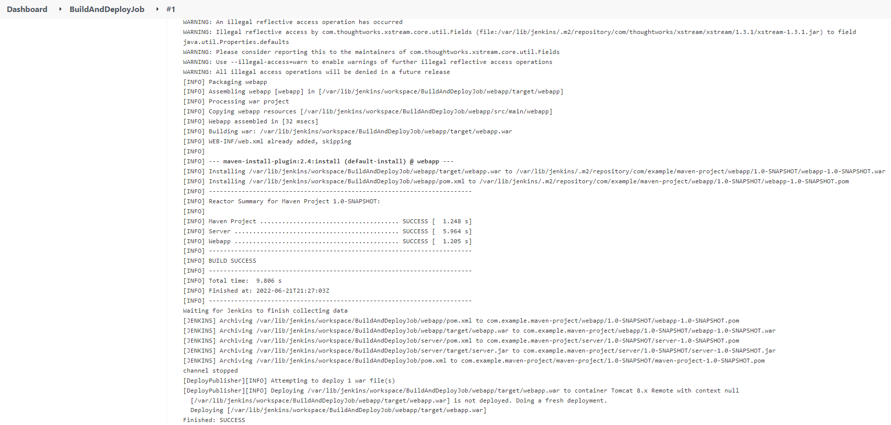

You can see webapp.war file is generated in the tomcat server by going through this path

Sudo su –

Cd /opt/tomcat/webapps

ll

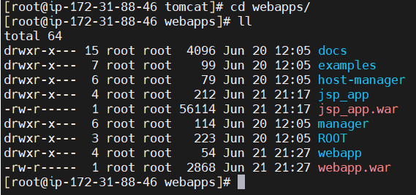

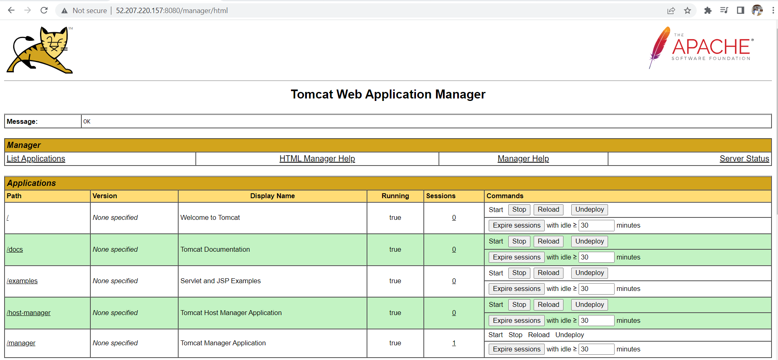go to tomcat server and reload it

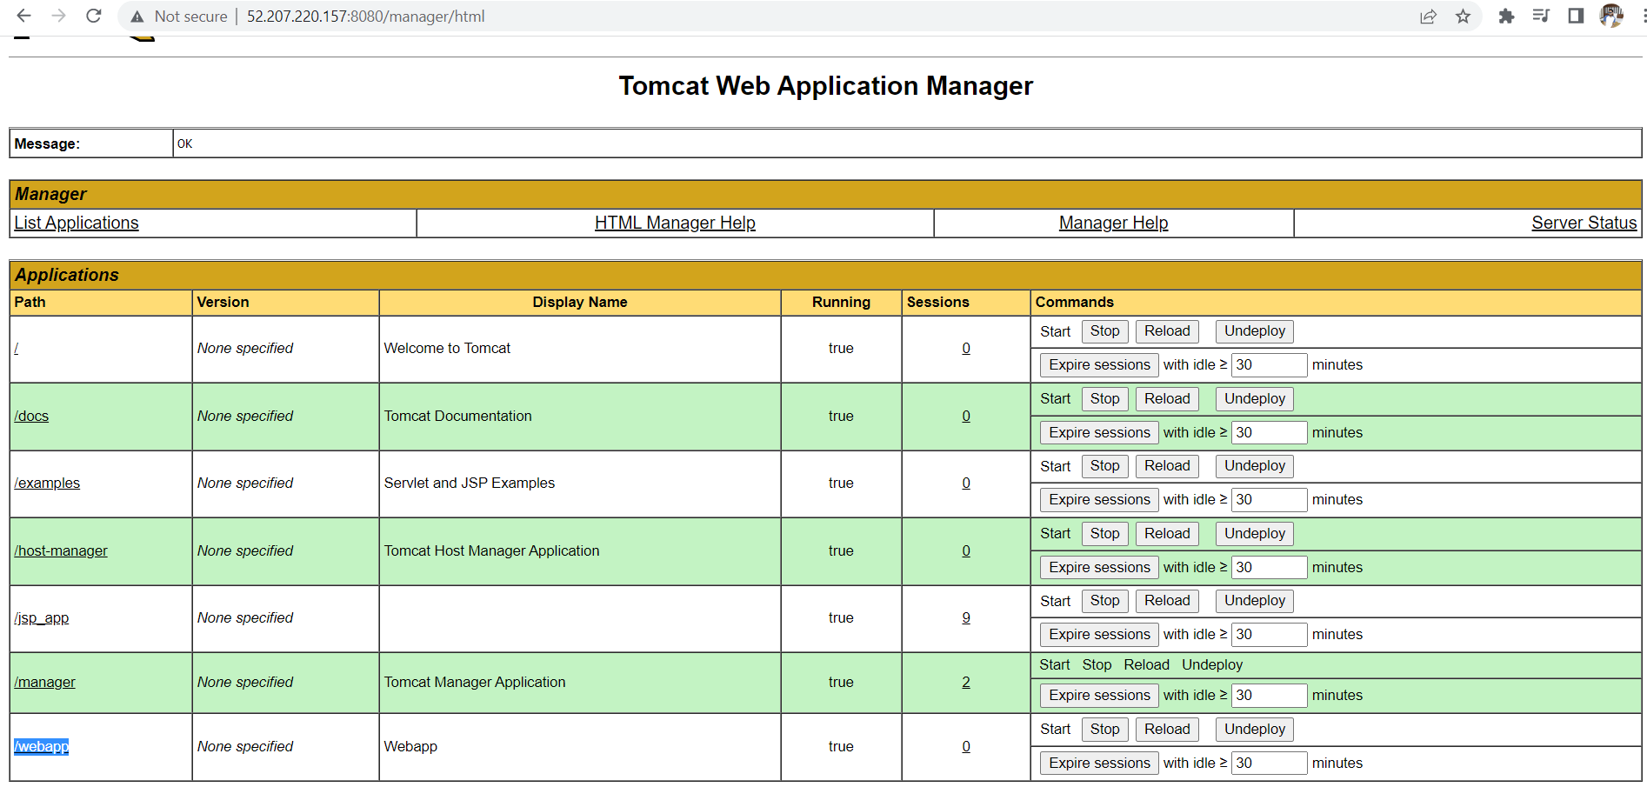now you can find webapp option click on it

You will get the output page like this as shown below

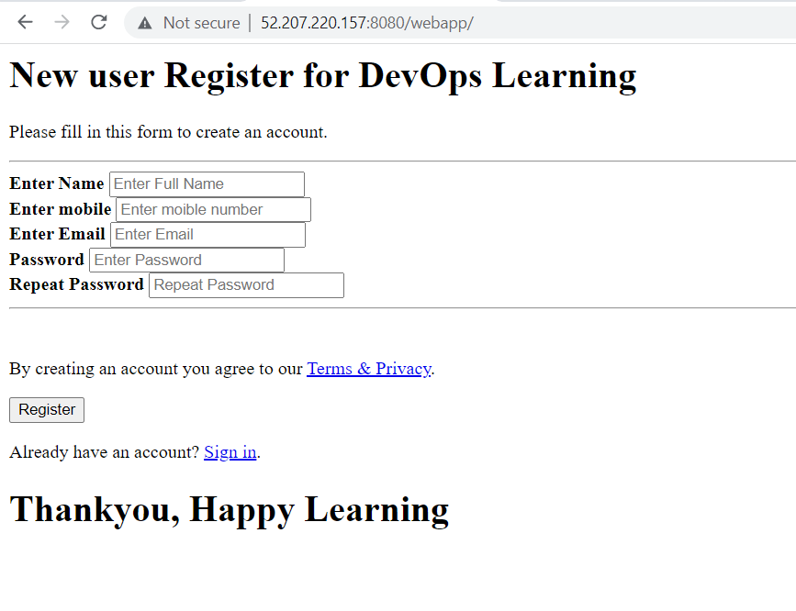if we want to change the code deploy it again we can do as follows

We should have git bash in our local machine

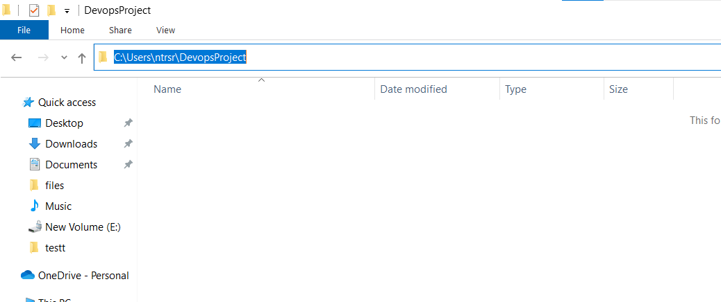create a folder and copy the path now open the git bash

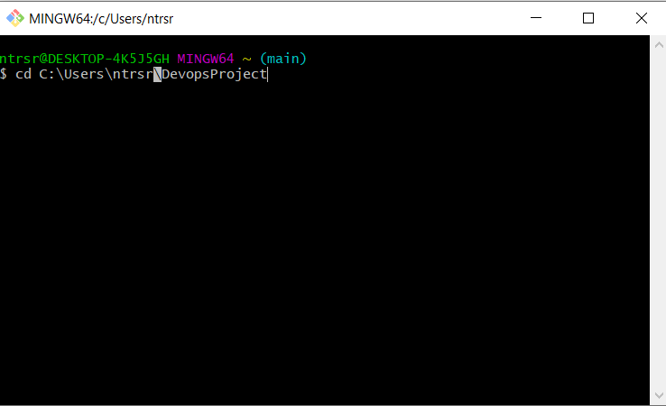

Change this slashes to front as shown below

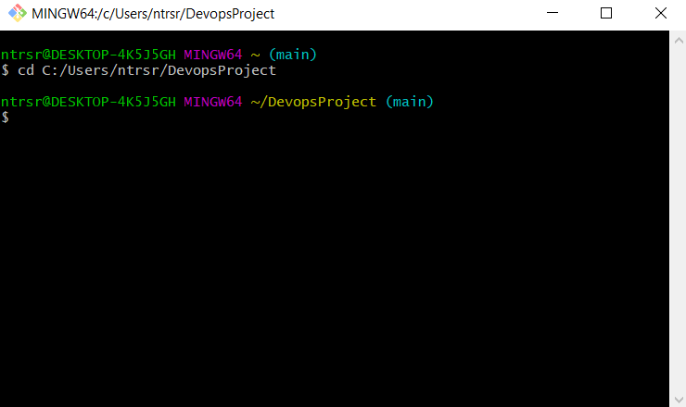

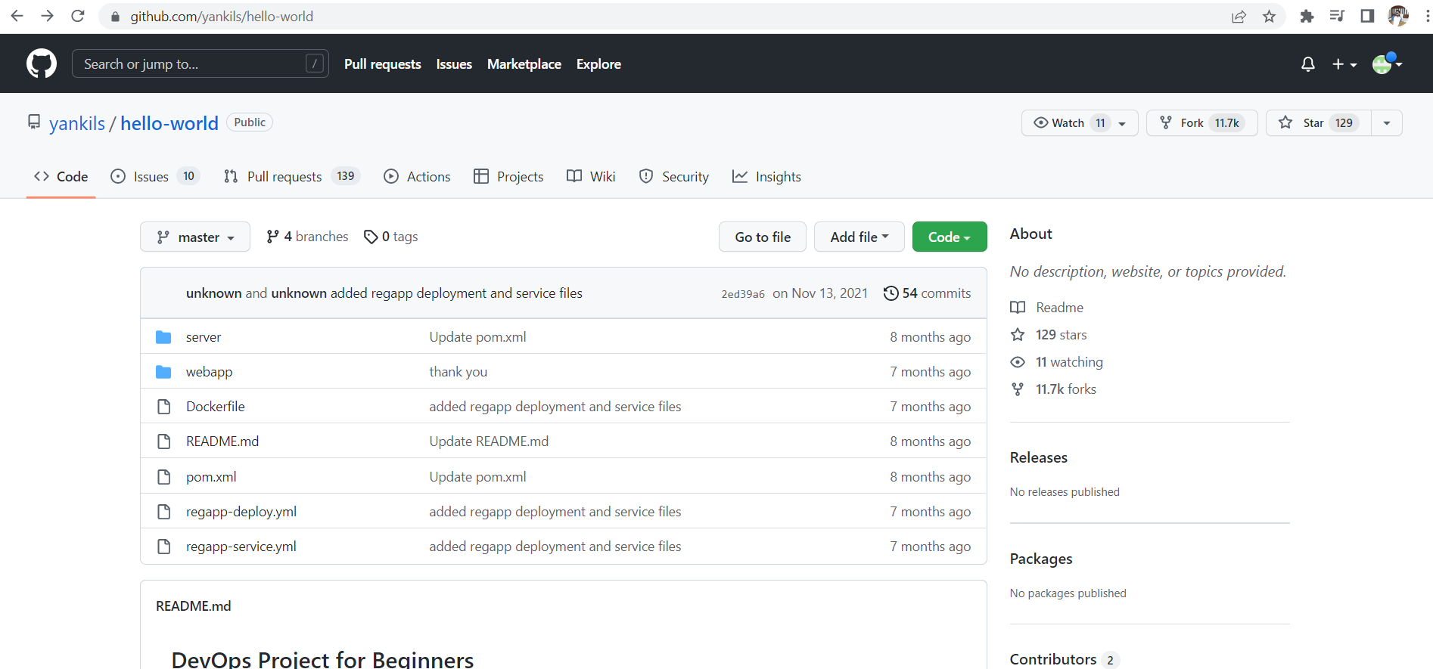

First we need to fork the code into our account click on fork symbol

Later you will get the code into your account as shown below

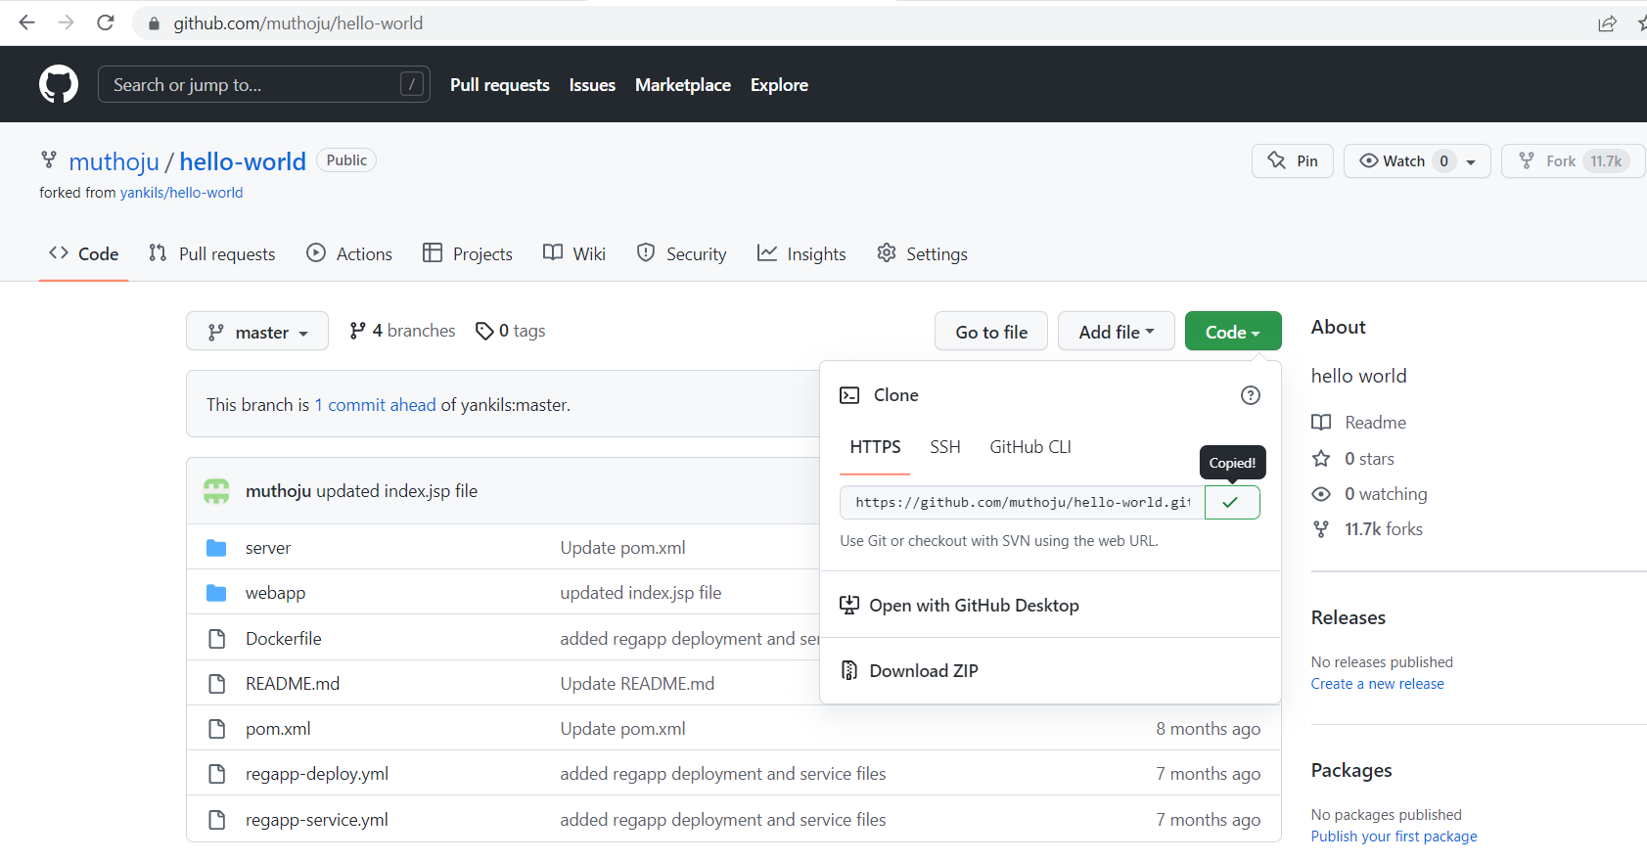

Copy the url

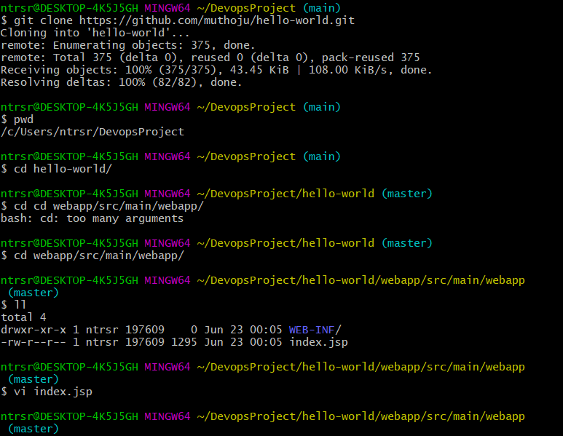

Follow the above commands

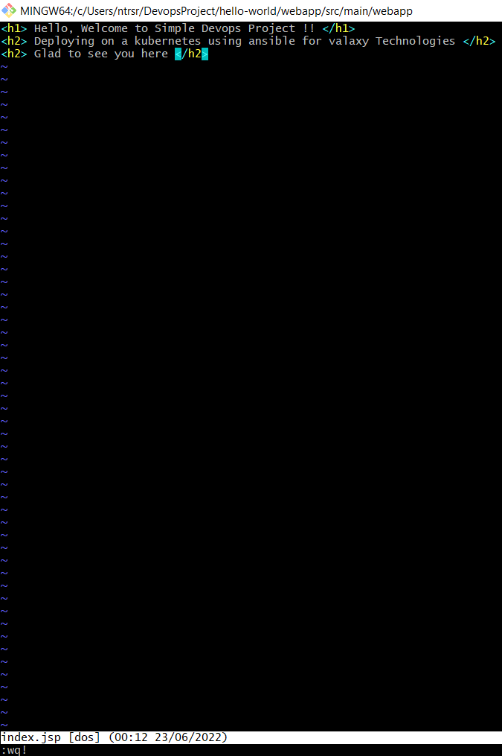

Remove the old code replace the above given code and save the file

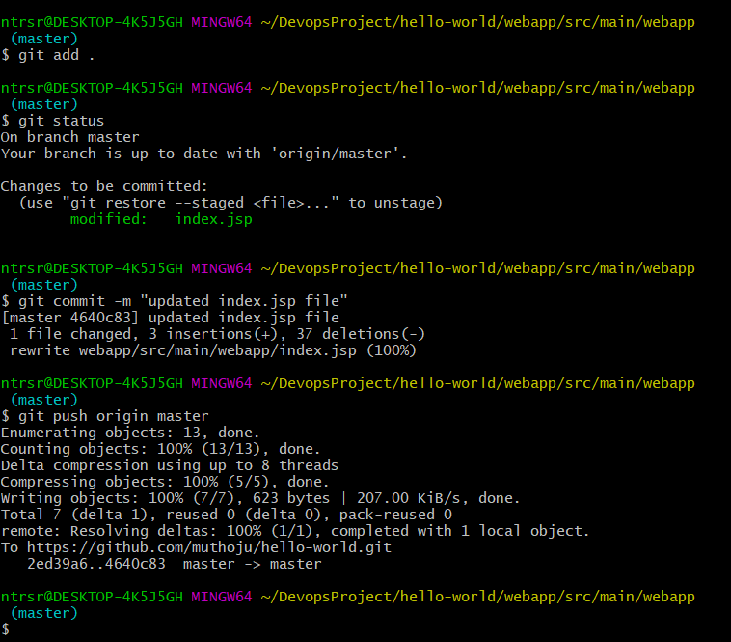

Follow the above commands to push the code into github

Now check the code is changed or not in your github

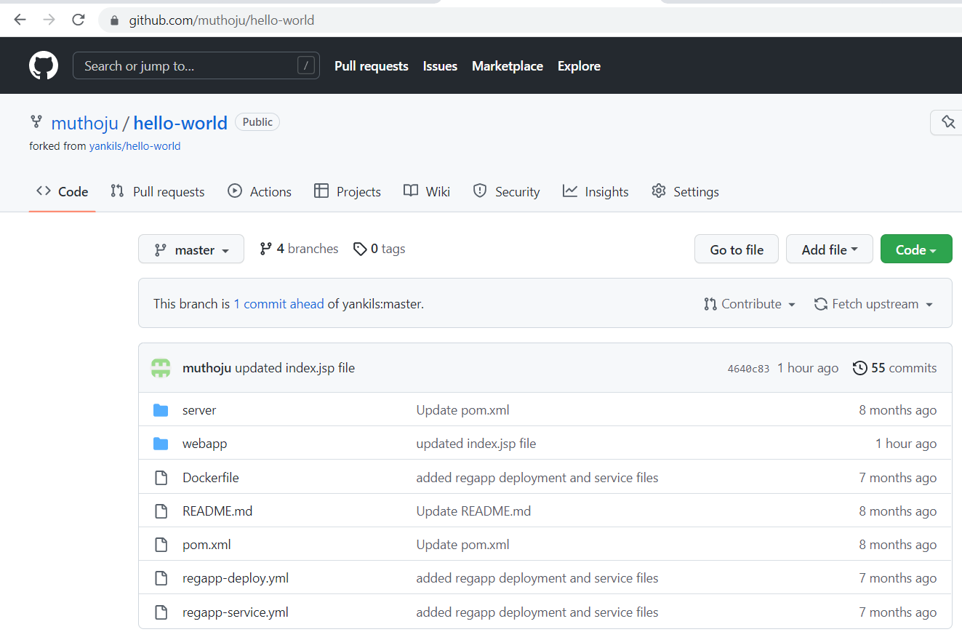click on webapp

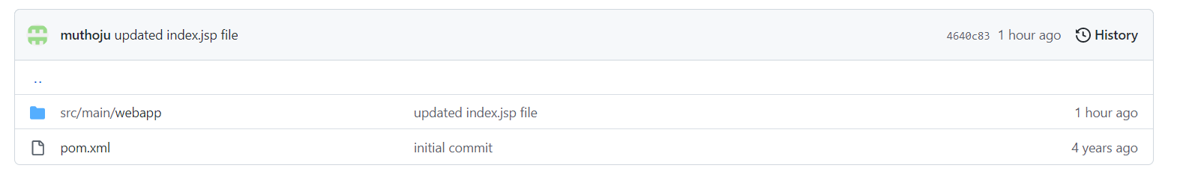click on src/main/webapp

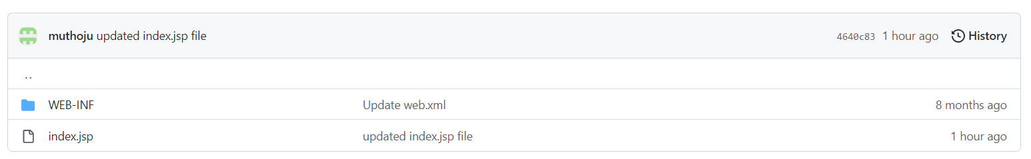

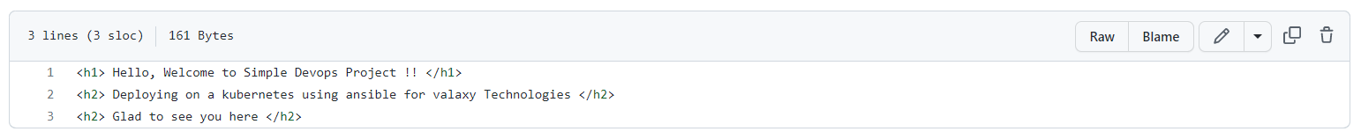you can see the code is changed

Go to Jenkins

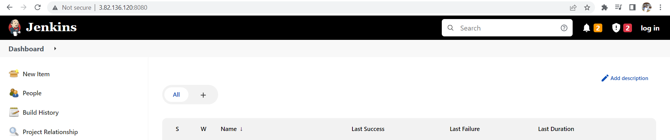

Click on new item

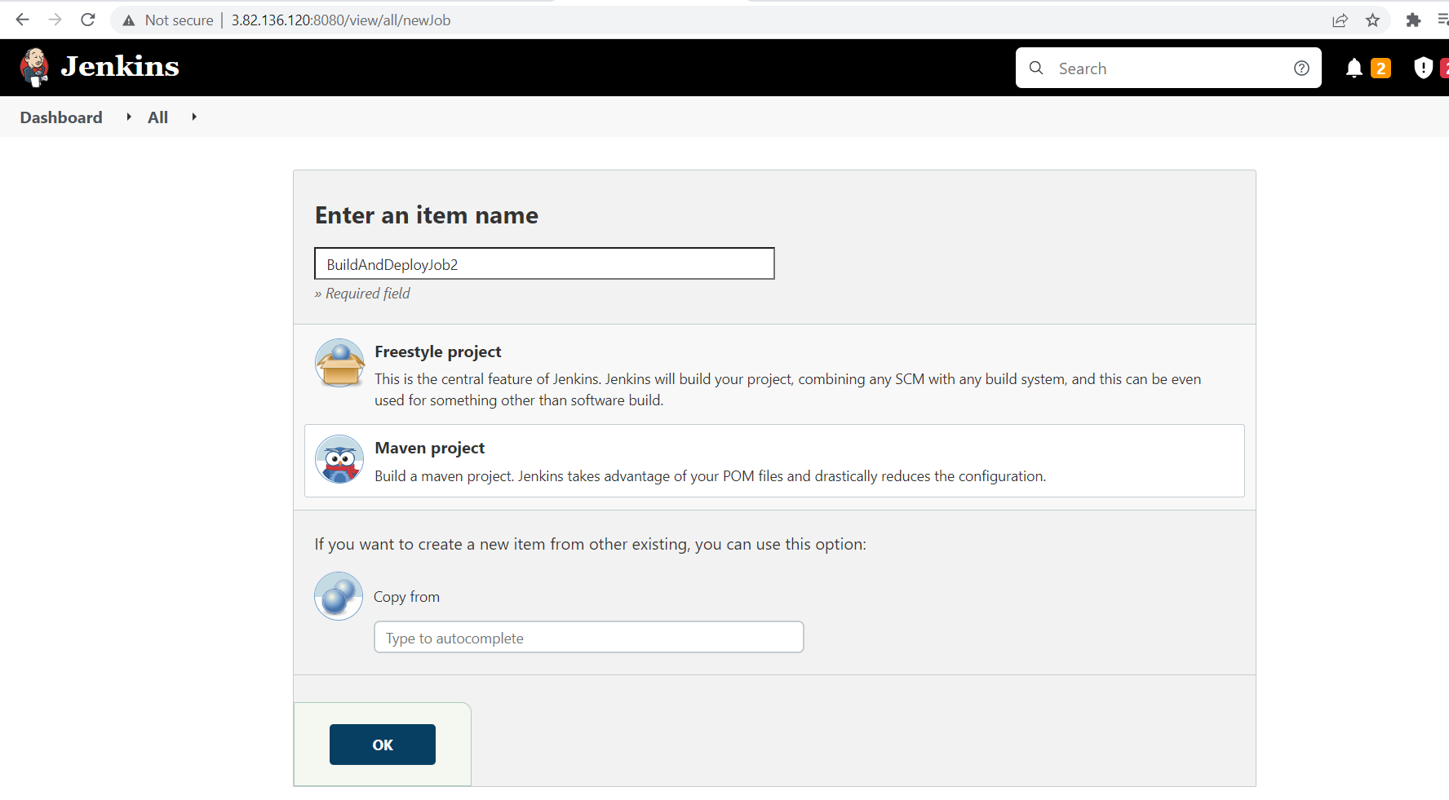

Enter the name and select maven and press ok

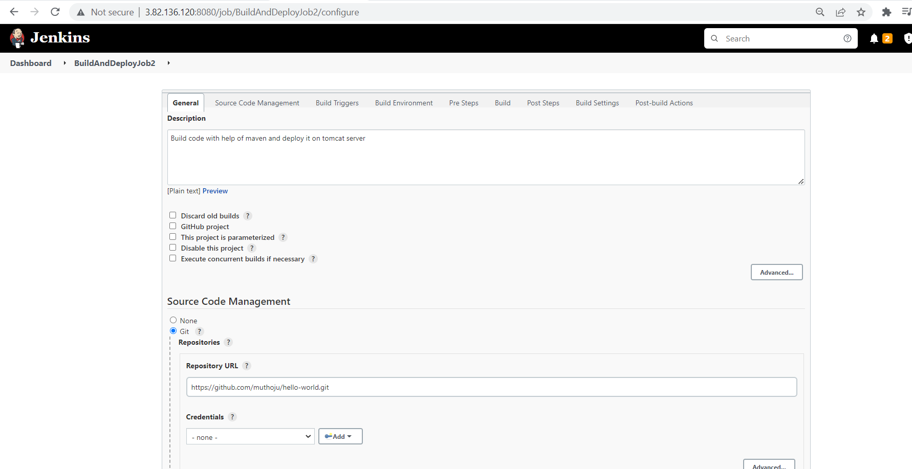

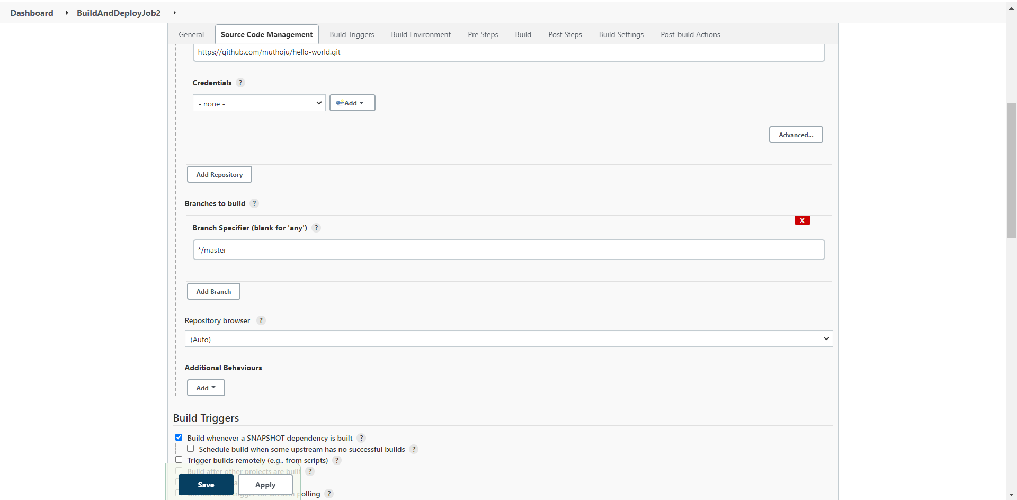

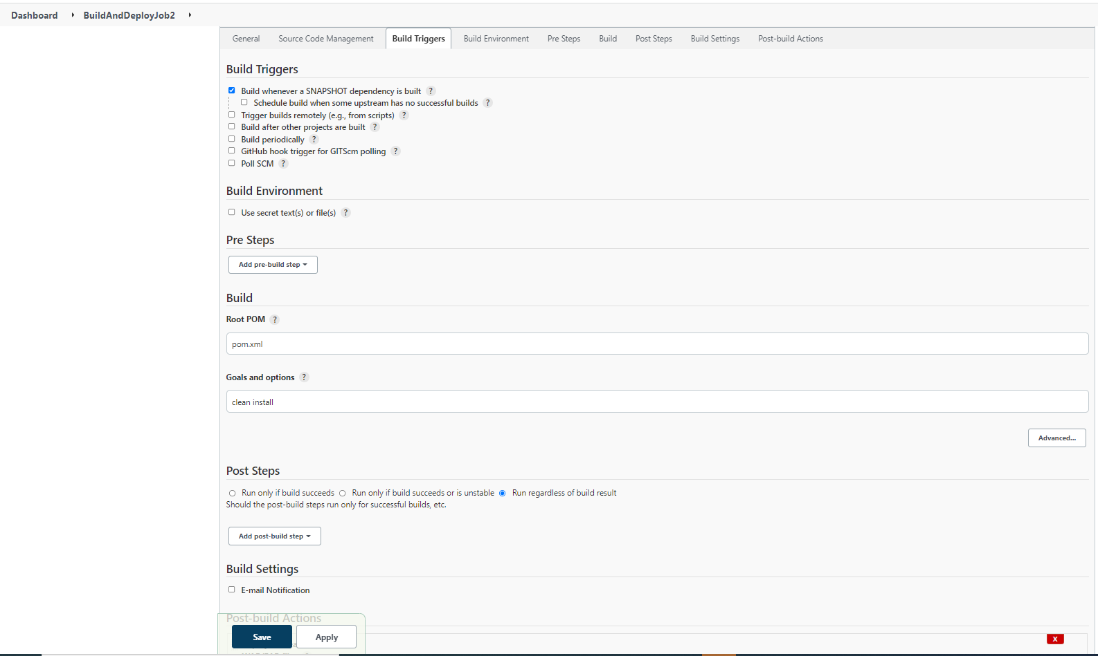

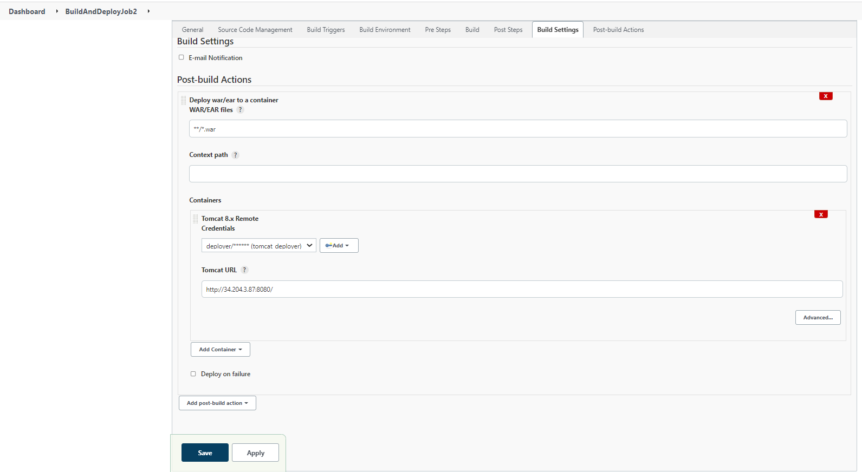

Please follow the above steps click on apply and save

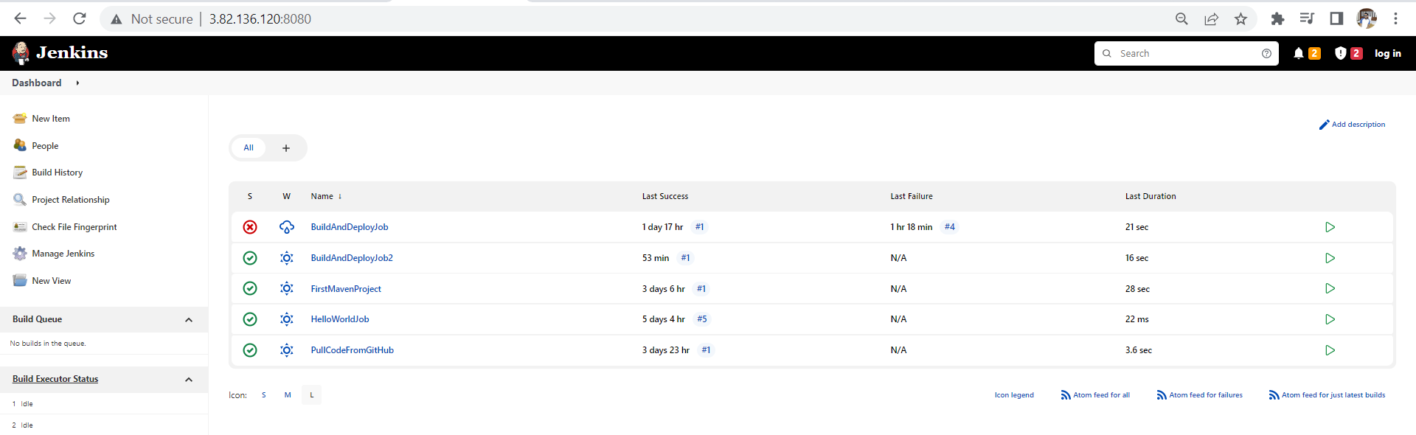

Click on BuildAndDeployjob2

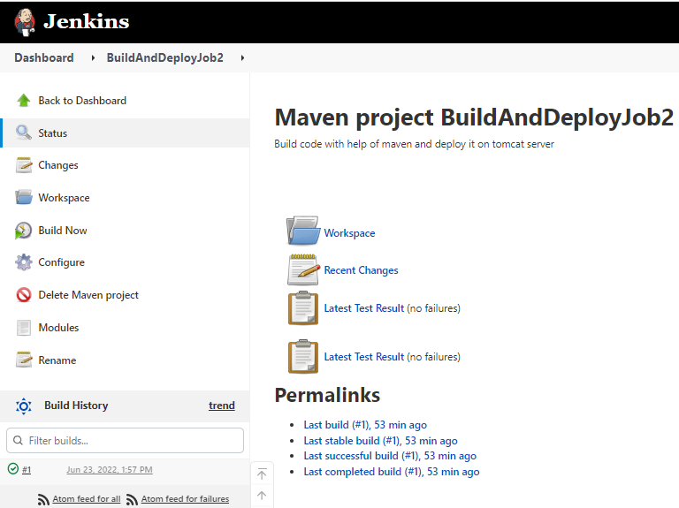

Click on build now click on right tick mark

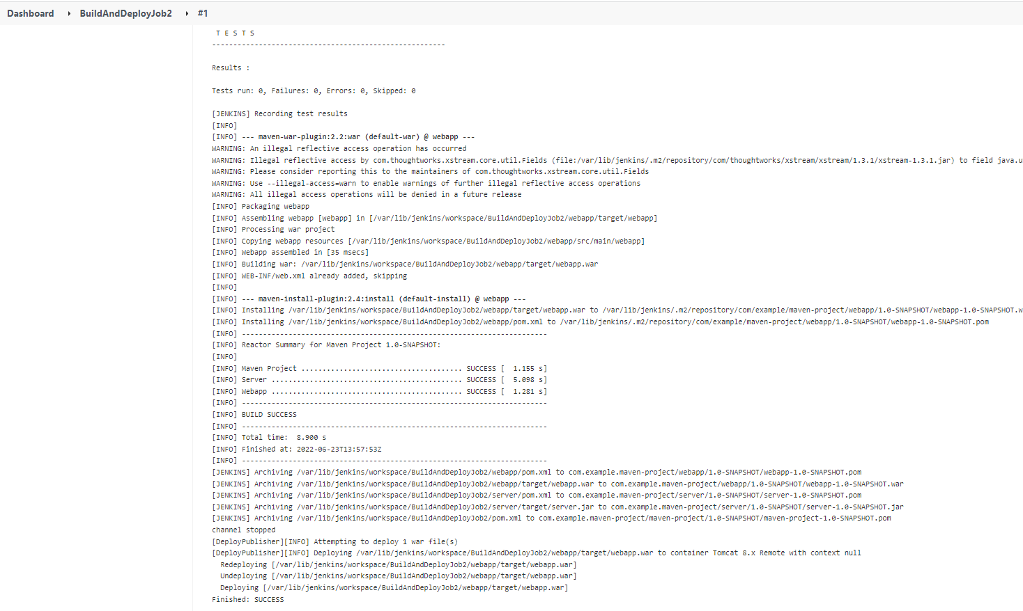

You can see the build is successful

Now move to tomcat

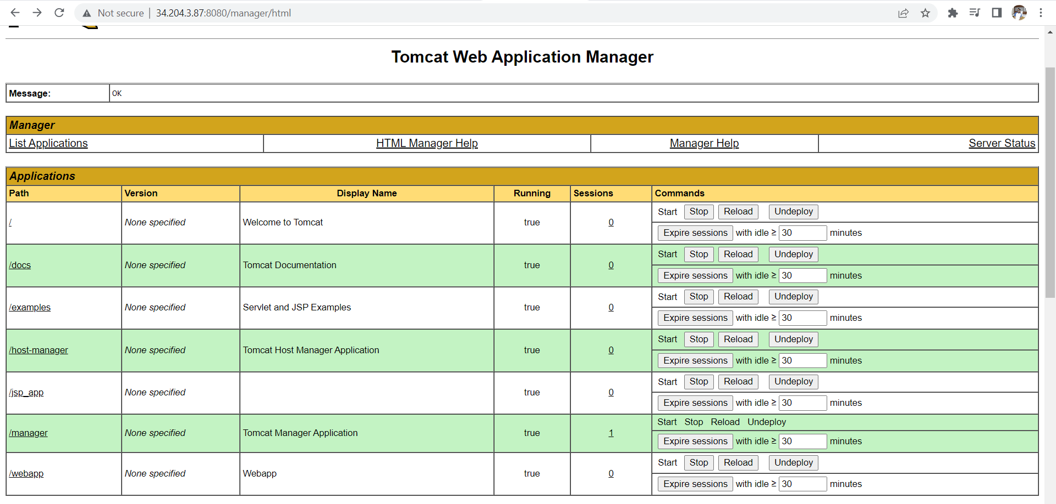

Click on webapp you can see the output

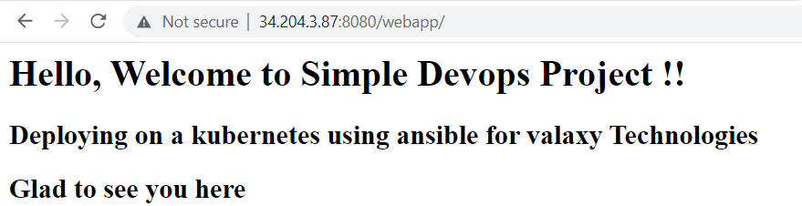

You can automate your Jenkins job when the code get changes in your github it automatically gets build by the Jenkins job

Follow the below step to

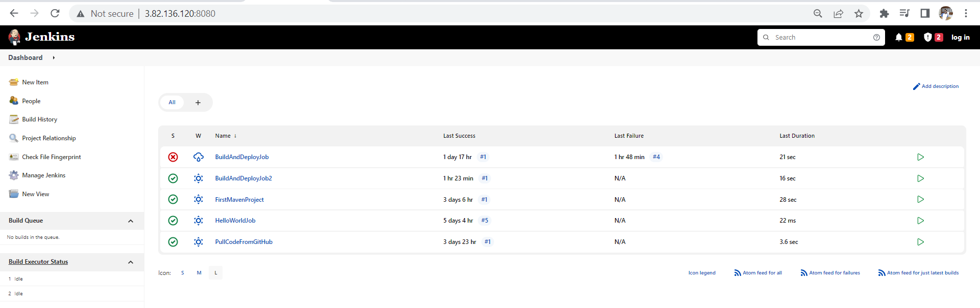click on BuildAndDeployjob2

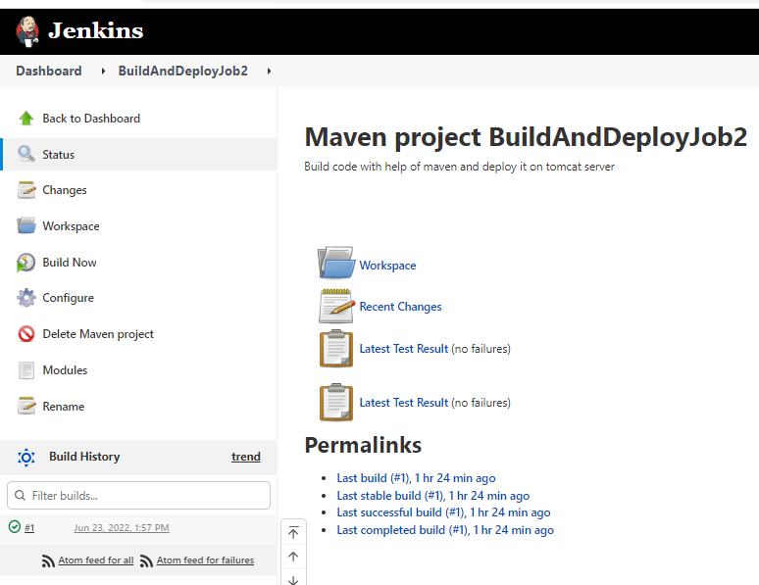click on configure

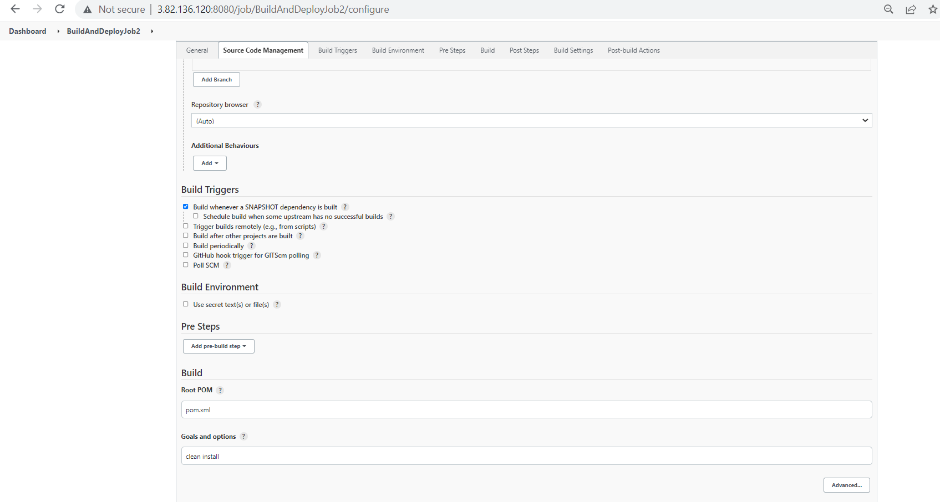

In Build Triggers select poll SCM later follow the below steps

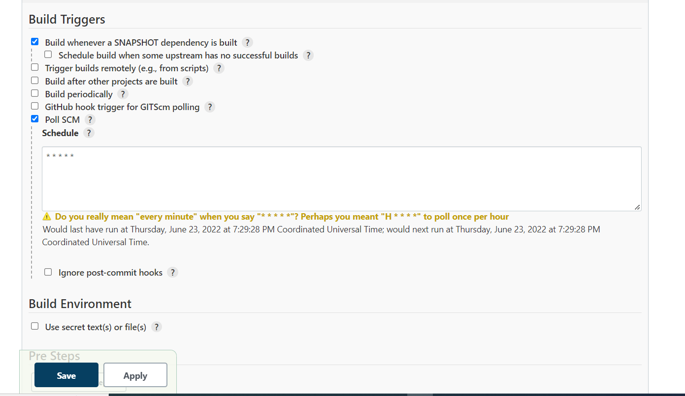

Apply and save

Later open your gitbash and go to devopsproject folder and follow below commands

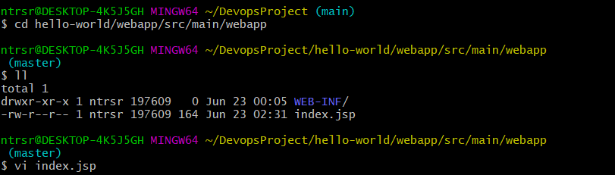

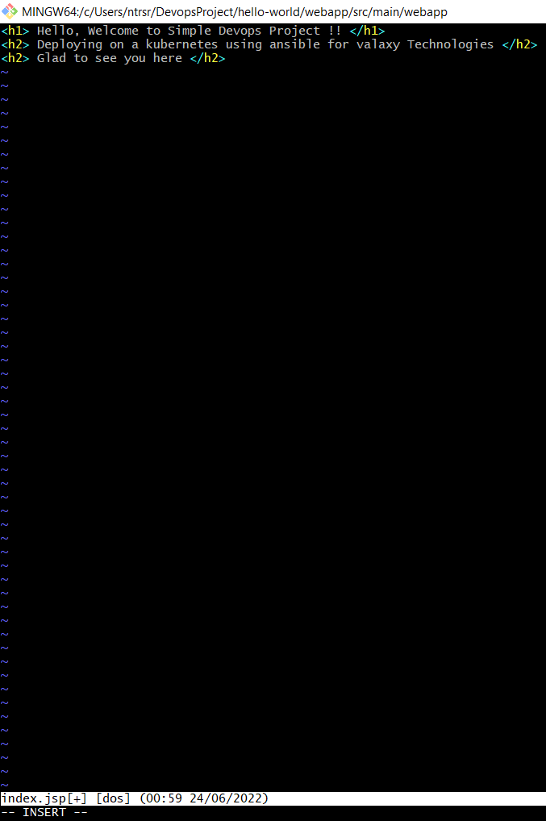this is the existing code I had changed as shown below

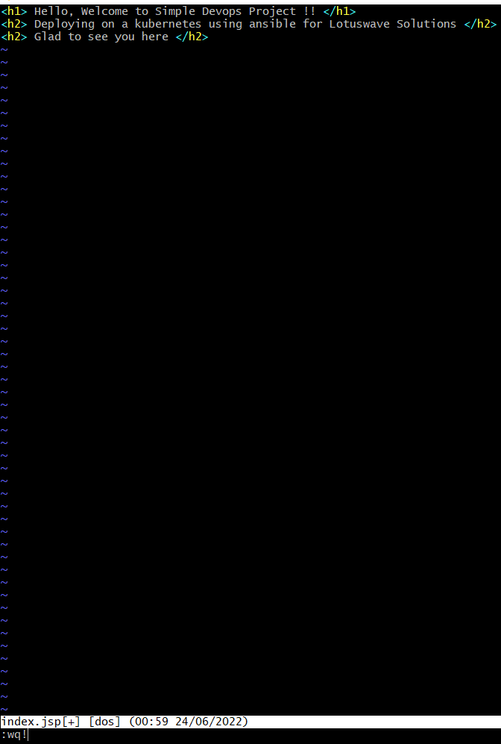save it

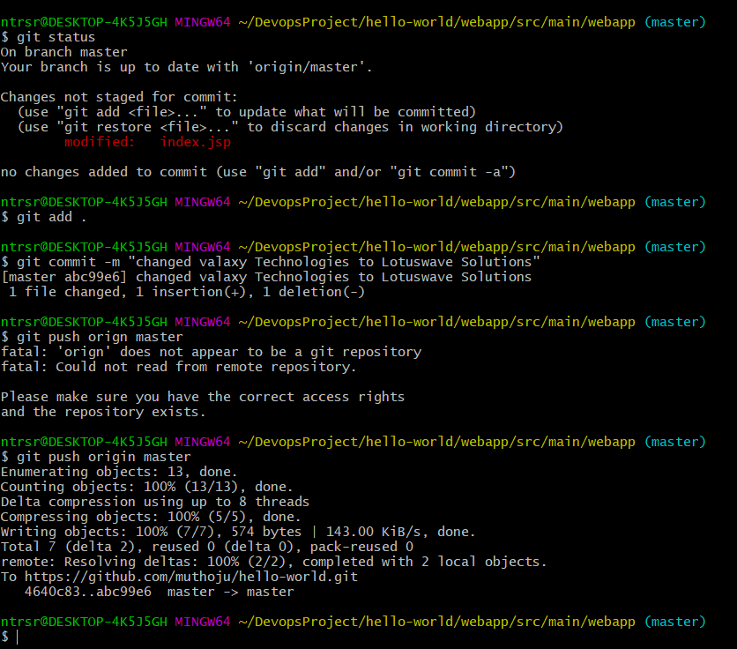

Follow above commands to push the code from local to github

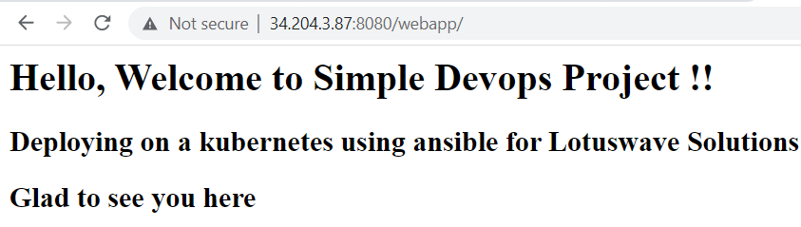

You can see the following output in the tomcat server;

Integrating Docker in CI/CD Pipeline

Pre-Requisites

* Set up Linux EC2 Instance/Cent OS
* Install Docker

Login to AWS console

Step-1: Create a EC-2 instance for Docker-Host

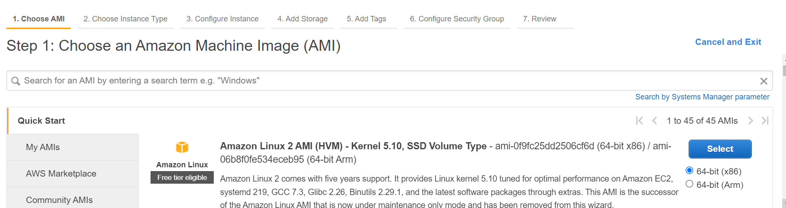

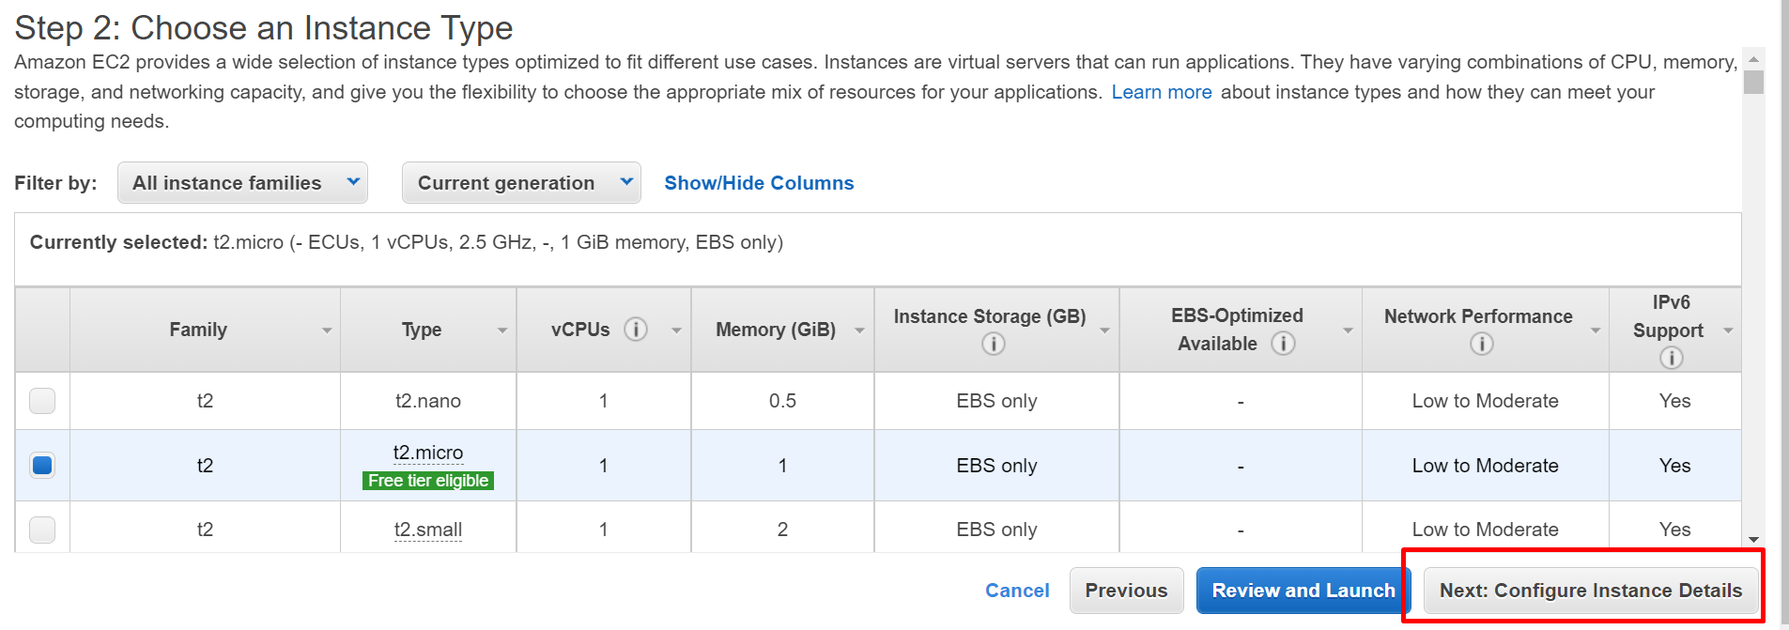

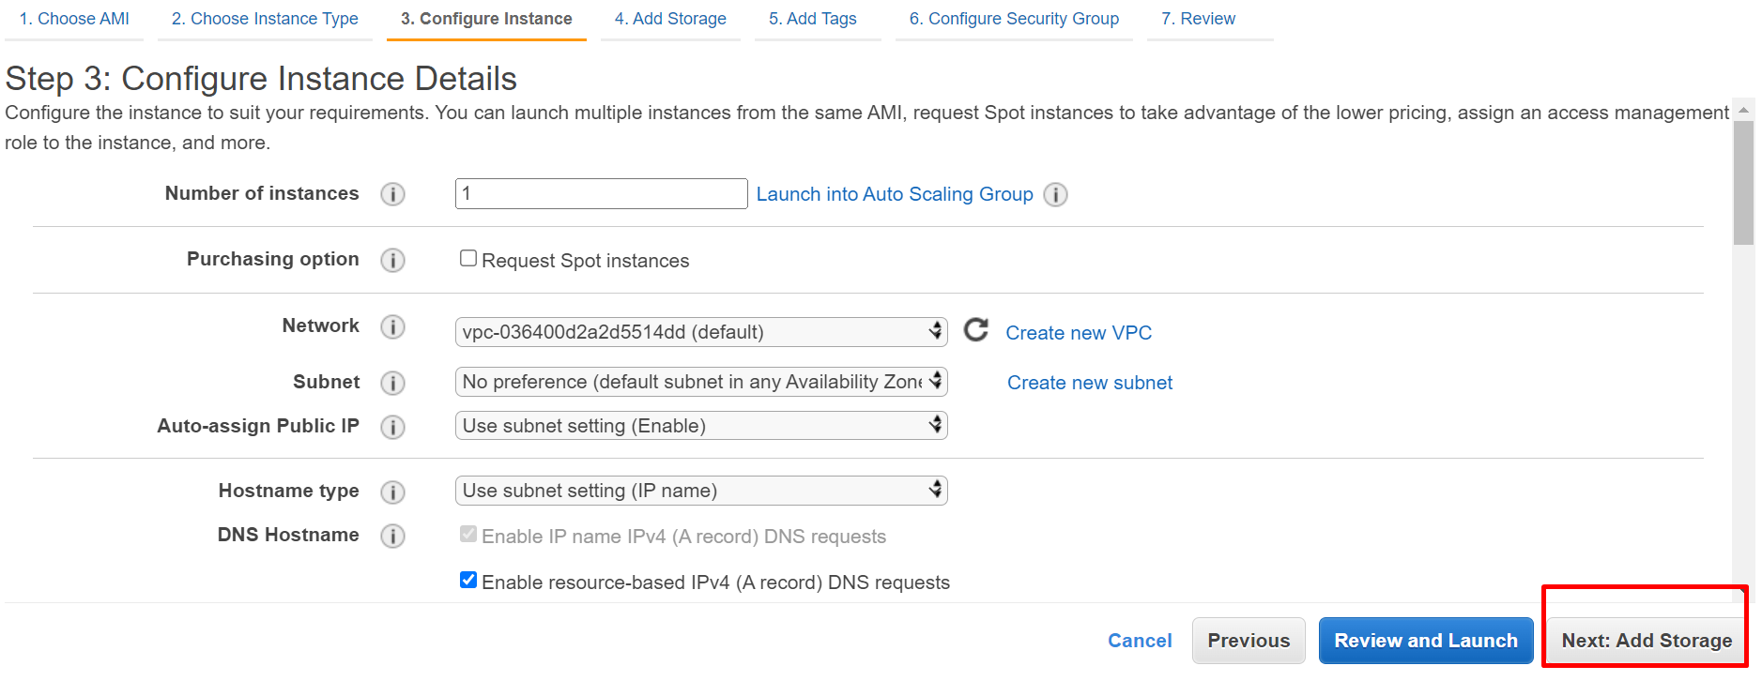

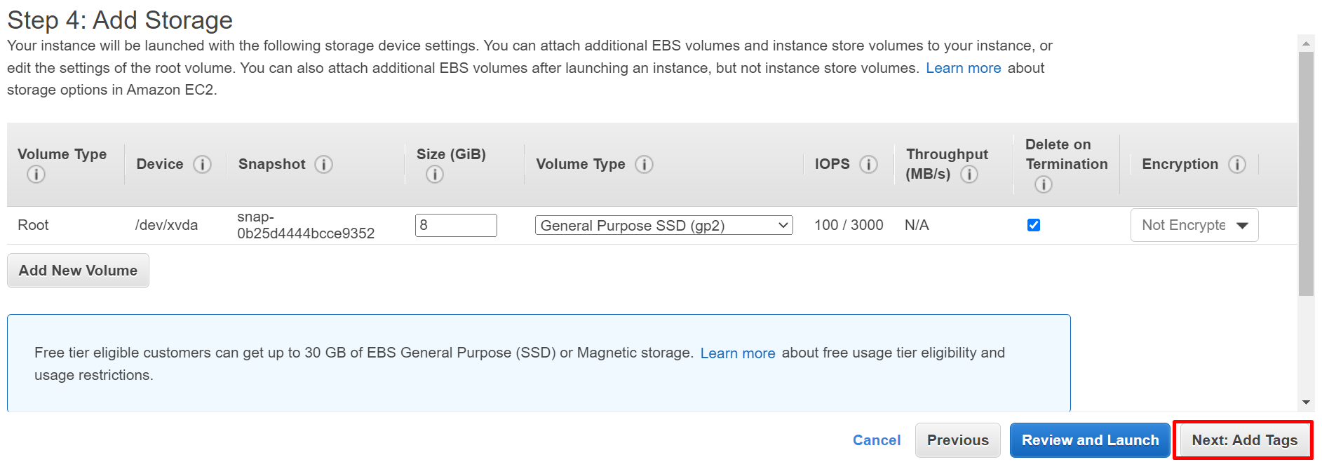

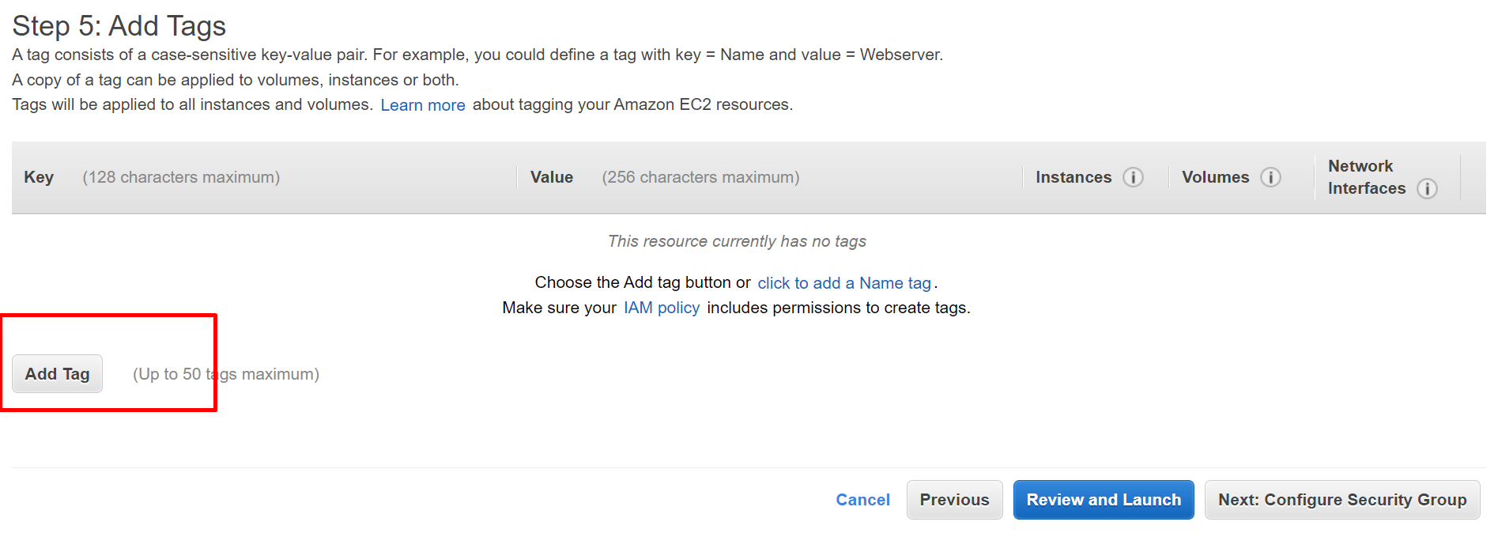

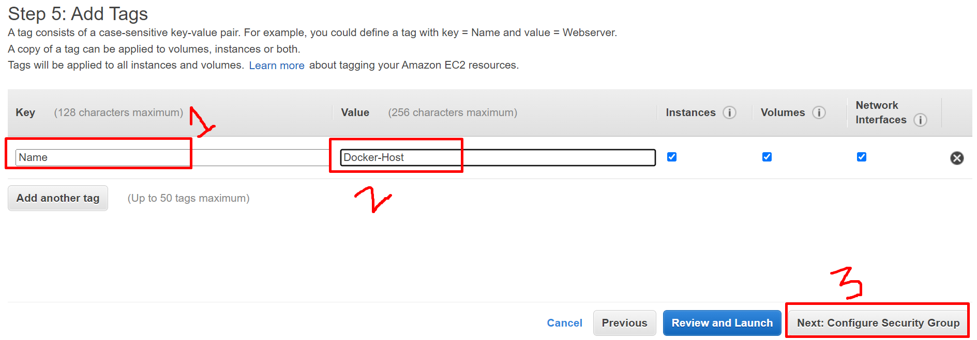

Step 6: You can create a new security group/Select an existing security group

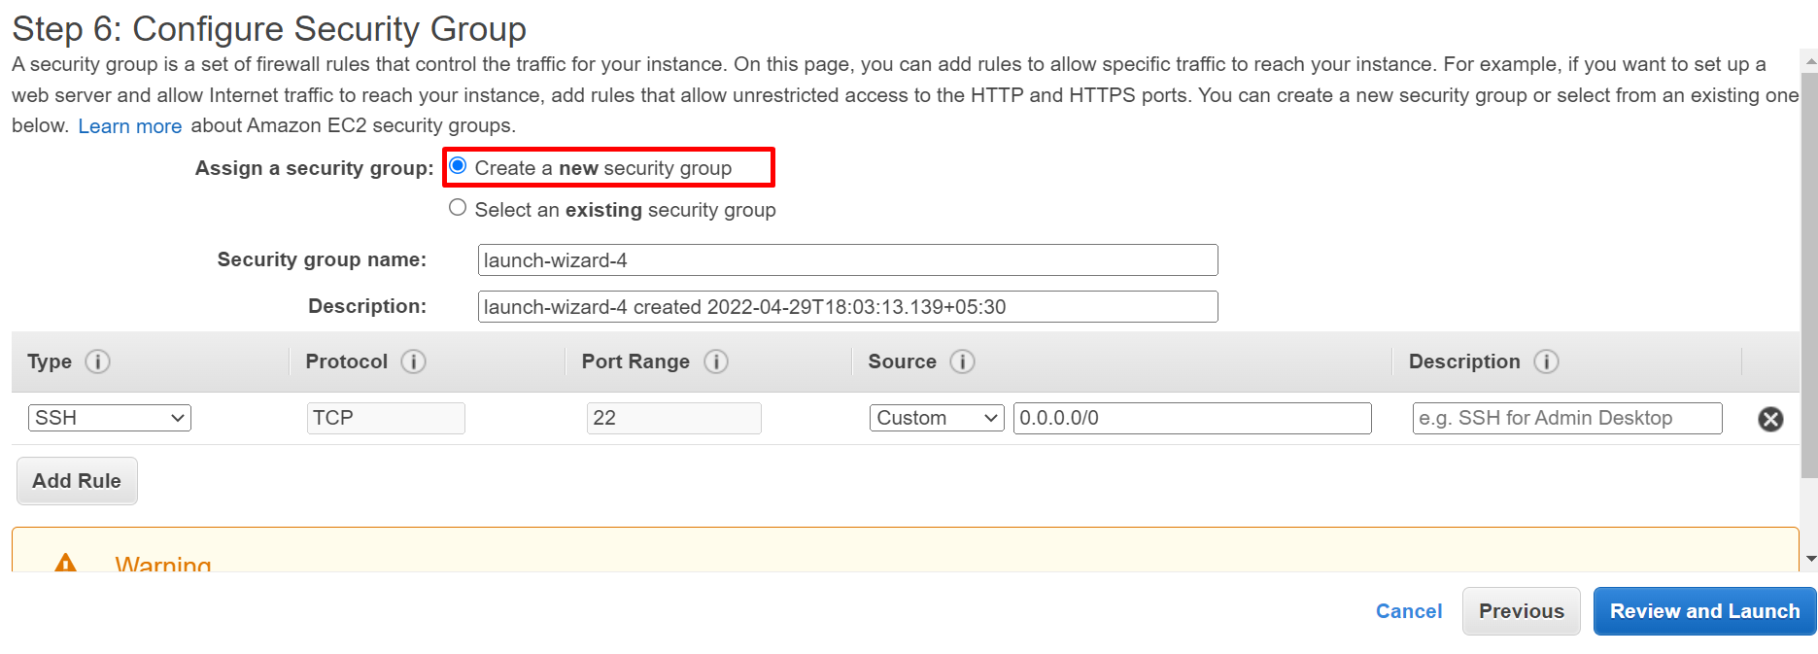

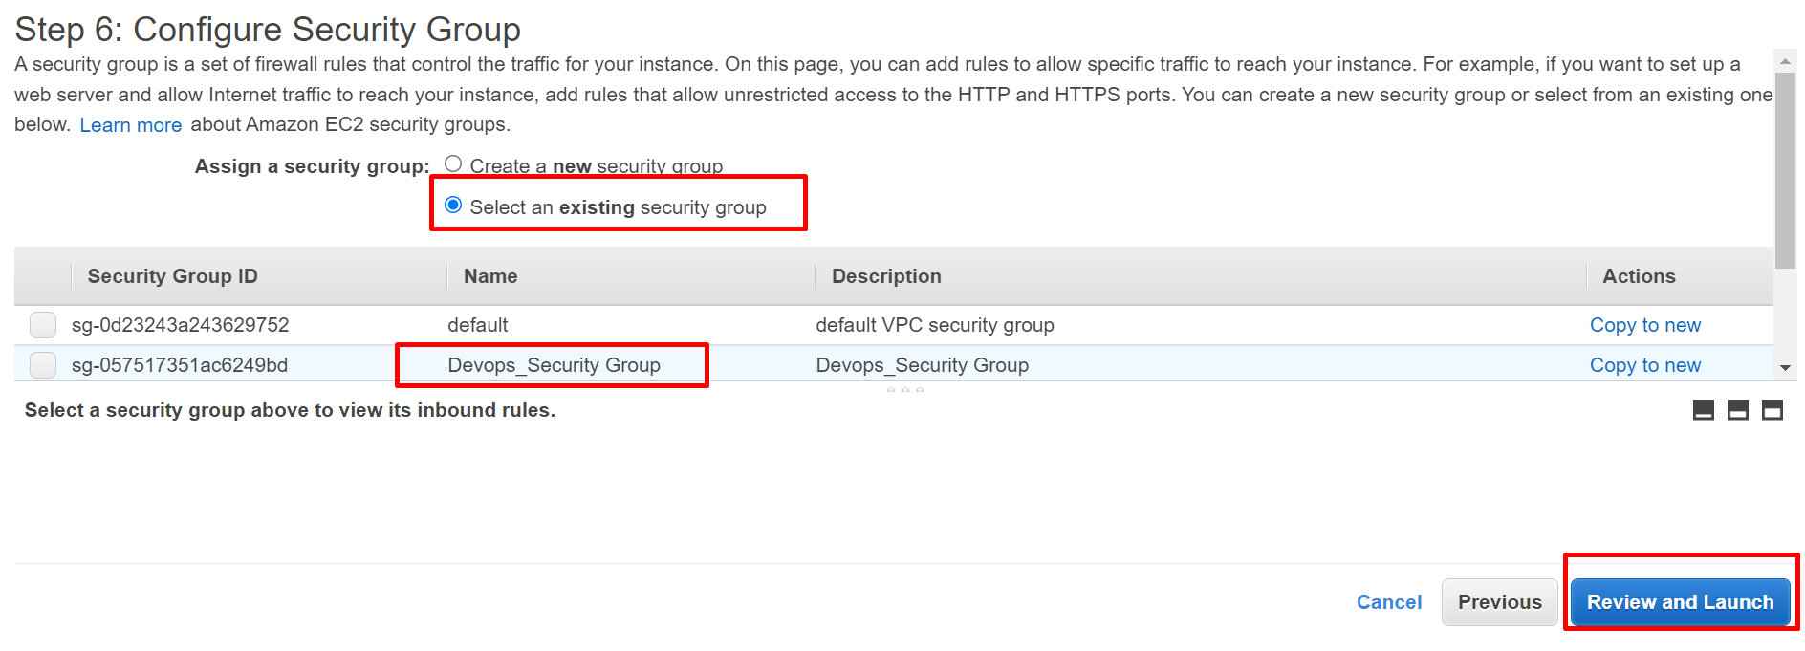

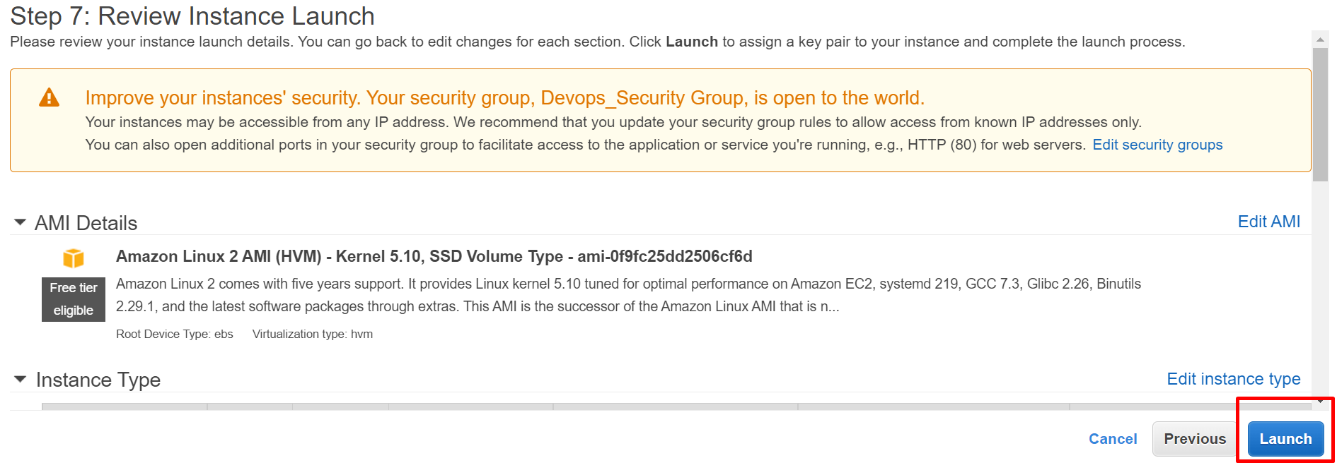

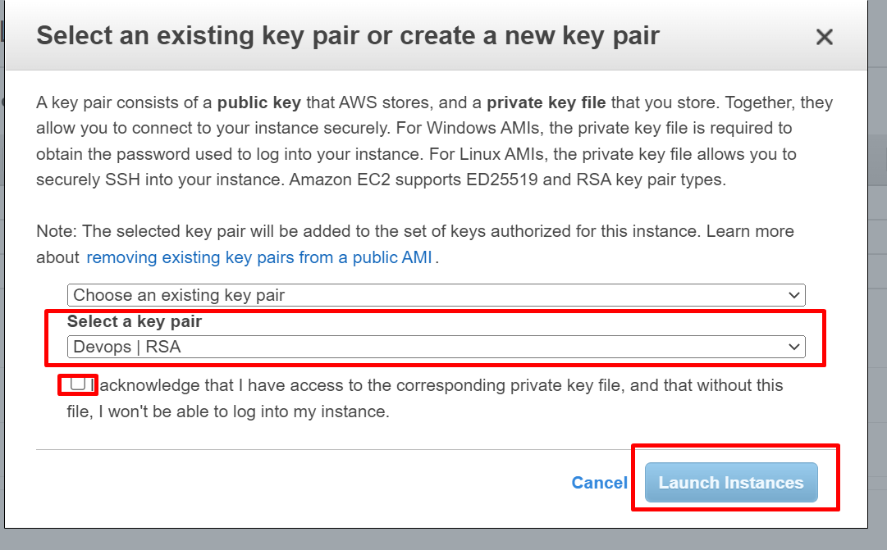

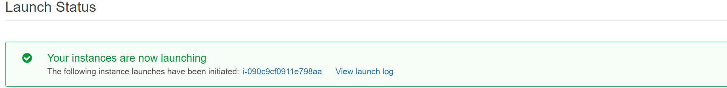

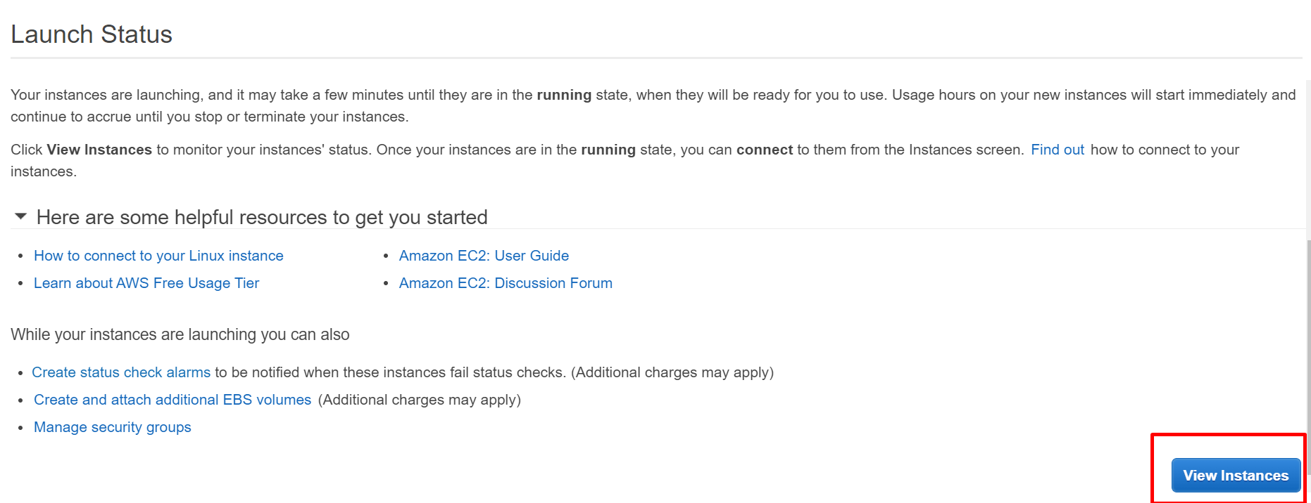

Copy the Public Ip

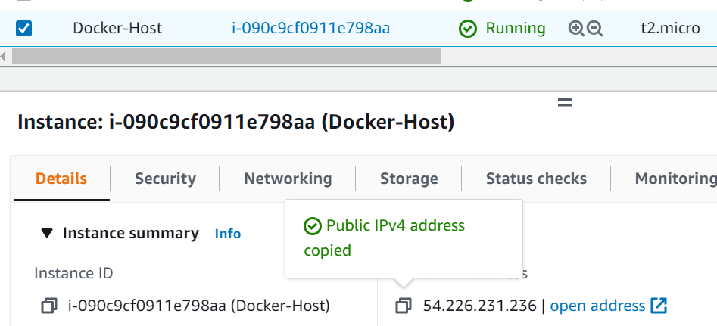

With the help of MobaXterm/Putty and provide public Ip, ssh key and login as ec2-user

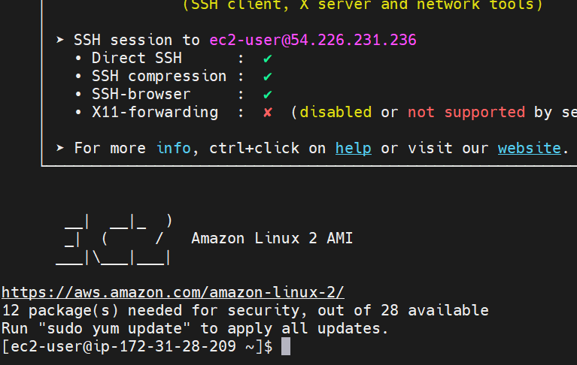

Navigate Root user

sudo su –

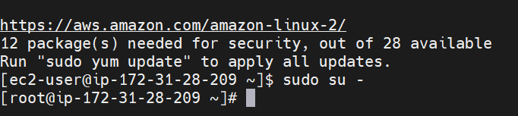

## Docker Installation Steps

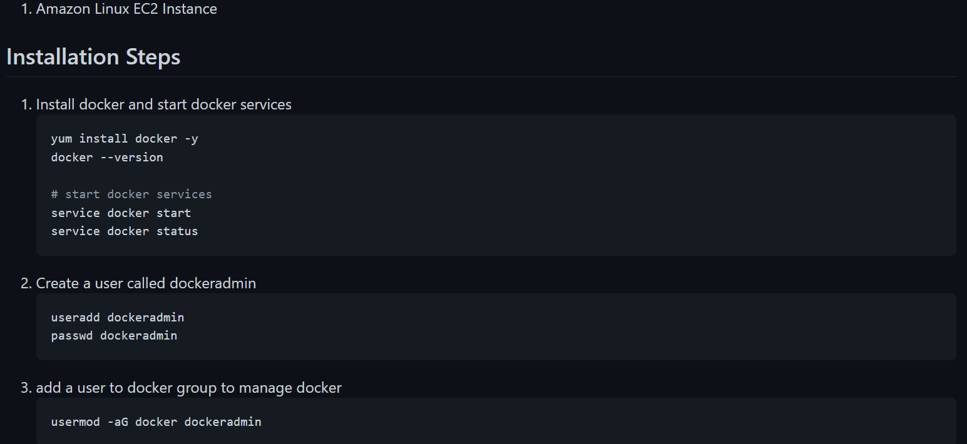

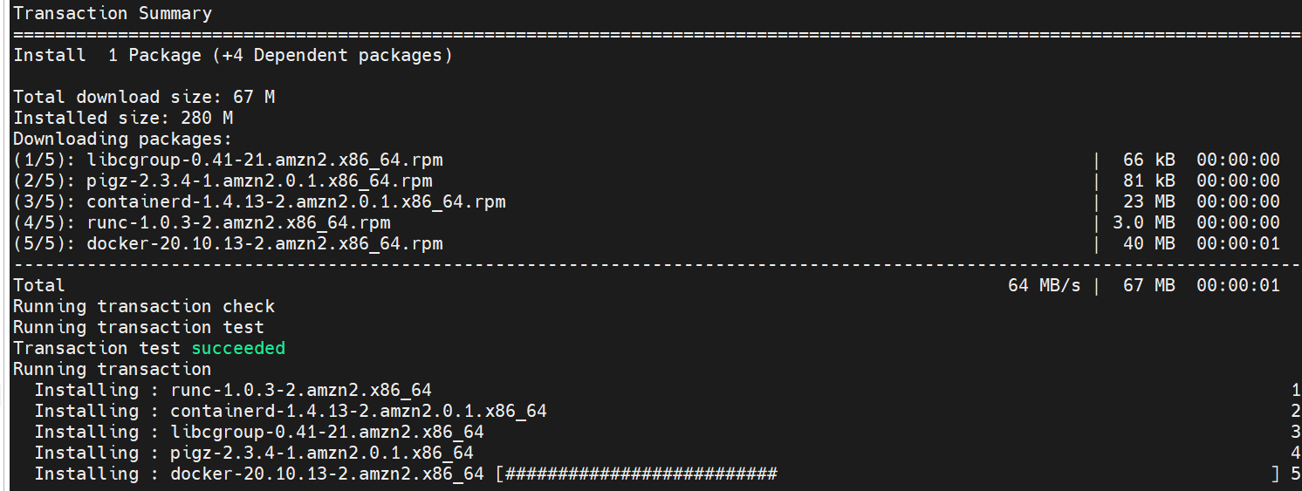

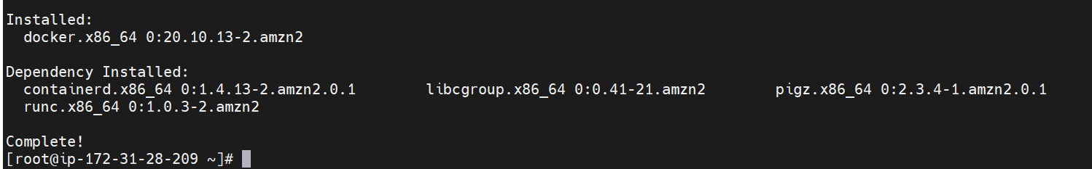

Check the version

docker --version

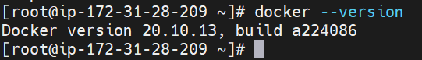

# start docker services

service docker start

service docker status

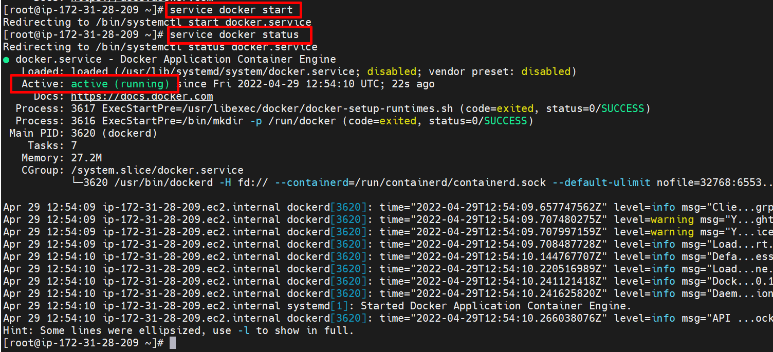

docker images

which tells how many images having in docker images

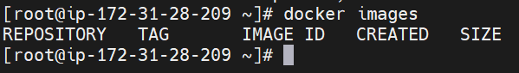

docker ps

which tells how many docker containers are running

docker ps -a

which tells how many total docker containers we are having.

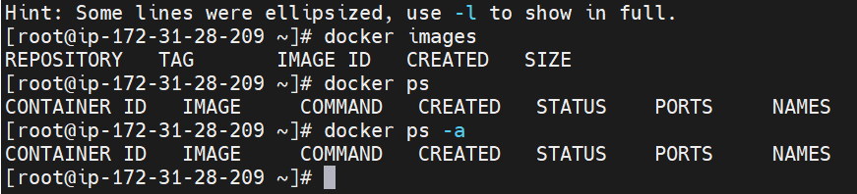

docker --help

Create a Docker Container

Requisites

Docker images

We can get the Docker images in two ways

1.Docker hub(Public repository)

docker pull

2.Docker file (private/customisation)

docker build

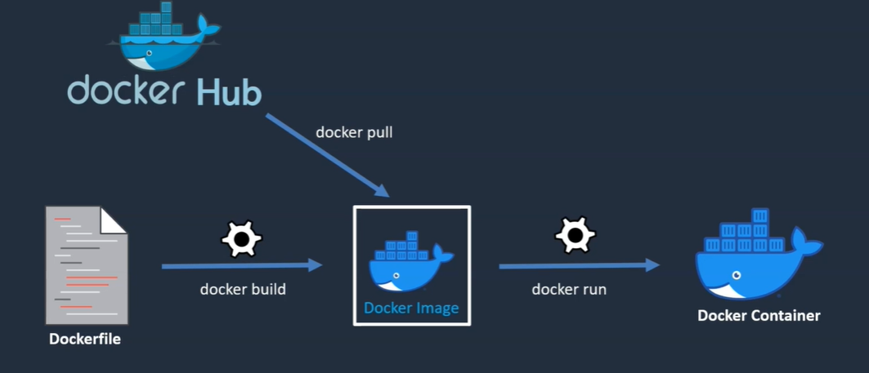

1.Navigate to docker hub repository <https://hub.docker.com/>

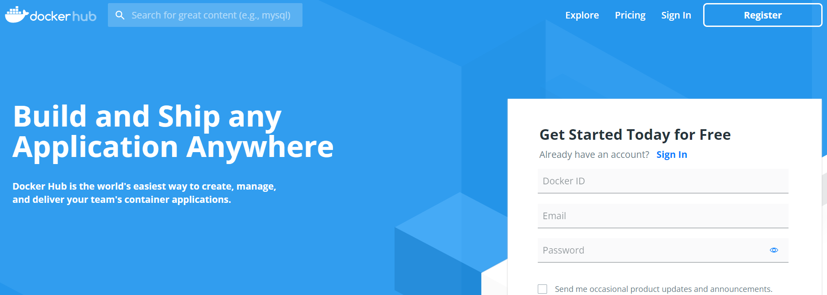

2.Search tomcat in search box

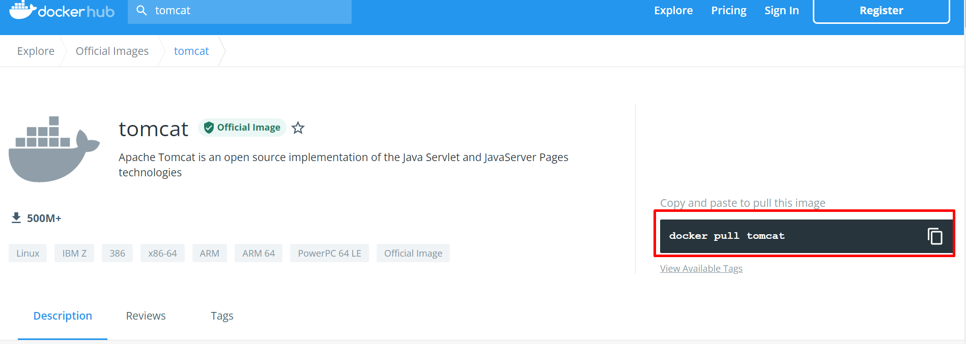

To change the host name vi /etc/hostname

Insert and dockerhost and save it.

>> docker pull tomcat

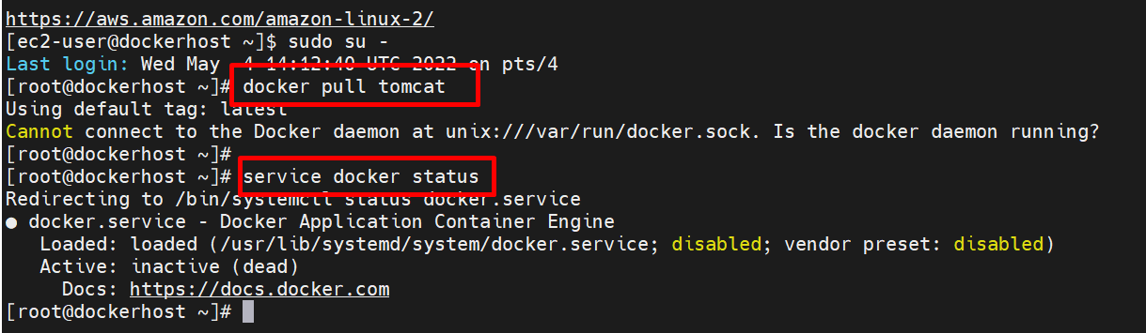

services docker start

docker pull tomcat:10.0(latest tag)

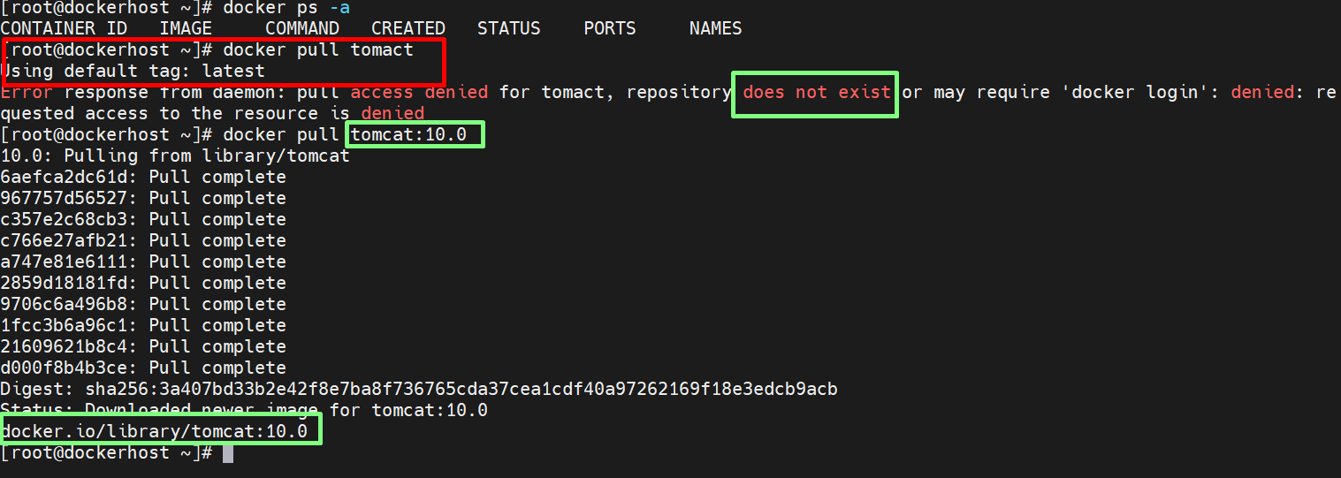

docker images

docker run -d --name tomcat-container -p 8080:8080 tomcat:10.0

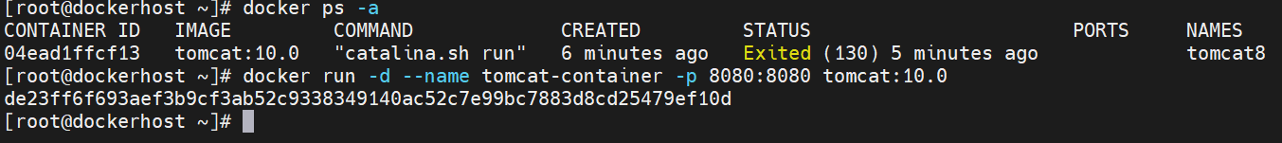

Open chrome and paste the public ip with :8080

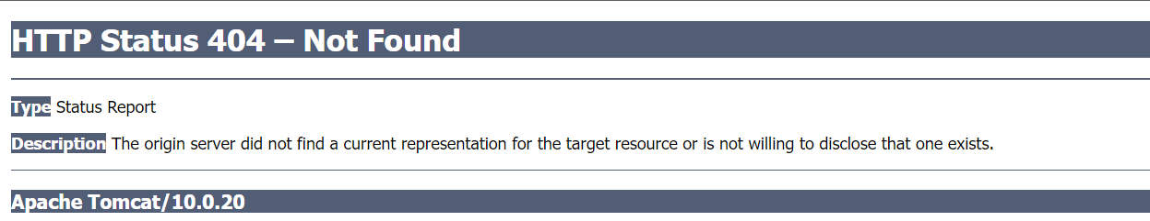

To solve the above one follows the steps

docker exec -it tomcat-container /bin/bash

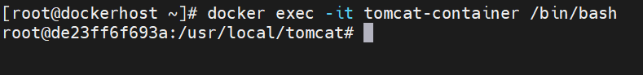

No data in the webapps directory so all the data stored in webapps.dist need to be copy the data from webapps.dist to webapps directory

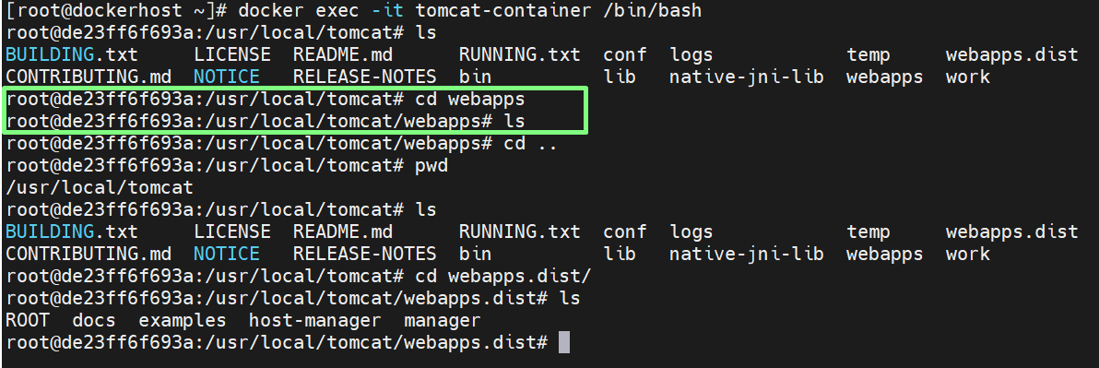

Copy >> cp -R * ../webapps

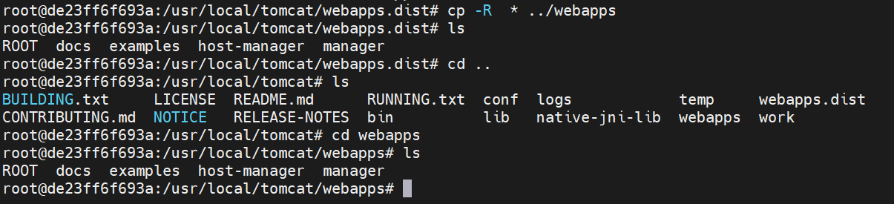

We can able to see the tomcat homepage after refreshing

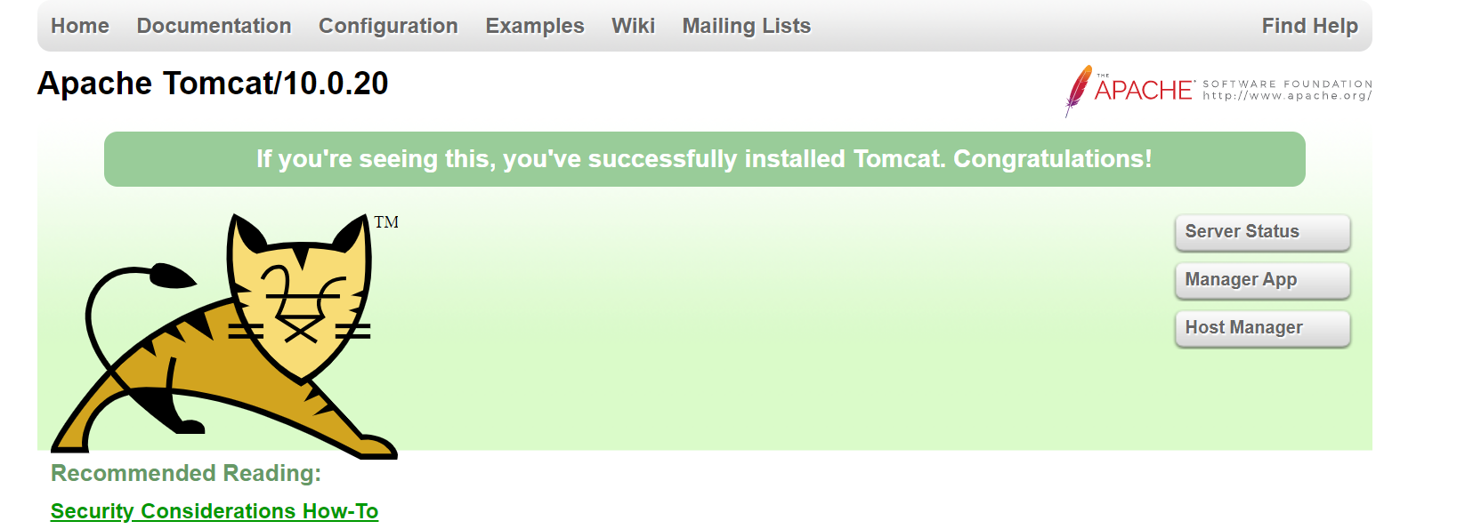

exit

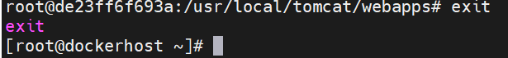

docker stop <name>



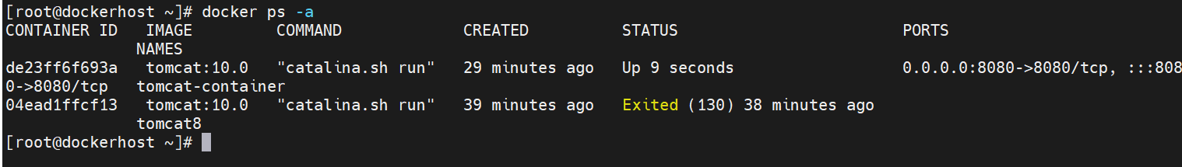

If you want create more images

docker run -d --name tomcat-container -p 8080:8080 tomcat:10.0

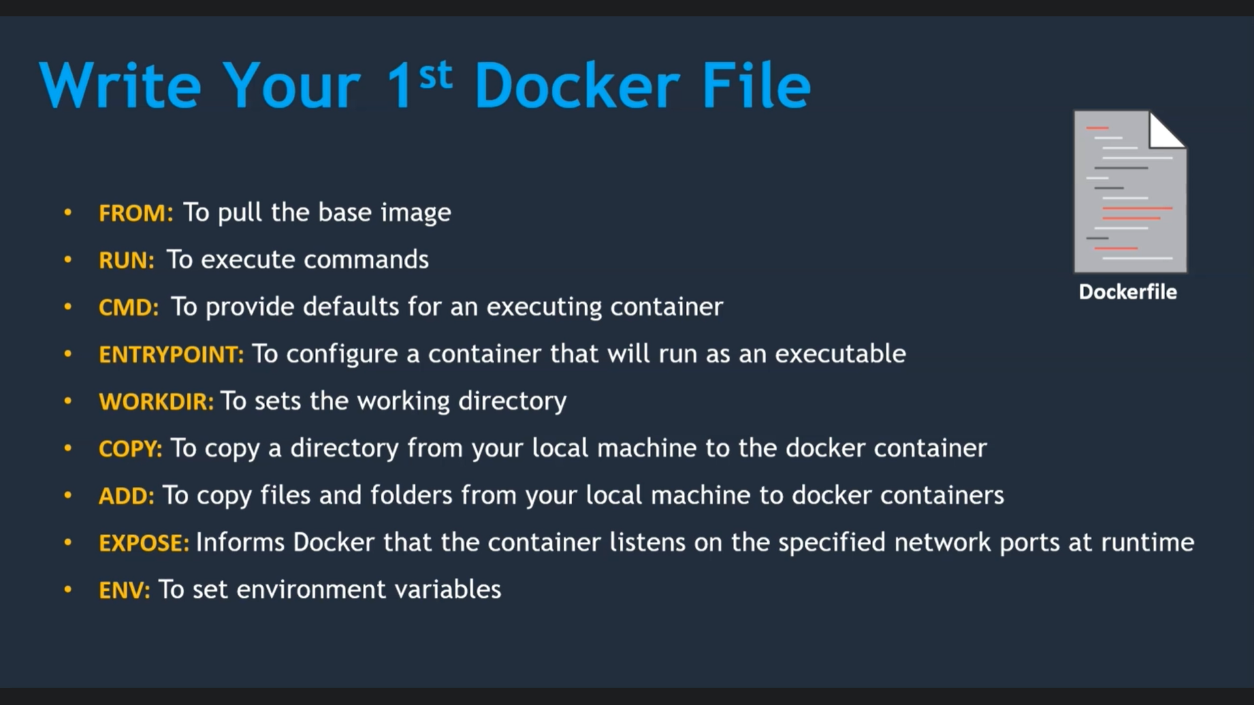

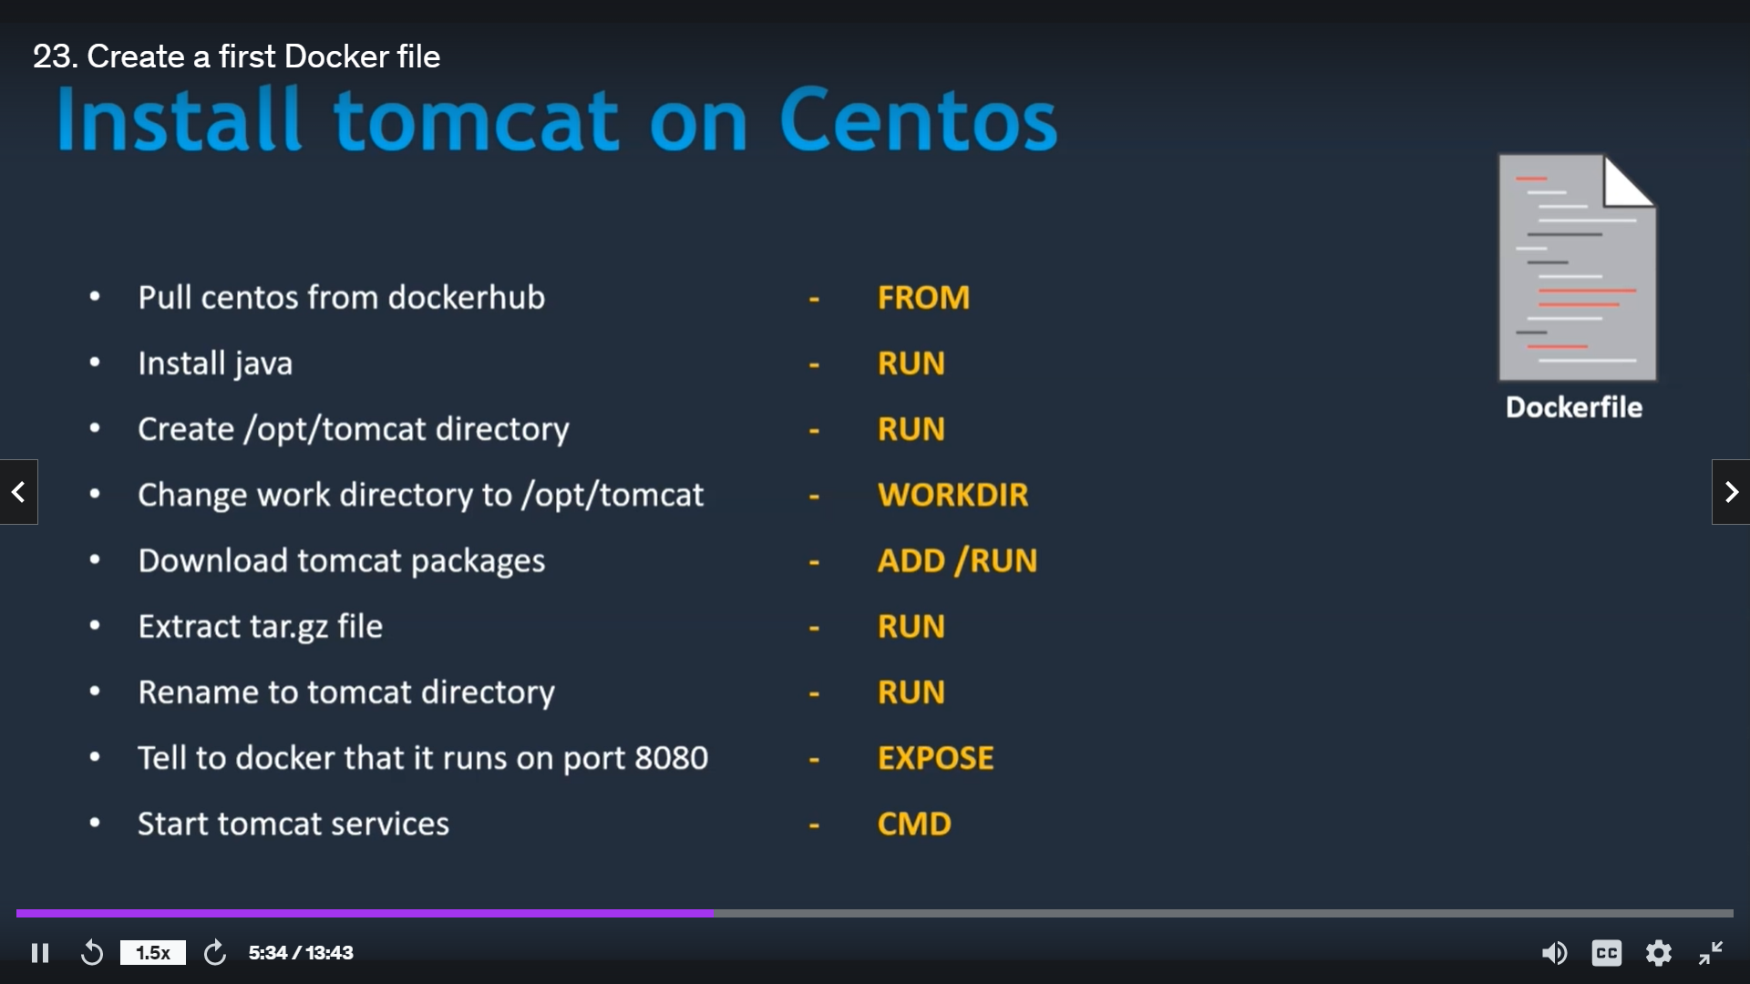

Integrate Docker with Jenkins

* Create a dockeradmin user
* Install “publish over ssh” plugin
* Add docker host to Jenkins “configure systems”

cat /etc/passwd

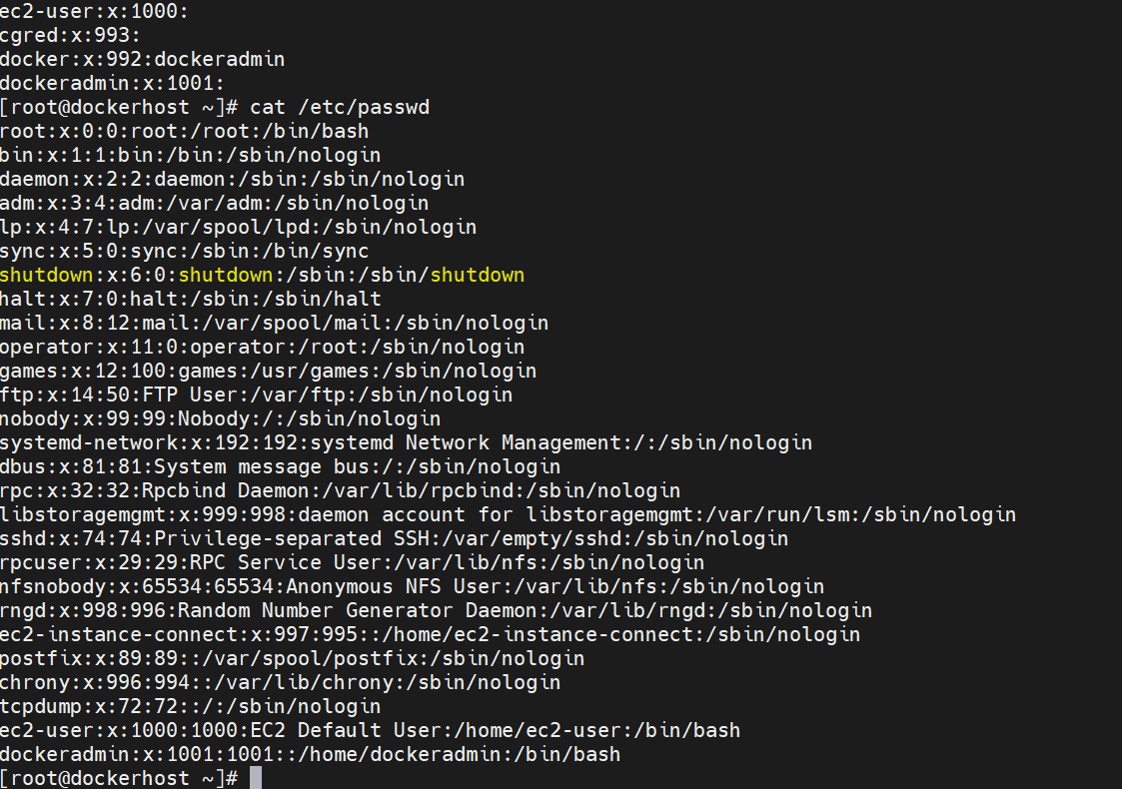

cat /etc/group

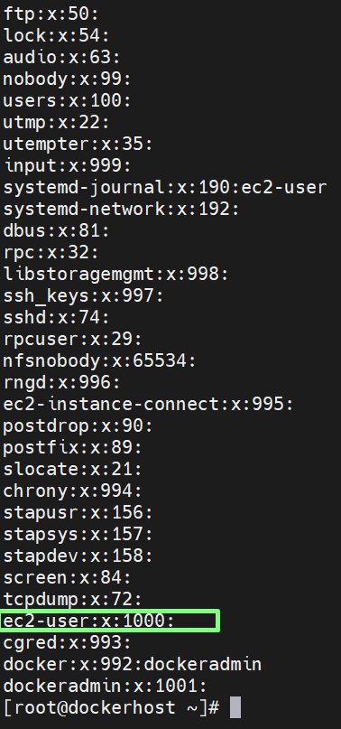

Now create a docker user, password and add it to group

* Create a user called dockeradmin

useradd dockeradmin

passwd dockeradmin

then give password and confirm it by retyping it again if password matches we can see that it is updated successfully.

* Now modify the user to docker group to manage docker

usermod -aG docker dockeradmin

In docker server enable password less authentication

Go to the sshd_config file and enable password authentication to yes as shown below

vi /etc/ssh/sshd_config

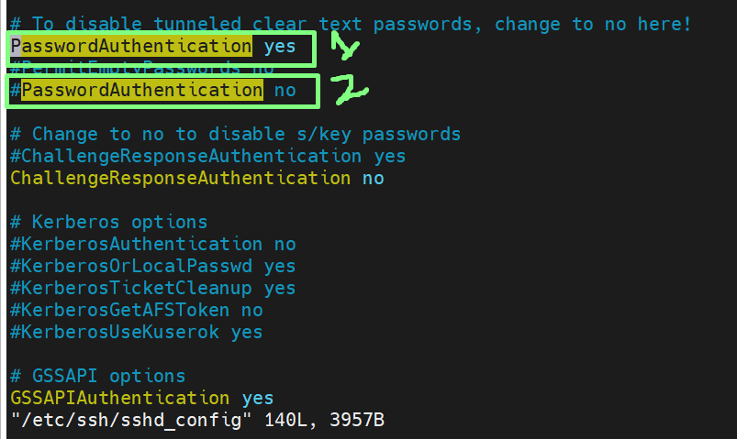

* Restart sshd service after saving the changes by command

service sshd reload

Integrate docker host to the Jenkins

Login to jenkins

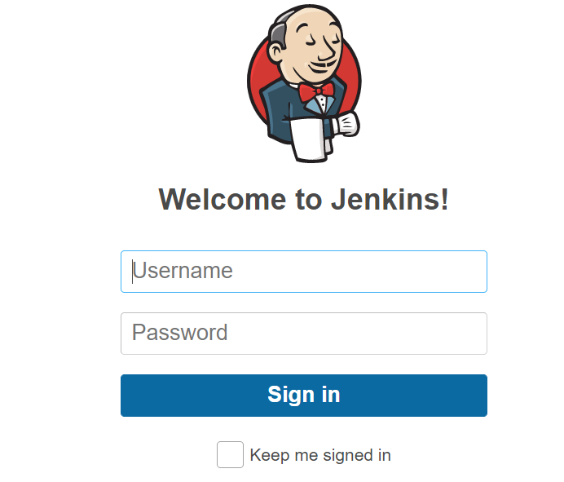

* go to manage plugins section in jenkins and Install publish over ssh

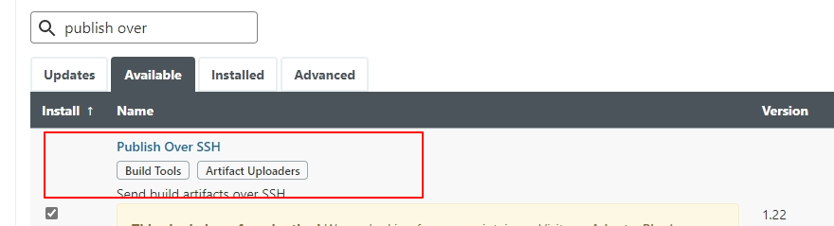

Now in jenkins server navigate to configure system

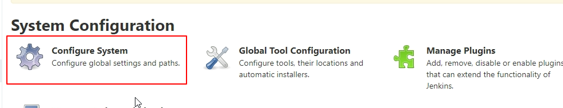

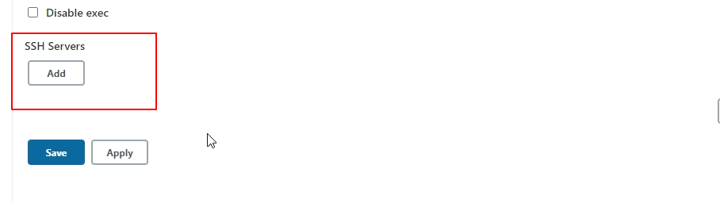

Now give name as docker host or anything else you wish

Hostname as private-ip

Username as dockeradmin

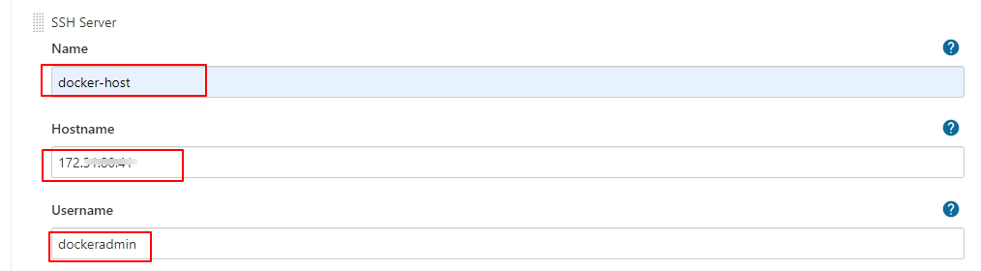

And choose advance option right below in that section and add password the same password and username given in docker group

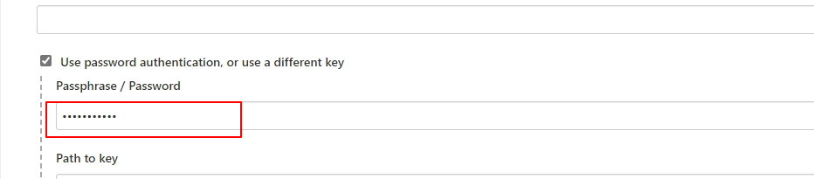

Instead of password we can use path to key also

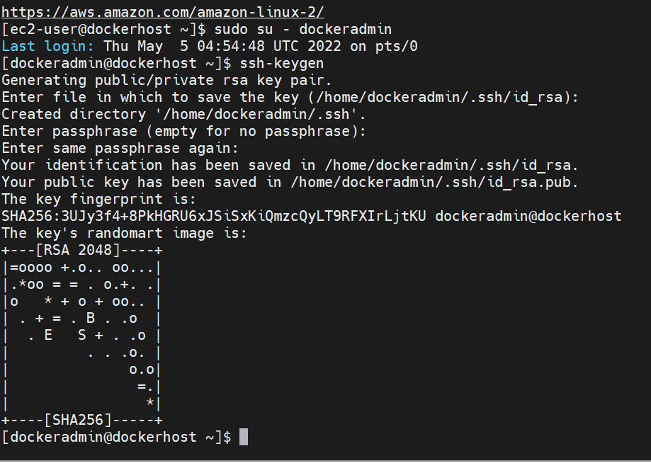

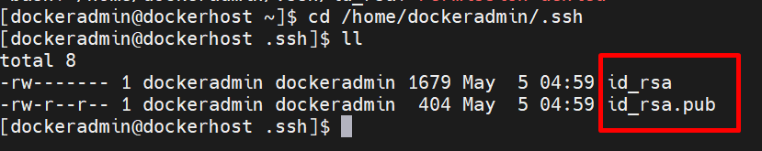

After providing credentials test the connection, if provided credentials are configured we get success

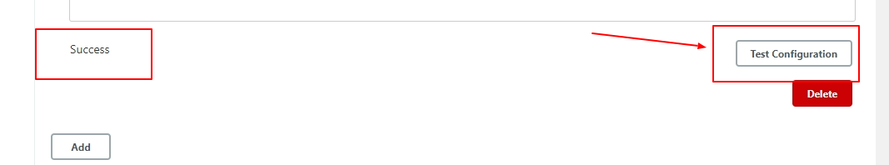

Jenkins Job to Copy Artifracts on to Docker Host

* Create a new job on Jenkins
* Select as maven project

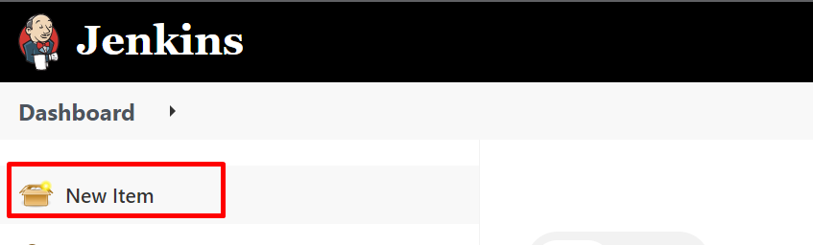

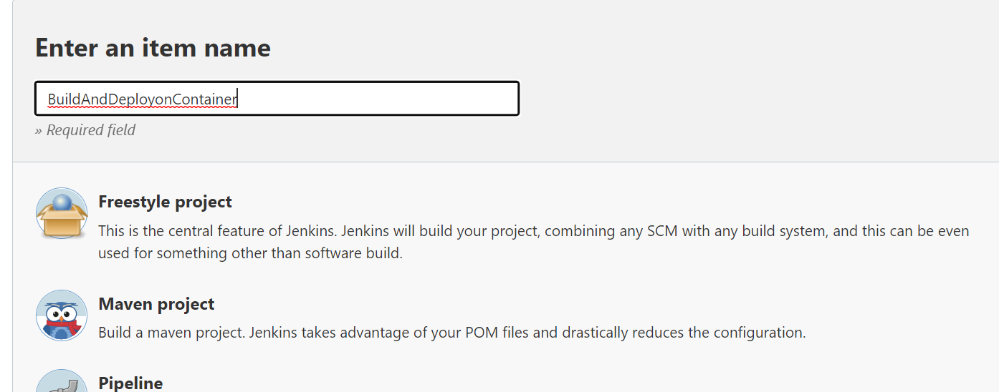

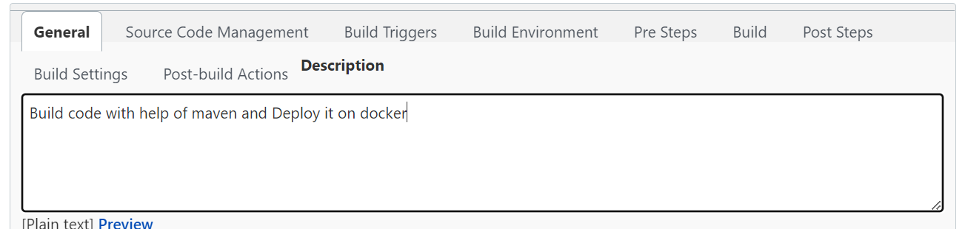

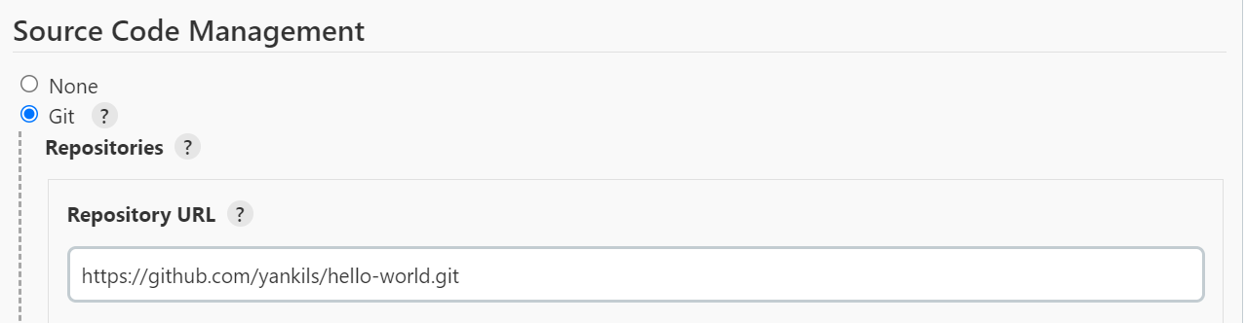

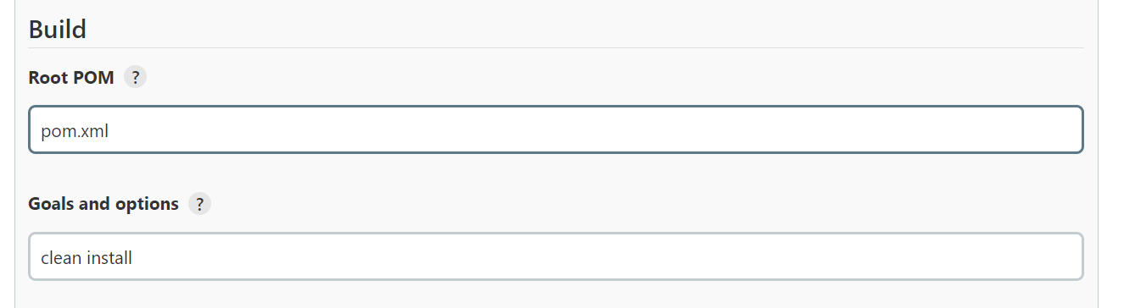

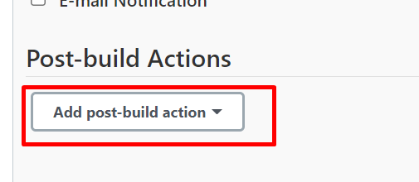

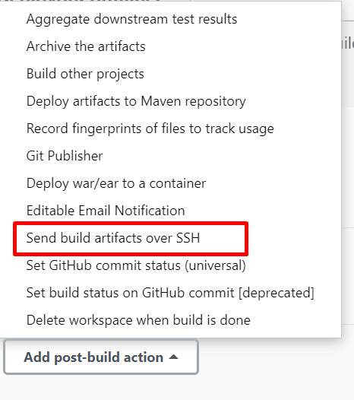

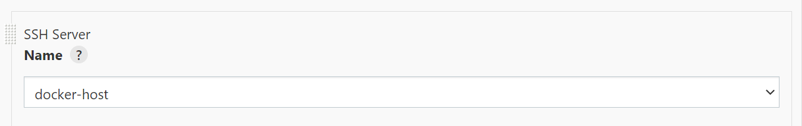

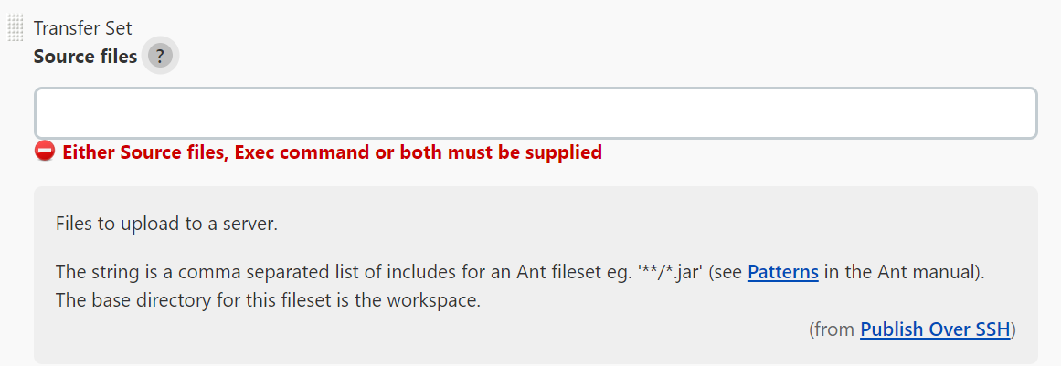

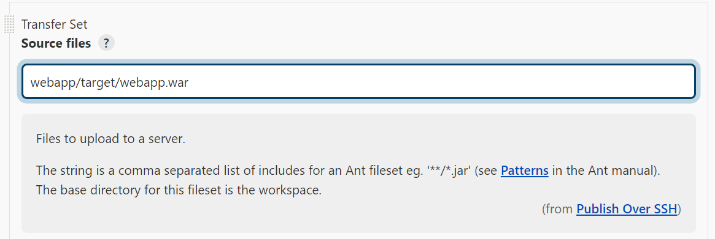

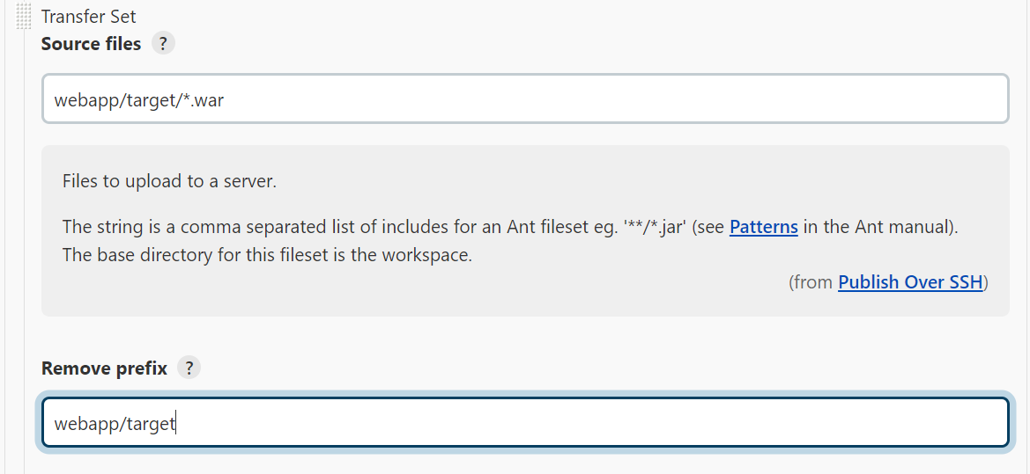

Optional for remote directory

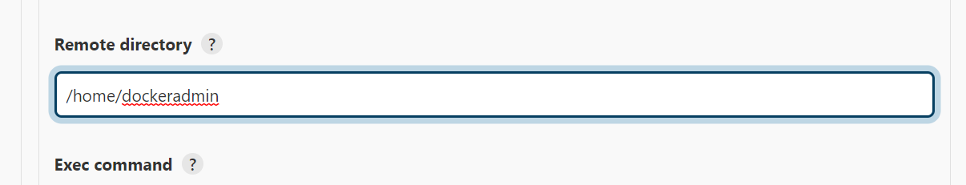

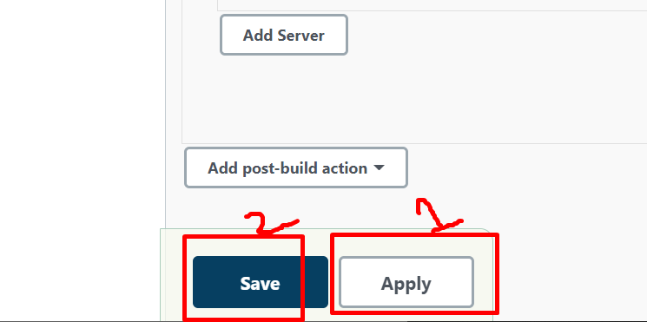

Goto to docker admin >> no files are existing

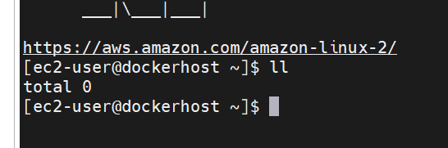

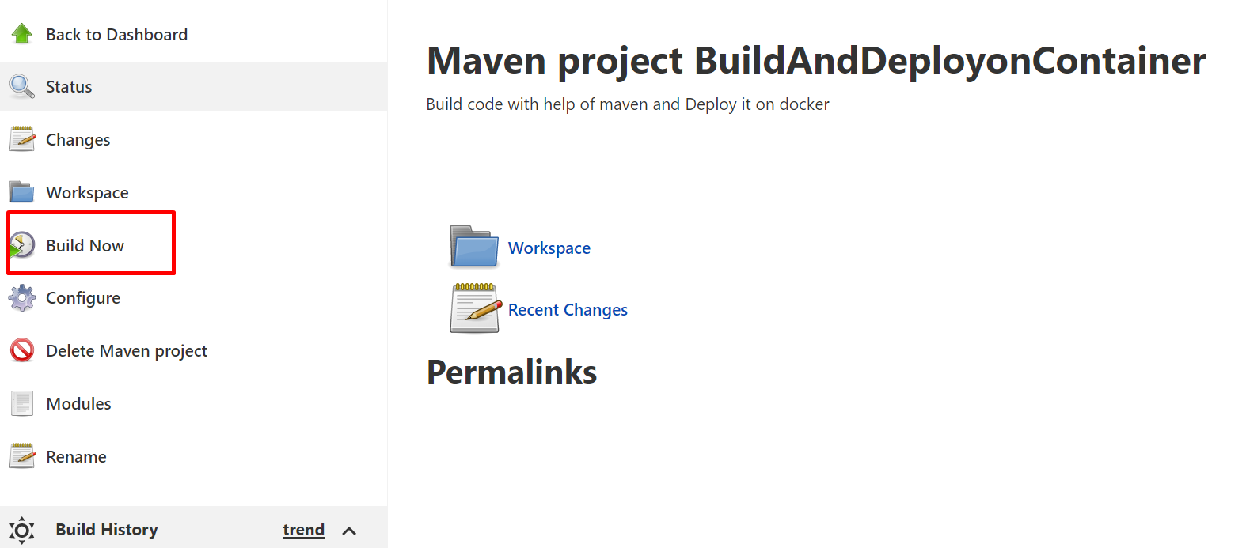

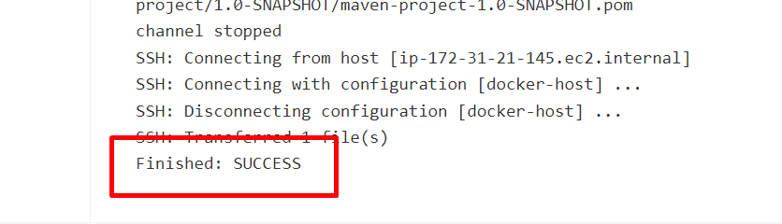

**INTEGRATE ANSIBLE WITH JENKINS**

[Ansible](https://www.ansible.com/), a software platform famous for its easy-to-use means for automation and development in the software powered organization

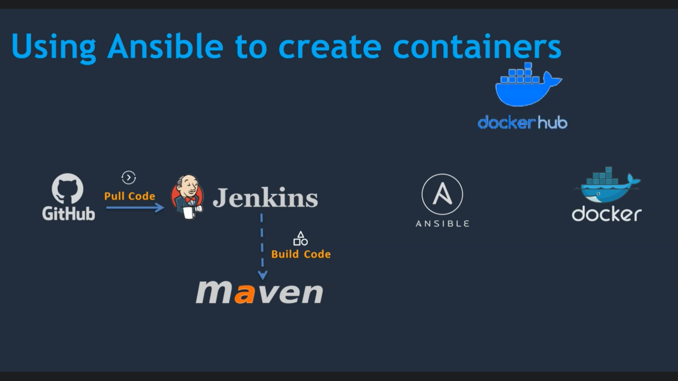

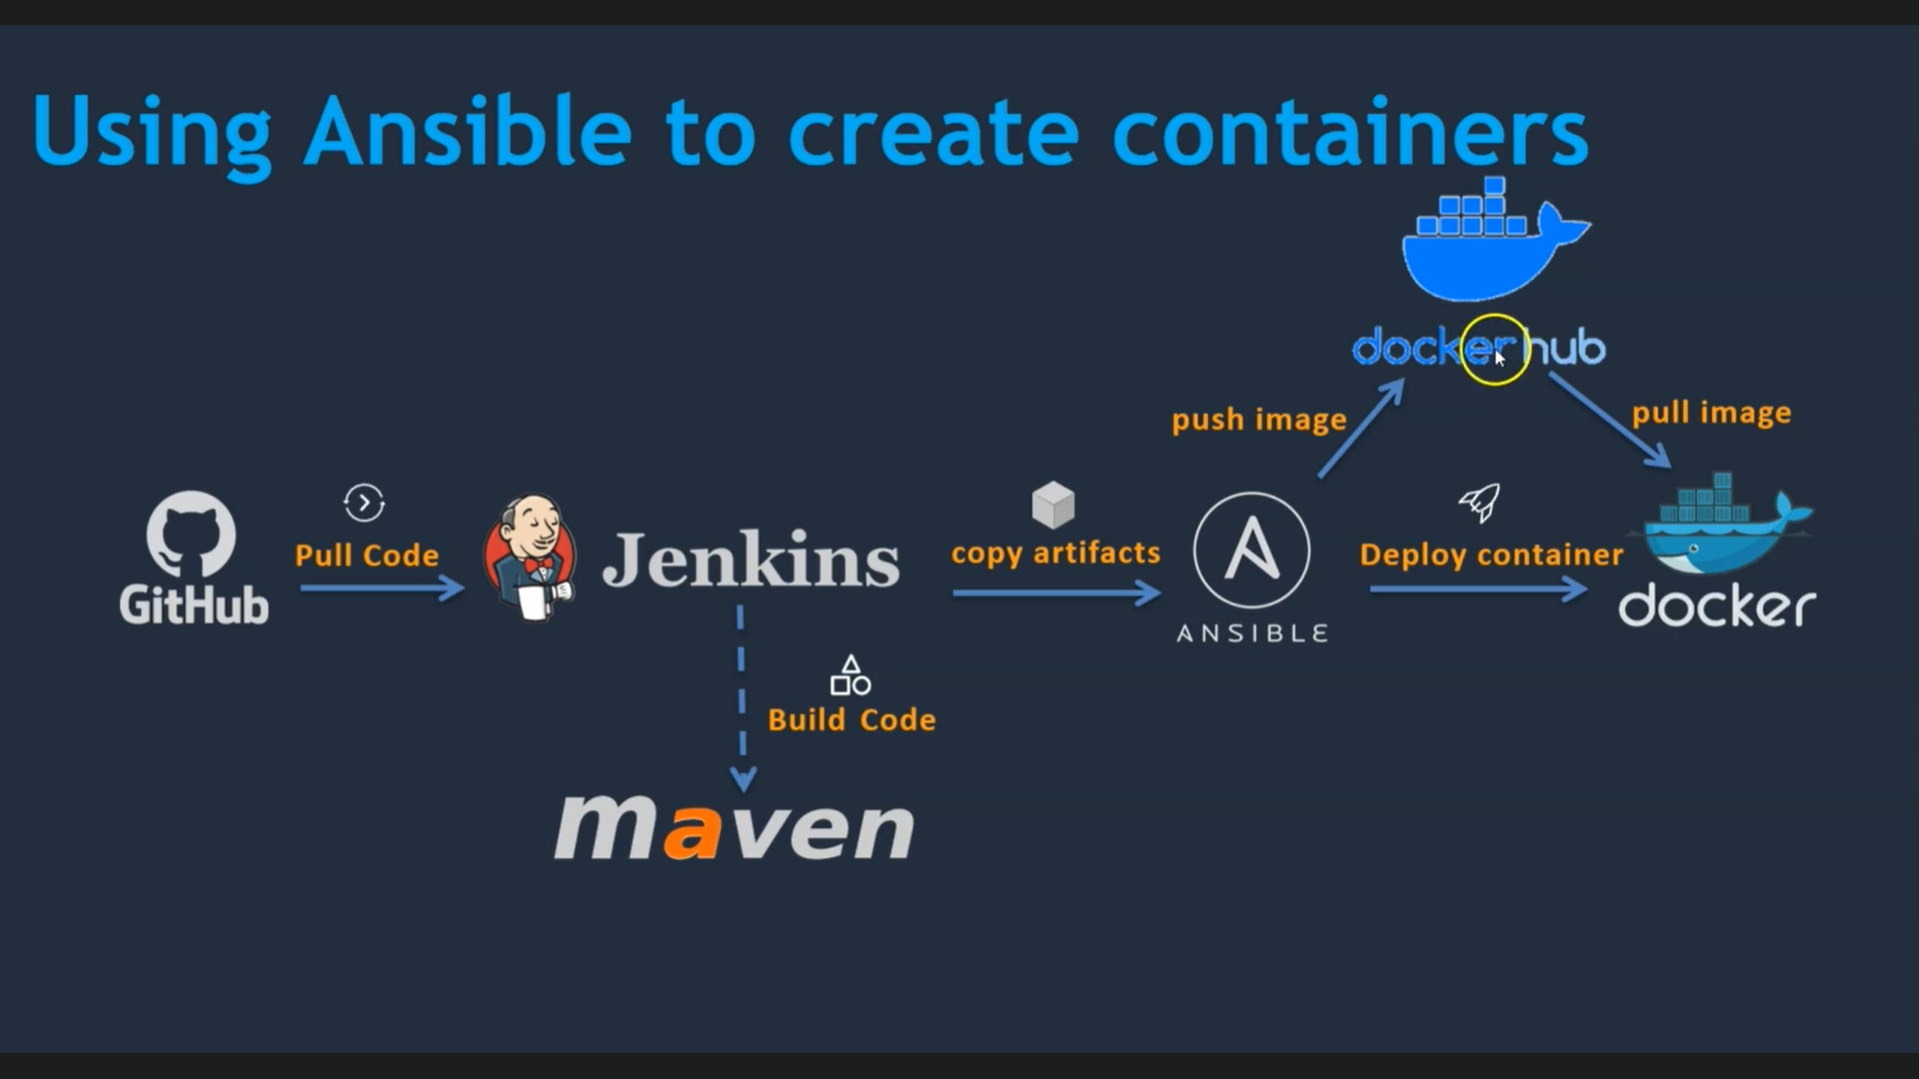

**Prepare Ansible server**

**Setup Ec2 instance**

**Setup hostname**

**Create ansadmin user**

**Add user to sudores file**

**Generate ssh keys**

**Enable password based login**

**Install ansible**



With the help of Mobaxterm ide you can launch the ec2 console

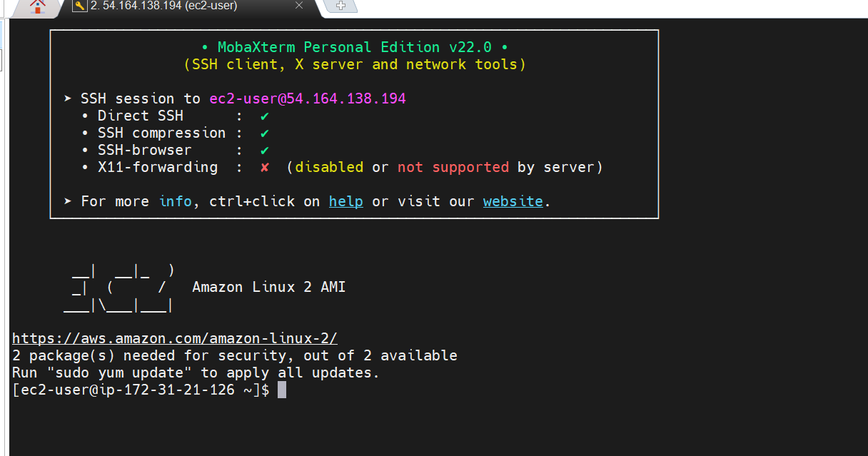

Navigate to root user

sudo su –

Change the host name

vi /etc/hostname

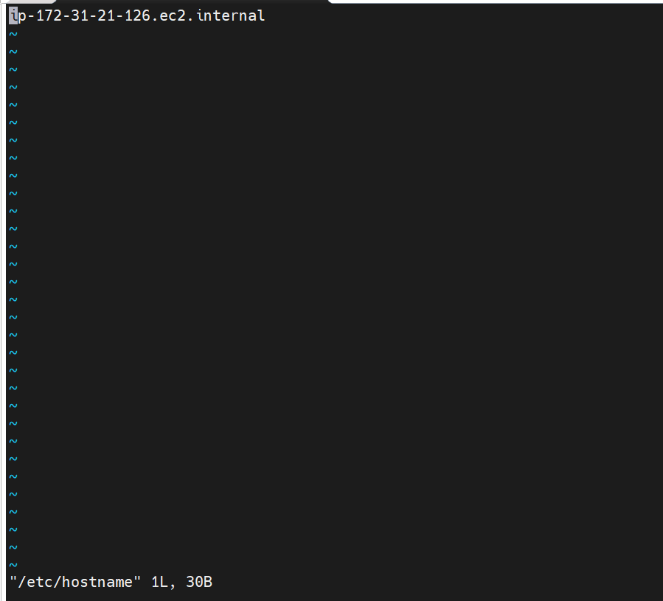

Enter i

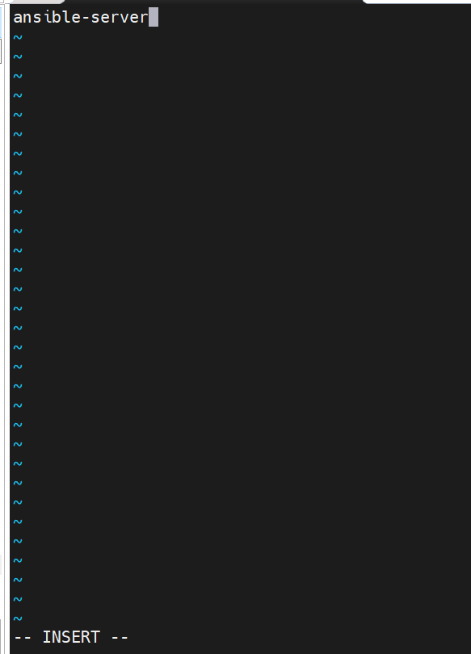

Escape >> :wq >> enter

Reboot

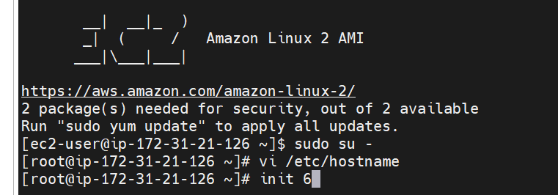

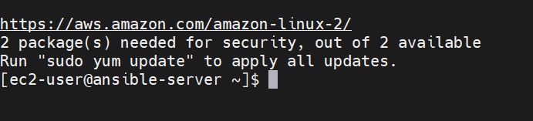

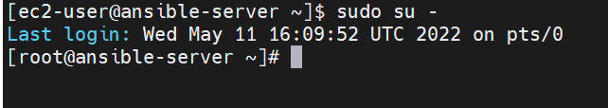

Let’s create the user

useradd ansadmin

passwd ansadmin

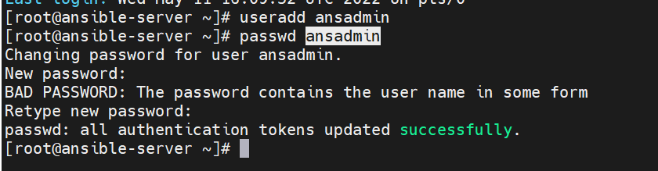

**Add user to sudores file**

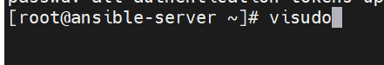

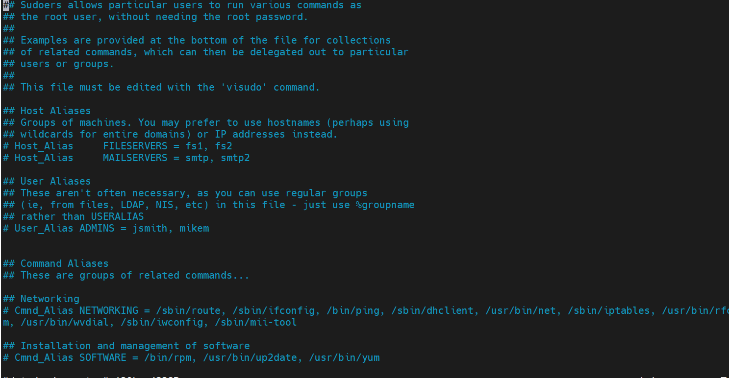

Shift +g to go to end of the file

And the following

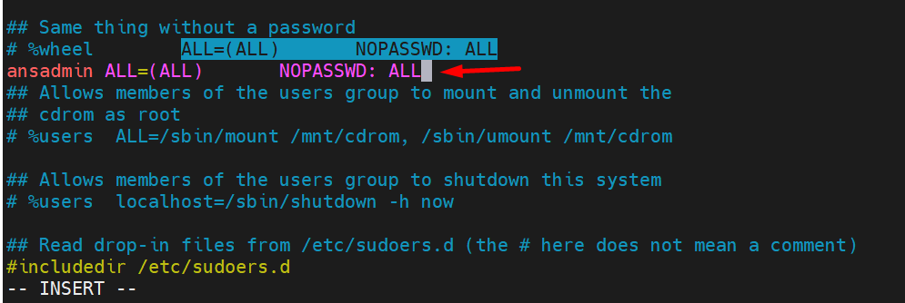

And save the file

Esacpe >> :wq

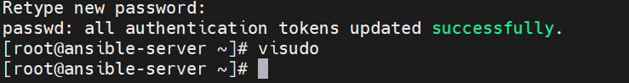

vi /etc/ssh/sshd_config

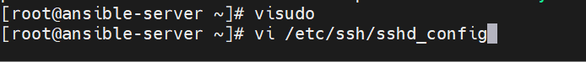

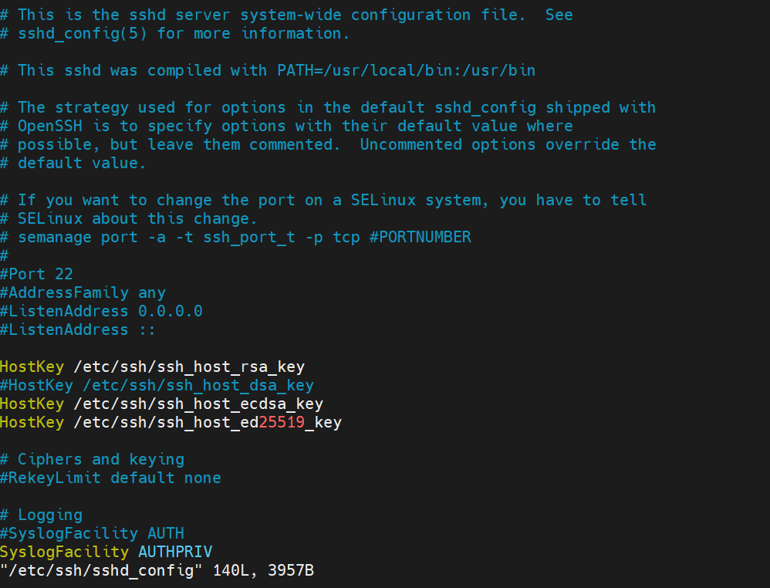

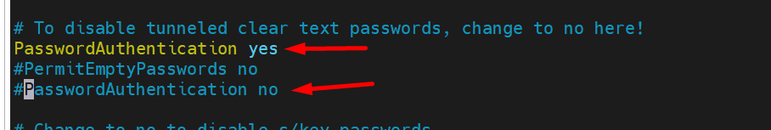

And save it

Escape >> :wq

service sshd reload

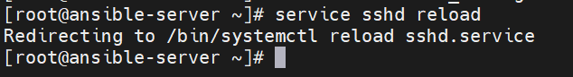

Create a new ssh keys with public ip and logging as ansadmin

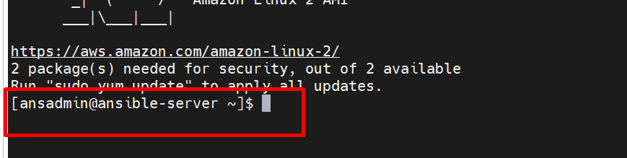

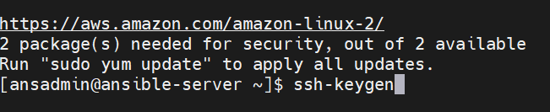

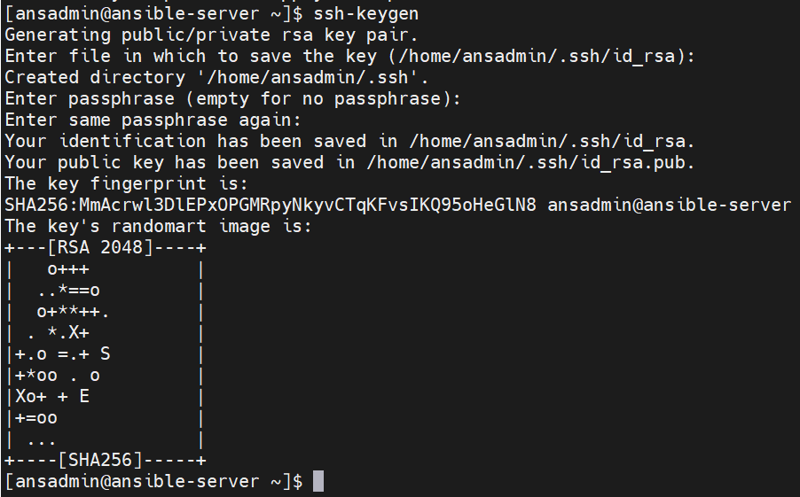

And it’s time for install ansible

Navigate to root user

sudo su -

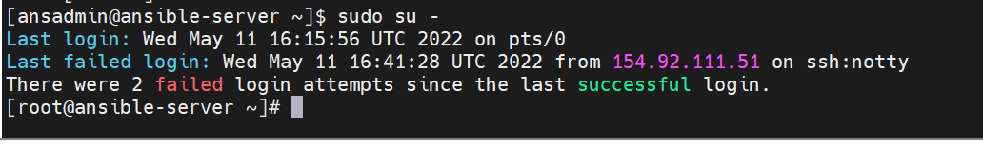

yum install ansible

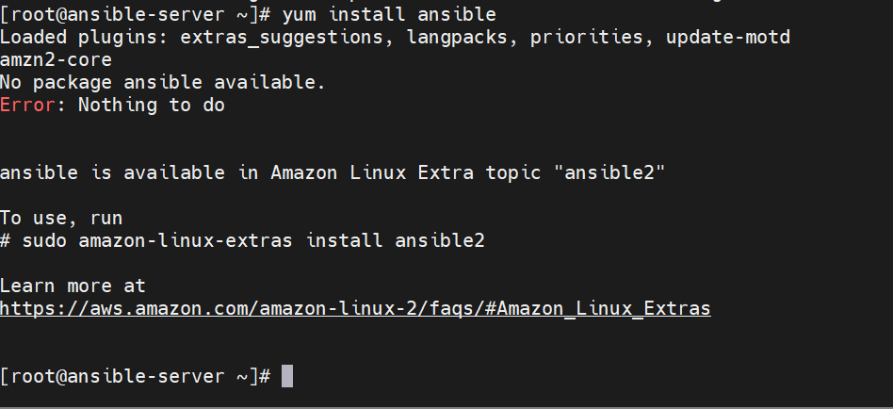

So this is the amazon linux right so use

amazon-linux-extras install ansible2

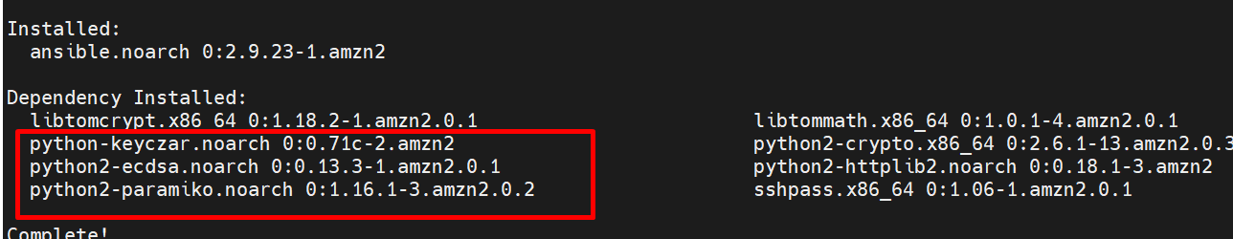

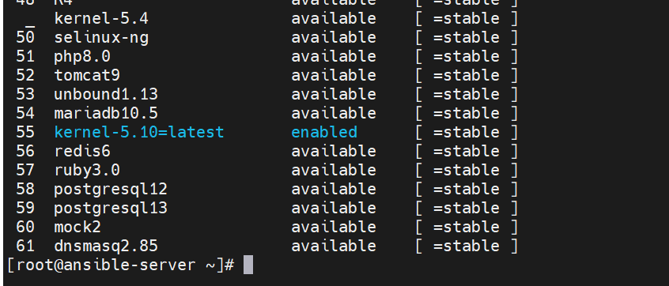

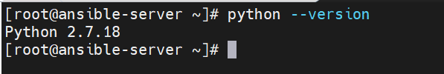

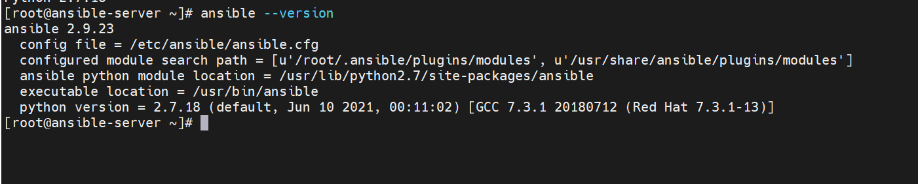

**Integrate Docker with Ansible**

Write a playbook in Ansible that playbook going to tell a docker host how to create container.

On Docker Host

* Create ansadmin
* Add ansadmin to sudoers files
* Enable password based login

On Ansible Node

* Add to hosts file
* Copy ssh keys
* Test the connection



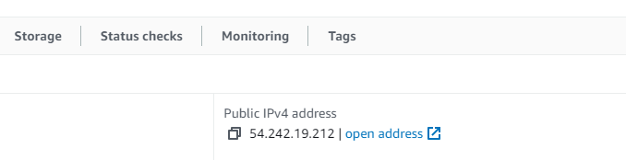

With the help of Mobaxterm connect to the Docker Host server(IP)

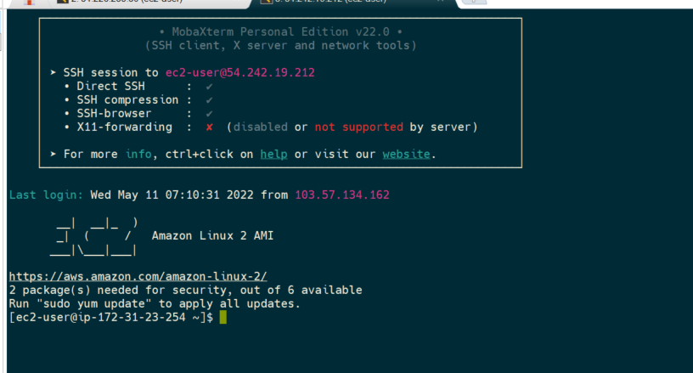

Navigate to root user

sudo su –

if you need to change the host name

vi /etc/hostname

Add user:

useradd ansadmin

passwd ansadmin

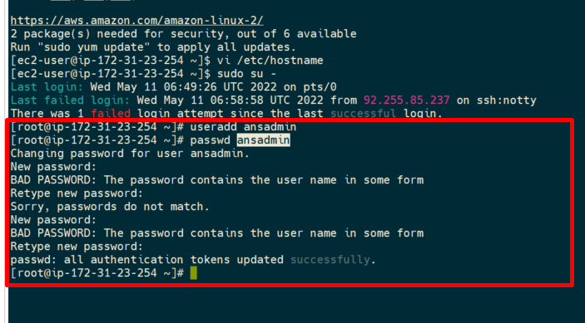

visudo

Enter i

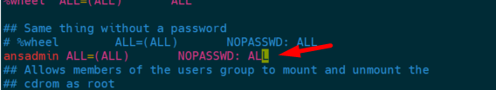

Save the file

Escape >> :wq

grep Password /etc/ssh/sshd_config

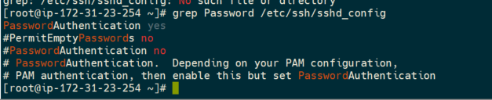

Jump to Ansible server

vi /etc/ansible/hosts

shows some examples of how to define hosts.

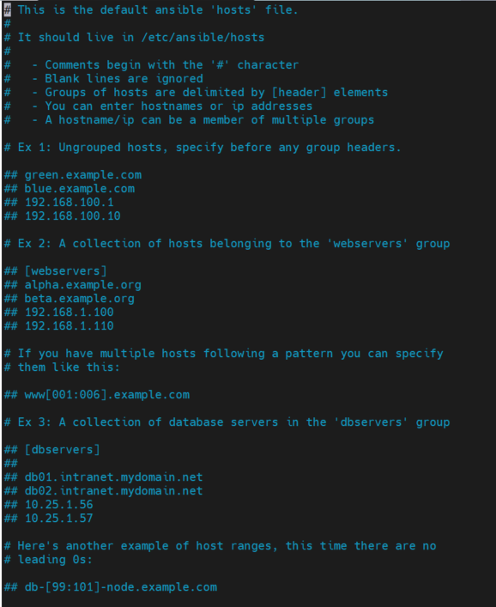

In docker host

ifconfig

Copy the Private IP form the docker server and pasted into the ansible server

Docker

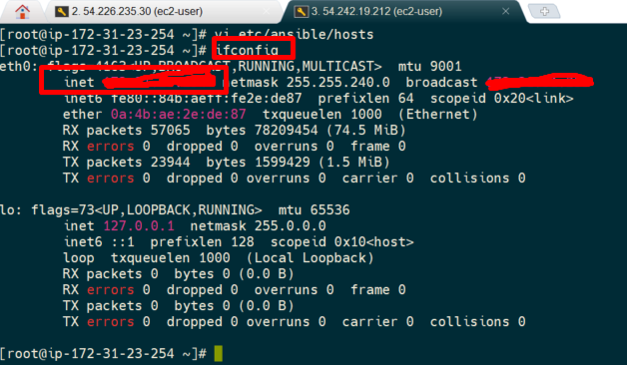

Pasted in to the ansible

vi /etc/ansible/hosts

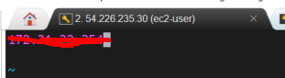

And save it

Now copy ansadmin user keys on to target ansadmin user account

ansadmin user

sudo su – ansadmin

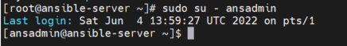

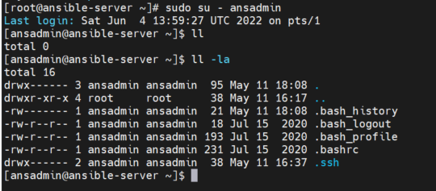

Navigate to .ssh

cd .ssh

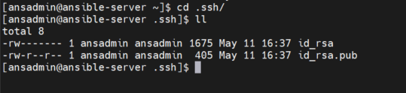

cd ..

private ip from docker

ssh-copy-id private ip

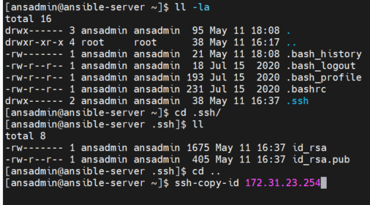

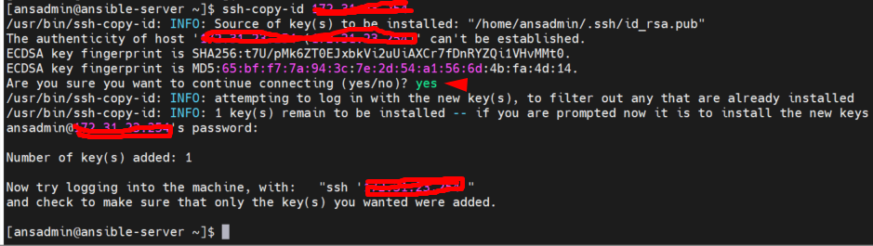

Docker server

sudo su – ansadmin

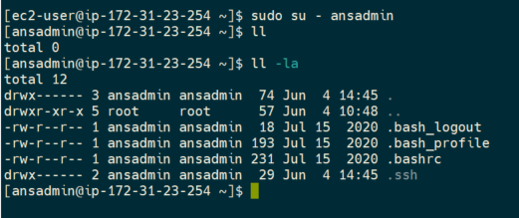

cd .ssh

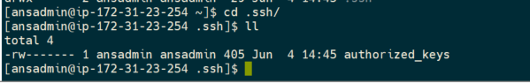

cat authorized_keys



Ansible server

cat .ssh/id_rsa

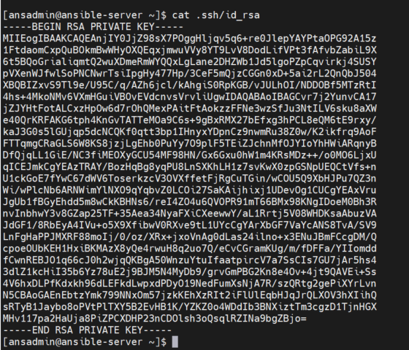

cat .ssh/id_rsa.pub

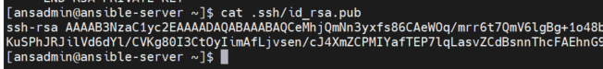

The authorized key from docker and rsa.pub key from ansible should be same.

Need to verify it’s connected or not

Ansible server:

cd ..

ansible all -m ping

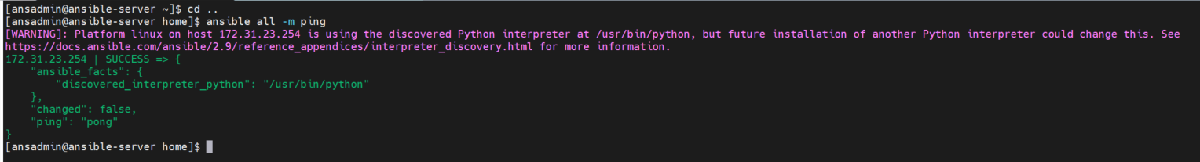

ansible all -m command -a uptime



Docker server

Uptime

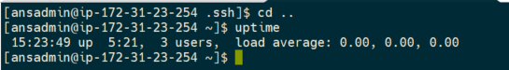

**Integrate Ansible with Jenkins**

Jenkins can able to copy the artifacts on to ansible system,(Build activities)

Ansible can able create image or it can deploy the container in docker host.(Deploy activities).

Create a user

Enable password authentication

Public over ssh plug in

Configure system with ansible

Start the Jenkins server and log in to Jenkins

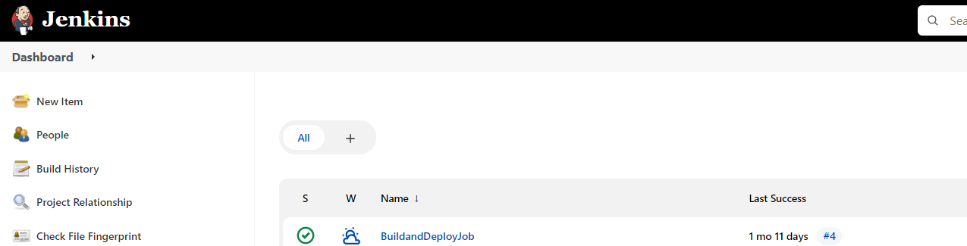

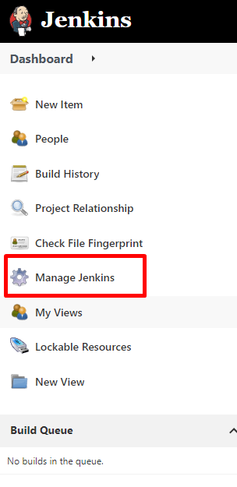

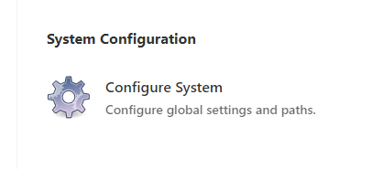

You can see at the public ssh servers with docker host credentials if you not found just add the ssh plug in to the Jenkins and provide the docker credentials

And add Ansible system



Provide the private ip of ansible server

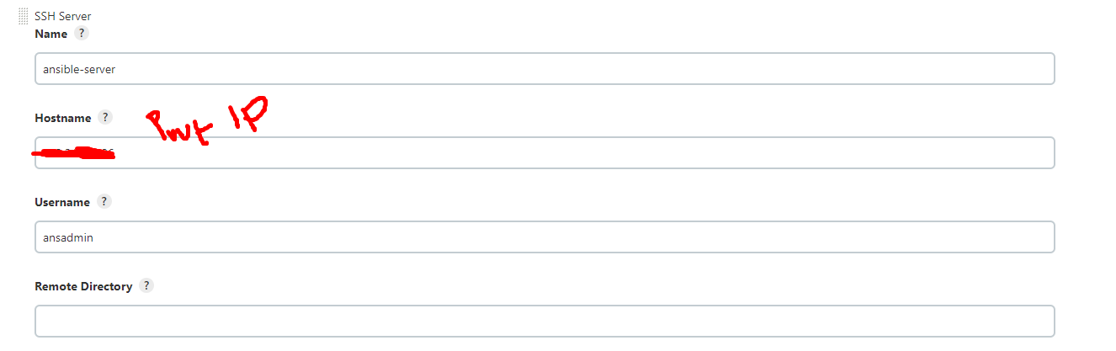



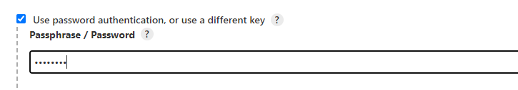

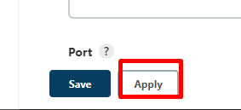





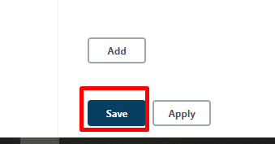

Create a new Jenkins job

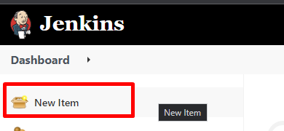

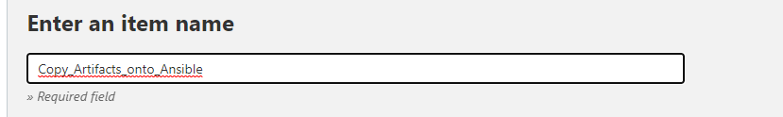

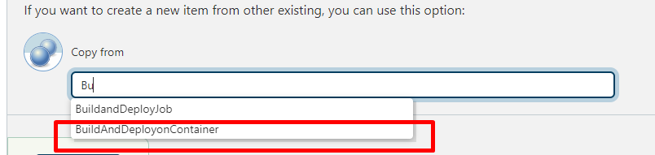

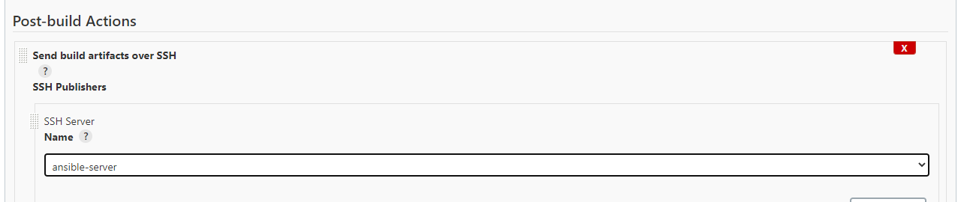

Need to create a following directory ansible server

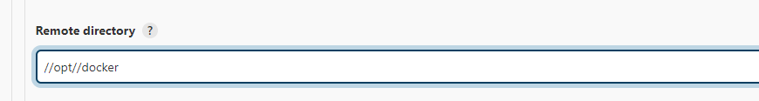

Ansible server

cd /opt

ll

mkdir docker

sudo mkdir docker

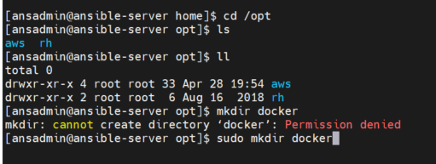

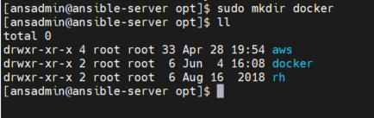

For the directory need to give the permissions

sudo chown ansadmin:ansadmin docker

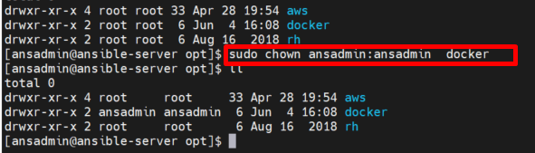

In Jenkins



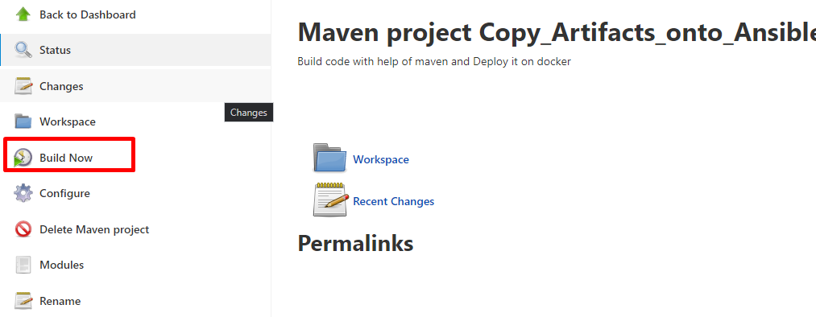

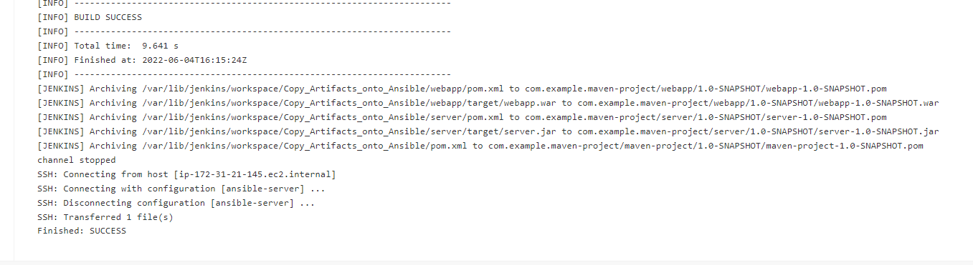

Ansible server

cd docker/

ll

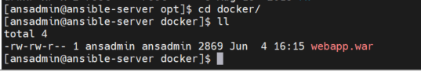

**Build an Image and create container on Ansible**

Install docker in Ansible server

Need to verify the docker group exist or not

cat /etc/group

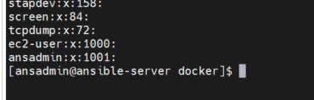

No docker exist in ansible so need to be install docker in ansible server

sudo yum install docker -y

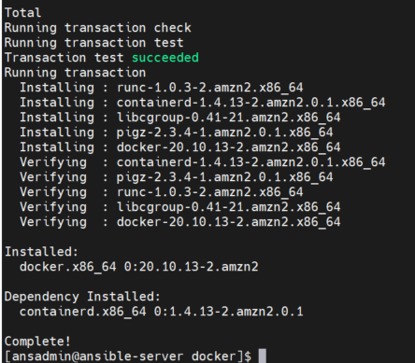

to add ansadmin to the docker group for the user need to modify

sudo usermod -aG docker ansadmin

id ansadmin

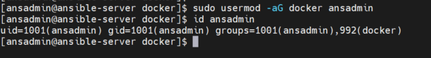

Start the docker services

service docker status

sudo service docker start

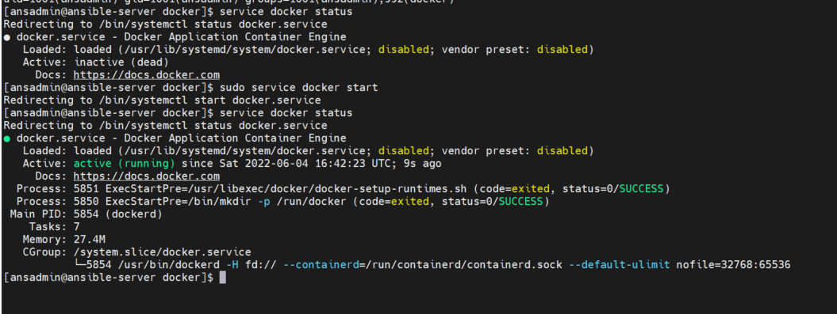

Build a docker image

Already created in docker host need to get from docker host

Docker server

sudo su -

cd /opt/docker/

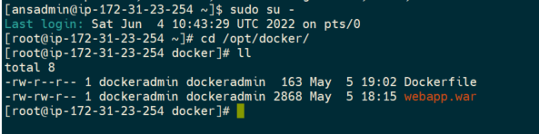

cat Dockerfile

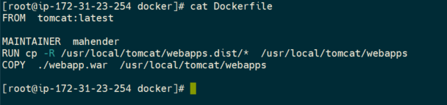

Copy the content and goto ansible server

FROM tomcat:latest

MAINTAINER mahender

RUN cp -R /usr/local/tomcat/webapps.dist/* /usr/local/tomcat/webapps

COPY ./webapp.war /usr/local/tomcat/webapps

Ansible server

vi Dockerfile

paste

FROM tomcat:latest

MAINTAINER mahender

RUN cp -R /usr/local/tomcat/webapps.dist/* /usr/local/tomcat/webapps

COPY ./webapp.war /usr/local/tomcat/webapps

And save it :wq

sudo chmod 777 /var/run/docker.sock

docker build -t regapp:v1 .

and throws some permissions requires

then perform as sudo

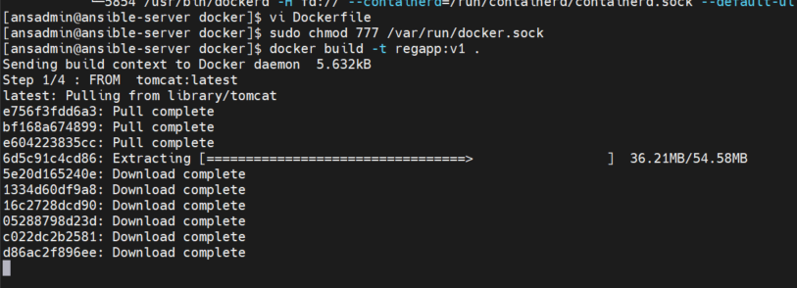

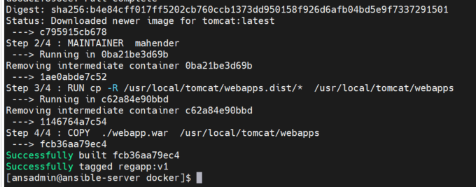

docker images

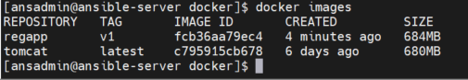

Create a containers

docker run -t --name regapp-server -p 8081:8080 regapp:v1

(port 8081 should be open)

public ip:8081/webapp

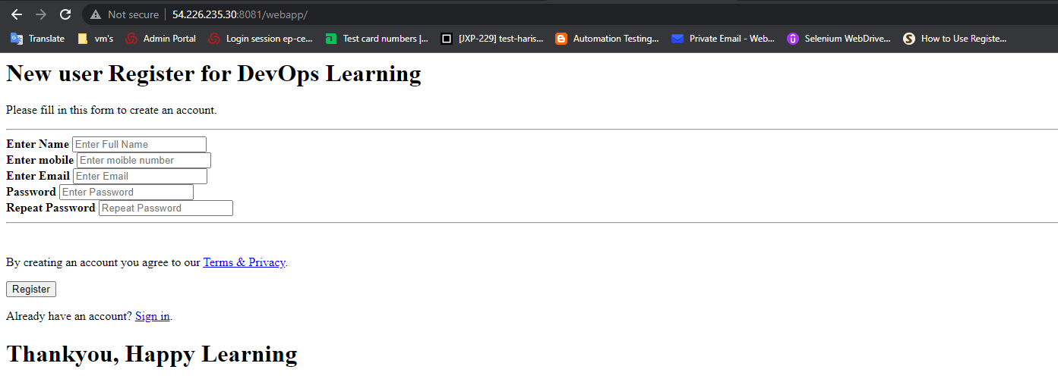

34 part completed

**Ansible Playbook to create image and container**

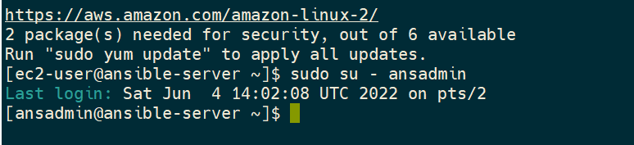

cd /opt

ll

cd docker

ll

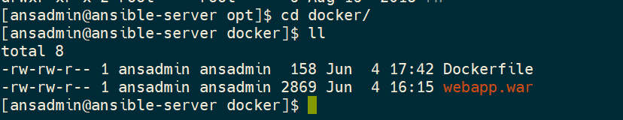

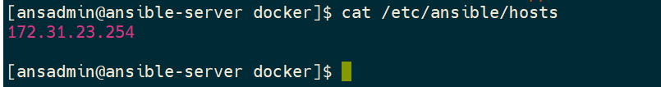

The above ip shows the docker host private ip related to the docker file

So need add ansible server ip and tell to ansible playbook to execute in ansible server.

Ifconfig

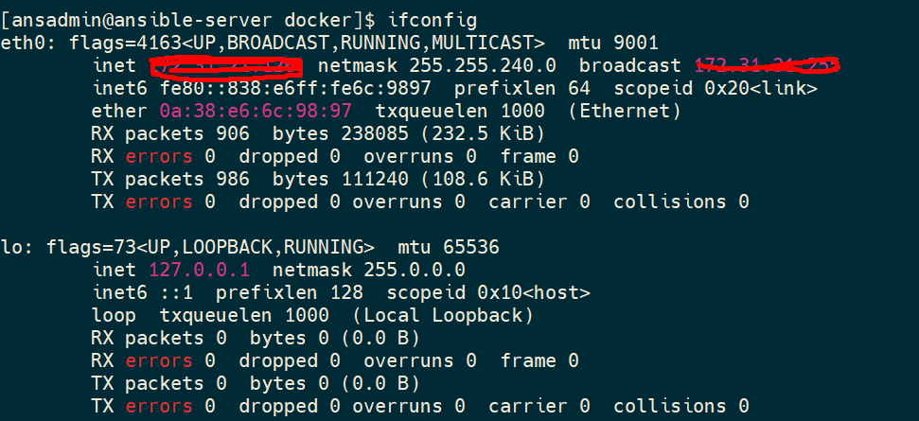

sudo vi /etc/ansible/hosts



Enter i

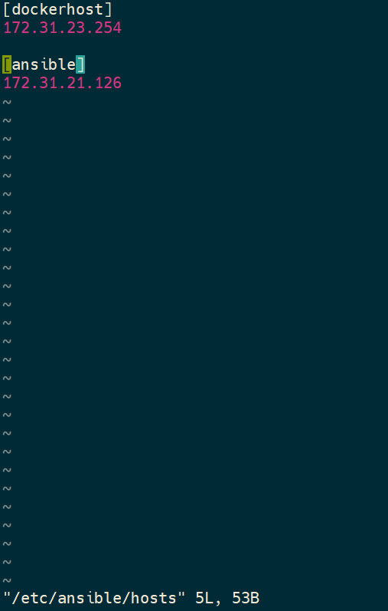

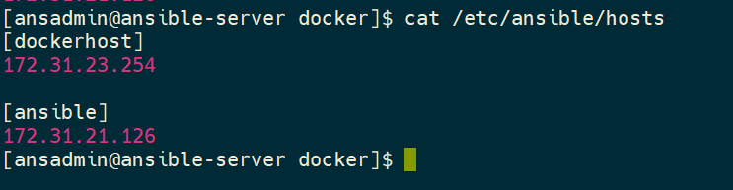

To make work with ansible copy the ssh keys on to the ansible servers

To check whether communicated with ansible and docker

ansible all -a uptime

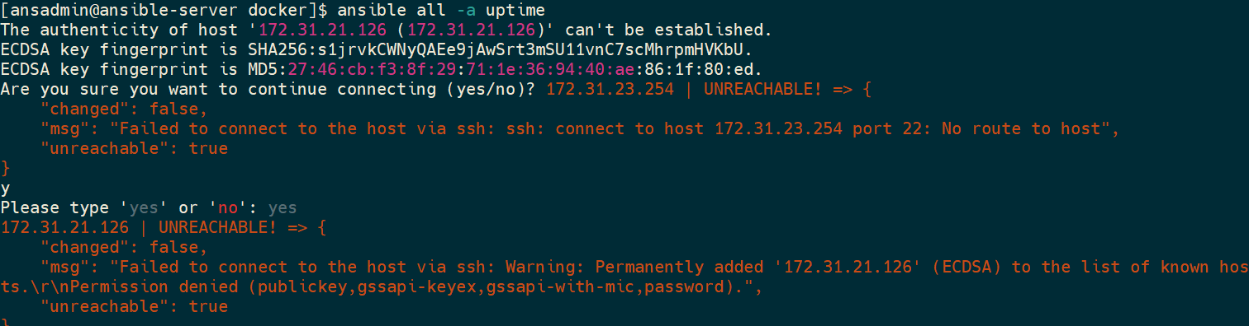

If you get unreachable, check the docker server should be running status.

ansible all -a uptime

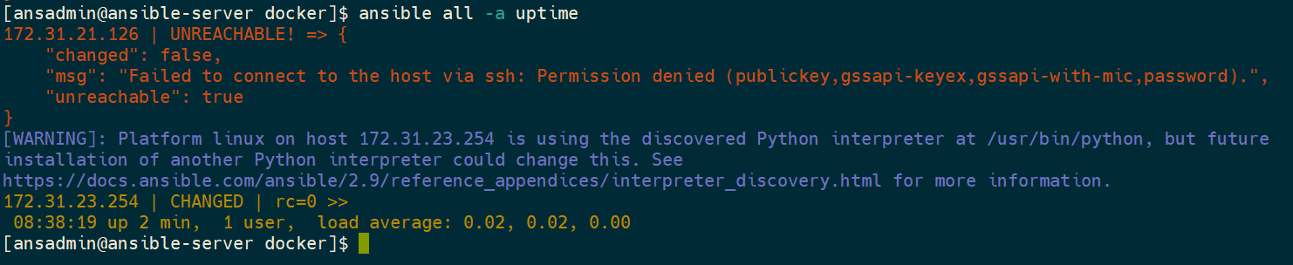

ssh key permission denied so need to copy the ssh keys

ssh-copy-id 172.31.21.126

provide the password

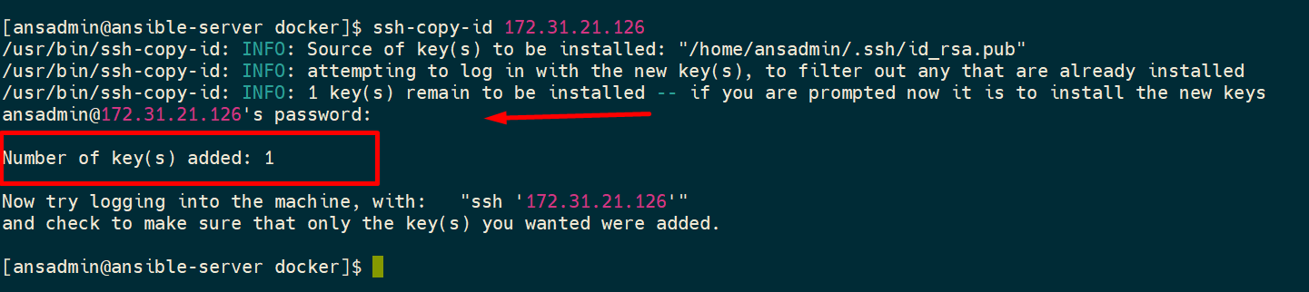

ansible all -a uptime

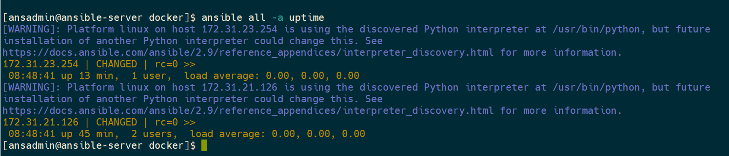

Check the present working directory.

pwd

vi regapp.yml

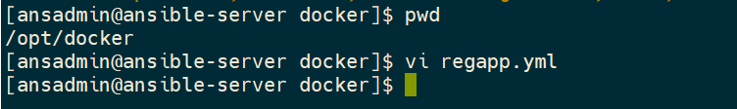

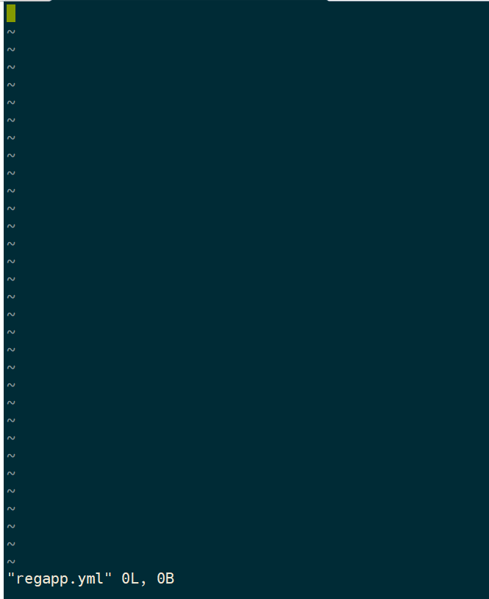

To write the ansible playbook basic level

become: true

if you want run as a root include this.

---

* hosts: ansible

tasks:

- name: create docker image

command: docker build -t regapp:latest .

args:

chdir: /opt/docker

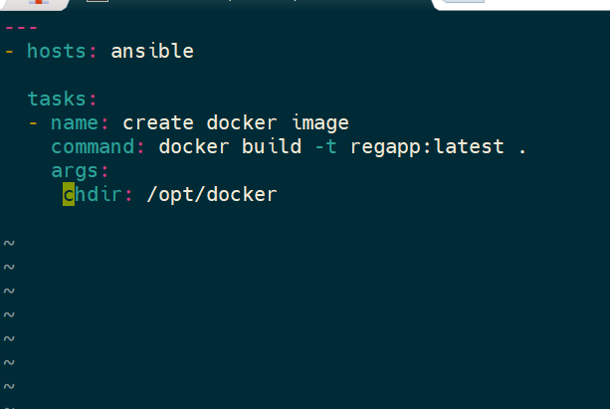

ansible-playbook regapp.yml --check

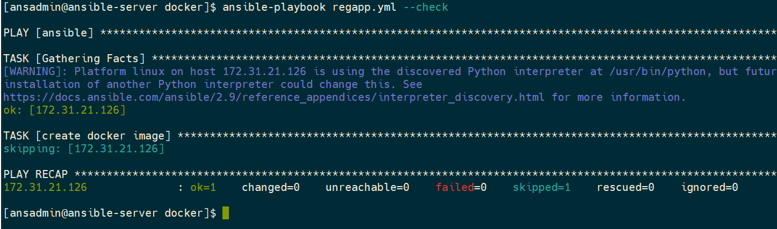

docker images

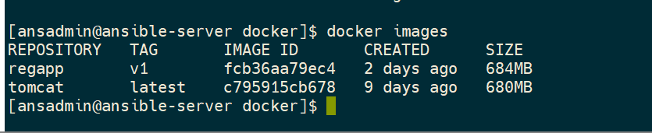

ansible-playbook regapp.yml

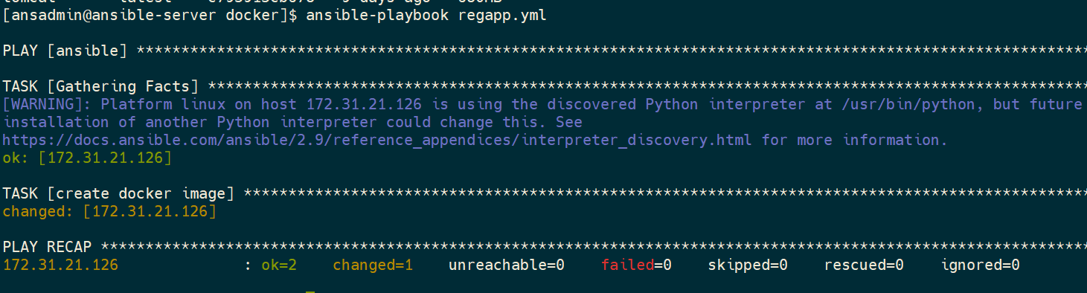

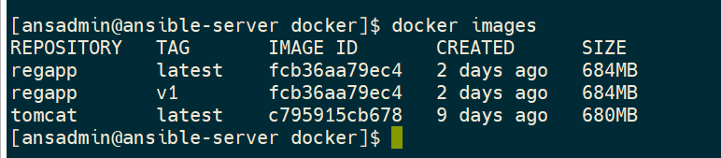

Copy image on to dockerhub

<https://hub.docker.com/>

Sign up and login to docker hub

Need to login docker hub in ansible server

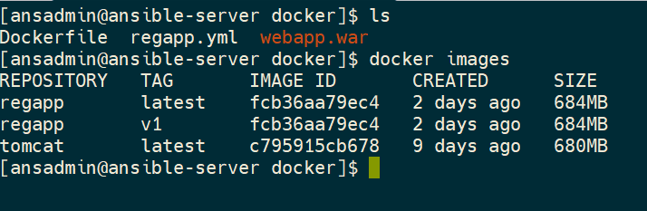

docker login

username:

password:

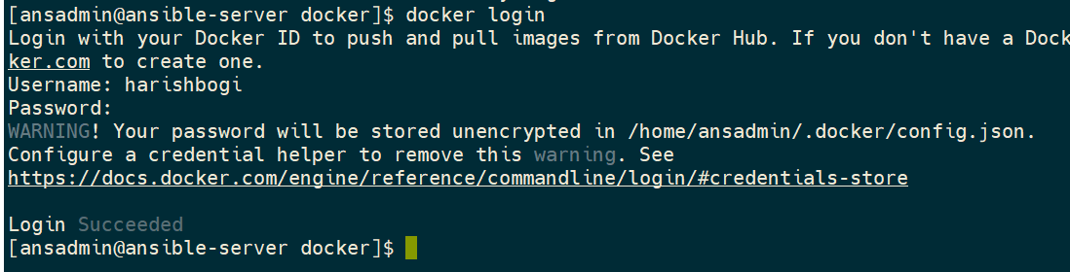

Need to push the image to docker hub

docker tag <image id> harishbogi/regapp:latest

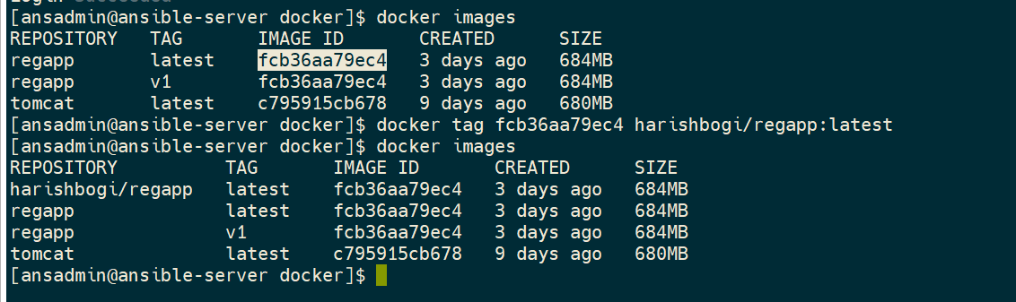

docker push harishbogi/regapp:latest

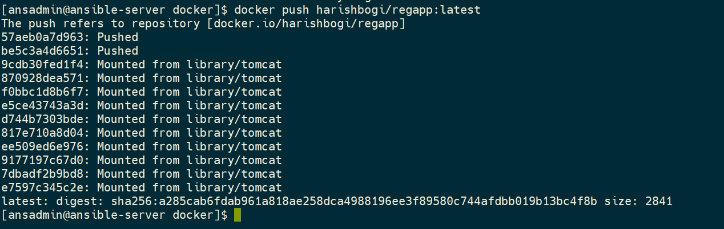

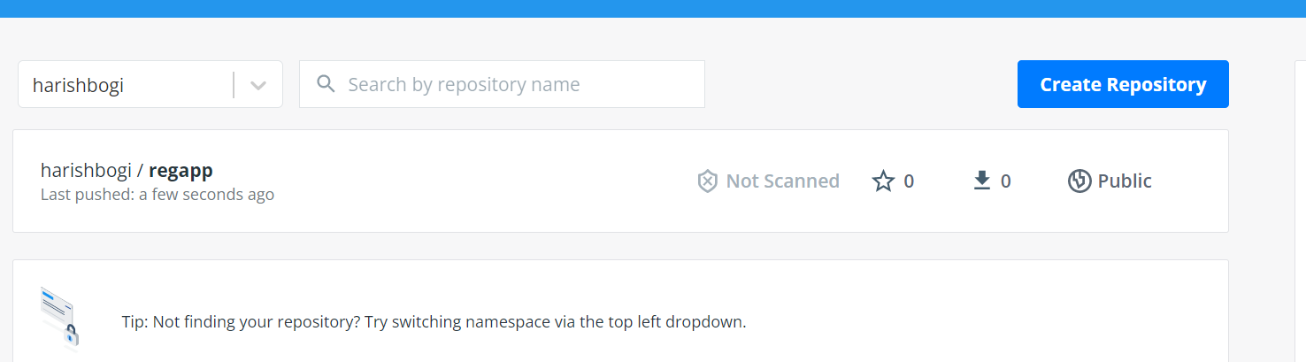

Jenkins job to build an image onto ansible

pwd

add to regapp.yml file

vi regapp.yml

* name: create tag to push image onto dockerhub

command: docker tag regapp:latest harishbogi/regapp:latest

* name: push docker image

command: docker push harishbogi/regapp:latest

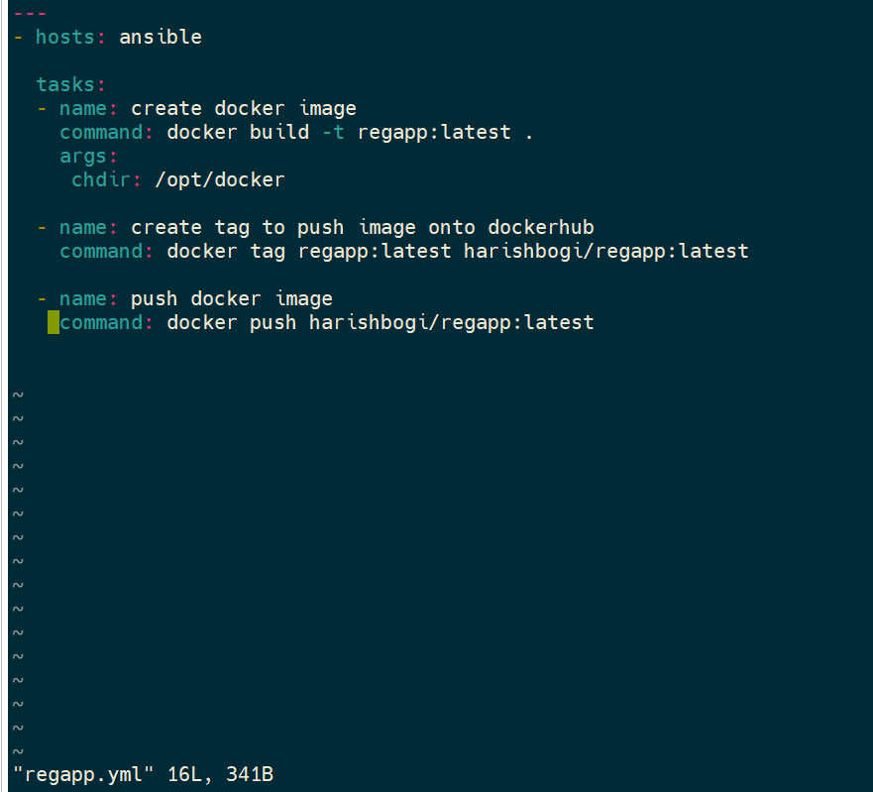

ansible-playbook regapp.yml --check

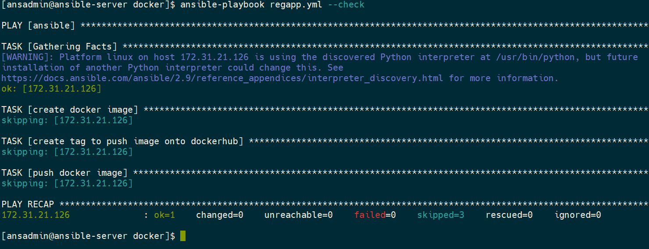

Note:

You should login as docker as a ansadmin only,

With root user you are not able to push the image

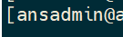

cat regapp.yml

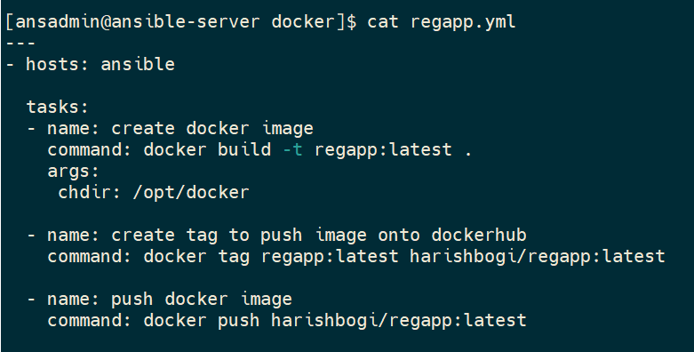

cat /etc/ansible/hosts

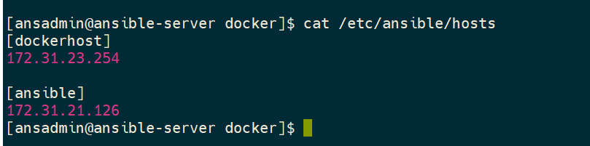

Limits:

ansible-playbook regapp.yml --limit localhost

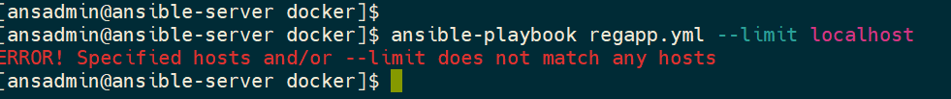

Navigate to Jenkins

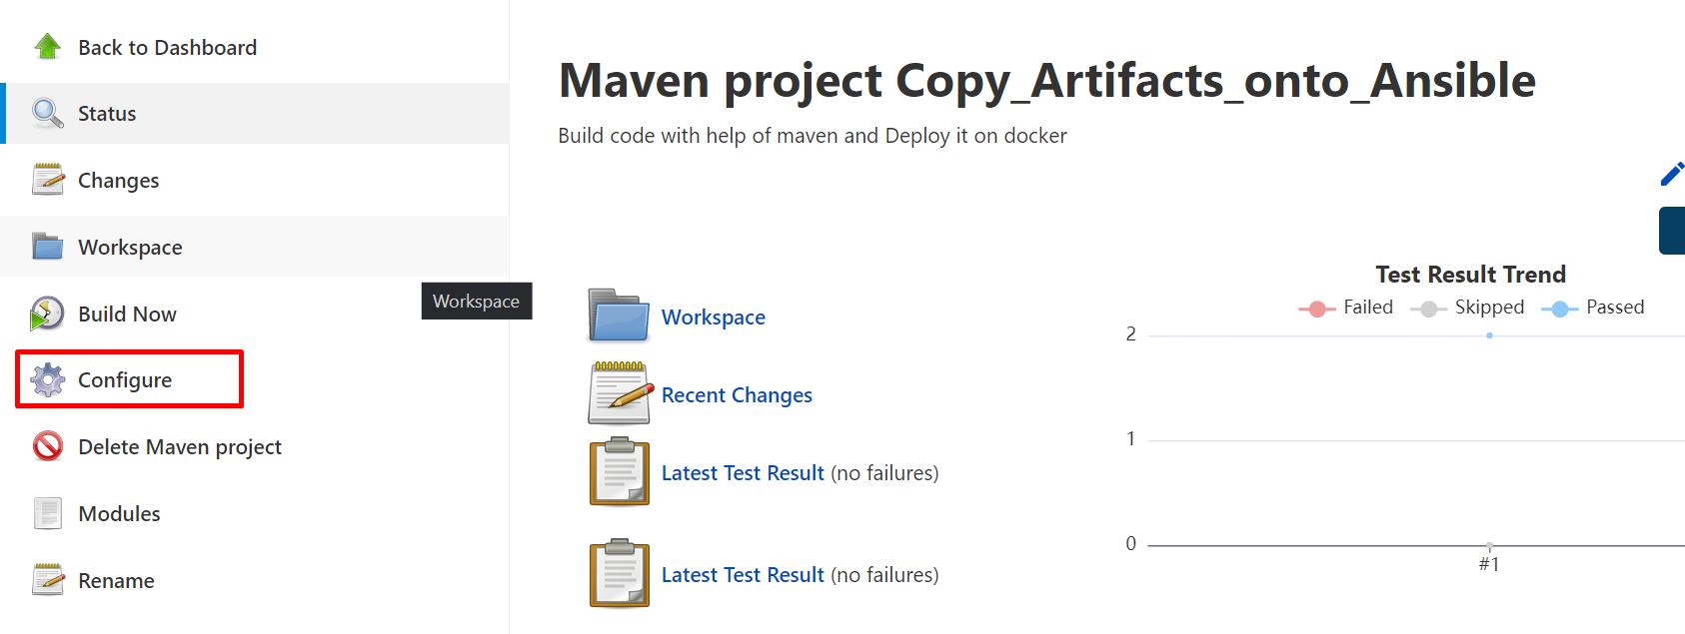

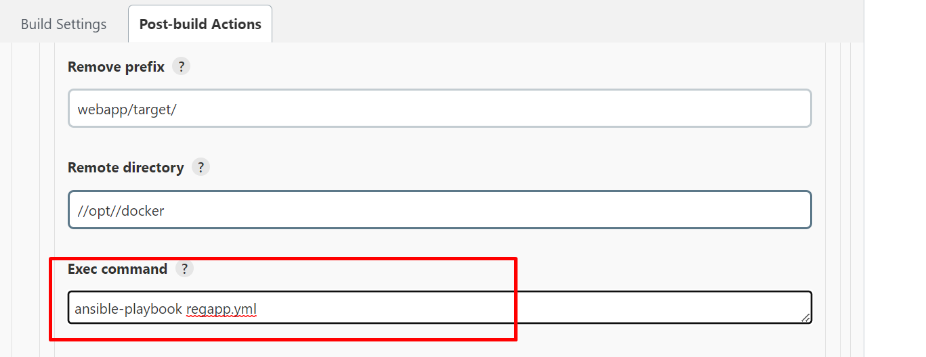

ansible-playbook regapp.yml

apply >> save

For automate if any changes in code in git

* * * * *

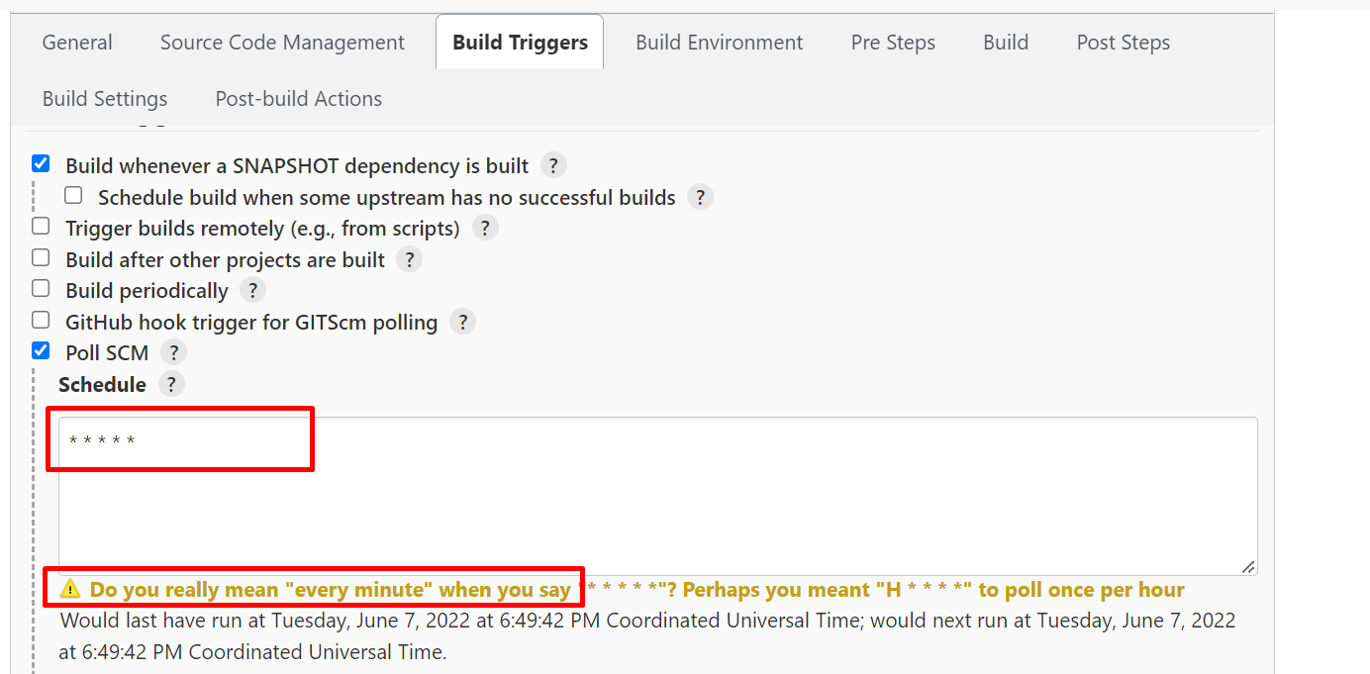

Apply >>save

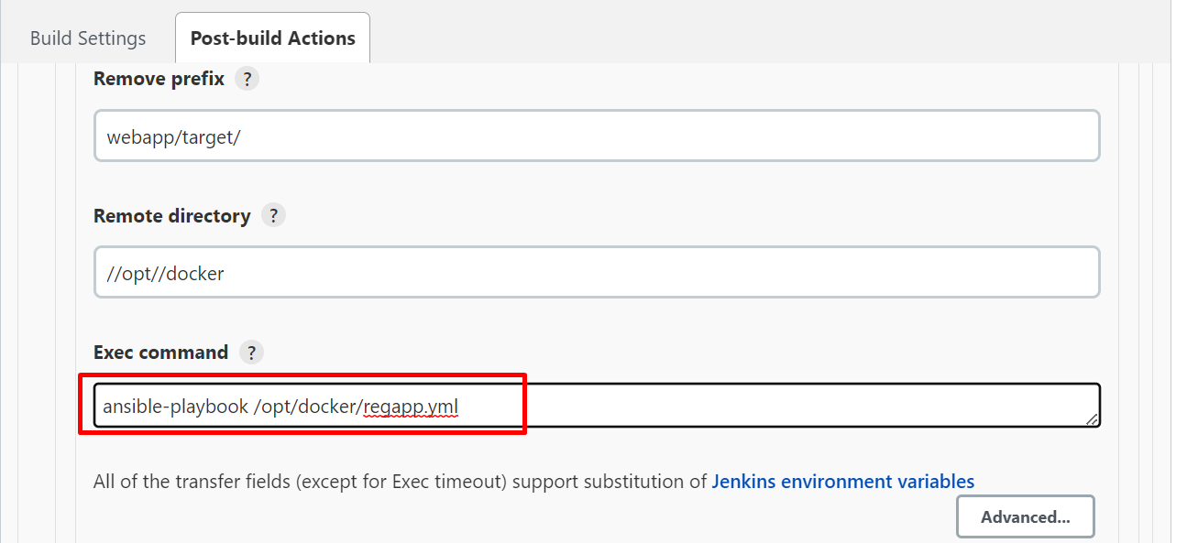

Build now

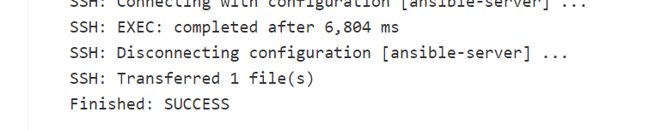

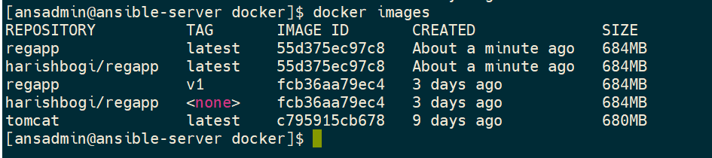

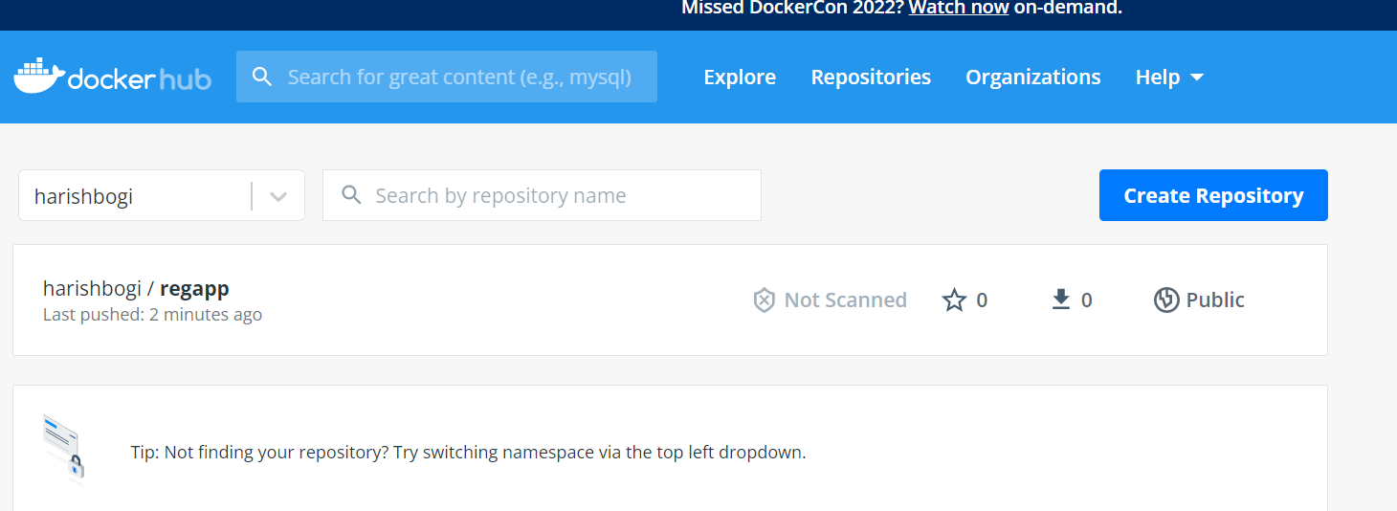

37 completed

Create a container dockerhost using ansible playbook

Create a container playbook

vi deploy_regapp.yml



---

* hosts: dockerhost

tasks:

- name: create container

command: docker run -d --name regapp-server -p 8082:8080 harishbogi/regapp:latest

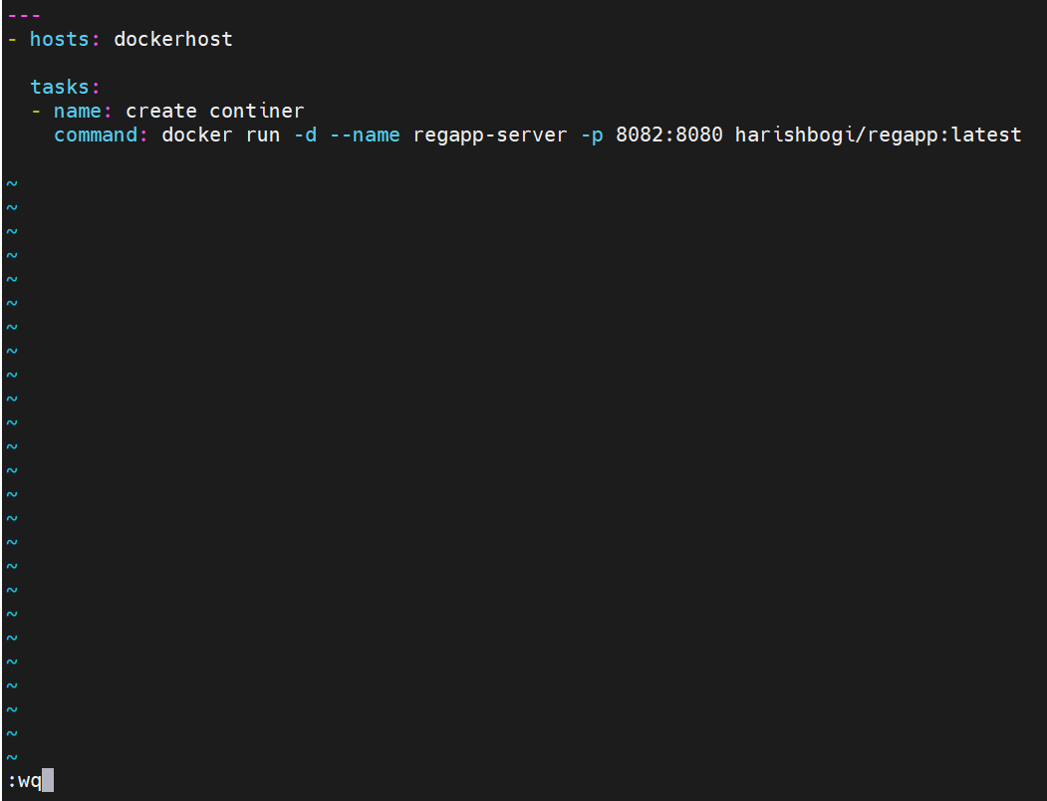

Need to check the playbook

ansible-playbook deploy_regapp.yml –check



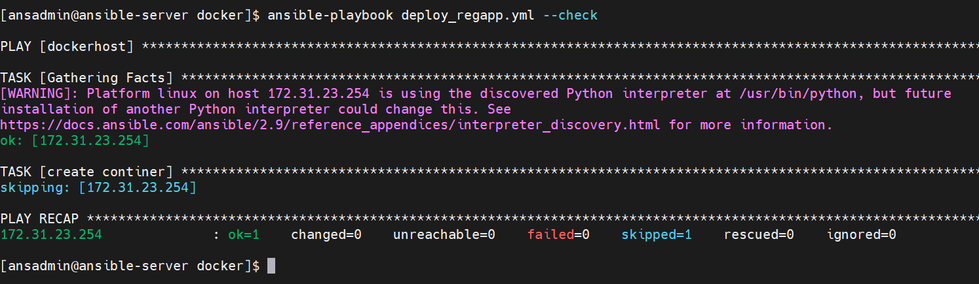

Docker services should be active in both ansible and docker hosts otherwise you will get like this

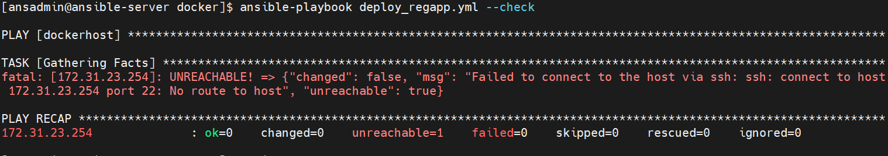

Need to clear all the images and again need to build so

At the Docker host:

docker images

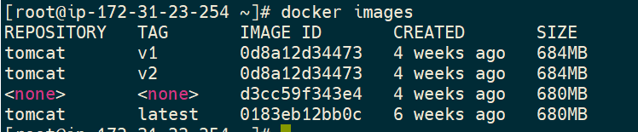

For the containers

docker ps -a

if your see any latest containers related to ansible just remove

docker rm -f <container id>

for the delete images

docker images

docker image prune

if any docker images exist delete those images

docker rmi <image id>

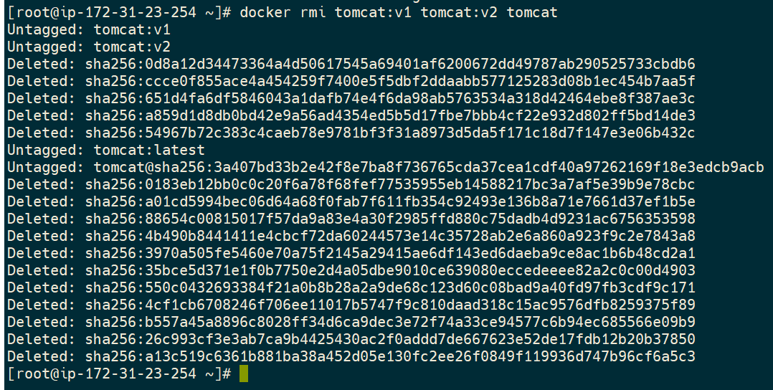

At the Ansible host:

Run

ansible-playbook deploy_regapp.yml



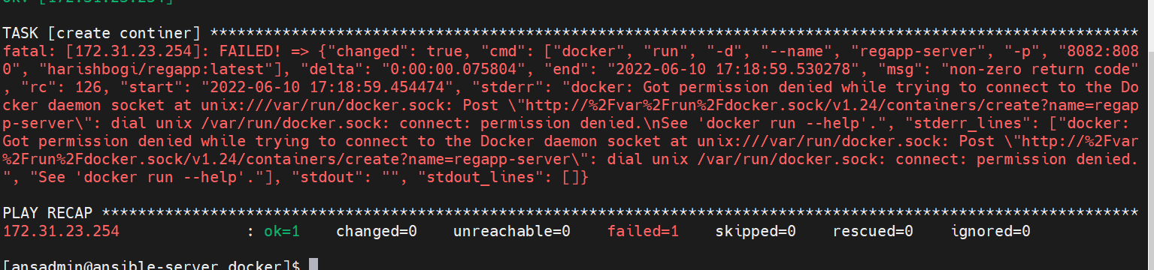

Failed because permission issues

So need to change the permissions at the docker host

Docker host:

chmod 777 /var/run/docker.sock



At the ansible:

ansible-playbook deploy_regapp.yml

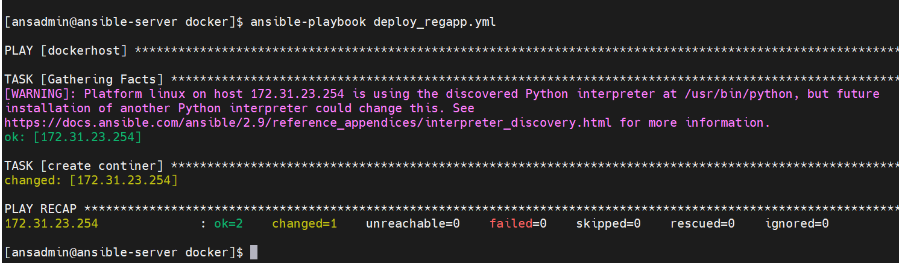

Check the images at docker host

Docker host:

docker images

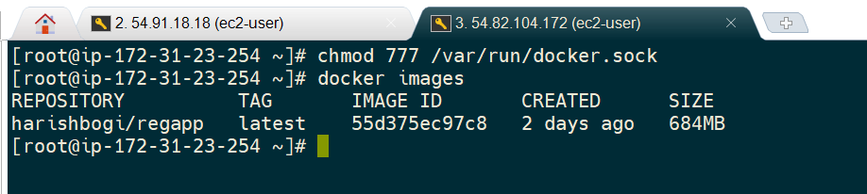

docker ps -a

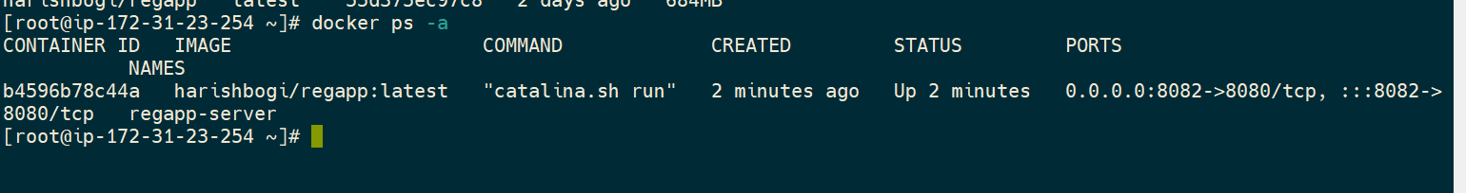

Image and container created successfully

Copy the public ip of docker host

Open in browser and paste

54.82.104.172:8082

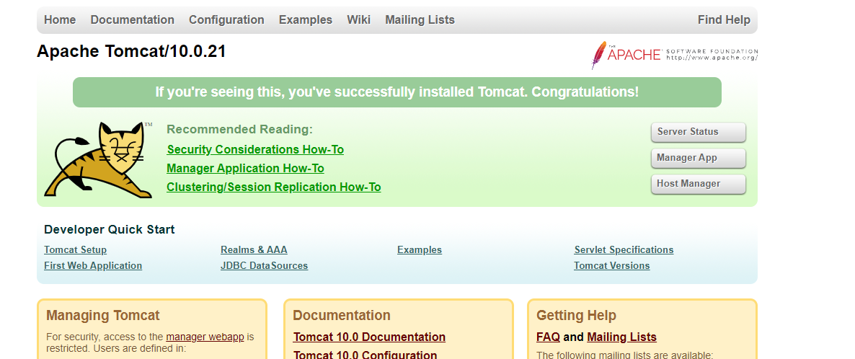

<http://54.82.104.172:8082/webapp/>

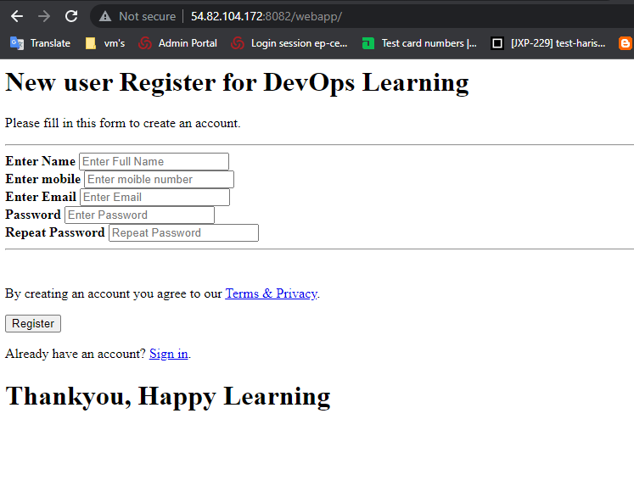

Note :

If you try to execute ansible playbook you will get a error like this because of the container already exist so need to remove the images and containers before execute the ansible playbook

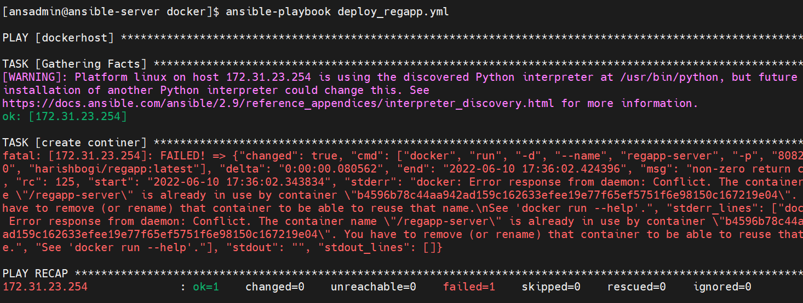

**Continues deployment of docker container using ansible playbook**

**In order to overcome the error**

**Remove the exist images**

**Remove the exist container**

**Create new container**

**Ansible host:**

**Pwd**

**/opt/docker**

**ll**

**cat deploy_regapp.yml**

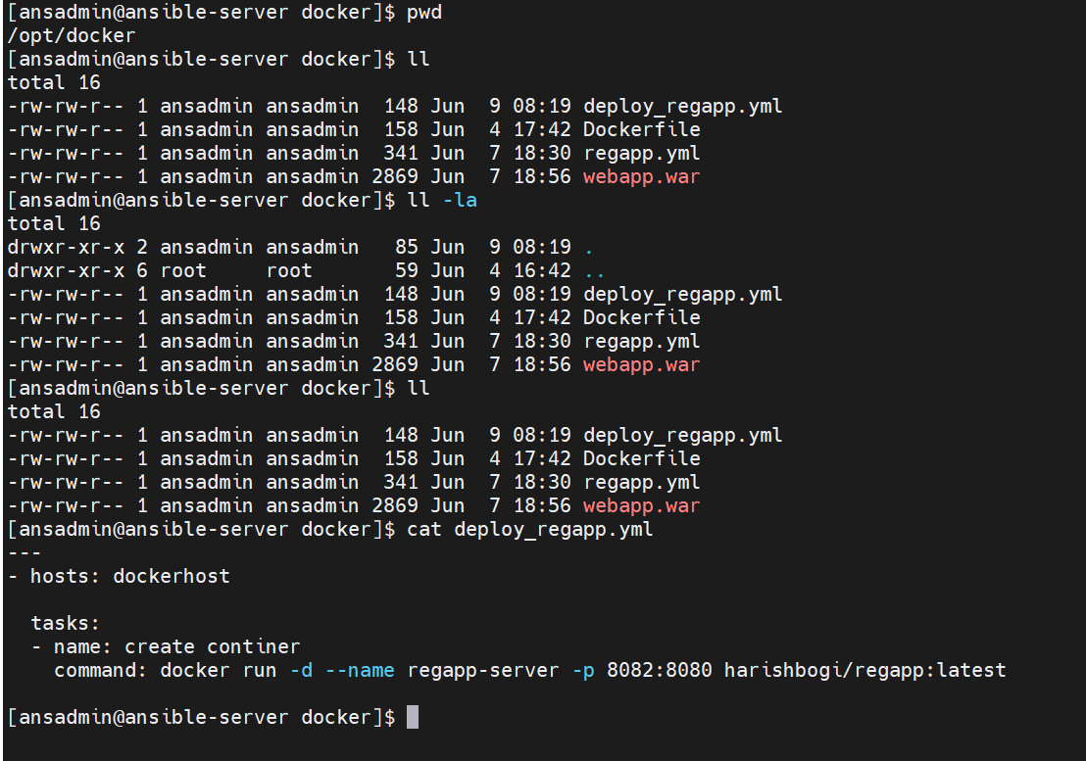

**Need to edit the deploy-playbook yml file**

**vi deploy_regapp.yml**

**add**

**---**

**- hosts: dockerhost**

**tasks:**

**- name: stop existing container**

**command:docker stop regapp-server**

**- name: remove the container**

**command: docker rm regapp-server**

**- name: removeimage**

**command: docker rmi harishbogi/regapp:latest**

**- name: create continer**

**command: docker run -d --name regapp-server -p 8082:8080 harishbogi/regapp:latest**

**to avoid the errors**

**---**

**- hosts: dockerhost**

**tasks:**

**- name: stop existing container**

**command: docker stop regapp-server**

**ignore_errors: yes**

**- name: remove the container**

**command: docker rm regapp-server**

**ignore_errors: yes**

**- name: removeimage**

**command: docker rmi harishbogi/regapp:latest**

**ignore_errors: yes**

**- name: create continer**

**command: docker run -d --name regapp-server -p 8082:8080 harishbogi/regapp:latest**

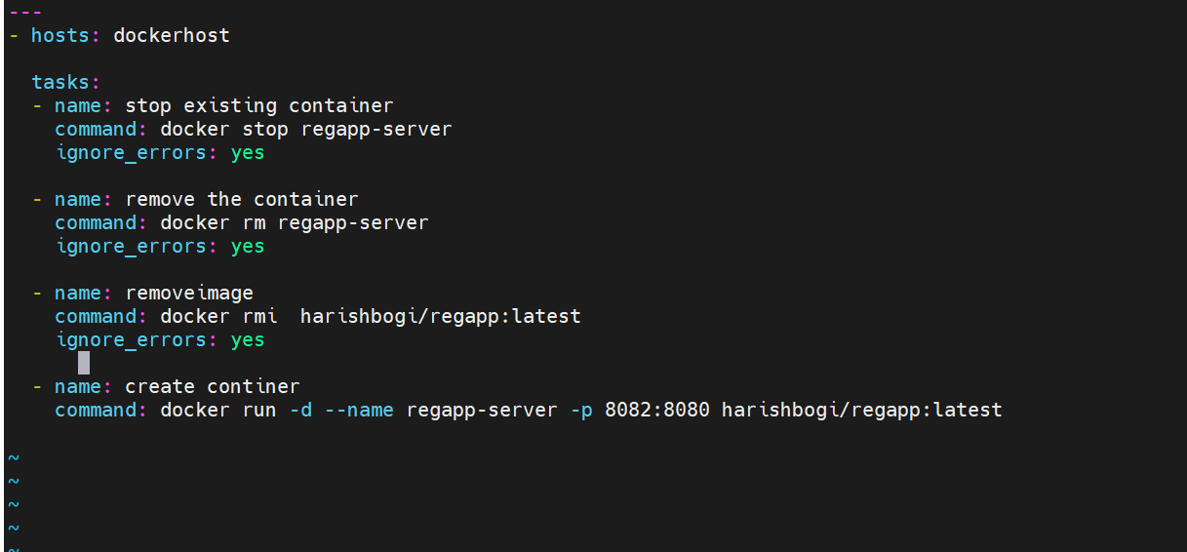

**Save the escspe>>:wq**

**And run the ansible playbook**

ansible-playbook deploy_regapp.yml --check

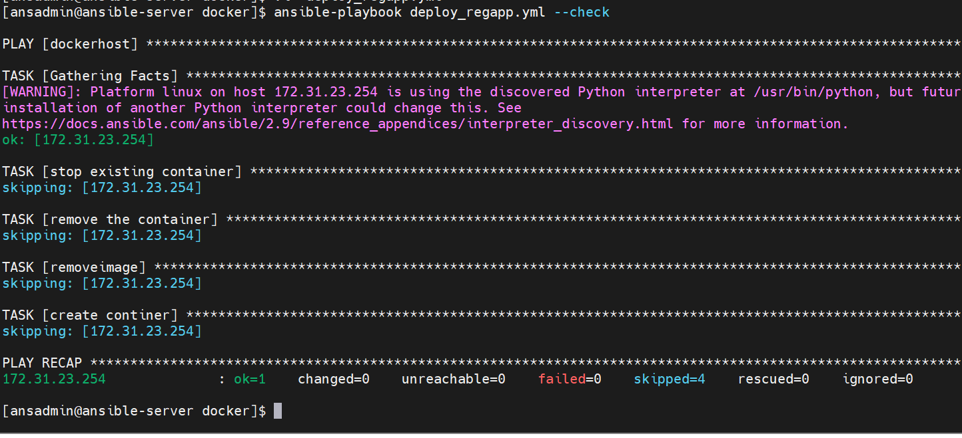

ansible-playbook deploy_regapp.yml

docker host

Checked the images and containers

docker images

docker ps -a

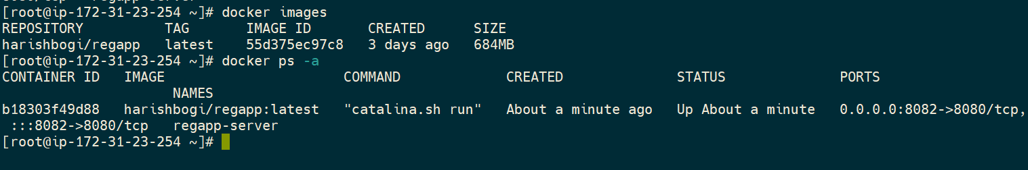

Examples for the docker images modules for ansibles

<https://docs.ansible.com/ansible/latest/collections/community/docker/docker_image_module.html>

**Jenkins CI/CD to deploy oncontainer using Ansible**

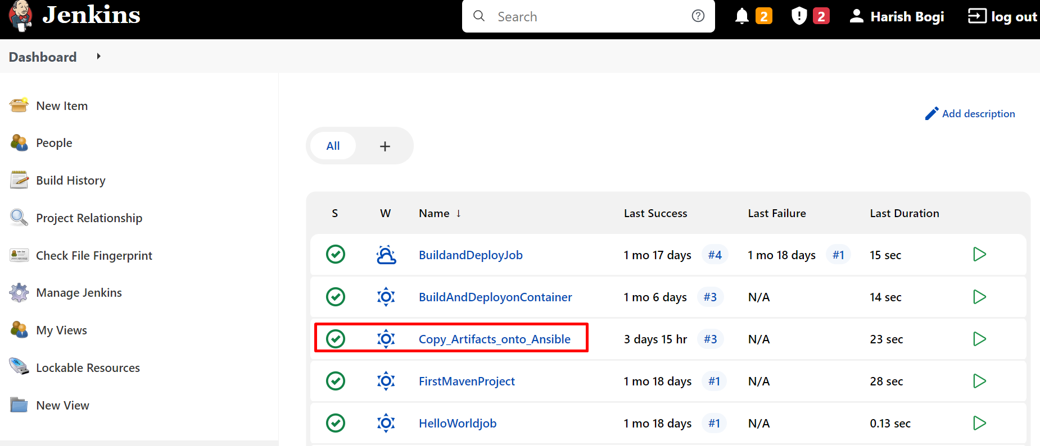

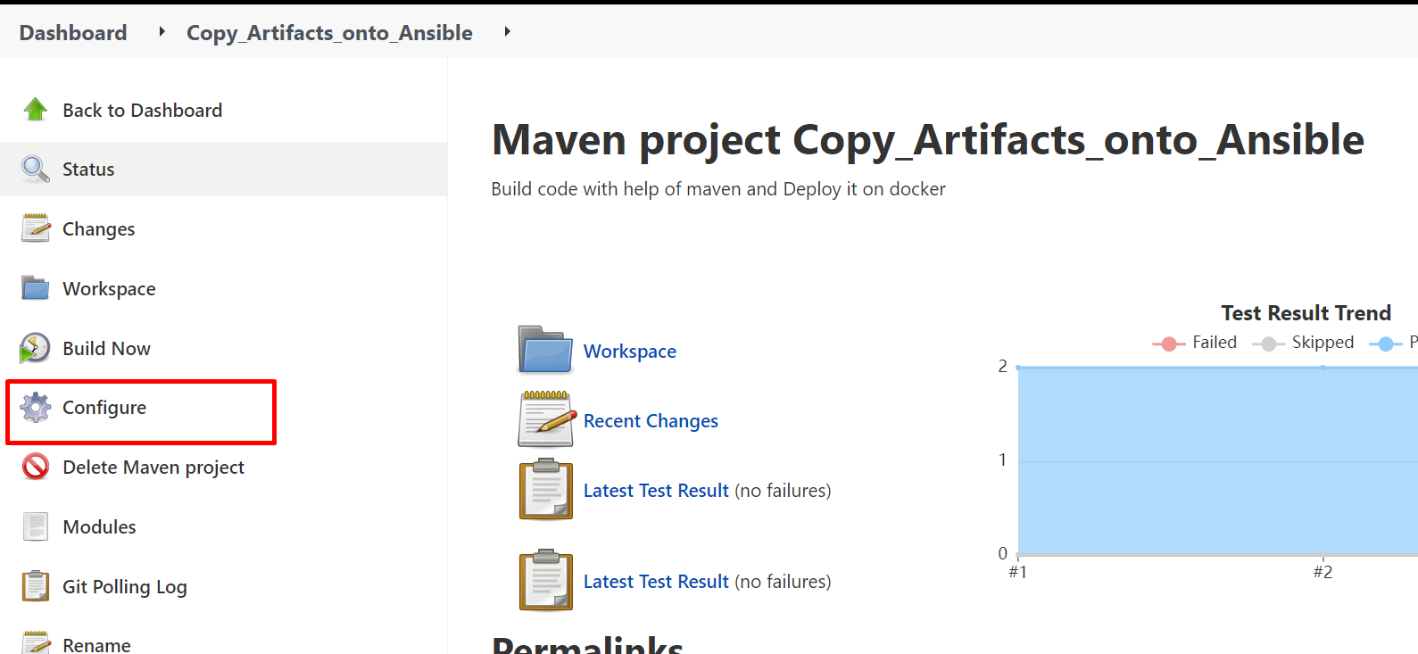

Shows only the command create docker images

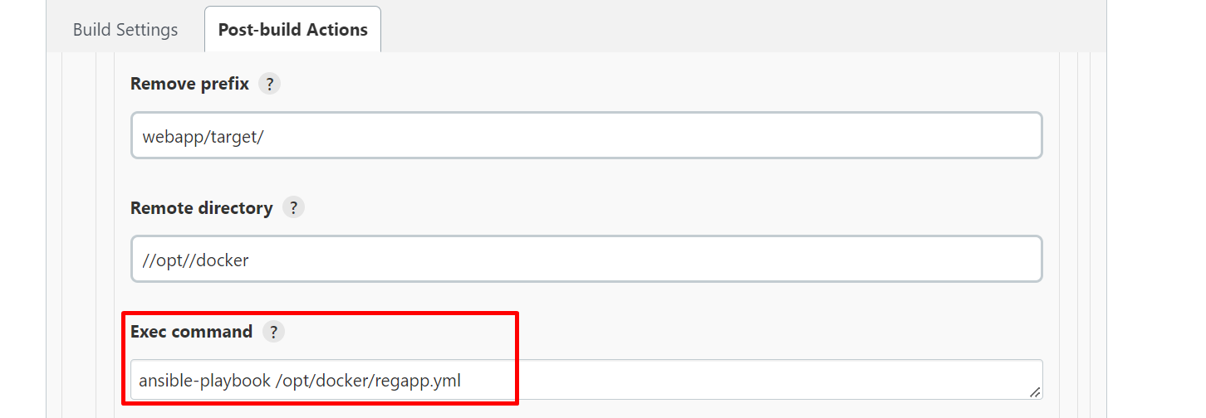

ansible-playbook /opt/docker/regapp.yml;

sleep 10;

ansible-playbook /opt/docker/deploy_regapp.yml

Apply >> Save

If you have any changes in your code the automatically triggered with the setting of poll SCM and automatically build.

Build Now manually

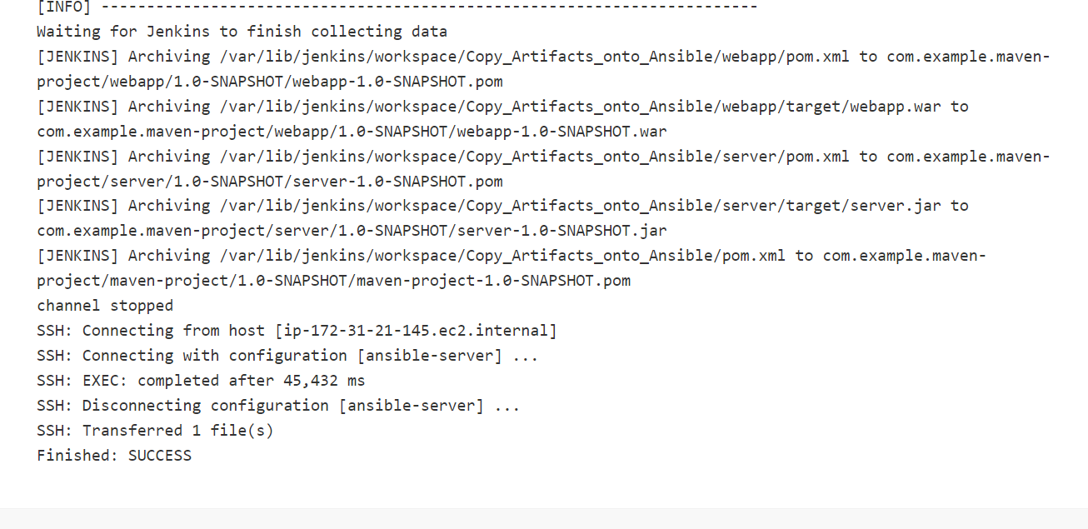

Copy the public ip of docker host and paste the browser

Public ip:8082/webapp

